Process Modelling for Photo-Iniferter RAFT with Multiple Chain Transfer Agents

Rui Liu,a Xiaowen Lin,a Xi Chen,a, b Antonios Armaouc, d

aState Key Laboratory of Industrial Control Technology, College of Control Science and Engineering, Zhejiang University 310027, Hangzhou China.

bNational Center for International Research on Quality-targeted Process Optimization and Control, Zhejiang University 310027, Hangzhou China. xi_chen@zju.edu.cn

cChemical Engineering Department, University of Patras, Patras 26504, Greece.

dChemical Engineering & Mechanical Engineering Departments, Pennsylvania State University, College Park, PA 16802 USA. armaou@upatras.gr & armaou@psu.edu

Abstract

Model development constitutes a pivotal part in process systems engineering. Specifically, modelling polymerization processes with newly clarified mechanisms holds significance in guiding experiment/process design and optimizing polymer production. Advanced photo-induced reversible deactivation radical polymerization (RDRP) techniques, such as photo-iniferter reversible addition-fragmentation chain-transfer (PI-RAFT), leverage light irradiation to control polymer growth. The introduction of diverse chain transfer agents (CTAs) into the PI-RAFT system yields varied polymer generation rates and microstructural properties, thereby affording expanded opportunities for material discovery and applications in high-value industries. In this study, an accelerated Monte Carlo (MC) model at a microscopic resolution is established for the dynamic PI- RAFT processes. Subsequently, the impact of multiple CTAs on the final polymers of the PI-RAFT process is investigated via the developed model. The accuracy and efficiency of the established accelerated MC model are validated against the equation-oriented deterministic method. The insights derived from this study provide guidance towards the experimental design and process optimization in PI-RAFT polymerization.

**Keywords**: Monte Carlo simulation, PI- RAFT, microscopic scale, process modelling.

* 1. Introduction

Developing modelling approaches for polymerization processes, practically those involving pioneering and newly clarified mechanisms, is of great demands to advance kinetic comprehension and facilitate industrial applications. Over the last decades, reversible deactivation radical polymerization (RDRP) has shown significant promise among various polymerization techniques due to its ability for precise control over polymer growth. RDRP enables the production of polymers with desired properties through establishing dynamic equilibriums among different polymer species within the system (Zhou et al., 2020). Furthermore, several photo-induced strategies for radical (re)generation have been applied in RDRP, leveraging light irradiation as an external stimulus (Corrigan et al., 2020). Such photo-RDRP techniques contribute to environmentally sustainable polymerization processes and enhance the potential of resulting polymers for biocompatible applications.

Among diverse photo-RDRP techniques, the photo-iniferter reversible addition-fragmentation chain transfer (PI-RAFT) emerges as a powerful and versatile photo-RDRP polymerization method. PI-RAFT enables the production of polymers with intricate and well-defined structures through meticulously controlled polymerization processes. The introduction of diverse chain transfer agents (CTAs) into the PI-RAFT system further yields polymers with varied microstructural properties, including molecular weight distribution (MWD) (Lehnen et al., 2023). As microstructural polymeric properties directly influence the end-use functionalities of polymer products, the development of efficient modelling approaches for PI-RAFT with microscopic resolution holds significance in reducing the number of experiments required for process optimization.

Focusing on computational modelling methods with embedded MWD, they can be classified into two categories: deterministic equation-based methods and stochastic Monte Carlo (MC) methods (Liu et al., 2023). The former encounters challenges in accurately describing polymeric properties since direct solution of the underlying ordinary differential equation systems is computationally infeasible due to memory resource limitations and stiffness. These hurdles are surpassed via coarse graining and/or order reduction for computational efficiency at the cost of limited applicability to simpler mechanisms (Saldívar-Guerra, 2020). In contrast to deterministic methods, MC simulations enable the characterization of individual polymers based on probability theory, providing more microscopic-scale information, albeit at a computational expense due to tracking all discrete reaction events alongside time (Cole et al., 1994).

In this study, an accelerated MC model, coupled with the constant-number MC (CNMC) approach, is established for dynamic PI-RAFT processes with multiple CTAs. The evolution of MWDs from processes with varying ratios of two distinct CTAs is simulated. The accuracy and efficiency of the developed accelerated MC model are validated against the deterministic method of moments (MoM). This study provides an opportunity for the further design and optimization of polymerization processes.

* 1. Photo-iniferter RAFT polymerization process

The schematic representation of PI-RAFT polymerization, featuring a single CTA species is presented in Figure 1. The corresponding kinetic mechanism is detailed in reactions 1-16 in Table 1. Herein, *R*\*, *M*, *TR*, and *T*\* denote primary radicals, monomers, CTA, and thiocarbonylthio radicals, respectively. *Dn*, *Pn*\*, and *TPn*\* represent dead polymers, radical polymers, and inactive polymers with chain lengths of *n*, respectively. Also, *PnTR* and *PnTPm* signify one-arm adduct and two-arm adduct radicals, wherein the latter exhibits chain lengths of *n* and *m* on each arm. The directional arrows in the chemical equations of Table 1, labelled “*hv*”, indicate reactions triggered by light irradiation.

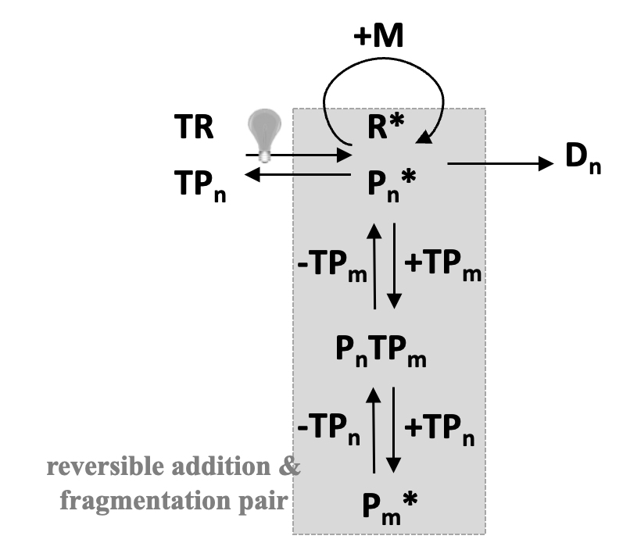

**Figure 1.** Reaction mechanism scheme for PI-RAFT polymerization.

Upon light irradiation, *TR* agents undergo photo-dissociation, yielding primary radicals (*R*\*) and thiocarbonylthio radicals (*T*\*) (reaction 13 in Table 1). Similarly, inactive polymers decompose under light, leading to the production of radical polymers and thiocarbonylthio radicals *T*\* (reaction 15 in Table 1). Primary radicals and radical polymersengage reversibly with *T*\* to form CTA and inactive polymers, respectively (reactions 14 & 16 in Table 1). Chain growth ensues through propagation reactions, where primary radicals and radical polymers react with monomers (reactions 1-2 in Table 1). Termination reactions result in the generation of dead polymers with the irreversible consumption of radicals (reactions 3-6 in Table 1). The core of the PI-RAFT processes is the dynamic equilibrium among three distinct polymer species: radical polymers, inactive polymers, and RAFT adduct radicals. This equilibrium is established through reversible addition and fragmentation reactions (reactions 7-12 in Table 1). The radical polymers partake in addition reactions with *TR* and inactive polymers *TPn*\* to generate one-arm and two-arm adduct radicals, respectively (reactions 7, 9, and 11 in Table 1). Reversely, the adduct radicals undergo fragmentations in either direction to generate radical polymers (reactions 8, 10, and 12 in Table 1).

**Table 1.** Kinetic mechanism for PI-RAFT

|  |  |  |  |  |  |
| --- | --- | --- | --- | --- | --- |
|  | **description** | | **event** | **equation** | **rate constant \*** |
| 1 | | Ini-propagation | ini-propagation | *R\**+*M →* *P*1*\** | *ki,R* = 200M-1s-1 |
| 2 | | Propagation | propagation | *Pn\**+*M → Pn*+1*\** | *kp* = 200M-1s-1 |
| 3 | | Termination | termination | *R\**+*R\** → *D*0 | *kt* = 2×104 M-1s-1 |
| 4 | | termination | *Pn\** +*R\** → *Dn* | *kt* = 2×104 M-1s-1 |
| 5 | | termination by combination | *Pn\**+*Pm* → Dn*+*m* | *ktc* = 104 M-1s-1 |
| 6 | | termination by disproportionation | *Pn\**+*Pm\** → *Dn*+*Dm* | *ktd* = 104 M-1s-1 |
|  | | **reactions related to chain transfer agent (CTA) of *TR*** | | | |
| 7 | | Equilibrium  for CTA of *TR* | addition | *TR*+*Pn* → PnTR* | *kaddT* = 2.857×103M-1s-1 |
| 8 | | fragmentation | *PnTR → TR*+*Pn\** | *k-addT* = 5.714×107 s-1 |
| 9 | | addition | *TPn\**+*R* → PnTR* | *kβT* = 1.333×108M-1s-1 |
| 10 | | fragmentation | *PnTR→ TPn\**+*R\** | *k-βT* = 2.667×1012 s-1 |
| 11 | | addition | *TPn\**+*Pm\**→ *PnTPm* | *kaddPT* = 2×103M-1s-1 |
| 12 | | fragmentation | *PnTPm* → *TPn\**+*Pm\** | *k-addPT* = 4×107s-1 |
| 13 | | Photo-iniferter for CTA of *TR* | photodissociation | *TR $\underset{→}{hv}$ T\**+*R\** | *kbsT*1 = 5×10-9s-1 |
| 14 | | addition | *T\**+*R\** → *TR* | *k-bsT*1 = 5M-1s-1 |
| 15 | | photodissociation | *TPn*T\**+*Pn\** | *kbsT*2 = 5×10-10 s-1 |
| 16 | | addition | *T\**+*Pn\** → *TPn\** | *k-bsT*2 = 5M-1s-1 |
|  | | **reactions related to chain transfer agent (CTA) of *XR*** | | | |
| 17 | | Equilibrium  for CTA of X*R* | addition | *XR*+*Pn* → PnXR* | *kaddX* 1.7×102M-1s-1 |
| 18 | | fragmentation | *PnXR → XR*+*Pn\** | *k-addX*= 3.4×1010 s-1 |
| 19 | | addition | *XPn\**+*R* → PnXR* | *kβX* = 2.267×1010M-1s-1 |
| 20 | | fragmentation | *PnXR→ XPn\**+*R\** | *k-βX* = 4.533 ×1018 s-1 |
| 21 | | addition | *XPn\**+*Pm\**→ *PnXPm* | *kaddPX*= 68 M-1s-1 |
| 22 | | fragmentation | *PnXPm* → *XPn\**+*Pm\** | *k-addPX* = 1.36×1010s-1 |
| 23 | | Photo-iniferter for CTA of *XR* | photodissociation | *XR $\underset{→}{hv}$ X\**+*R\** | *kbsX*1 = 1.2×10-4s-1 |
| 24 | | addition | *X\**+*R\** → *XR* | *k-bsX*1 = 1×102M-1s-1 |
| 25 | | photodissociation | *XPn* X\**+*Pn\** | *kbsX*2 = 9×10-5 s-1 |
| 26 | | addition | *X\**+*Pn\** → *XPn\** | *k-bsX*2 = 1×102 M-1s-1 |
| * Kinetic rate constants reported in the literature (Lehnen et al., 2023) were used in this work. | | | | | |

In more intricate PI-RAFT systems, the inclusion of an additional CTA species denoted as *XR*, enhances the efficiency and control of the process. The kinetic mechanism of PI-RAFT with two CTAs is tabulated in Table 1. The relevant chemical equations pertaining to *XR* can be found in reactions 17-26 in Table 1. Photodissociation of *XR* and inactive polymers *XPn\** produce primary radicals and radical polymers through light irradiation, respectively, alongside thiocarbonylthio radicals *X*\*. This photodissociation undergoes reversible reactions to reform agents *XR* and inactive polymers *XPn\**. Furthermore, the introduction of a second CTA species establishes a second equilibrium of addition-fragmentation reactions based on *XR* (reactions 17-22 in Table 1).

The polymerization process of PI-RAFT with two CTA species comprises 14 distinct reactants, eight of which are polymers with an additional dimension of information regarding chain lengths. To accurately model this process, it is necessary to track the concentrations of non-polymer reactants, including monomers (*M*), CTA with *T* (*TR*), CTA with *X* (*XR*), primary radicals (*R*\*), and thiocarbonylthio radicals with 𝑇 and *X* (*T*\* and *X*\*). For a microscopic understanding of the polymeric information, the structures of individual polymers, including radical polymers (*Pn*\*), dead polymers (*Dn*), inactive polymers with *T* and *X* (*TPn*\* and *XPn*\*), one-arm adduct radicals with *T* and *X* (*PnTR* and *PnXR*), and two-arm adduct radicals with *T* and *X* (*PnTPm* and *PnXPm*), should be recorded over time. It is worth noting that describing the individual two-arm adduct radical poses a significant challenge, as it requires recording chain lengths of two dimensions on both arms. Predicting the evolution of microscopic polymer properties with all possible chain lengths as a function of time through solving a large-scale ODE system with thousands of equations is computationally infeasible. However, MC simulation offers a mathematically straightforward tool for modelling processes characterized by complex mechanisms and provides results at the microscopic scale.

* 1. PI-RAFT process modelling with constant-number Monte Carlo

In a general MC simulation for polymerizations, the reaction rate *R* is defined as the product of the kinetic rate constant ($k$) and the instantaneous numbers of the reactants ($n$) in the system (Gillespie, 1977). For reactions involving single reactant $A$, the reaction rate is calculated as:

$R=k×n_{A}$ (1)

For reactions involving two distinct reactants $A$ and $B$, the reaction rate is calculated as:

$R=\frac{{k×n_{A}×n}_{B}}{VNA}$ (2)

For reactions with two reactants of the same species $B$, the reaction rate is calculated as:

$R=\frac{{k×n_{B}×(n}_{B}-1)}{2×VNA}$ (3)

where, $VNA$ denotes the product of the simulated volume size and the Avogadro constant. The instantaneous probability ($P$) of each reaction taking place is calculated as the proportion of the corresponding reaction rate to the summation of the reaction rates of all reactions ($R_{SUM}$). Random numbers are generated to select the next reaction. Subsequently, the system states are updated based on the selected reaction, and the reaction time is evaluated by a time interval defined as:

$τ=-\frac{1}{R_{SUM}}ln⁡(rnd)$ (4)

This process repeats until a preset time or monomer conversion is reached. It should be noted that the simulated volume size remains constant, and the total number of particles changes forward in time. A sufficiently large volume size is necessary for accurate modeling, which results in smaller time intervals and more discrete simulation steps, as evidenced in Eqs. (2)-(4). However, simulating a dynamic PI-RAFT process with high monomer conversion requires a significant number of steps for reaction selection and system state updates, resulting in longer computational time. In the rest of this article, the general MC simulation technique is referred to as constant-volume MC (CVMC).

CNMC is a variation of MC simulation for process modelling (Khalili et al., 2010). In CNMC, a system with an initialized total number (*N*) of particles is considered. At each simulation step, the selected reaction leads to a net loss or increment ($∆n$) in the total particle number within the system. To maintain the total particle number, CNMC simulation either bootstraps $∆n$ particles to replenish the system in case of a net loss, or randomly discards $∆n$ particles from the system in case of a net increment. To accurately represent the concentrations of reactants in the real system, the simulated volume size is recalculated at each CNMC simulation step. In batch PI-RAFT processes, the total particle number tends to decrease as monomers are integrated into polymers, which necessitates increasing the simulated volume size to maintain the fixed total number. With comparable precision in MWDs at the later stages of the process with high monomer conversion, CNMC simulation is more computationally efficient than CVMC as the simulated volume size is relatively small in the initial stage of the CNMC simulation.

* 1. Results and discussions

Simulations for dynamic PI-RAFT processes were conducted. All simulations were performed on a personal desktop computer with 32 GB of RAM and an Intel i7-10700 CPU core running Windows 11 OS using Python version 3.

* + 1. Simulations of PI-RAFT with single CTA for microscopic properties

A batch PI-RAFT process with one single CTA is simulated through developing a CVMC model, a CNMC model, and a deterministic MoM model. The initial concentrations of monomers and CTA are 2 $M∙L^{-1}$ and 0.04 $M∙L^{-1}$. The volume size (*VNA*) is fixed to 105 in CVMC simulation. The initial volume size (*VNA*) is set to 104 with a fixed particle number of 20,400 in CNMC simulation. The simulated results are presented in Figure 2. As shown in Figure 2(a)-(b), the macroscopic properties of polymers obtained from the CNMC simulation is in good agreement with the results from the deterministic MoM and the CVMC simulation. The MWD from the deterministic MoM is absent in Figure 2(c) due to its inability for such microscopic properties. The computational time required for CVMC and CNMC simulations to model the process until 95% monomer conversion at the microscopic scale is 2470.4 s and 266.7 s, respectively, representing an acceleration of approximately 10 times.

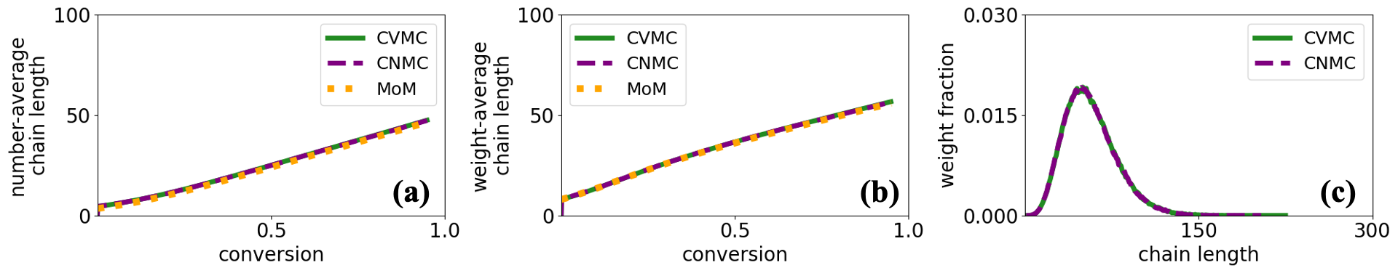

**Figure 2.** Simulation results using CVMC simulation, CNMC simulation, and deterministic MoM. (a) number-average and (b) weight-average chain lengths as a function of monomer conversion; (c) MWDs of polymers at 95% monomer conversion.

* + 1. Simulations of PI-RAFT with varied ratios of CTAs for microscopic properties

The PI-RAFT processes were simulated using two distinct CTAs, and the resulting MWDs at 95% monomer conversion are shown in Figure 3. The simulations were performed using CNMC with a fixed particle number of 20,400. The initial sum concentration of the two CTAs was set at 0.04 $M∙L^{-1}$. The varying transparencies of color in the figure represent results from systems with different ratios of the two CTAs, where curves with less transparency indicate the use of less *XR* and more *TR*. Due to the relatively small number of particles used in the simulations, the MWDs displayed a jagged appearance. Furthermore, the average chain lengths obtained were consistent across different ratios of CTAs, but the MWDs exhibited broader widths with higher ratios of *XR*. The development of the CNMC models with microscopic resolution is essential for a comprehensive understanding of the kinetic characteristics in PI-RAFT.

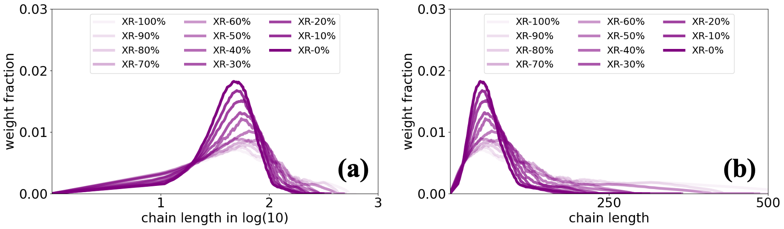

**Figure 3.** MWDs of polymers at 95% monomer conversion obtained from CNMC simulations, displayed with chain length axes in (a) log10 scale and (b) linear scale. The varying transparencies of color represent the results from systems utilizing different ratios of the two CTAs. The numbers in the legends denote for the initial proportions of *XR* in the system.

* 1. Conclusions

The study has presented the development of CVMC, CNMC, and deterministic MoM models for predicting and understanding dynamic PI-RAFT processes at the microscopic scale. The effects of varying CTA ratios on the MWDs of polymers were further investigated through simulations. The acceleration and accuracy of the developed CNMC model have been validated against the CVMC simulations and the MoM model. The presented CNMC simulation is efficient and flexible for integration into prospective tasks related to process design and optimization.

Acknowledgments

The financial support of the National Key Research and Development Project (No. 2023YFB3307803) is gratefully acknowledged by the first, second, and third authors. The financial support of the University of Patras, Medicus program (No. 81816) is gratefully acknowledged by the fourth author. The financial support from the China Scholarship Council is gratefully acknowledged by the first and third authors.

References

Y. Zhou, et al., 2020, Role of External Field in Polymerization: Mechanism and Kinetics, Chem. Rev., 120(5), 2950–3048.

N. Corrigan, et al., 2020, Reversible-deactivation radical polymerization (Controlled/living radical polymerization): From discovery to materials design and applications, Prog. Polym. Sci., 111(1), 101311.

A. Lehnen, et al., 2023, Xanthate-Supported Photo-Iniferter (XPI)-RAFT Polymerization: Facile and Rapid Access to Complex Macromolecules, Chem. Sci., 3.

R. Liu, et al., 2023, Monte Carlo Simulation o Photoinduced Atom-Transfer Radical Polymerization for Dynamic Microscopic Properties, Chem. Eng. Sci., 276(15), 118811.

E. Saldívar-Guerra, 2020, Numerical Techniques for the Solution of the Molecular Weight Distribution in Polymerization Mechanisms, State of the Art, Macromol. React. Eng., 14(4), 2000010.

J. Cole, et al., 1994, Monte Carlo Simulation of Radiative Heat Transfer in Rapid Thermal Processing (RTP) Systems, MRS Proceedings, 342, 425.

D. Gillespie, 1977, Exact Stochastic Simulation of Coupled Chemical Reactions, J. Phys. Chem., 81(25), 2340–2361.

S. Khalili, et al., 2010, Constant Number Monte Carlo Simulation of Population Balances with Multiple Growth Mechanisms, AIChE J., 56(12), 3137-3145.