Towards Cognitive Engineering-Driven knowledge graphs for Chemical Processes: Serialization of Abstraction Decomposition Hierarchy Using OntoCAPE

Nazanin Hamedia*, Anselm Kloseb, Leon Urbasc

aDFG RTG Conducive Design of Cyber Physical Systems, TU Dresden, Germany

bChair of Process Control Systems, Process-to-Order Lab, TU Dresden, Germany

cProcess Control Systems & Process Systems Engineering, TU Dresden, Germany

[naznin.hamedi@tu-dresden.de](mailto:naznin.hamedi@tu-dresden.de)

Abstract

Inspired by principles of cognitive engineering, this study explores the formalization of the results of an Abstraction Decomposition Hierarchy (ADH) towards a Digital Twin for supporting the design of interactive information systems for chemical processes. ADH is a two-dimensional hierarchical space, comprising a functional abstraction hierarchy and a physical decomposition hierarchy. While the decomposition dimension deals with the process sectioning from a superficial organizational perspective, the functional dimension analyzes the actual phenomena occurring in the process. This framework offers a formalism for presenting information in a way to enhance the decision-making and fault diagnosis abilities of human operators.

In this research, we leverage OntoCAPE, a widely recognized ontology for semantically describing Computer-Aided Process Engineering (CAPE), to create a knowledge graph of the ADH. To investigate the merits and limits of the suggested formalization, we applied it to the Tennessee Eastman Process (TEP). Our model is capable of answering competency questions not only regarding the structural aspects of the process, including the configuration of process units and the connectivity between various pieces of equipment, but also the actual physico-chemical phenomena happening in the process and their influence on process parameters.

This work presents promising results for further development of software tools based on an ADH-driven knowledge graph for the design of decision support systems. These tools have the potential to significantly advance decision support and fault diagnosis in complex processes.

**Keywords**: Abstraction Decomposition Hierarchy, OntoCAPE, Knowledge graph, Information querying

* 1. Introduction

As the complexity of production plants continues to grow, the demand for decision support systems for operators becomes increasingly imperative. One of the major problems arises from different level of novelty of events from the viewpoints of the operators and designers of systems representing the process (e.g., expert systems, or human-machine interface). To deal with this problem a formalism is needed to be considered for knowledge representation that covers different aspects of the process (Jamieson and Vicente, 2001). This knowledge representation, often referred to as a Knowledge Graph (KG), serves as a pivotal component within the developed software tools, playing a crucial role in enhancing the efficiency and effectiveness of decision-making processes (Eibeck, Lim and Kraft, 2019).

Rooted in cognitive engineering, the Abstraction-Decomposition Hierarchy (ADH) serves as an effective tool for representing the task related knowledge in complex work domains. This two-dimensional hierarchical framework comprises two distinct hierarchies, as illustrated on the right side of Figure 1: the abstraction hierarchy (AH) along the vertical axis and the decomposition hierarchy along the horizontal axis. The decomposition hierarchy involves the sectionalization of the process from a surface-level perspective (e.g., plant ➔ units ➔ equipment). Conversely, the vertical aspect encapsulates the AH, delving into the actual phenomena occurring in the process. In fact, the solution to the question of how to achieve the objectives of this layer lies at a lower level in the hierarchy (Rasmussen and Vicente, 1989; Jamieson, Ma and St-Cyr, 2020).

The ADH has previously been employed to describe chemical processes (Jamieson and Vicente, 2001 Son *et al.*, 2019). However, the crucial area requiring investigation lies in the utilization of an established standard for formally (in a computer-understandable manner) describing processes using ADH. Indeed, two crucial facts should be taken into account: Firstly, the serialization of the ADH-based KG; secondly, and perhaps of equal or greater significance, a standardized way for serialization. The latter not only provides a foundational framework for collaborative developing of ADH-based KGs but also enables seamless interaction among different individuals with each other's KGs and empowers computational tools to engage with diverse KGs crafted by various contributors.

In this study, OntoCAPE has been utilized for developing the KG of Tennessee Eastman Process (TEP) based on ADH. In the remainder of this paper, the general hypothesis will be initially presented, followed by an outline of the requirements analysis. Subsequently, the modelling approach will be detailed, concluding with an evaluation of the model.

* 1. Research Approach

Based on previous studies (Jamieson and Vicente, 2001; Son *et al.*, 2019), the hypothesis of this contribution is that the ADH can provide a robust structure for constructing a KG with the capability to address diverse inquiries posed by operators across various facets of the process. To investigate this research hypothesis, we chose the TEP (Downs and Vogel, 1993) for an use case study, given its extensive utilization in process control and specifically in exploring fault diagnosis methodologies (Reinartz *et al.*, 2019; Suresh, Sivaram and Venkatasubramanian, 2019). The major input to our study was the detailed description of the TEP given by (Vosloo *et al.*, 2020).

* 1. Case Study
     1. Requirement Analysis

Left side of Figure 1 outlines the general structure of ADH. As mentioned, the horizontal direction of this two-dimensional framework deals with structural decomposition of a chemical plant; while the vertical hierarchy describes the functional aspects of the process. Its topmost level; Functional Purpose, encapsulates the purpose of the process in the most abstract form. Progressing to the second tier, the Abstract Function, endeavours to analyse the function of each component within the process. Subsequently, the Generalized Function links the abstract functional perspective with the physical functional layers. The final level, Physical Function, is the closest to the tangible reality, offering detailed insights into each equipment constituting the process (Jamieson and Vicente, 2001; Son *et al.*, 2019).

* + 1. Phenomena-oriented Analysis of the Generalized Function Level

An analysis of the ADH literature reveals that the most problematic layer seems to be the generalized functions layer as the different studies are not coherent on how to fill this layer. Jamieson & Vicente (2001), for instance suggest to provide information about heat transfer and material flow on this layer, as well as chemical reactions. Son et. al. (2019) described on this layer the general processes that are involved in accomplishing the defined functional purposes. Both approaches are cumbersome: The approach of Jamieson & Vicente lacks of a clear distinction to the abstract function layer, while the approach of Son has too many degrees of freedom and does not provide the necessary guidance. We, therefore, suggest to follow the approach proposed by (Lutze, 2011), which introduces phenomena as a set of eight classes that serve as the (physico-chemical) building blocks for processes, such as mixing, stream dividing, phase contact, phase transition, phase change, phase separation, reaction and energy transfer (Lutze, 2011). This approach makes it possible to describe the generalized function layer with a fixed set of classes, a prerequisite for proper modelling and comparison of different analyses.

* + 1. Selection of Information Model

As highlighted previously, the principal objective of this study is to develop not only a computer readable, but also standard compatible KG for the ADH of TEP. Hence, it was important to identify an existing standard which is capable of describing different layers of information considered in ADH. To this end, some of the notable existing standards such as Data Exchange in the Process Industry (DEXPI) (Wiedau *et al.*, 2019), Computer Aided Engineering Exchange (CAEX) (IEC 62424, 2016), and OntoCAPE (Marquardt *et al.*, 2010) has been considered. In fact, the bottleneck for choosing the right information modelling standard for the purpose of describing an ADH of a process is the Generalized Function layer which involves the description of the behavior of the process. This fact made OntoCAPE the only suitable information representation standard for the aim of developing an ADH-based KG.

* + 1. Modeling in OntoCAPE

OntoCAPE is a formal ontology that has been implemented in the OWL notation. It describes diverse aspects of CAPE. It has an extensible architecture that makes it possible to cover very many tasks of CAPE, such as mathematical modelling, or data integration and management with sub-models. OntoCAPE is organized through different layers of abstraction, spanning from the most generic abstract layer, the Meta Layer, to the most detailed application specific layer. OntoCAPE models a process as a composite system (Morbach, Wiesner and Marquardt, 2008) and tries to capture systems from different composition aspects, such as its function, realization, and behaviour.

As shown in Figure 1, the Abstract Function, Generalized Function, and Physical Function layers of ADH, are respectively modeled by the CPS_function, CPS_behavior, and CPS_realization partial models of OntoCAPE. Moreover, it models each aspect of a system as a network of connected Devices and Connections. This pattern is identical in all of the process aspects of interest in this paper. As noted earlier, the most challenging part of serializing ADH was to define the Generalized Function; therefore, this section will be explained in more detail in the next sub section.

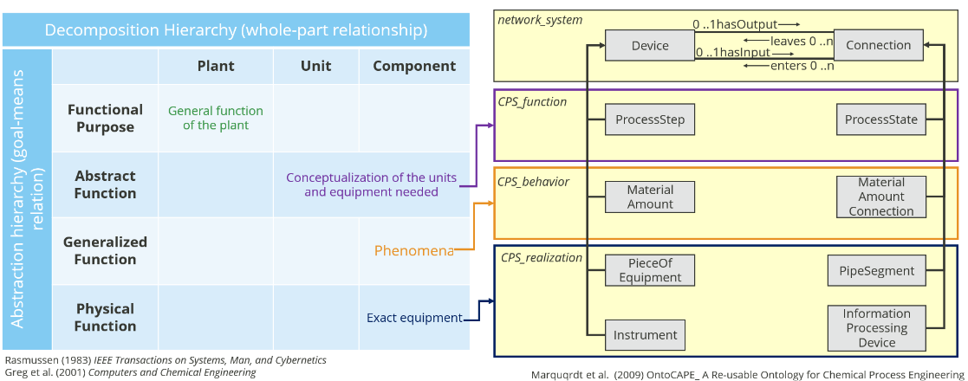

Figure 1: Compatibility of OntoCAPE and ADH

* + - 1. Description of Generalized Function in OntoCAPE

In previous publications regarding ADH (Jamieson and Vicente, 2001; Son *et al.*, 2019), Generalized Function level was developed in different formats, thereby introducing considerable complexity and diminishing its practical utility. Establishing a standardized format for Generalized Function level development not only expedites the developer's workflow by providing a pre-defined structure but also fosters collaborative development and software interoperability. OntoCAPE behavioral model (from partial model CPS_behavior) arises as an appropriate candidate due to its alignment with our criteria for the Generalized Function level. Indeed, it tries to qualitatively model the behavior of chemical processes. Figure 2 depicts this model for the reactor. As can be seen, at first, the Material Amount or Material Amount Connection should be defined which reflects the material content of a physical piece of equipment, on which a physico-chemical phenomenon happens, and governs its behavior (Marquardt *et al.*, 2010). Afterwards, we have the physical properties that are influenced by the phenomenon.

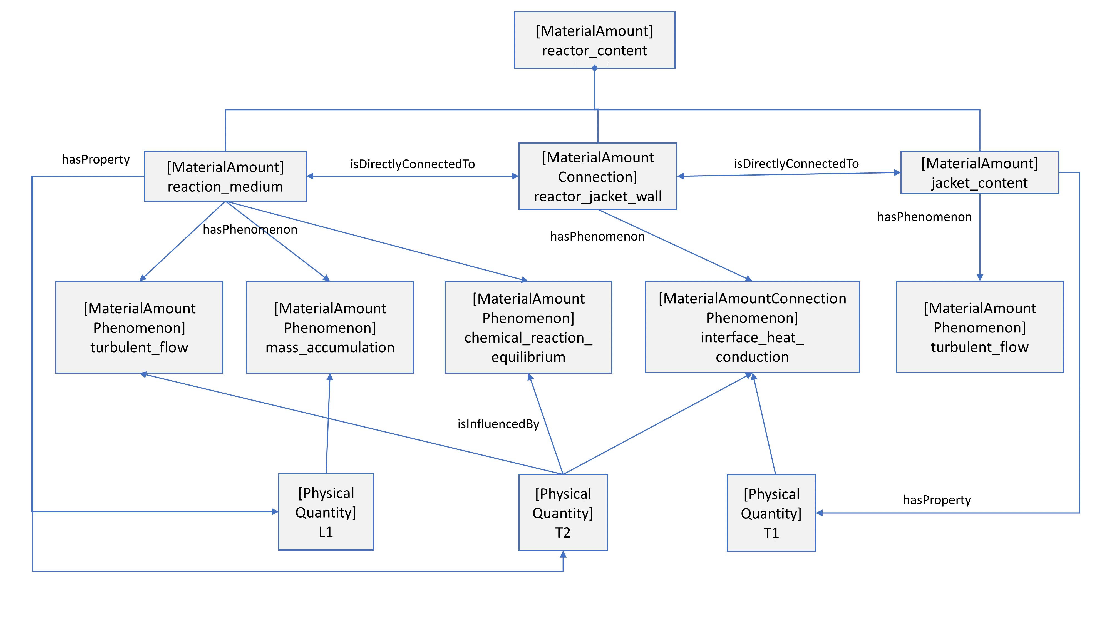

Figure 2: Behavioral model of TEP reactor based on OntoCAPE

* + 1. Querying information in the developed KG

As OntoCAPE is an OWL based ontology, the construction of our KG was smoothly done utilizing the software Protégé. Subsequently, to query in the developed graph-based space, it was imported to Python using Owlready2 library (Lamy, 2017), where series of formulated queries were executed.

* 1. Evaluation

To evaluate our developed KG, some competency questions are shaped, which then formulated as queries, and answered by our KG. One of the competency questions is: How is pipe segment 14 (pipe entering the reactor) connected to condenser? This question should be converted to a computer algorithm as shown in Figure 3**.**. The result of this algorithm would be an array named connectivity which is equal to [PS14, reactor vessel, PS20, PI01, PS21, condenser1] (PS 20 and PS21 respectively show the pipe segment between reactor and PI01, and PI01 and condenser 1). Some more competency questions, their query format, and the obtained result are tabulated in Table 1. It should mention that in both Table 1 and Figure 1 entities defined in OntoCAPE are illustrated by ***italic bold*** style.

Table 1: Competency questions as a means for evaluating the KG (query format is based on owlready2 library in Python, where the imported ontology is named ADH).

|  |  |  |
| --- | --- | --- |
| **Competency question** | **Query format of the competency question** | **Result of the query** |
| What process units exist in TEP? | ADH. ***ProcessUnit***. instances () | [reactor, condenser, V-L separator, stripper, compressor] |
| What are the components of the control loop for controlling flow A? | ADH. controlling_flow_A ***hasSubsystem*** | [FI01, valve01, FC01] |
| What phenomena happens in the boiler’s shell-tube wall? | ADH. boiler_shell_tube_wall. ***hasPhenomenon*** | [interface_heat_conduction] |
| What phenomena influences temperature of the reactor? | ADH. T2. ***isInfluencedBy*** | [interface_heat_conduction,  chemical_reaction_equilibrium,  turbulent_flow] |



Figure 3: Algorithm for finding the plant items between PS14 (reactor entering pipe segment) to condenser.

* 1. Conclusions

In summary, this study highlights the potential of the ADH as a robust framework for the development of a KG that appropriately represents chemical processes. An inherent strength of the ADH lies in its ability to explain both the superficial, and functional aspects of a complex system, here a chemical plant. To model the ADH in a computer understandable way, OntoCAPE, as a well-know ontology was used. A significant contribution of this work is to offer a formalism for developing the Generalized Function layer of the ADH, which provide a qualitative modelling approach to explain the behaviour of the process. To evaluate our KG, several competency questions were formulated and queried in the KG. Our result indicates the capability of the model in different aspects of the process.

**Acknowledgments:** This work was Funded by the Deutsche Forschungsgemeinschaft (DFG, German Research Foundation) – 319919706 /RTG2323.

References

J. J. Downs, E. F. Vogel, 1993, A plant-wide industrial process control problem, *Computers & Chemical Engineering*, 17, 3, 245–255.

A. Eibeck, et. al., 2019, J-Park Simulator: An ontology-based platform for cross-domain scenarios in process industry, *Computers & Chemical Engineering*, 131, 106586.

IEC 62424, 2016, *Representation of process control engineering - Requests in P&I diagrams and data exchange between P&ID tools and PCE-CAE tools*.

G. A. Jamieson, 2020, Benefits of Ecological Interfaces Under Equivalent Sensor Sets, *IEEE International Conference on Systems, Man, and Cybernetics (SMC)*, 2232–2236.

G. A.Jamieson, K. J. Vicente, 2001, Ecological interface design for petrochemical applications: supporting operator adaptation, continuous learning, and distributed, collaborative work, *Computers & Chemical Engineering*, 25, 7, 1055–1074.

J. B. Lamy, 2017, Owlready: Ontology-oriented programming in Python with automatic classification and high level constructs for biomedical ontologies, *Artificial Intelligence in Medicine*, 80, 11–28.

Lutze, P., 2011, *An Innovative Synthesis Methodology for Process Intensification*. PhD thesis, DTU.

W. Marquardt, et al., 2010, *OntoCAPE A Re-Usable Ontology for Chemical Process Engineering*. Springer Berlin Heidelberg.

J. Morbach, et. al., 2008, Onto CAPE 2.0 —A (Re-)usable ontology for Computer-Aided Process Engineering, *18 European Symposium on Computer Aided Process Engineering*. 991–996.

J. Rasmussen, K. J. Vicente, 1989, Coping with human errors through system design: implications for ecological interface design, *International Journal of Man-Machine Studies*, 31(5), 517–534.

Reinartz, C. et al., 2019, Generation of Signed Directed Graphs Using Functional Models, *IFAC-PapersOnLine*, 52(11), 37–42.

Son, C. et al*.,* 2019, Reflecting Abstraction Hierarchy of a Chemical Processing System on Standard Operating Procedures, *Proceedings of the Human Factors and Ergonomics Society Annual Meeting*, 63(1), 1806–1810.

R. Suresh, et al, 2019, A hierarchical approach for causal modeling of process systems, *Computers & Chemical Engineering*, 123, 170–183.

J. Vosloo, et al., 2020, Exergy-based fault detection on the Tennessee Eastman process, *IFAC-PapersOnLine*, 53, 2, 13713–13720.

M. Wiedau, et al., 2019, ENPRO Data Integration: Extending DEXPI Towards the Asset Lifecycle, *Chemie Ingenieur Technik*, 91, 3, 240–255.