Energy- and process real-time optimization through hybrid modeling – a case from Viking Malt A/S

Peter Jul-Rasmussena, Adem R.N. Aouichaouia, Maciej Korzepab, Kurt Engelbrechtc, Katrine Kongsgaardd, Jakob K. Huusoma*

aDept. of Chemical and Biochemical Engineering, Technical University of Denmark, Søltofts Plads 228A, 2800 Kgs. Lyngby, Denmark.

bBioLean ApS, Søndre Jernbanevej 32, 3400 Hillerød , Denmark

cViegand Maagøe A/S, Nørre Søgade 35, 1370 København K, Denmark

dViking Malt A/S, Spirevej 5, 4760 Vordingborg, Denmark

jkh@kt.dtu.dk

Abstract

The production of barley malt is an energy-intensive process due to the need for cooling, drying, and heating. This work introduces model-based real-time energy- and process optimization for an industrial malting process. A hybrid model is introduced for the germination stage in the malting process by combining population- and mass balances with probabilistic ML, providing accurate predictions with no indication of overfitting when applied to historical process data. Based on the model predictions, optimal setpoint trajectory for the temperature of process air passing through the grain bed and the water/gibberellic acid addition are recommended for operators of the malting plant. Both the model and optimization algorithm are deployed to servers at the malting plant, and the recommendations are presented in a user-friendly dashboard at a dedicated monitor in the control room, enabling the decision-making in the process to be objective-driven rather than human-driven. No previous work has been found in the literature on applying hybrid model-based real-time optimization to the germination stage in an industrial-scale malting process.

**Keywords**: Malting process, Probabilistic hybrid modeling, Real-time energy optimization, Operator support tool.

* 1. Introduction

The quantity and quality of data acquired in the manufacturing industry has increased in recent years, but the full potential of the process data is often not realized due to the high cost, time-demanding development of applications, and high complexity of integrating the applications into production. The project “Machine Learning for Energy- and Process Optimization” (MLEEP) aims to implement machine learning (ML) algorithms directly in five Danish production facilities to investigate the potentials, opportunities, and barriers of using ML for energy- and process optimization (MLEEP, 2023). One such production facility is the Viking Malt A/S malting plant in Vordingborg (DK).

Malting is the process of turning grain, typically barley, through germination, into malt as a raw material for brewing. The malting process consists of three main stages: 1) steeping, 2) germination, and 3) kilning (MacLeod, 2004). In the steeping stage, the grains are hydrated using water, raising the moisture level of the grains from 10-15 wt.% to 42-47 wt.%. During germination, enzymes are synthesized and released, cell-wall breakdown occurs in the endosperm, and acrospires and rootlets are grown typically at a moisture level of 45 wt.%. Finally, the growth of the grains is stopped in the kilning using a heat treatment, drying the grains to a moisture level of 4-5 wt.% for storage (MacLeod, 2004). The strict requirements for moisture levels, heating, cooling, and gas usage result in an energy-intensive process with the key utilities accounting for approximately 10 % of the total input costs (MacLeod, 2004). The high energy consumption of the malting process has been addressed in an optimization effort by Müller and Methner (2015) by increasing the steeping and germination temperature, thereby accelerating the whole process and reducing cost and energy consumption. However, applications of model-based real-time optimization of malting processes leveraging process data have not been found in the literature.

Over the previous 30 years, the field of hybrid modeling, combining first principles knowledge with ML, has been gaining increased interest (Sansana et al., 2021). Often hybrid models are constructed either as modular structures of interconnected ML algorithms representing different subsystems or as semi-parametric structures using first principles models and ML in tandem (Thon et al., 2021). Semi-parametric hybrid models allow the modeling of well-known phenomena using first principles, while unknown or uncertain phenomena can be modeled using ML (Sansana et al., 2021). Hybrid models have been shown to display robustness towards measurement noise and low measurement frequency to a point where the system dynamics are still seen in the data (Jul-Rasmussen et al., 2023). Semi-parametric hybrid models have been used for modeling particle processes by combining first principles population- and mass balances with ML (Nazemzadeh et al., 2021).

This work focuses on realizing optimal operation of the germination stage in a malting process through real-time energy optimization enabled by semi-parametric hybrid modeling. The introduction of real-time optimization for the germination stage enables decision-making in the process to be objective-driven rather than human-driven, eliminating human variance and biases in a process that is traditionally operated purely based on operator experience without the aid of simulation tools.

* 1. Germination Stage

Germination is typically performed over 3-5 days using a pneumatic system in vessels of different shapes, such as drums or rectangular Saladin boxes (Figure 1), and in varying sizes (MacLeod, 2004). The grains rest on perforated plates, allowing for temperature-controlled airflow from the bottom of the grain bed to provide cooling and oxygen supply while preventing overheating from grain respiration. The grain bed is turned regularly, keeping the grain bed loose, and allowing for proper airflow and distribution of water (MacLeod, 2004). Water and potentially gibberellic acid (GA) are added from the turner to maintain the water content at approximately 45 wt.% and to enhance growth. The main operating conditions affecting the germination are the germination time, the water content, the temperature in the grain bed, and processing aids, but also barley characteristics such as the barley variety and the crop year affect the growth rate (Müller and Methner, 2015).

Figure 1: Schematic drawing of germination stage in malting process.

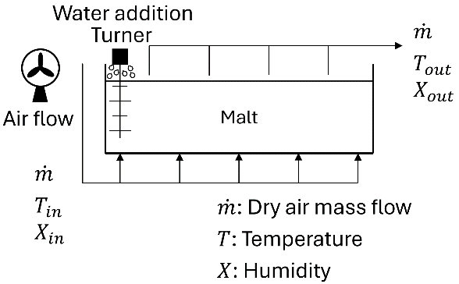

* 1. Modeling of Germination Stage

The germination stage model consists of two key components: 1) a barley acrospire population balance predicting the length distribution of the acrospires, and 2) a water mass balance predicting the moisture in the grain bed.

* + 1. Acrospire Population Balance

A population balance for the length distribution of the acrospires is introduced by discretizing the length domain into $M$ bins. For each bin, the material balance is

|  |  |
| --- | --- |
| $$N_{i,j+1}=N_{i,j}+N_{i-1,j}⋅G_{i-1}-N_{i,j}⋅G_{i} for i=0…M$$ | (1) |

where $j$ is the index of the current time step, $N_{i,j}$ is the number of grains in bin $i$ at time step $j$, and $G_{i}$ is the growth rate of grains in bin $i$. The change in the length distribution of the acrospires is only due to growth i.e., $N_{i,j}$ is increased by the number of grains moved from bin $i-1$ to bin $i$ and decreased by the number of grains moved from bin $i$ to bin $i+1$. $G_{i}$ is assumed to be represented by the expression $G_{i}=\left(1-e^{-k_{i}⋅Δt}\right)$ where $k_{i}$ is the growth constant for bin $i$ and $Δt$ is the time between two consecutive time steps. The resulting population balance model is

|  |  |
| --- | --- |
| $$N_{i,j+1}=N_{i,j}+N_{i-1,j}⋅\left(1-e^{-k_{i-1}⋅Δt}\right)-N_{i,j}⋅\left(1-e^{-k_{i}⋅Δt}\right) for i=0…M$$ | (2) |

The growth rates for the different bins are unknown and therefore inferred from process data. This is done using a probabilistic ML approach based on neural networks implemented by BioLean ApS using their proprietary ML framework. By using a probabilistic ML approach, the model not only accounts for the inherent noisiness of the data, but also for limited availability of data. When forecasting using the probabilistic ML model, a collection of process outcomes is sampled, allowing for the expectation to be calculated as the average and the uncertainty to be quantified. The setpoint for the temperature of the air leaving the grain bed, water content in the grain bed, barley variety, crop year, barley characteristics (protein, starch, water sensitivity, etc.), and addition of GA are used as inputs for the probabilistic ML model. The input data can be characterized in 3 different types: 1) the barley variety, crop year, and barley characteristics are fixed constants for a given batch, 2) the setpoint for the temperature of the air leaving the grain bed and the addition of GA can be directly manipulated, and 3) the water content is a state in the system which has to be predicted before the population balance can be used for forecasting.

* + 1. Water Mass Balance

Changes in the water content in the grain bed are due to uptake of water in the humid air passing through the grain bed and addition of water from the turner. A mass balance for the water content can be introduced as

|  |  |
| --- | --- |
| $$\frac{dm_{H_{2}O} }{dt}=\dot{m}⋅\left(X_{in}-X_{out}\right)+{\dot{m}}_{H_{2}O,Turner}$$ | (3) |

where $m_{H_{2}O}$ is the mass of water in the grain bed, $\dot{m}$  is the dry air mass flow passing through the grain bed, $X_{in}$ and $X_{out}$ is the humidity of the air entering and leaving the grain bed respectively, and ${\dot{m}}_{H_{2}O, Turner}$ is the water addition from the turner. However, Eq. (3) was found not to be feasible to use for the physical system, as no reliable measurements were available for $\dot{m}$, $X_{in}$, or $X_{out}$ and as some of the water added to the grain bed would pass through the grain bed without increasing the water content. As an alternative to Eq. (3) the semi-parametric hybrid model is introduced based on the water mass fractions

|  |  |
| --- | --- |
| $$x_{H_{2}O,j+1}=x_{H_{2}O,j}+\left(x_{H_{2}O,j}-x_{min}\right)⋅\left(1-e^{-k_{out}⋅Δt}\right)+\left(x_{max}-x_{H_{2}O,j}\right)⋅\left(1-e^{-k_{in}⋅{\dot{m}}_{H_{2}O,Turner}⋅Δt}\right)$$ | (4) |

where $x_{H_{2}O, j}$ is the water mass fraction in the grain bed at time step $j$, $k_{in}$ is the water uptake constant, $k_{out}$ is the water usage constant, and the constants $x_{min}$ and $x_{max}$ are defined as

|  |  |
| --- | --- |
| $$\lim_{t→∞}{x_{H_{2}O}=\left\{\begin{aligned}x_{min}, &No water addition \\ x_{max}, &Constant water addition\end{aligned}\right.}$$ | (5) |

In Eq. (4), the first term is the water content at time step $j$, the second term represents the water usage, while the last term represents the water addition to the grain bed. The constants $k_{in}$ and $k_{out}$ are predicted using a probabilistic ML model with the setpoint for the temperature of the air leaving the grain bed, the water addition from the turner, the barley variety, and the crop year as input.

* 1. Case Study: Viking Malt A/S

The germination stage model, Eq. (2) and (4), is introduced using the malting process at the Viking Malt A/S malting plant in Vordingborg (DK) as a case study. The malting plant produces malts for the beer and distilling industries and has a production capacity of 120,000 t/y (Viking Malt, 2023). The malting process is operated manually and decision-making in the process is human-driven based on “best guesses” by the operators. The human-driven decision-making cannot reliably account for varying context (e.g. barley variety and crop year) and multiple operational subgoals and it is susceptible to the operator’s biases (e.g. finding patterns in noise and risk-aversion), the operator’s experience and heuristics, and the psychophysical state of the operator (e.g. illness, focus, and hurry). By introducing hybrid-model based real-time optimization, these issues are addressed by basing the decision-making on a well-defined objective and eliminating human variance and biases. The objective-driven decision-making is improved over time and adapts to momentary circumstances when new process data is available.

The semi-parametric hybrid model for the germination stage is trained using historical data from the malting plant from the previous 3.5 years (2020-2023). Measurements on the water content and the length of acrospires are taken once per day by sampling from the grain bed. Setpoints for the temperature of the air entering and leaving the grain bed, the water addition from the turner, the barley variety, the crop year, and the barley characteristics are recorded along with the measurement data from the malting plant. Using the historical data, a global (prior) model is trained. During operation, the prior model is updated for each new measurement, hereby training a batch specific (posterior) model. This approach allows for predictions to be made before the start of a batch purely using the prior model, while improved predictions are made as new measurements are available using the posterior model.

* + 1. Real-time Optimization

A main contributor to the energy consumption in the malting process is the need for drying once germination is complete to achieve a water content that makes the malt stable for storage. Energy optimization can therefore be introduced by minimizing the water content at the end of the germination stage, while still achieving an acceptable length distribution of the acrospires. Depending on the type of product, optimal ranges for the distribution of the acrospire length, and optimal water content for the germination are defined along with penalty terms for deviating from the optimal values. The germination stage is optimized by finding the setpoint trajectory for the temperature of the air leaving the grain bed and the water/GA addition, which maximizes the utility function

|  |  |
| --- | --- |
| $$U=1-α⋅p_{d}-β⋅p_{m}$$ | (6) |

where $p_{d}$ is the penalty on the acrospire distribution, $p_{m}$ is the penalty on the moisture content, $α$ is the penalty strength for the acrospire distribution, and $β$ is the penalty strength for the moisture content. The utility function is optimized using four steps:

1. Setpoint trajectories are prepared based on historical data.
2. Setpoint trajectories are adjusted based on batch, product, and time-specific requirements.
3. The utility function is evaluated for predictions using each setpoint trajectory.
4. The setpoint trajectory with the highest utility is recommended to the operators.

Once new measurements are available, the optimization is re-run using the new posterior model, determining the optimal trajectory based on the available knowledge for the current batch. Both the germination model and the optimization algorithm are deployed to a server at the malting plant. The model predictions, sample measurements, setpoint on the air temperature, and the operator actions recommended by the optimization algorithm are displayed in a dashboard (Figure 2) for the operators using a dedicated monitor.

Figure 2: Dashboard with model predictions, sample measurements, setpoint on air temperature, and operator actions recommended by the optimization algorithm displayed in dedicated monitor.

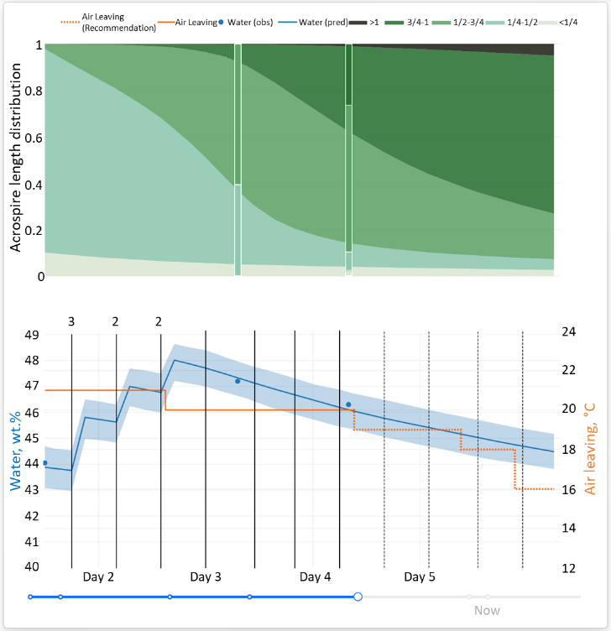

* + 1. Evaluation

From the prediction accuracy of the semi-parametric hybrid model (Table 1) it is apparent that the prior model performs well for both the train and test set in the historical data.

Table 1: Prior model mean absolute error (MAE) for the acrospire (length range 0.125-1.125) and water content based on the historical data.

|  |  |  |
| --- | --- | --- |
| Data Set | Acrospire  (Average length) | Water Content  (wt.%) |
| Train MAE | 0.049 | 0.83% |
| Test MAE | 0.052 | 0.88% |

By minimizing the water content at the end of the germination stage, the energy consumption of the malting process can be reduced by up to 4 % due to the reduction in the heat demand for the kilning.

* 1. Conclusions

Data-based energy- and process optimization in production processes is enabled by the increased quantity and quality of process data in the manufacturing industry. This work introduces model-based, real-time optimization for an industrial malting process. A hybrid model is developed both for predicting the growth of acrospires and the water content in the grain bed, leveraging process knowledge and probabilistic ML. The model provides the expectation of the process outcome as well as quantification of uncertainty of the prediction. The predictions are used for real-time optimization, identifying the optimal setpoint trajectory for the temperature of the air leaving the grain bed and the water/GA addition. Future work will quantify the impact of the optimization on the energy consumption and the acrospire length distribution in the malting process.

Acknowledgments

This study was financially supported by the Danish agency of Energy. ELF221-496435: Machine Learning til Energi- og Proces-optimering (MLEEP).

References

C. Müller, F. J. Methner, 2015. An accelerated malting procedure - influences on malt quality and cost savings by reduced energy consumption and malting losses, J. Inst. Brew. , 121(2), 181-192.

C. Thon, B. Finke, A. Kwade, C. Schilde, 2021. Artificial Intelligence in Process Engineering, Adv. Itell. Syst., 3 (6), 2000261.

J. Sansana, M. N. Joswiak, I. Castillo, Z. Wang, R. Rendall, L. H. Chiang, M. S. Reis, 2021. Recent trends on hybrid modeling for Industry 4.0, Comput Chem Eng., 151, 107365.

L. MacLeod, 2004, Barley | Malting, In *Encyclopedia of Grain Science*, Elsevier-Academic Press, Oxford, 68-76.

MLEEP, Om projektet, mleep.dk, <https://mleep.dk/om-projektet> (Accessed at 23-11-2023)

N. Nazemzadeh, A. A. Malanca, R. F. Nielsen, K. V. Gernaey, M. P. Andersson, S. S. Mansouri, 2021. Integration of ﬁrst-principle models and machine learning in a modeling framework: An application to ﬂocculation, Chem. Eng. Sci. , 245, 116864.

P. Jul-Rasmussen, X. Liang, X. Zhang, J. K. Huusom, 2023. Developing robust hybrid-models, Comput. Aided Chem. Eng. , 52, 361-366.

Viking Malt, Our Malt houses, vikingmalt.com, <https://vikingmalt.com/about-us/our-malt-houses/> (Accessed at 23-11-2023)