Multi-objective Optimization of Hybrid Fossil/Renewable Carbon Clusters for Methanol Production

Sachin Jog,a Juan D. Medrano-García,a Gonzalo Guillén-Gosálbeza*

aInstitute for Chemical and Bioengineering, Department of Chemistry and Applied Biosciences, ETH Zurich, Vladimir-Prelog-Weg 1, 8093 Zurich, Switzerland

*\*gonzalo.guillen.gosalbez@chem.ethz.ch*

Abstract

Transitioning to more sustainable chemicals will require shifting to renewable carbon technologies (captured CO­2, waste, or biomass), which are often evaluated decoupled from each other. However, opportunities for energy and mass integration may arise that could improve their economic and environmental performance, thus making them more appealing than originally thought. In this work, we consider integrated chemical clusters based on fossil and renewable carbon for methanol production. We apply multi-objective optimization to the integrated cluster and unintegrated configuration, finding that the integrated solution can substantially improve the environmental performance *via* hybridization of technologies, with reductions in global warming potential (GWP) impact ranging from 19 % to 183 % for a given unitary cost target.

**Keywords**: integrated chemical clusters, multi-objective optimization, global warming potential

* 1. Introduction

The climate goals set by the Paris Agreement have spurred efforts in the chemical industry to move away from the current fossil-based synthesis. This requires shifting to renewable carbon feedstock, including captured CO­2 *via* carbon capture and utilization (CCU), waste, and biomass. Many current studies of such alternative synthesis routes, which may differ in the feedstock and the reaction pathway, focus on isolated processes and neglect the potential synergistic effects between them, thus failing to evaluate their full potential as an integrated industrial system minimizing material and energy usage, waste generation, etc. (Boix *et al.*, 2015). Notably, savings realized *via* *e.g.*, heat and mass integration, common waste disposal systems and wastewater treatment plants, could substantially improve such emerging technologies when deployed in integrated clusters. For example, Baliban *et al.* (2013) proposed an optimization framework for a biomass-to-liquid fuels (BTL) system, which simultaneously addressed heat, electricity, and water integration along with process synthesis decisions, finding that BTL refineries using existing technologies with capacities above 5,000 barrels per day could be economically feasible across the United States. Ioannou *et al.* (2023) conducted a techno-economic and life-cycle assessment of an integrated CO­2 refinery co-producing methanol, olefins, and aromatics, with an Allam cycle (Allam *et al.*, 2017) for residual gas utilization. The Allam cycle operates at high pressures (*i.e.*, up to 330 bar), and utilizes oxy-combustion of the purge stream to generate power and pure CO­2­. The authors reported savings of 135 % in the GWP impact in the integrated CO­­2­ refinery compared to the business-as-usual. Therefore, exploiting synergies between various synthesis routes can lead to substantial savings resulting from heat and mass integration. Moreover, integrating emerging technologies for residual gas utilization (*e.g.*, the Allam cycle) provides additional benefits in terms of environmental impact reduction. Thus, in order to optimize economic and environmental performance, we focus here on multi-objective optimization of a chemical cluster for methanol production that integrates fossil and renewable carbon technologies.

* 1. Process modeling and optimization

We explore the hybridization of fossil and renewable carbon technologies for methanol production through the multi-objective optimization (production cost and GWP impact) of the integrated and unintegrated configurations, as shown in Figure 1.

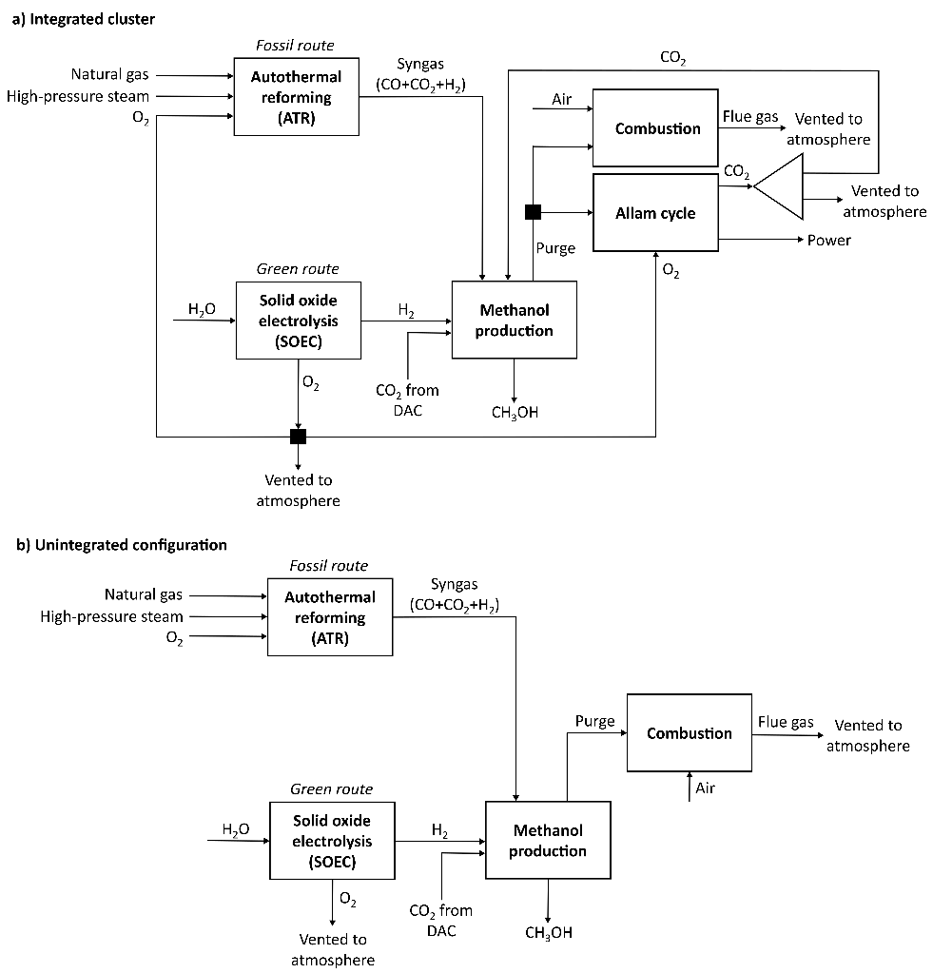

Figure 1: Process block diagrams of the integrated cluster and the unintegrated configuration.

The fossil-based route consists of the autothermal reforming (ATR) of natural gas with high-pressure steam and oxygen (O2­) for syngas production. The renewable route uses direct air-captured carbon dioxide (CO2­) with hydrogen (H­2­) obtained from wind-powered water electrolysis *via* solid oxide electrolysis (SOEC). In the integrated cluster, the purge from the methanol process, which comes from the flash units (vapor stream consisting mainly of CH­4­, CO­2­, CO, and H­2) and distillation column (vapor stream consisting mainly of CH­3­OH and CO­2), can be utilized in an Allam cycle to generate electricity and pure CO­2­, or can be combusted using air­. Note that the specific composition of the purge depends on the route/s chosen (*i.e.*, green and/or fossil), and the values of the other degrees of freedom. Moreover, the O2 generated in the SOEC can also be used in the Allam cycle and in the ATR. All processes are simulated in Aspen HYSYS® v11, where Aspen Custom Modeler® (ACM) v11 is used to model the SOEC. To calculate the climate change impact, we quantify the 100-year time horizon (hierarchist perspective) GWP following the ReCiPe 2016 v1.13 methodology. The multi-objective optimization is carried out using the algorithm *surrogateopt* in MatLab® vR2021b through the COM interface. For simplicity, we use the weighted sum of objectives method, which can only identify solutions lying in the convex envelope of the Pareto front. We consider nine degrees of freedom: ATR – natural gas molar flow rate,   
O­2/natural gas­ molar ratio, and steam/natural gas molar ratio; SOEC – H­2 molar flow rate; CH­3­OH – Plug flow reactor (PFR) temperature, PFR pressure, PFR volume, and purge percentage; Allam cycle – feed temperature.

* 1. Results and Discussion

The Pareto frontier obtained from the multi-objective optimization is shown in Figure 2. The minimum cost solution implements the ATR process (*i.e.*, fossil route), while the minimum GWP impact solution deploys CO­2­ hydrogenation (*i.e.*, renewable route). Note that the GWP can attain negative values due to the cradle-to-gate scope of the life cycle assessment (LCA) that omits the use phase of methanol. The integrated cluster shows substantial improvements over the unintegrated configuration. More specifically, the reduction in GWP impact in the integrated cluster with respect to the unintegrated configuration falls in the range 19-183 % for the Pareto points shown in the figure. These savings are due to mass and heat integration, and the incorporation of the Allam cycle, which enables recycling of pure CO­2­ to the methanol process (instead of venting the flue gas resulting from the combustion process directly into the atmosphere). Additionally, the intermediate Pareto points show the different levels of hybridization between the fossil and renewable carbon technologies.

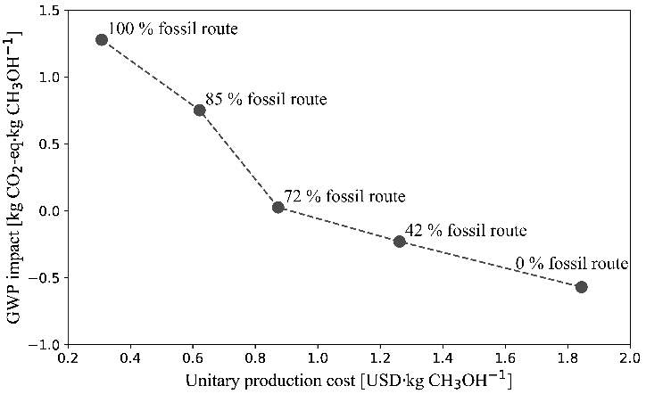

Figure 2: Pareto frontier from the multi-objective optimization (the percentages are calculated based on the mole fraction of natural gas used as feed in the ATR process, *i.e.*, the fossil route).

* 1. Conclusions

In this work, we studied the synergistic effects of integrating fossil and renewable processes based on heat, mass and power integration. Our results show that the integrated cluster can greatly reduce the environmental impact (*i.e.*, between 19 % and 183 %). In addition, the Pareto-optimal frontier demonstrates different combinations of the fossil and renewable routes, showing their hybridization potential that could enable a gradual transition to more sustainable chemicals.

References

Allam, R., Martin, S., Forrest, B., Fetvedt, J., Lu, X., Freed, D., Brown, G.W., Sasaki, T., Itoh, M., Manning, J., 2017. Demonstration of the Allam Cycle: An Update on the Development Status of a High Efficiency Supercritical Carbon Dioxide Power Process Employing Full Carbon Capture. Energy Procedia 114, 5948–5966.

Baliban, R.C., Elia, J.A., Floudas, C.A., 2013. Biomass to liquid transportation fuels (BTL) systems: process synthesis and global optimization framework. Energy Environ. Sci. 6, 267–287.

Boix, M., Montastruc, L., Azzaro-Pantel, C., Domenech, S., 2015. Optimization methods applied to the design of eco-industrial parks: a literature review. J. Clean. Prod. 87, 303–317.

Ioannou, I., Javaloyes-Antón, J., Caballero, J.A., Guillén-Gosálbez, G., 2023. Economic and Environmental Performance of an Integrated CO­2 Refinery. ACS Sustain. Chem. Eng. 11, 1949–1961.