Application of Co-Simulation Techniques in Process Systems Engineering and Algorithmic Challenges
Alexander Zinser*, Martin Arnold
Martin Luther University Halle-Wittenberg, Institute of Mathematics, Halle, Germany
alexander.zinser@mathematik.uni-halle.de
Abstract
With regard to process optimisation and process control, the efficient simulation of high dimensional spatially distributed systems is vital in process engineering. Co-simulation enables the parallel simulation of multiple subsystems. In this contribution, a basic co-simulation algorithm is introduced and exemplified on a model of an adiabatic plug flow tubular reactor (PFTR). Algorithmic parameters of the co-simulation such as the signal extrapolation method and the macro step size are investigated in detail. It is shown that the co-simulation approach for the stated test problem consisting of three coupled partial differential equations (PDE) already has the ability to compete with a monolithic reference simulation.
Keywords: Co-Simulation, Process Simulation, Process Systems Engineering
  - Introduction
Mathematical modelling and simulation are fundamental tools in process systems engineering. Modern reactor models are typically described by coupled spatially distributed partial differential equations (PDE). The discretisation of these systems often leads to a system of several thousand ordinary differential equations (ODE) that have to be solved numerically (Bremer et al., 2017). While such problems are typically simulated in a monolithic manner, co-simulation enables the parallel simulation of several subsystems. Co-simulation is a well-established tool in mechanical and electrical engineering (Eguillon et al., 2022), but there are just a few works on co-simulation in the field of process engineering (Gomes et al., 2017). Existing standards for co-simulation are investigated by Oppelt et al. (2015) and they conclude that the availability of co-simulation approaches is limited to specific industries.
In this contribution, we investigate the potential of co-simulation techniques in the parallel solution of systems of coupled PDE models. In sec. 2 a basic co-simulation algorithm is introduced, sec. 3 states our proposed test model of a PFTR, and in sec. 4 the proposed co-simulation approaches are analysed in detail w.r.t. their performance in terms of error and CPU time.
  - Co-Simulation
Co-simulation refers to simultaneous simulation of coupled subsystems. Consider dynamical systems, described by an ODE for the states, ${\dot{x}}_{i}=f_{i}(x_{i},u_{i})$, and an output $y_{i}=g_{i}(x_{i},u_{i})$ for a given input $u_{i}$. A basic example of two subsystems with outputs $y_{i}=g_{i}\left(x_{i},u_{i}\right)≔x_{i}$ and the corresponding monolithic system is shown in Fig. 1 (a)-(b).
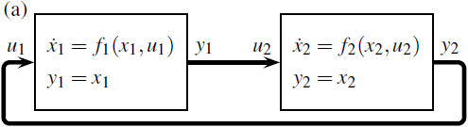
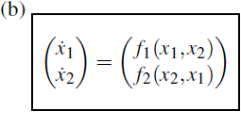
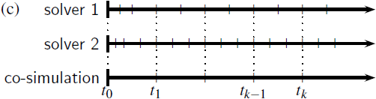
    - Basic concept of a co-simulation algorithm
Figure 1: (a) Co-simulation of two subsystems and (b) the corresponding monolithic system. (c) Micro time steps of the ODE solvers, and macro time steps of the co-simulation for the communication between the subsystems.
For known inputs $u_{i}$, each subsystem can be simulated independently of the other subsystems in parallel. While each ODE solver can proceed using its own step size controller, the information of the outputs $y_{i}$ has to be propagated back to the corresponding inputs $u_{i}$ at certain communication points. At each macro time step, a signal extrapolation for each input $u_{i}$ is performed (Eguillon et al., 2022). Fig. 1 (c) visualises the solver-specific micro time steps and the macro time steps of the co-simulation in which the communication between the subsystems takes place.
    - Signal extrapolation
In this work, the input signals of the subsystems are extrapolated linearly at each communication point $t_{k}$. Let $p_{i}^{\left(k\right)}(t)$ the linear extrapolation based on the input signal at communication points $t_{k-1}$ and $t_{k}$ as shown in Fig. 2 (a). This extrapolation method is not continuous at the communication points, i.e. $p_{i}^{\left(k-1\right)}\left(t_{k}\right)≠p_{i}^{\left(k\right)}(t_{k})$. Therefore, a continuous and a continuously differentiable extrapolation method are additionally used. The continuous linear (C⁰) extrapolation $p_{\text{C},i}^{\left(k\right)}(t)$ is a linear extrapolation that satisfies $p_{\text{C},i}^{\left(k\right)}\left(t_{k}\right)=p_{i}^{\left(k-1\right)}\left(t_{k}\right)$ and $p_{\text{C},i}^{\left(k\right)}\left(t_{k+1}\right)=p_{i}^{\left(k\right)}\left(t_{k+1}\right)$, Fig. 2 (b). Additionally, the linear C¹ extrapolation is a cubic polynomial based on the linear extrapolation, that satisfies also $∂_{t}p_{\text{C1},i}^{\left(k\right)}\left(t_{k}\right)=∂_{t}p_{i}^{\left(k-1\right)}\left(t_{k}\right)$ and $∂_{t}p_{\text{C1},i}^{\left(k\right)}\left(t_{k+1}\right)=∂_{t}p_{i}^{\left(k\right)}\left(t_{k+1}\right)$, as shown in Fig. 2 (c).
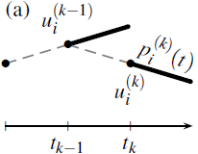
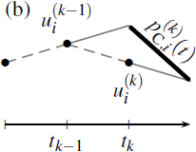
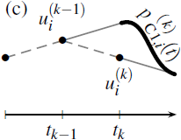
A quadratic or cubic signal extrapolation would also be possible. However, in order to achieve a better asymptotic behaviour of the error than in the linear case, Arnold (2021) showed that a sophisticated start-up procedure of the co-simulation is required.
Figure 2: (a) Linear signal extrapolation, (b) continuous C⁰, and (c) continuously differentiable C¹.

  - Modelling
In this work, we consider an adiabatic plug flow tubular reactor (PFTR), such as an exhaust gas treatment of a species A. Similar exothermic gas phase processes of high impact for the transition from fossil sources towards a sustainable recycling industry are, for example, the methanation of carbon dioxide, or the methanol synthesis from CO₂.
    - PFTR model
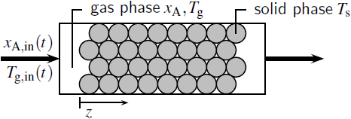
In our model, we consider two phases in one spatial dimension as depicted in Fig. 3. The gas phase is described by the molar fraction $x_{\text{A}}(t, z)$ and the temperature $T_{\text{g}}(t, z)$. The solid phase consists of a fixed bed catalyst layer and is described by the temperature field $T_{\text{s}}\left(t, z\right)$. While in the gas phase only convective mass and energy transport is considered, in the solid phase only diffusive energy transport, i.e. heat conduction, occurs. The governing equations of the model are stated as follows:
Figure 3: Schematic overview of the adiabatic PFT reactor model.
$$\frac{∂x_{\text{A}}}{∂t}=-v\frac{∂x_{\text{A}}}{∂z}-\frac{a}{c_{\text{tot}}}r\left(x_{\text{A}},T_{\text{g}}\right), \\ {\left(ρc_{\text{p}}\right)}_{\text{g}}\frac{∂T_{\text{g}}}{∂t}=-{\left(ρc_{\text{p}}\right)}_{\text{g}}v\frac{∂T_{\text{g}}}{∂z}-Δ_{\text{r}}h r\left(x_{\text{A}},T_{\text{g}}\right)-a q\left(T_{\text{g}},T_{\text{s}}\right), \\ {\left(ρc_{\text{p}}\right)}_{\text{s}}\frac{∂T_{\text{s}}}{∂t}=λ\frac{∂^{2}T_{\text{s}}}{∂z^{2}}+a q\left(T_{\text{g}},T_{\text{s}}\right).$$ | (1a)  (1b)  (1c)
The reaction rate $r(x_{\text{A}},T_{\text{g}})$ is described by a basic power law with Arrhenius equation,
$$r\left(x_{\text{A}},T_{\text{g}}\right)=k_{0}\exp\left(\frac{-E_{A}}{R T_{\text{g}}}\right)x_{\text{A}},$$ | (2a)
and the heat exchange between gaseous and solid phase is described by
$$q\left(T_{\text{g}},T_{\text{s}}\right)=α\left(T_{\text{g}}-T_{\text{s}}\right).$$ | (2b)
The gas phase velocity $v$ is calculated from the inlet volumetric flow $F_{\text{in}}$ and the free cross-section area $A_{\text{free}} = 0.4π{\left(d/2\right)}^{2}$ by $v = F_{\text{in}}/A_{\text{free}}$. A summary of the system parameters that are used in the simulations is given in Tab. 1.
    - Boundary conditions
The boundary conditions of the gas phase equations are given by the inlet mole fraction $x_{\text{A}}(t,0) = x_{\text{A,in}}(t)$ and temperature $T_{\text{g}}\left(t,0\right)= T_{\text{g,in}}(t)$, respectively. In the boundary conditions of the solid phase equation, it is assumed that no heat conduction across the system boundary occurs, i.e. $∂_{z}T_{\text{s}}\left(t,0\right)=∂_{z}T_{\text{s}}\left(t,L\right)=0$ . In our simulations, two different sets of boundary conditions are used. First, a constant feed with a molar fraction of $x_{\text{A,in}}(t) = 0.0025$ and a temperature of $T_{\text{g,in}}(t)=500\text{K}$. Second, a fluctuating feed in the molar fraction is applied. This is simulated by a Wiener process with a sampling rate of $1\text{s}$, i.e. $x_{\text{A,in}}(t)∼\left|W\left(t\right)\right|$, and normalised to $\frac{1}{t_{\text{f}}}\int_{0}^{t_{\text{f}}}{x_{\text{A,in}}\left(t\right)\text{d}t}=0.0025$. Here, only the feed temperature is kept constant, $T_{\text{g,in}}(t) = 520\text{K}$.
    - Discretisation
In order to solve the PDE (1), it is discretised along the spatial coordinate using a finite volume method (LeVeque, 2002). Therefore, the domain of the spatial coordinate $Ω=\left[0,L\right)$ is discretised into $n_{\text{FV}}$ finite cells $Ω_{i}=\left[z_{i-1/2}, z_{i+1/2}\right)$ such that $\bigcup_{i=1}^{n_{\text{FV}}}{Ω_{i}}=Ω$ and $Ω_{i}∩Ω_{j}=∅$ for $i≠j$, and an equidistant grid is assumed. Within a cell, the values of the spatially distributed variables are approximated by their integral mean. In the discretisation of the accumulation terms, the Leibniz integral rule is applied. In the case of the convective and diffusive transport terms, the divergence theorem is utilised. The values on the boundaries of the cells are reconstructed by a first order upwind, and the gradients are interpolated linearly from the neighbouring values. This leads to a stiff set of $3⋅n_{\text{FV}}$ coupled ODE.
  - Simulations
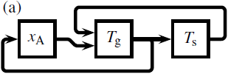
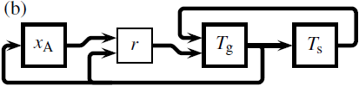
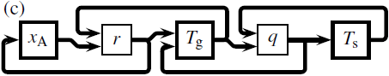
The simulation of the proposed model was implemented in Python using NumPy and SciPy packages. The integration of the ODE was done using a backward differentiation formula (BDF) according to Shampine and Reichelt (1997) which is part of the SciPy package. The integration interval was always chosen to be $\left[0, t_{\text{f}}\right]$ with the upper bound of $t_{f}=750\text{s}$. All simulations were performed on a system with the following configuration: Hardware — Intel® Core™ i5-10500T CPU (6 Cores, 2.3 GHz), 8.0 GiB RAM, Software — Windows 10 Pro, Python 3.8.10, NumPy 1.24.1, SciPy 1.10.1, Spyder 5.4.5. Besides the Monolithic simulation of the overall set of $3⋅n_{\text{FV}}$ ODE, the system was simulated by means of a co-simulation as described below. The number of communication points in a co-simulation is denoted by $n_{\text{CP}}$.
Table 1: System parameters.
Symbol | Description
$$a={10}^{4} {\text{m}}^{\text{2}}/{\text{m}}^{3} \\ α=50 \text{W}/{\text{m}}^{2}\text{K} \\ d=0.09 \text{m} \\ E_{A}=80 \text{kJ}/\text{mol} \\ F_{in}=7 {\text{m}}^{3}/\text{h} \\ Δ_{r}h=-1200 \text{kJ}/\text{mol} \\ k_{0}={10}^{6} \text{mol}/{\text{m}}^{2}\text{s} \\ L=0.3 \text{m} \\ λ=5 \text{W}/\text{m} \text{K} \\ R=8.3145 \text{J}/\text{mol} \text{K} \\ {\left(ρc_{\text{p}}\right)}_{\text{g}}=1.2 \text{kJ}/{\text{m}}^{3}\text{K} \\ {\left(ρc_{\text{p}}\right)}_{\text{s}}=950 \text{kJ}/{\text{m}}^{3}\text{K}$$ | specific surface area  heat transfer coefficient  reactor diameter  activation energy  inlet volume flow  enthalpy of reaction  kinetic constant  reactor length  heat conductivity  gas constant  density/heat capacity..  ..of gas/solid phase

Figure 4: Different co-simulations. (a) Co-Simulation 1: Direct feedback of the internal states, (b) Co-Simulation 2: the reaction rate $r$, Eq. (1b), is extrapolated, and (c) intermediate calculation of reaction rate $r$ and heat exchange $q$.
    - Structure of the co-simulations
Since the system consists of three coupled PDE, it is natural to regard each discretised PDE as one subsystem. The outputs of the subsystems are the states itself, $x_{\text{A}},T_{\text{g}},T_{\text{s}}$. Fig. 4 shows different structures for a co-simulation. The first structure, Fig. 4 (a), performs direct feedback of the internal states and extrapolates them as described in sec. 2.2. This structure is denoted by Co-Simulation 1. In the structure shown in Fig. 4 (b), denoted by Co-Simulation 2, the reaction rate $r$ is used as input to the subsystem for the gas temperature $T_{\text{g}}$, Eq. (1b). This has the advantage, that the Jacobian of this subsystem becomes constant.
The third structure, Fig. 4 (c), performs a signal extrapolation on the reaction rate $r$ and heat exchange $q$. It has to be noted that this structure does not lead to a feasible simulation. Consider the PDE for the mole fraction, Eq. (1a); this equation has a local stationary point at $x_{\text{A}}→0$. Replacing the reaction rate in this equation by a system input $u\left(t\right)$ leads to a disappearance of this stationary point and a co-simulation algorithm would require an infinitesimal small communication step size. The same holds for the two PDE for the temperatures which have their stationary points at $T_{\text{g}}→T_{\text{s}}$ and vice versa.
    - Results
For all simulations, the CPU time, and the accuracy in terms of the $L_{2}$-error were measured. Let $x_{jk}$ be the numerical solution of the $j$-th state of the overall simulation at the $k$-th communication time step $t_{k}$, and let ${\tilde{x}}_{jk}$ the corresponding value of a high-precision simulation. Then, the time-dependent $L_{2}$-error is defined by $\text{err}\left(t_{k}\right)≔ {\left\|{\tilde{x}}_{⋅k}-x_{⋅k}\right\|}_{2}/{\left\|{\tilde{x}}_{⋅k}\right\|}_{2}$, and the global $L_{2}$-error is defined by $\text{err ≔ }{\left\|{\tilde{x}}_{⋅⋅}-x_{⋅⋅}\right\|}_{2}/{\left\|{\tilde{x}}_{⋅⋅}\right\|}_{2}$.
A first simulation was conducted with $n_{\text{FV}}=50$ finite volumes and $n_{\text{CP}}=3001$ communication points in time with linear signal extrapolation for both types of boundary conditions, the constant feed system and the fluctuating feed system. Fig. 5 shows the $L_{2}$-error w.r.t. the simulated time $t$ for both systems. The absolute and relative tolerances of the ODE solver were always fixed at ${10}^{-6}$. Since the co-simulation employs a signal extrapolation of the states of the other subsystems, it is clear that a loss in accuracy can be observed. The CPU times of the simulations are shown in the legend of the figures. This indicates that the co-simulation approach has a higher potential at the fluctuating feed system.
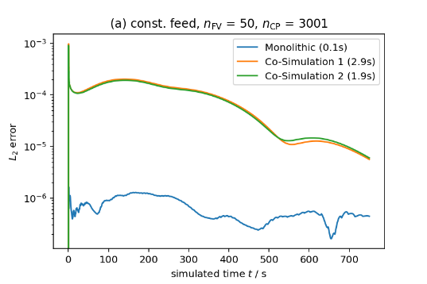
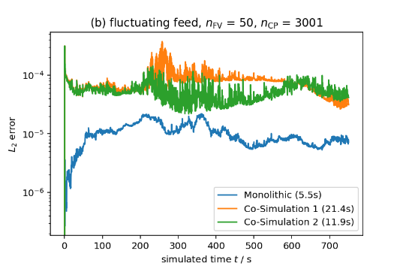
Additionally, the signal extrapolation methods C⁰ and C¹ lead to a slightly higher error, but also to a significantly better performance as shown in Fig. 6 (c). The reason is that the ODE solver does not have to handle the discontinuities at each communication point $t_{k}$. The influence of the number of communication points $n_{\text{CP}}$ is shown in Fig. 6 (a)-(b) for the C⁰ and the C¹ signal extrapolation, respectively. It was observed that one should not go below $n_{\text{CP}}≈2000$ communication points since this leads to problems because of a too large macro step size of the co-simulation. On the other hand, an increasing number of communication points leads to a higher CPU time. Hence, for the given system $n_{\text{CP}}=2201$ communication points seem to be a reasonable choice.
Figure 5: $L_{2}$-error w.r.t. simulated time $t$ for (a) the constant feed system, and (b) the fluctuating feed system. Both simulations use the linear signal extrapolation.
Finally, Fig. 6 (d) shows the influence of the number of finite volumes $n_{\text{FV}}$ of the spatial discretisation on the CPU time of the simulation. It can be seen clearly, that for every size of the problem, at least one of the two considered co-simulation structures shows a better performance than the Monolithic simulation. Especially for a fine discretisation with $n_{\text{FV}}≥400$, both co-simulation structures show a better performance than the monolithic simulation.
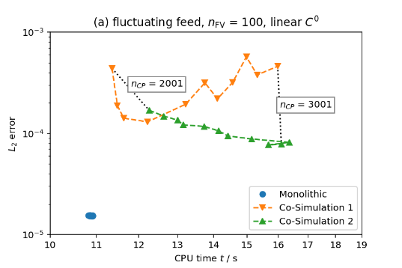
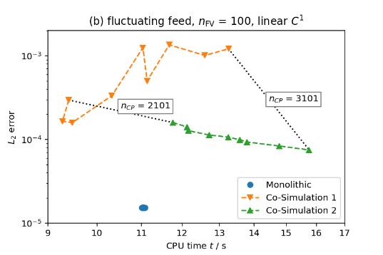
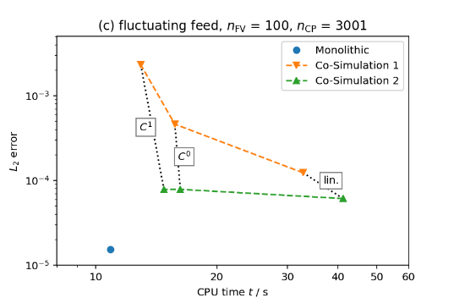
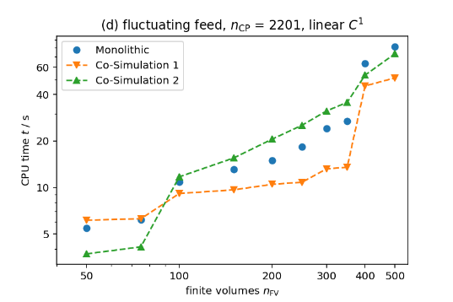
  - Conclusion
Figure 6: Influence of (a)-(b) the number of communication points $n_{\text{CP}}$ for C⁰ and C¹ signal extrapolation, (c) the type of signal extrapolation, and (d) the number of finite volumes $n_{\text{FV}}$.
It was shown that the proposed co-simulation approaches enable the parallel simulation of spatially distributed PDE models in process engineering. Since the co-simulation of only three coupled PDE can already compete with a monolithic simulation, it is expected that a much higher performance can be achieved in simulations with much more coupled PDE.
References
M. Arnold, May 2021. How to verify worst case asymptotic error bounds for co-simulation algorithms. International Symposium on Co-Simulation and Solver Coupling in Dynamics, Ferrol, Spain.
J. Bremer, K. H. G. Rätze, K. Sundmacher, 2017. CO₂ methanation: Optimal start-up control of a fixed-bed reactor for power-to-gas applications. AiChE J. 63(1), 23–31.
Y. Eguillon, B. Lacabanne, D. Tromeur-Dervout, 2022. F₃ORNITS : a flexible variable step size non-iterative cosimulation method handling subsystems with hybrid advanced capabilities. Eng. Comput. 38, 4501–43.
C. Gomes, C. Thule, D. Broman, P. G. Larsen, H. Vangheluwe, 2017. Co-simulation: State of the art, arXiv:1702.00686 [cs.SY].
R. J. LeVeque, 2002. Finite Volume Methods for Hyperbolic Problems. Cambridge University Press.
M. Oppelt, G. Wolf, L. Urbas, 2015. Life Cycle Simulation for a Process Plant based on a Two-Dimensional Co-Simulation Approach. Comput. Aided Chem. Eng. 37, 935–40.
L. F. Shampine, M. W. Reichelt, 1997. The Matlab ODE Suite. SIAM J. Sci. Comput. 18(1), 1–22.

