Sustainability analysis of a large-scale calcium looping plant coupled with concentrated solar energy

Ricardo N. Diasa, Rui M. Filipeb,c, Carla I.C. Pinheiroa, Henrique A. Matosc

aCentro de Química Estrutural, IMS, Department of Chemical Engineering, Instituto Superior Técnico, Universidade de Lisboa, Av. Rovisco Pais 1, 1049-001 Lisboa, Portugal

bInstituto Superior de Engenharia de Lisboa, Instituto Politécnico de Lisboa, R. Conselheiro Emídio Navarro 1, Lisboa 1959-007, Portugal

cCentro de Recursos Naturais, Department of Chemical Engineering, Instituto Superior Técnico, Universidade de Lisboa, Av. Rovisco Pais 1, 1049-001 Lisboa, Portugal

ricardo.n.dias@tecnico.ulisboa.pt

Abstract

Concentrated solar energy represents one potential solution for the energy transition of energy-intensive industries, including the cement industry, wherein temperatures exceeding 800 ºC are required. The present study provides a sustainability analysis of a calcium looping plant coupled with a thermochemical energy storage system. Three process alternatives were evaluated: V0, which used CO2 as the fluidization fluid, and V1 and V2, were CO2 is replaced by water vapor as the fluidization fluid and different calciner temperatures are used (800 ºC and 900 ºC). The sustainability of each option was evaluated using the GREENSCOPE analysis tool and the four metrics provided by GREENSCOPE were analysed in detail. To determine the most sustainable alternative, TOPSIS was used and V2 was found to be the best alternative overall. V1 had a similar sustainability to V2 due to both using water vapor as the fluidization fluid, which was found to be the primary factor in improving sustainability. However, using water vapor to achieve fluidization instead of CO2 has some drawbacks, as significant process changes are necessary, which increase energy consumption and capital costs.

**Keywords**: LCA, Ca-Looping, Thermochemical Energy Storage, Sustainability

# Introduction

Concentrated solar energy (CSE) when coupled with a power generation facility, offers a viable alternative to mainstream solar harvesting technologies such as photovoltaics. However, this technology is dependent on a highly intermittent energy source, the sun. There are many factors influencing the performance of CSE units, with cloud coverage being one of the most influential. Yet, when CSE is capable of operating at optimal conditions, temperatures higher than 1000 ºC can be achieved. These temperatures make it a viable solution for many energy intensive industries struggling to achieve a clean energy transition (Marques et al., 2023).

The cement industry is one of the largest contributors to carbon emissions, accounting for 8 % of worldwide emissions. These emissions result from the combustion of fossil fuels used to achieve the high temperatures required for the calcination endothermic reaction and clinkerization, as well as the inherent CO2 produced by the calcination reaction. Therefore, replacing the fossil fuels with a clean energy source could reduce emissions by approximately 40 %. It would also enable an easier capture of the CO2 produced, since the effluent is not diluted with the air used in the combustion with fossil fuels. An example of such technology is solar calcination of calcium carbonate, which has several projects demonstrating the feasibility of this technique (SoCaLTES, 2019). A pure CO2 stream can be used to achieve fluidization during calcination, making the capture of this greenhouse gas straightforward. Another solution has been presented, with the use of water vapor has fluidization fluid (Rodrigues et al., 2023a), where a separation unit for water/CO2 is required. However, this separation is easier than the capture from a flue gas stream.

The reversibility of the calcination reaction makes it suitable for a looping process, where the products of the calcination reaction store energy in chemical form (Teixeira et al., 2021). This process is termed calcium looping for thermochemical energy storage (CaL-TCES) and has been demonstrated at pilot scale. Yet, some hurdles must be addressed before full scale implementation, namely the deactivation of the sorbent (calcium oxide, the product of the calcination reaction). As proposed by Rodrigues et al. (2023b), the deactivation of the sorbent can be addressed by purging it, making the CaL an open cycle, where the calcium carbonate is 100 % converted to CO2 and CaO, and later these products are reacted together to produce back the calcium carbonate in the carbonator, where an 81 % conversion is achieved. The effluent stream from the carbonator is purged, forcing a make-up of fresh calcium carbonate to be fed to the calciner.

This work presents a sustainability analysis of a CaL-TCES plant using GREENSCOPE. Several process alternatives have been evaluated, including the use of CO2 and water vapor as fluidization fluids, and different calciner temperatures. This work further elaborates on the sustainability analysis of the process (Dias et al., 2023b), presenting a detailed analysis of the GREENSCOPE metrics. The sustainability results obtained from GREENSCOPE (global and by metric) were evaluated using TOPSIS to choose the most sustainable process alternative and demonstrate the advantage of an integrated analysis.

# Calcium Looping for Thermochemical Energy Storage

The case study used in this work is a CaL-TCES plant, that has been previously modelled in Aspen Plus® (Rodrigues, et al., 2023a). The process was designed with a focus on thermochemical energy storage. Therefore, the optimal operating conditions were defined to maximize the energy conversion of the process, the solar to electrical efficiency. A solar field of 100 MJ was considered as the energy source for the calciner. Three process alternatives from the base process were evaluated: use of CO2 as the fluidization fluid (V0), use of water vapor as the fluidization fluid (V1), and a reduced temperature in the calciner prompted by the use of water vapor (V2). Table 1 outlines the different process alternatives considered.

Table 1 – Evaluated CaL-TCES process alternatives, adapted from (Dias et al., 2023b).

|  |  |  |  |
| --- | --- | --- | --- |
| Alternative | Purge (%) | Fluidization Fluid | Calciner temperature (ºC) |
| V0 | 100 | CO2 | 900 |
| V1 | Water vapor |
| V2 | 800 |

# Methodology

The sustainability analysis presented evaluated the impact of proposed process design changes on the sustainability of the CaL-TCES plant model. As the models used are not representative of a real plant and the alternatives compared are conceptual models, the assessment boundaries were set at the "gates" of the model. Therefore, the supply chain of raw materials and the subsequent use of system products are not considered. These boundaries are the most appropriate for comparing process changes (Smith et al., 2015).

* + 1. GREENSCOPE

Gauging Reaction Effectiveness for the ENvironmental Sustainability of Chemistries with a Multi-Objective Process Evaluator (GREENSCOPE) is a sustainability analysis tool developed by Gonzalez and Smith (2003), that focus on evaluating process design changes. A total of 139 sustainability indicators are considered, distributed across 4 metrics, as shown in Table 2.

Table 2 – GREENSCOPE metrics and the total number of indictors in each.

|  |  |
| --- | --- |
| Metrics | Nº of indicators |
| Mass Efficiency | 26 |
| Environment | 66 |
| Energy | 14 |
| Economy | 33 |

Each indicator is computed with a specific equation (Ruiz-Mercado et al., 2012), which leads to an absolute indicator value ($x_{i}$), for each indicator *i*. The upper ($x_{i, upper}$) and lower ($x_{i, lower}$) possible values for each indicator are defined based on heuristics (e.g. water consumption limits) or inherent to the indicator (e.g. reaction yield). A maximum-minimum normalization, Eq. (1), is then applied to all indicators, yielding a score ($\%G_{j}\left(i\right)$), for each alternative *j*, that facilitates comparison and graphical representation, where *n* is the number of indicators and *V* the number of alternatives.

|  |  |
| --- | --- |
|  | (1) |

* + 1. TOPSIS

Technique for Order of Preference by Similarity to Ideal Solution is a multi objective decision making (MODM) method presented by Yoon and Hwang (1981) It determines the best option based on Euclidean distances of each alternative to the others (relative distance to the best performance) in each indicator. In this work, TOPSIS is used to decide on which process alternative assessed with GREENSCOPE is the more sustainable. TOPSIS implementation method was previously described by Dias et al. (2023).

# Results

The GREENSCOPE results for the assessment of the CaL-TCES alternatives are presented, firstly the results for each metric, secondly, the TOPSIS analysis of the GREENSCOPE results.

* + 1. Spider graphs from each metric

The sustainability results obtained using GREENSCOPE for the CaL-TCES plant indicate that the three evaluated alternatives have a similar sustainability performance. As shown in Figure 1, deciding which alternative is the most sustainable, just based on the spider graphs obtained, is inaccurate. If the decision on which alternative is the most sustainable was to be made from the energy indicators (Figure 1c), alternative V0 was to be selected as the most sustainable, as it has a similar performance to the other alternatives, except in indicator four, where it outperforms the other ones. Conversely, in economic indicators (Figure 1d) alternative V0 was to be selected as worst performing one, because of a similar performance of the alternatives in all but one indicator. In Figures 1a and 1b there is no difference between the three alternatives, so these do not allow for a solid decision on which alternative is the most sustainable.

a)

b)

c)

d)

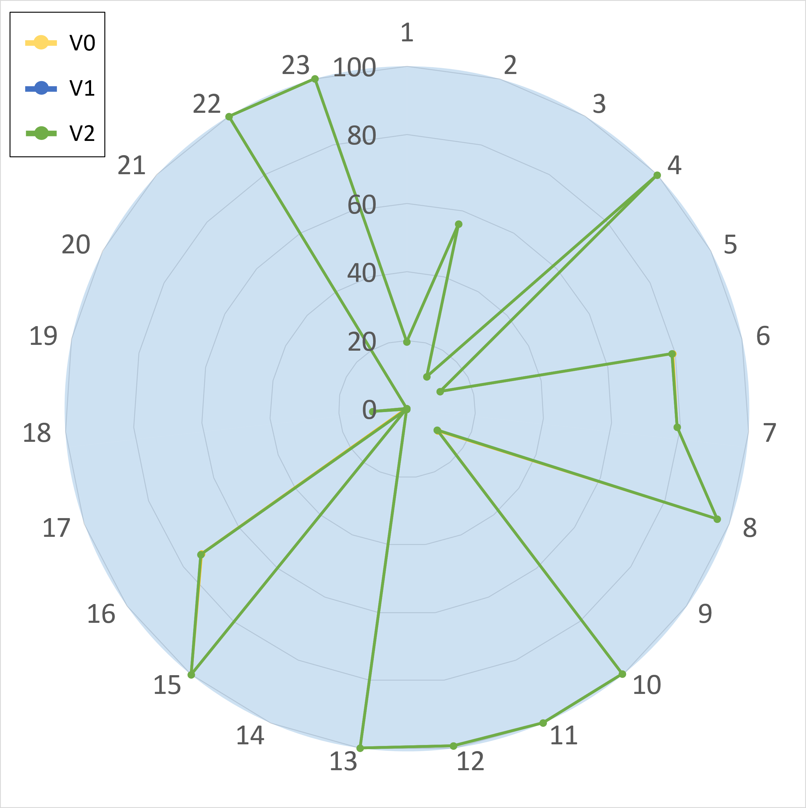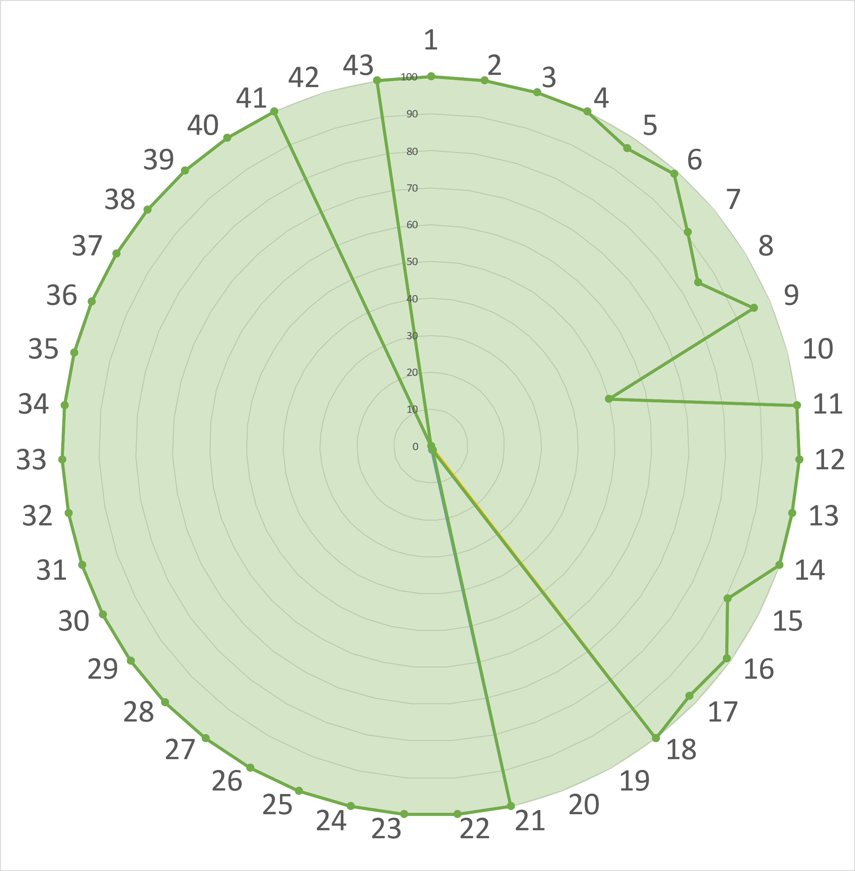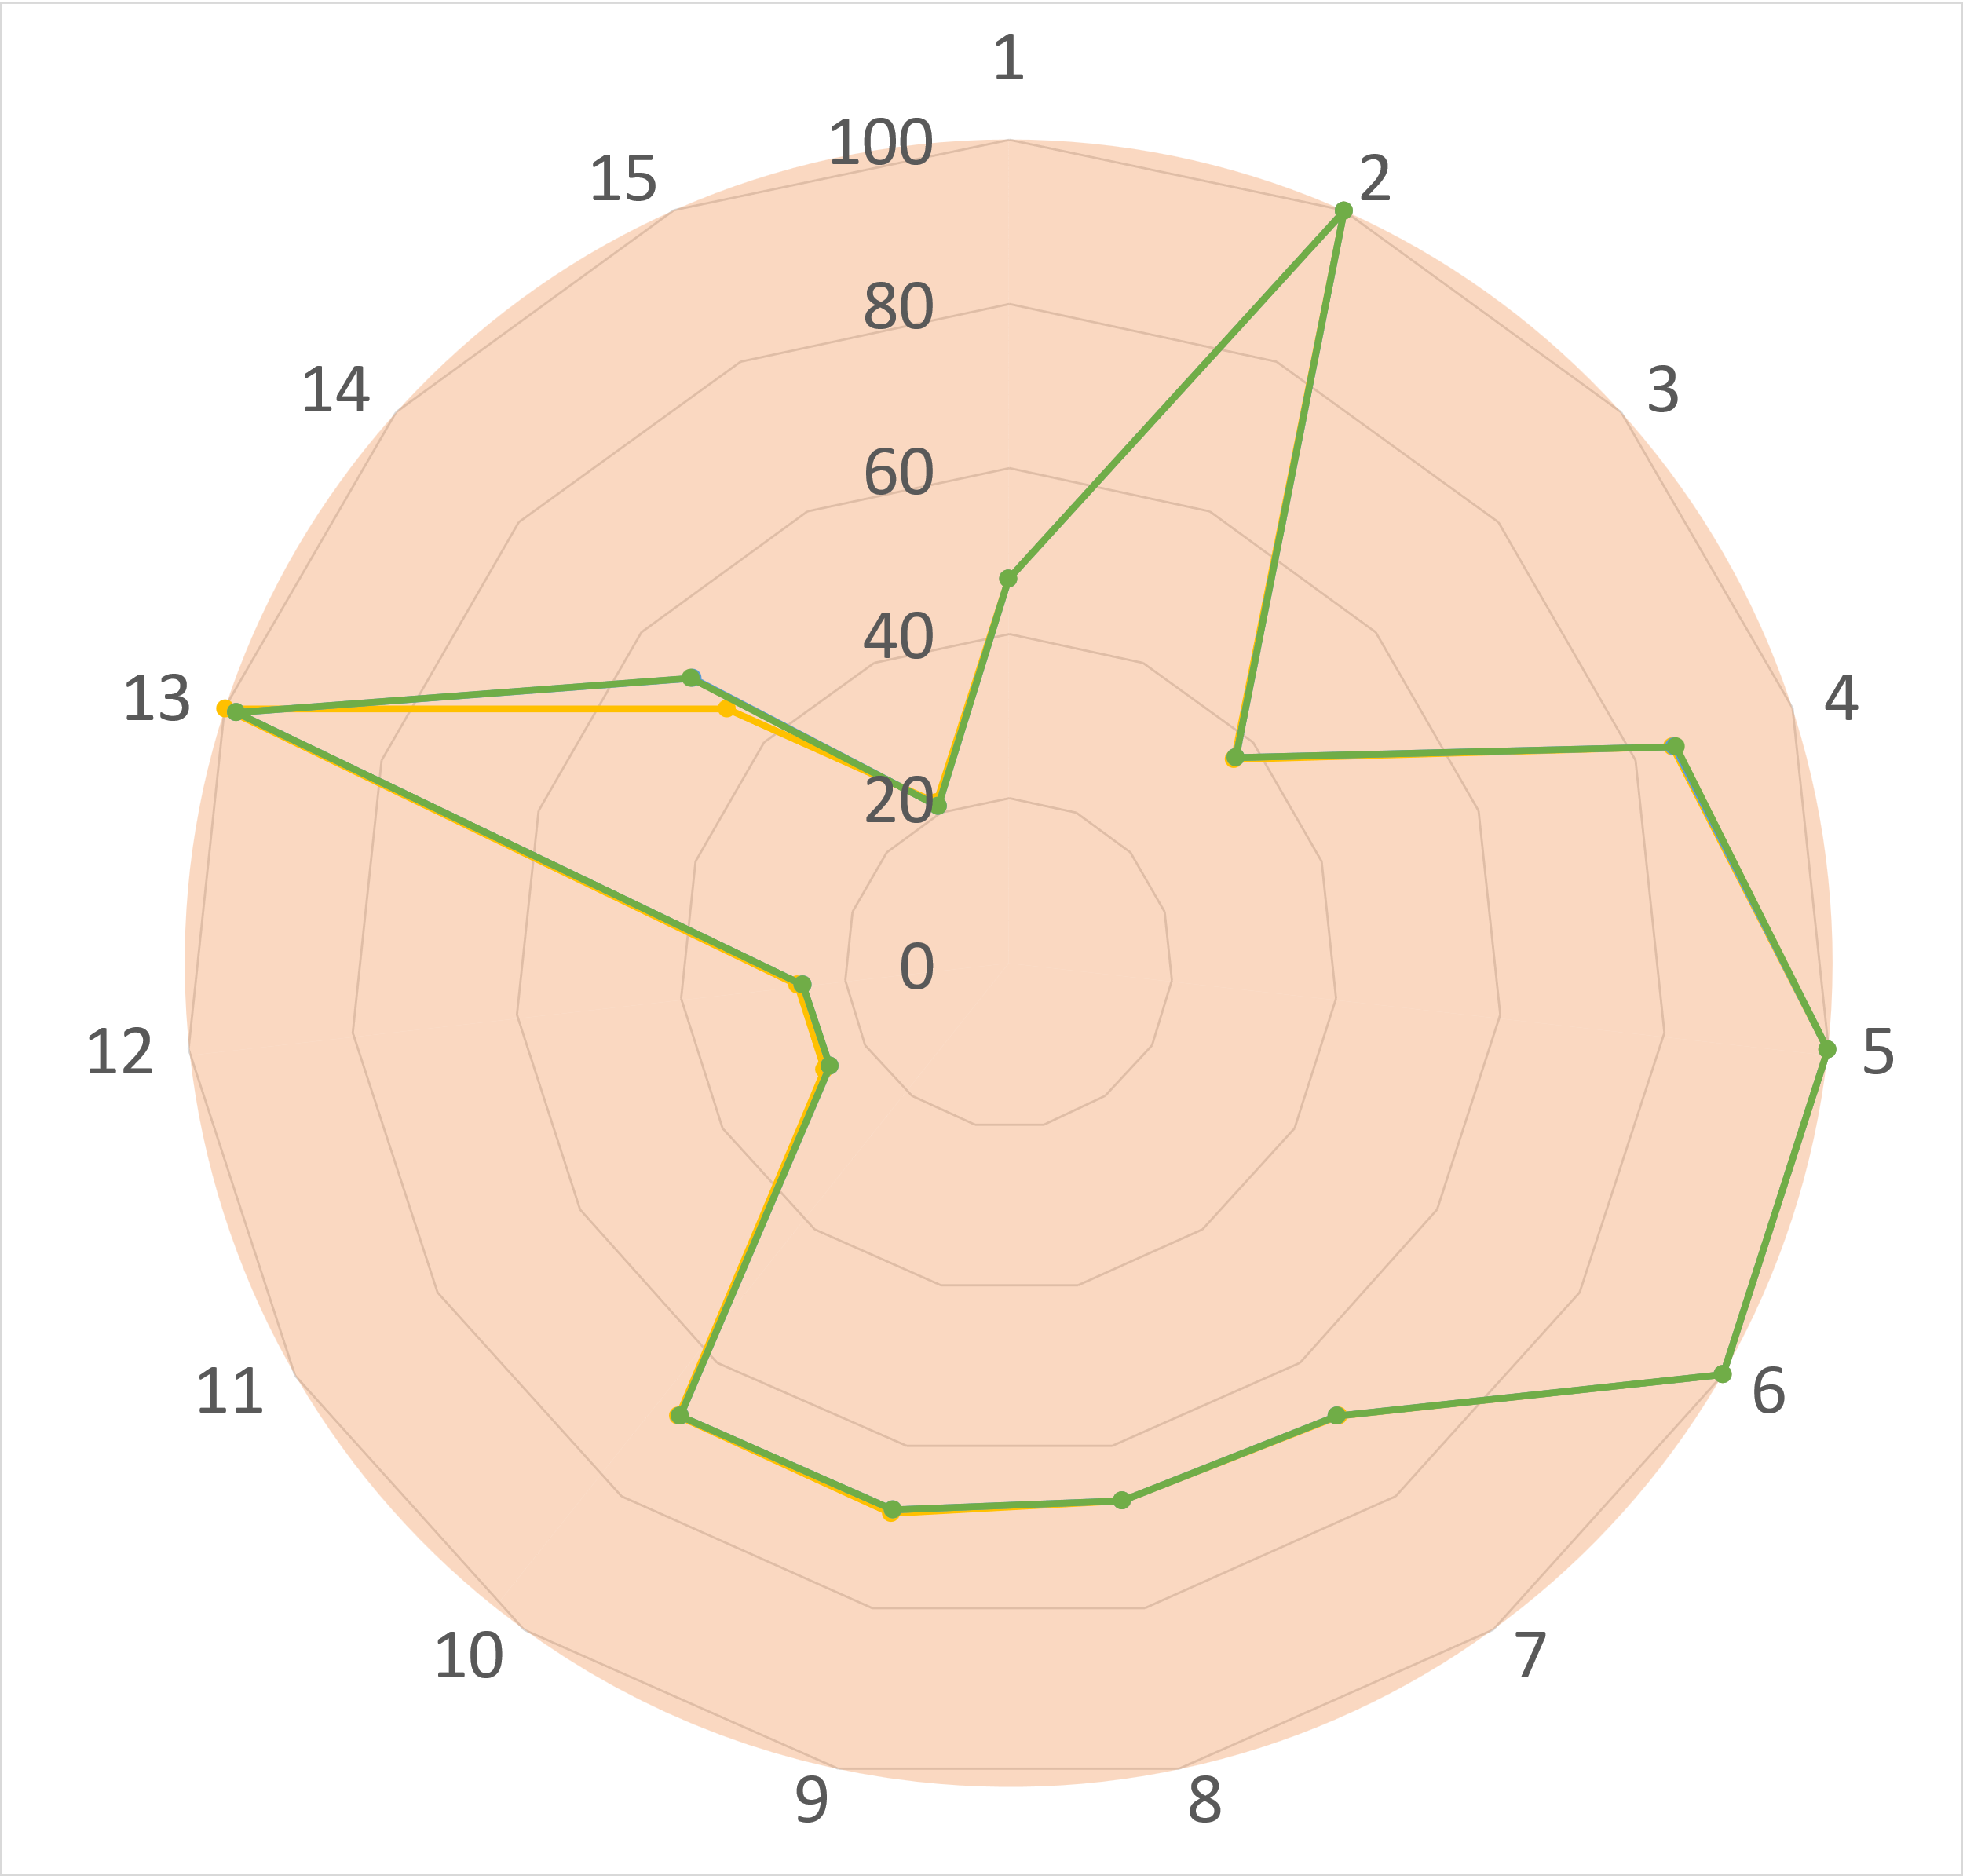

Figure 1 - GREENSCOPE results for each metric. a - Efficiency, b - Environment, c - Energy, d - Economy.

The differences identified between alternatives in Figures 1c and 1d can be attributed to the introduction of water vapor as the fluidization fluid (alternatives V1 and V2), which significantly improves the calcination reaction efficiency (Rodrigues et al., 2023a). However, this change introduces a more complex process with the need for a water/CO2 separation unit, leading to an energy penalty, as compressors and coolers are required to carry out the separation. Therefore, in Figure 1c, alternative V0 outperforms the remaining alternatives.

The introduction of the separation unit also affects the economic indicators, due to the increased expenditure on equipment and operational costs. The increase in the costs is not easily noticeable from Figure 1d, as the three alternative scores are almost overlayed. Hence, a variation in the economic indicators between the alternatives was expected.

* + 1. TOPSIS results

The data presented in Figure 1 was fed to the TOPSIS algorithm, allowing it to rank each alternative, as described in section 3.2. The results obtained for an overall assessment (considering all indicators) can be found in Table 3. From the overall evaluation is possible to observe a clear difference between the three process alternatives considered. These results are contrasting with the ones in Figure 1, and clearly show that V0 as an inferior alternative to V1 and V2. V2 is elected as the most sustainable alternative, with a score obtained from TOPSIS of 0.9213. Which means that in almost every indicator, V2 has the highest GREENSCOPE score.

Table 3 – TOPSIS results for the three alternatives evaluated using GREENSCOPE results.

|  |  |  |  |
| --- | --- | --- | --- |
|  | V0 | V1 | V2 |
| TOPSIS | 0.0787 | 0.9036 | 0.9213 |
| Rank | 3 | 2 | 1 |

V1 has a TOPSIS result similar to alternative V2, as expected, since these two alternatives feature the use of water vapor as fluidization fluid in the calciner, which allows for a more efficient calcination reaction. However, V2 was modelled with a lower calcination temperature (800 ºC), which increases its sustainability performance.

The results for the metrics assessment using TOPSIS are presented in Table 4 were obtained. These used the same indicator split as for the results shown in Figure 1. As seen in Table 4, TOPSIS ranks each alternative in each metric, which was not possible to obtain with the GREENSCOPE results shown in Figure 1. Alternatives V1 and V2 are similar, but use different calciner temperatures tied, which justifies the very close, but not equal, values obtained for the efficiency metric. V1 and V2 are closely matched in the environment metric, but V2 is still the best performing alternative.

Table 4 – TOPSIS results split into metrics for the three alternatives evaluated using GREENSCOPE results.

|  |  |  |  |
| --- | --- | --- | --- |
|  | V0 | V1 | V2 |
| Efficiency | | | |
| TOPSIS | 0.0074 | 0.9926 | 0.9926 |
| Rank | 3 | 2 | 1 |
| Environment | | | |
| TOPSIS | 0.0001 | 0.9249 | 0.9999 |
| Rank | 3 | 2 | 1 |
| Energy | | | |
| TOPSIS | 0.9762 | 0.0781 | 0.0229 |
| Rank | 1 | 2 | 3 |
| Economy | | | |
| TOPSIS | 0.2716 | 0.7306 | 0.7294 |
| Rank | 3 | 1 | 2 |

In the energy metric alternative V0 is clearly the best performing alternative, as expected, since this alternative does not feature the energy consuming of the water/CO2 separation unit. The economic results from GREENSCOPE are more evenly distributed across the alternatives, with V1 and V2 being closely matched. In this simpler configuration V1 was the best performing alternative.

# Conclusions

A sustainability analysis was performed on a calcium looping plant coupled with thermochemical energy storage using GREENSCOPE. To facilitate the decision-making process and determine the most sustainable option, TOPSIS was used because the results obtained from GREENSCOPE did not provide a straightforward decision. Thus, the use of TOPSIS was essential in distinguishing between the alternatives under consideration.

When considering an overall evaluation of all alternatives using TOPSIS, the alternative using steam as fluidization fluid and 800 ºC in the calciner (V2) proved to be more sustainable. However, a closer analysis of each metric gave a clearer understanding of the impact of the proposed process changes. It was found that, although V2 is the best alternative, it is the worst performing in the energy metric. These results show that considering only one metric may lead to wrong decisions on the selection of the more sustainable alternative.

The use of water vapor to achieve fluidization is shown to increase the sustainability of the CaL-TCES system, which will be further investigated in the future with a detailed techno-economic analysis.

# Acknowledgements

The present work was financed by the Portuguese Foundation for Technology and Science (FCT) PTDC/EAM-PEC/32342/2017, CQE strategic project FCT-UIDB/00100/2020, CERENA strategic project FCT-UIDB/04028/2020 and PhD grant PRT/BD/154409/2023, this support is gratefully appreciated.

# References

R. N., Dias, R. M., Filipe & H. A., Matos (2023a). Decision-making based on sustainability analysis using GREENSCOPE. Clean Technologies and Environmental Policy, https://doi.org/10.1007/s10098-023-02647-4

R. N., Dias, R. M., Filipe & H. A., Matos (2023b). Sustainability analysis of a solar-driven calcium looping plant for thermochemical energy storage. Journal of Cleaner Production, 139551. https://doi.org/10.1016/J.JCLEPRO.2023.139551

M. A., Gonzalez & R. L., Smith (2003). A Methodology to Evaluate Process Sustainability. Environmental Progress, 22(4). https://doi.org/10.1002/ep.670220415

C.-L., Hwang & K., Yoon (1981). Multiple Attribute Decision Making Methods and Applications A State-of-the-Art Survey. Lecture Notes in Economics and Mathematical Systems, 186.

L. M., Marques, S. M., Mota, P., Teixeira, C. I. C., Pinheiro, & H. A., Matos (2023). Ca-looping process using wastes of marble powders and limestones for CO2 capture from real flue gas in the cement industry. Journal of CO2 Utilization, 71, 102450. https://doi.org/10.1016/J.JCOU.2023.102450

D., Rodrigues, C. I. C., Pinheiro, R. M., Filipe, L. F., Mendes, & H. A., Matos (2023a). Optimization of an improved calcium-looping process for thermochemical energy storage in concentrating solar power plants. Journal of Energy Storage, 72, 108199. https://doi.org/10.1016/J.EST.2023.108199

D., Rodrigues, M., Alvarez Rivero, C. I. C., Pinheiro, J. P., Cardoso, & L. F., Mendes (2023b). Computational model of a Calcium-looping fluidized bed calcination reactor with imposed concentrated solar irradiance. Solar Energy, 258, 72–87. https://doi.org/10.1016/J.SOLENER.2023.04.018

G. J., Ruiz-Mercado, R. L., Smith, & M. A., Gonzalez (2012). Sustainability indicators for chemical processes: II. Data needs. Industrial and Engineering Chemistry Research, 51(5). https://doi.org/10.1021/ie200755k

R. L., Smith, G. J., Ruiz-Mercado, & M. A., Gonzalez (2015). Using GREENSCOPE indicators for sustainable computer-aided process evaluation and design. Computers and Chemical Engineering, 81. https://doi.org/10.1016/j.compchemeng.2015.04.020

SoCaLTES. (2019). SoCaLTES Project Solar-driven Ca-Looping Process for Thermochemical Energy Storage. https://socaltes.net/

P. Teixeira, A., Fernandes, F., Ribeiro, & C. I. C., Pinheiro (2021). Blending wastes of marble powder and dolomite sorbents for calcium-looping CO2 capture under realistic industrial calcination conditions. Materials, 14(16). https://doi.org/10.3390/ma14164379