Process Simulation of biofuel production from Waste Cooking Oil
Suresh Kumar Jayaraman
AVEVA Group Plc, Lake Forest, California 92630, United States of America
Suresh.jayaraman@aveva.com
Abstract
Increasing oil demand, climate change and depletion of fossil fuel play vital role in alternate fuel research. This study explores a design methodology to produce HEFA (Hydroprocessed Esters and Fatty Acids) biofuel from waste cooking oil (WCO). Waste cooking oil is used as a renewable resource to avoid food crops being used for fuel production and to reduce the raw material cost. This article involves developing a detailed steady state simulation of production of HEFA jet fuel & green diesel from WCO using first principles unit-operations models and rigorous thermodynamics on a next generation commercial simulation tool, AVEVA Process Simulation. The production process involves three key steps, Hydrogenation & Hydrodeoxygenation, Hydrocracking, and Separation of the products to obtain desired jet fuel and diesel.
Keywords: Waste cooking oil, biofuel, process simulation, sustainability

Introduction
The contribution to greenhouse gas emissions (GHG) by aviation industries is growing faster in recent decades compared to other mode of transport (Catarina I. Santos, 2018). Thus, aviation industries are actively seeking for a sustainable crude oil jet fuel substitute (Maria Fernanda Rojas Michaga, 2022). Bio-jet fuel, also known as Sustainable Aviation Fuel (SAF) is a biofuel used to power aircraft that has similar properties like traditional jet fuel with a lesser carbon footprint (Sustainable Aviation Fuels). Biofuel is made from renewable biomass that comes from plants and animals. Food crops are usually used for biofuel production, but researchers are focusing on waste resources and non-food crops to make the process profitable (Jayaraman, 2023).
Waste Cooking Oil (WCO) serves as an economical feedstock for biofuel production (Monika, 2023). WCO is usually disposed or dumped into the drainage system, and the inappropriate disposal of WCO increases environmental pollution and contaminates both terrestrial and aquatic habitats (Omojola Awogbemi, 2021). Thus, the interest in using WCO as a feedstock has increased in the recent years to make the biofuel production economical and sustainable. The utilization of WCO contributes to the concept of circular economy.
This paper focuses on utilizing WCO as a viable feedstock to produce bio jet-fuel & green diesel and simulation hydrotreatment of WCO using AVEVA Process Simulation.

Process Description

Properties and chemical composition of WCO
Oil goes through three different types of reaction, namely thermolytic, oxidative and hydrolytic during the process of frying (Ján Cvengroš, 2004). The physical property like surface tension, viscosity, saponification, flash point, free fatty acid, and specific heat change after frying. These chemical changes make the cooking oil undesirable for human consumption and can be used for biofuel production. Research shows that the reported physicochemical properties and fatty acid composition of WCO change with the degree of usage (Omojola Awogbemi, 2021) (Monika, 2023). The properties and free fatty acid composition of WCO play a vital role in the quality and quantity of biofuel produced. Fatty Acid composition of WCO samples is listed in Table 1.
Type of Free Fatty Acid | Carbon chain | (Wan Nur Aifa Wan Azahar, 2017) | (Jeong-Hun Kim, 2021) | (Arjun B. Chhetri, 2008) | (O. Awogbemi, 2020)
Oleic acid | C18:1 | 43.67 | 56.98 | 52.9 | 7.9
Linoleic acid | C18:2 | 11.39 | 31.21 | 13.5 | 37.35
Palmitic acid | C16:0 | 38.35 | 7.9 | 20.4 | 54.75
Stearic acid | C18:0 | 4.33 | 3.15 | 4.8 | -
Myristic acid | C14:0 | 1.03 | - | 0.9 | -
Palmitoleic acid | C16:1 | - | - | 4.6 | -
Linolenic acid | C18:2 | 0.29 | 0.76 | 0.8 | -
Others | - | 0.94 | 0 | 2.1 | 0
Table 1: Fatty acid composition of WCO samples

HEFA – Process Description
HEFA biofuel is produced by the Hydrogenation of the WCO, and the various steps in the process is shown in the Figure 1. The key steps of the process is hydrogenation and Hydrodeoxygenation of WCO, then the hydrocracking of the saturated and deoxygenated products, followed by the separation process to obtain the lights, jet fuel and diesel (Bealu, 2017).

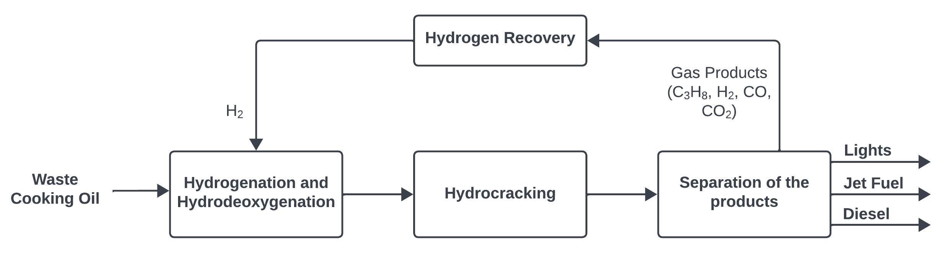
Figure 1: Key steps of Hydrotreatment of WCO.

Biofuel production process

Process Simulation
Process simulations are used to assess the commercial feasibilities of the proposed processes. The Next generation process simulation software, AVEVATM Process Simulation developed by AVEVA, is used in this work.

Component & Thermodynamic selection
The composition of WCO in this paper is based on the work done by (O. Awogbemi, 2020) as shown in Table 1. Triglycerides (Triolein, Trilinolein, and Tripalmitin) and respective FFA (Oleic acid, Linoleic acid, and Palmitic acid) & hydrocarbons are added from DIPPR (Design Institute for Physical Properties) and SIMSCI data bank. The fluid contains hydrocarbons, hydrogen, carbon dioxide and light gases, so Redlich-Kwong-Soave (SRK) and Ideal Gas Law thermodynamic properties are used in this simulation. Missing thermodynamic properties are entered manually in the fluid.

Production process
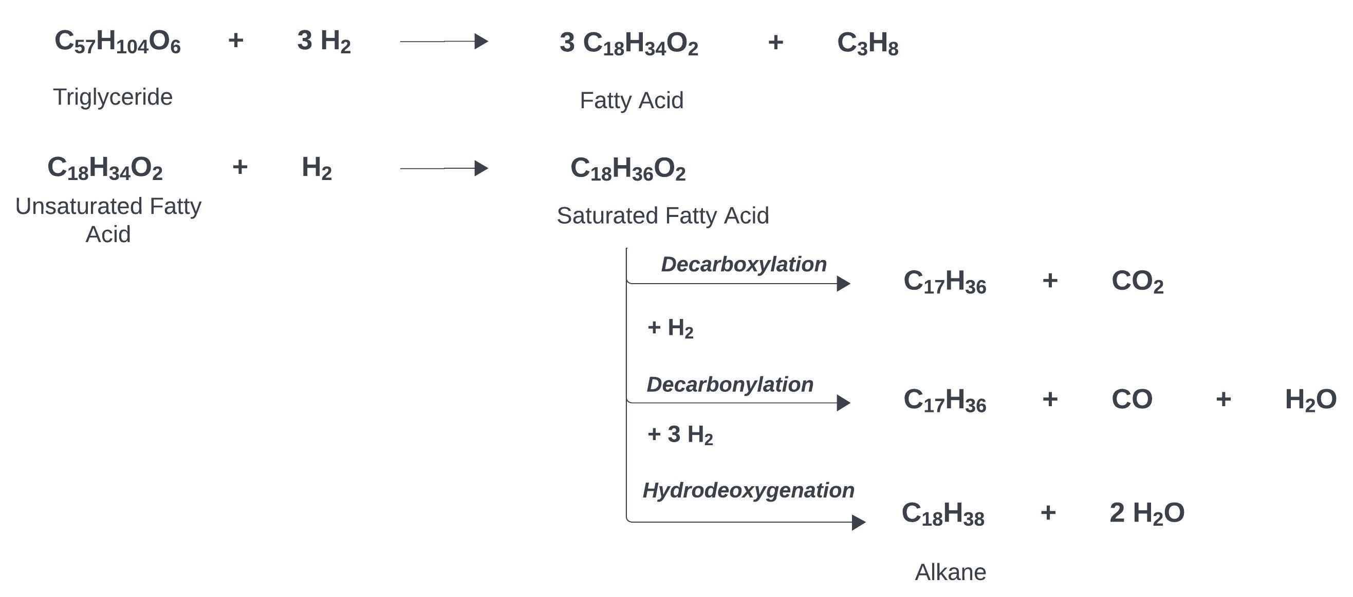
The production process of biofuel from WCO is presented in the Figure 4 based on the work of (Cláudia J.S. Cavalcanti, 2022). The WCO feed is mixed with Hydrogen stream for the Figure 2: Hydrogenation and Hydrodeoxygenation reactions.
Hydrogenation reaction for 100% fractional conversion of triglyceride into saturated fatty acid (SFA) at 400 C and 9.2 MPa in Reactor 1. Except for palmitic acid, Oleic acid and Linoleic acid goes through saturation to form stearic acid. So, the product stream mainly consists of palmitic acid, stearic acid, and propane. Then SFA goes through a series of reactions to produce alkanes, CO₂, CO, and H₂O at 400 C and 9.2 MPa in the presence of NiMo/Al2O3 as catalyst (Bambang Veriansyah, 2012) The Hydrogenation and Hydrodeoxygenation reactions in Reactor 1 and Reactor 2 are shown in the Figure 2.
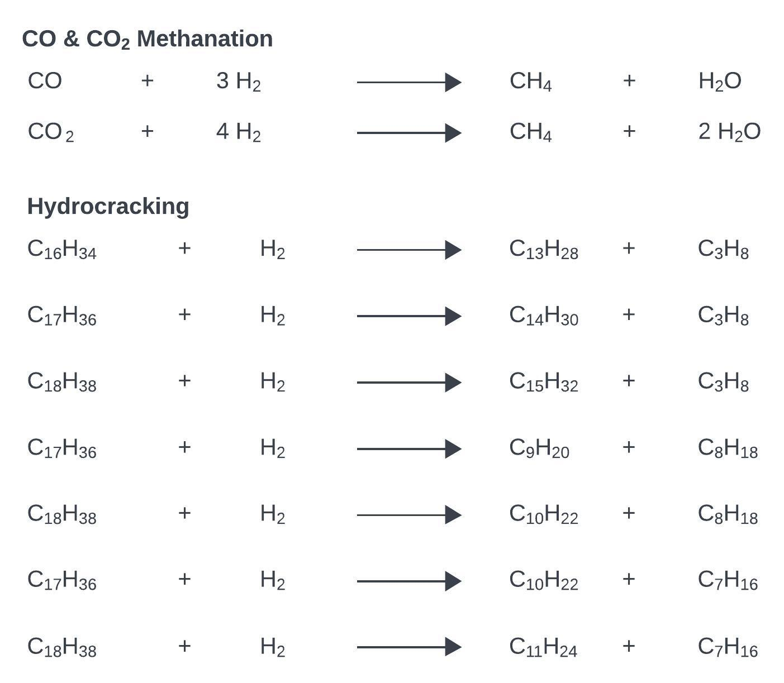
The product stream from Reactor 2 goes through two flash separators to separate alkanes from water, gases and unused H₂. A component separator is used to separate H₂ from water and tail gases. 30% of unused H₂ is recycled back to the H₂ make up tank and the rest of H₂ along with the alkanes is sent to Reactor 3 for Hydrocracking and CO & CO₂ Methanation reactions at 50 C and 3 MPa. Reactions in Reactor 3 are shown in the Figure 3. This reactor is operated with an excess of 10% H₂ to avoid deactivation of the catalyst. Hydrocracking helps with increasing carbon range to C7 – C18. Isomerization can be considered at this step to increase the production of jet fuel compared to the diesel (Bealu, 2017). Conversion reactor is used in the simulation for all three reactions due to the lack of reaction kinetics data in the literature. All three reactions are very specific to the triglycerides present in the feedstock. Figure 3: Hydrocracking reactions. A
The product stream from Reactor 3 is sent to a flash separator to separate heavy phase from H₂, H₂O & light gases like CO, CO_{2,} and Propane. The separated alkanes are sent to a distillation column with 22 theoretical stages, a reflux ratio of 0.9, total condenser, and kettle reboiler. The feed enters at Stage 12 and the column is operated at 1 atm pressure and condenser temperature is specified to be 60 C. Sensitivity analysis was performed to find the optimal reflux ratio and the feed stage to keep the energy consumption low. The vapor product of the column mostly consists of propane, and a small fraction of C7 – C9 (lights), The distillate product of the column consists of hydrocarbons in the range of C7 – C10 (jet fuel) and the bottom product of the column consists of hydrocarbons in the range of C10 – C18 (Diesel). The simulation results of feed and product mass flowrates are shown in Table 2. The ratio of oil to H₂ presented in this study is 0.038, which is considerably less than similar work reported in the literature.
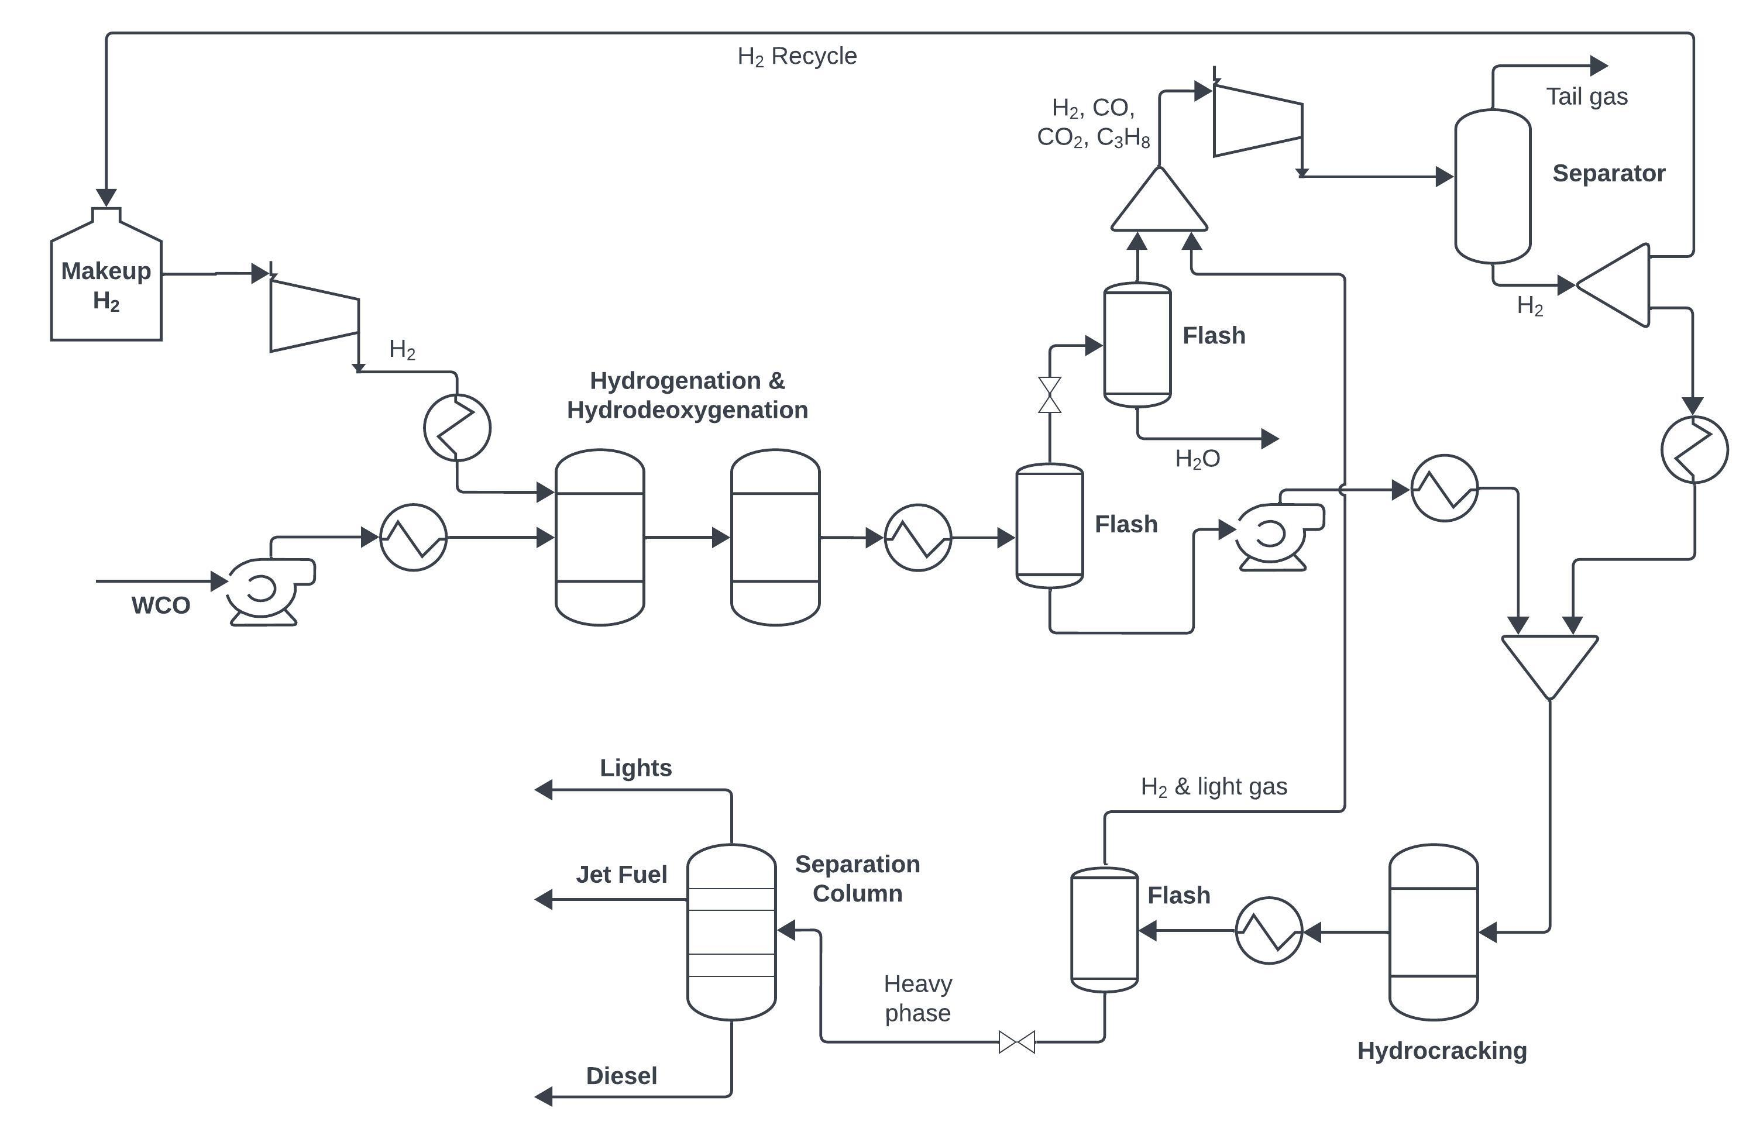
Figure 4: Process flowsheet of the hydrotreatment of WCO.

 |  | Flowrate (kg/hr)
Raw material feed | WCO | 1074
 | Hydrogen | 41
Products | Lights | 51.8
 | Jet Fuel | 128.2
 | Diesel | 710.6
Table 2: Simulation results of feed and product mass flowrates.

Conclusion
The process of Hydrotreatment of waste cooking oil to obtain jet fuel and green diesel was simulated using AVEVA Process Simulation based on the studies reported in the literature. The simulation results show that 710.6 kg/hr of green diesel and 128.2 kg/hr of jet fuel can be produced from 1074 kg/hr of WCO. Green diesel is a second generation of biofuel can be used as an alternate for petroleum diesel and the jet fuel can be used in the aviation gasoline range and the byproduct propane can be used to generate heat within the process. The simulation model shows that waste cooking oil can be used as a viable feedstock to produce quality renewable fuels like green diesel, and jet fuel. This process suggests that waste cooking oil can be converted to a sustainable renewable energy and addresses the serious concerns of food crop being used for biofuel production. The usage of WCO as the feedstock considerably decreases the raw material cost, thereby reducing the operating cost of the production plant.

References
Arjun B. Chhetri, K. C. (2008). Waste Cooking Oil as an Alternate Feedstock for Biodiesel Production. Energies, 3-18.
Bambang Veriansyah, J. Y.-A.-W.-G. (2012,). Production of renewable diesel by hydroprocessing of soybean oil: Effect of catalysts,. Fuel,, 578-585,.
Bealu, Z. (2017). Process Simulation and Optimization of Alternative Liquid Fuels Production. Doctoral thesis.
Catarina I. Santos, C. C. (2018). Integrated 1st and 2nd generation sugarcane bio-refinery for jet fuel production in Brazil: Techno-economic and greenhouse gas emissions assessment. Renewable Energy, 733-747.
Cláudia J.S. Cavalcanti, M. A. (2022). Simulation of the soybean oil hydrotreating process for green diesel production,. Cleaner Chemical Engineering.
Ján Cvengroš, Z. C. (2004). Used frying oils and fats and their utilization in the production of methyl esters of higher fatty acids. Biomass and Bioenergy, 173-181.
Jayaraman, S. K. (2023). Simulation of biodiesel production from algae. Computer Aided Chemical Engineering, 1187-1192.
Jeong-Hun Kim, Y.-R. O.-A.-S. (2021). Valorization of waste-cooking oil into sophorolipids and application of their methyl hydroxyl branched fatty acid derivatives to produce engineering bioplastics. Waste Management, 195-202.
Maria Fernanda Rojas Michaga, S. M. (2022). Bioenergy with carbon capture and storage (BECCS) potential in jet fuel production from forestry residues: A combined Techno-Economic and Life Cycle Assessment approach. Energy Conversion and Management, 115346.
Monika, S. B. (2023). Biodiesel production from waste cooking oil: A comprehensive review on the application of heterogenous catalysts,. Energy Nexus,, 100209.
O. Awogbemi, F. I. (2020). Effect of usage on the fatty acid composition and properties of neat palm oil, waste palm oil, and waste palm oil methyl ester. International Journal of Engineering and Technology, 110-117.
Omojola Awogbemi, D. V. (2021). Advances in biotechnological applications of waste cooking oil. Case Studies in Chemical and Environmental Engineering, 100158.
(n.d.). Sustainable Aviation Fuels. Office of Energy Efficiency & Renewable Energy.
Wan Nur Aifa Wan Azahar, R. P. (2017). Mechanical performance of asphaltic concrete incorporating untreated and treated waste cooking oil. Construction and Building Materials, 653-663.

