A Smooth and Pressure-Driven Rate-Based Model for Batch Distillation in Packed Columns Using Hold-Time Constraints for Bang-Bang Controllers

Torben Talisa*, Erik Eschea, Jens-Uwe Repkea

a Technische Universität Berlin, Process Dynamics and Operations Group, Sekr. KWT-9 Str. des 17.Juni 135, Berlin 10623, Germany

*t.talis@tu-berlin.de

Abstract

Batch processes are traditionally operated based on recipes. To replace the recipes and allow for more flexible operation, accurate process models are required for optimization or application of machine learning algorithms e.g., Reinforcement Learning. For optimal operation of real plants with help of model predictive control, the plant-model mismatch must be as small as possible. Available models for distillation in packed columns are insufficiently detailed for this purpose as they do not properly describe the dynamics and are typically not valid from start-up until shutdown. Therefore, we present a smooth and pressure-driven model of a real batch distillation column with a structured packing. We also show how to implement hold-time constraints for bang-bang controllers in continuously formulated systems.

**Keywords**: pressure-driven, rate-based, batch distillation, hold-time constraints.

* 1. Model

The proposed model describes the whole batch cycle from start-up to shut-down including inertization for the separation of an ethanol-water mixture as an example system. The phase equilibria are relaxed using methods from (Sahlodin et al., 2016), which allows individual phases to appear or disappear. The system structure does not change, when it transitions from vapor-liquid to vapor- or liquid-only. It is resulting in mathematically feasible, but unphysical, compositions for non-existing phases i.e., they do not need to fulfill the summation term. However, this is inconsequential, because these compositions always get multiplied with hold-ups or flowrates, which are obviously *0*, when the phase does not exist.

The vapor streams are modeled pressure-driven, they are calculated from the pressure differences between the stages. The liquid flow is also modeled rigorously, but here the main driving force is gravity. It is assumed to be a uniform film flow along the packing, with the flowrate being a function of gravity, density, viscosity, and packing specific geometric parameters e.g., surface area and void fraction of the packing. To consider wetting of the packing, the liquid flow is only activated, once the holdup surpasses a threshold, the dynamic liquid holdup of the packing. This activation is implemented in Eq. 1 to calculate the actual liquid flow, $F_{st}^{L}$,with the binary variable $σ_{st}^{L}$. Since experimental data for the holdup inside the packing is unavailable for the dynamic case in the open literature. The mentioned threshold is derived from the steady state correlation for total liquid holdup in packed columns at total reflux from (Rocha et al. (1993).

|  |  |
| --- | --- |
| $$F_{st}^{L}= σ_{st}^{L}F_{st}^{L,filmflow}$$ | (1) |

The model uses non-ideal thermodynamics. The activity coefficients are calculated with Wilson’s gE-Model (Wilson, 1964). To circumvent problems arising from unphysical compositions, the property equations are reformulated, when necessary, e.g., for activity coefficents and density. In Eq. (2), this reformulation is exemplarily shown for the activity coefficient. Here $γ_{i}^{gEmodel}$ and $γ_{i}^{actual}$ are the activity coefficients calculated from Wilson’s equation and the one which is actually used in the system, respectively. $γ_{i}^{dummy}$ is in this case 1 and $σ^{Σx}$ is a binary variable, which is 1 if the liquid phase exists and 0 in case it does not.

|  |  |
| --- | --- |
| $$γ_{i}^{actual}= γ_{i}^{dummy}+σ^{Σx}∙(γ_{i}^{gEmodel}-γ_{i}^{dummy})$$ | (2) |

The binary variables inside the model can be expressed by step- or the Kronecker-Delta functions, which are smoothened by sigmoidal or Gaussian functions, respectively. For numerical reasons alternative formulations based on complementarity constraints (Powell et al., 2016) are used in some places.

* 1. Hold-Time Constraints

The presented model is validated against a real-life plant at TU Berlin. The pressure inside the mini-plant column is controlled by a bang-bang controller: A magnet valve, which is either fully opened or closed, whenever the pressure is above or below the setpoint, respectively, what is typical for lab-scale columns. The switching frequency of real valves is limited. However, in a simple model the valve would flutter rapidly. To mimic the real-life behavior, it is suitable to add hold-time constraints in the model, which force the valve to stay at any position for at least a specified period in time.

Adding these hold-time constraints to a manipulated binary variable, such as the position of a valve or activation of a heater, is trivial in a discretized system, see Eq. 3, especially when discretized with constant time steps. Here *uk* is the manipulated variable at timestep *k*, which may only be altered, if at least *Nk* timesteps have passed since the last change. *Nk* depends of the time grid. In equidistant grids this simplifies to a constant *N*.

|  |  |
| --- | --- |
| $$0=(u_{k}-u_{k-1})∙\sum_{n=1}^{N_{k}}{{(u_{k-n-1}-u_{k-n})}^{2}}$$ | (3) |

Whilst discretization is beneficial and commonly used in some cases, e.g., for simultaneous optimization; forward integration of the continuously formulated system can still be advantageous in different scenarios, especially simulation. However, here it is non-trivial to add hold-time constraints.

We propose to superpose the switching condition, which is based on the controlled variable with a decaying signal, which is triggered by an actual switch of the manipulated variable, resulting in an oversaturation of the switching signal. Hence, the switching condition is only considered when the other signal has decayed. A signal flow graph for the exemplary pressure controller is shown in Fig. 1.

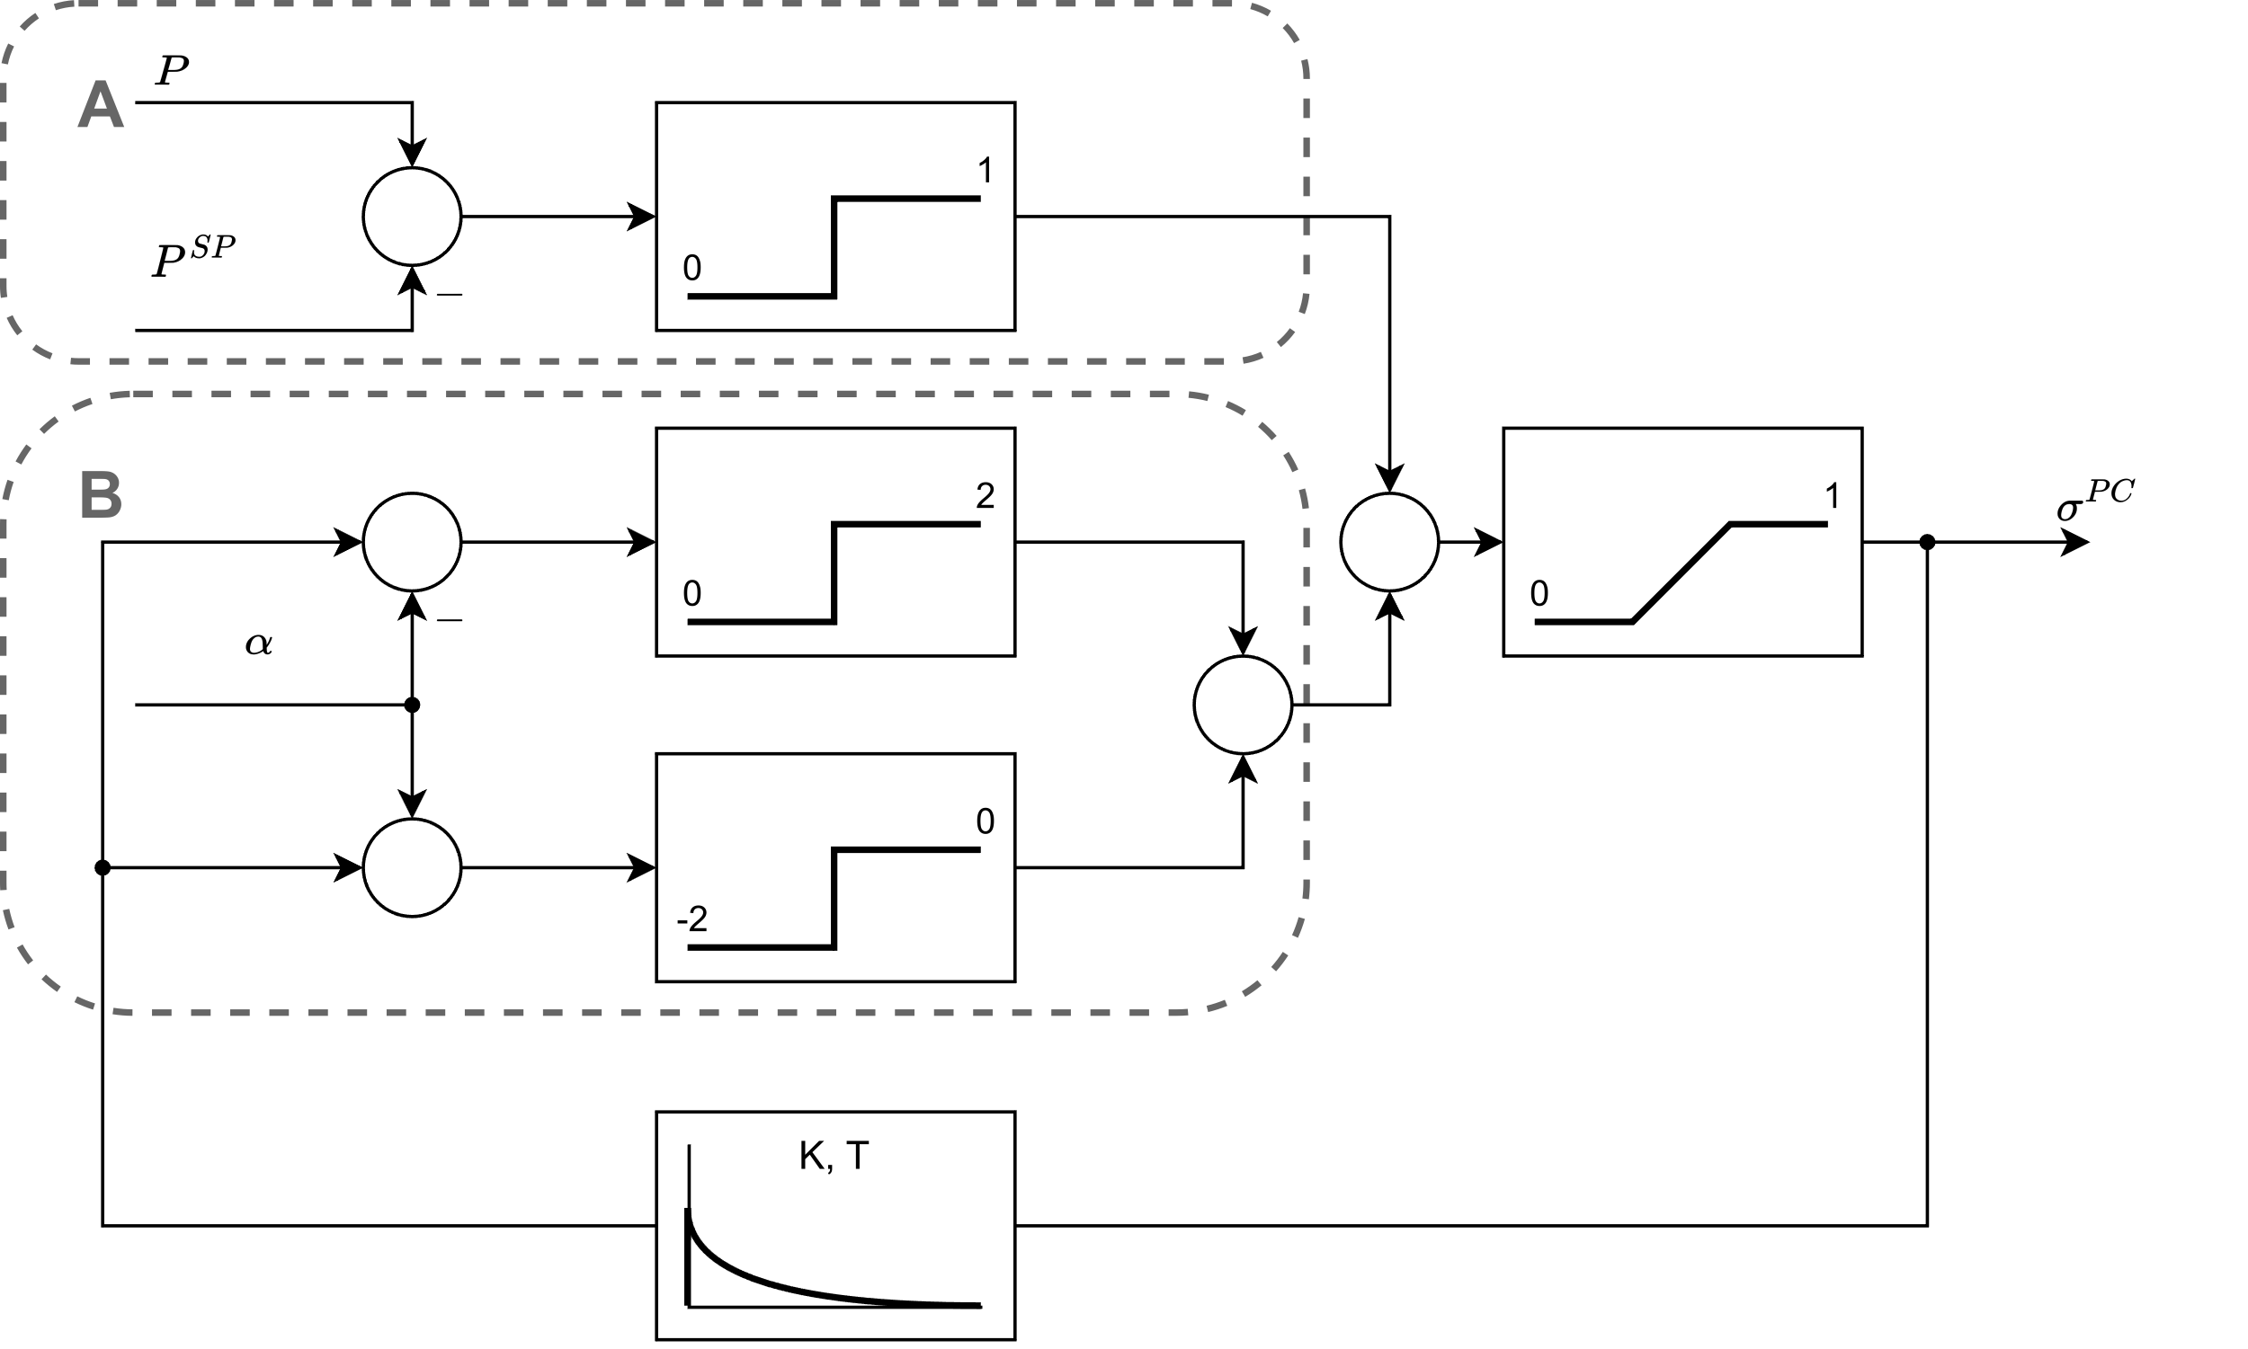

Figure 1: Signal Flow Graph of the proposed pressure controller

The output value of the whole System, $σ^{PC}$, describes the position of the valve. The output of the DT1-Element is a signal that peaks in either direction and then moves back to 0, whenever $σ^{PC}$ switches from 1 to 0 or vice versa. To circumvent the need to differentiate the input signal, the DT1-Element is replaced by a PT1 and a P element in parallel, which show the same behavior.

Section B takes this signal as an input. If it is in the interval [*-α, α*], it returns *0*, else it returns *+2* or *-2* depending on the input sign. This signal is added to the output of section A. The subsystem represents a classical bang-bang controller, which returns *1* or *0*, when the difference to the setpoint is positive or negative, respectively. Finally, the sum of the 2 sections is limited to [*0,1*] and represents the output of the whole system. *α* should be a small value e.g., *0.01* and the parameters for the transfer function can be calculated by Eq. 4, where *t* is the desired hold-time.

|  |  |
| --- | --- |
| $$T=\frac{-t}{\log\left(α\right)}$$ $$K=T$$ | (4) |

The described controller can be implemented as a differential-algebraic-equation system (DAE) and the same smoothing techniques as before can be applied.

* 1. Conclusions

We presented a smooth pressure-driven model of a batch distillation column with structured packing, which can describe the whole batch cycle starting and ending cold and empty, including inertization and phase changes. Furthermore, hold-time constraints were presented for both discretized, as well as continuously formulated systems. The controller was added to the column model and the resulting DAE system was solved with gPROMS®.

* 1. Acknowledgements

This work was funded by Deutsche Forschungsgemeinschaft (DFG, German Research Foundation) – 466380688 – within Priority Programme “SPP 2331: Machine Learning in Chemical Engineering. Knowledge Meets Data: Interpretability, Extrapolation, Reliability, Trust”.

**References**

Powell K., Eaton A., Hedengren J., Edgar T., 2016, A Continuous Formulation for Logical Decisions in Differential Algebraic Systems using Mathematical Programs with Complementarity Constraints, Processes, 4, 7.

Rocha J.A., Bravo J.L., Fair J.R., 1993, Distillation columns containing structured packings: a comprehensive model for their performance. 1. Hydraulic models, Industrial & Engineering Chemistry Research, 32, 641–651.

Sahlodin A.M., Watson H.A.J., Barton P.I., 2016, Nonsmooth model for dynamic simulation of phase changes, AIChE Journal, 62, 3334–3351.

Wilson G.M., 1964, Vapor-Liquid Equilibrium. XI. A New Expression for the Excess Free Energy of Mixing.