Developing a Decision-Support Model for Water and Sanitation Delivery Process in Sub-Saharan Africa: Integrating Environmental Life Cycle Assessment with Economic and Social Models

Brook Tesfamichael,a,b,* Ludovic Montastruc,a Stéphane Negny,a

a Université de Toulouse, INP-ENSIACET, LGC (Laboratoire de Génie Chimique) 4, allée Emile Monso, F-31432 Toulouse Cedex 04, France

b Addis Ababa University, Addis Ababa Institute of Technology, School of Chemical and Bio Engineering, Addis Ababa, Ethiopia

* brook.tesfamichael@aait.edu.com

Abstract

Achieving the Sustainable Development Goals on water and sanitation (SDG 6) is fundamentally important and conditional to realize the other SDGs. However, the achievement of this goal by 2030 is challenging in the Global South, especially in Sub-Saharan Africa (SSA). This is attributed to several challenges, in which weak supply chain network and inappropriate technologies along the water and sanitation supply chain are the major ones. To this end, a decision-support model is developed in this work for selecting the best supply chain network and technologies. After establishing a circular economy-based water and sanitation delivery process and performing an in-depth environmental life cycle assessment (ELCA), a multi-objective optimization model that aims to minimize the ecocost, capital cost and operating cost as well as maximize the job creation of the supply chain is developed.

**Keywords**: Decision-support model, optimization, water and sanitation, Sub-Saharan Africa

* 1. Introduction

Several quantitative-based decision support models have been developed so far for supply chains of different goods and services. Nevertheless, there is a limitation of considering the water and sanitation delivery process simultaneously. Rather, many research either focus on the water supply or sanitation process individually. Despite numerous decision support models were formulated by considering the different local-, national- and regional-level cases, none of them taken into account the water and sanitation sector of Sub-Saharan Africa (SSA), as per the author’s knowledge. It is difficult to directly adapt and utilize the models developed so far for SSA as the region has its own unique features in the water and sanitation sector, which need to be incorporated in model formulation.

The center of an investigation in the previous water or sanitation related models is either of the economic, environmental or social objectives, not three of them together. Furthermore, the techniques of environmental life cycle assessment (ELCA), environmental cost accounting, and social audits have been fairly well developed in the models but separately from each other regardless of the interdependence of the three aspects. Moreover, the previous models are largely oriented toward the selection of appropriate technologies (Ddiba et al., 2023) and overlooked the design of the best supply chain network.

Based on the above research limitations, this study intends to develop an optimization-based decision-support model, which integrates the environmental, economic, and social criteria of the water and sanitation process in SSA. In the proposed research, the ELCA, environmental cost accounting, and social auditing will be combined to develop the model. This novel methodology that integrates the three sustainability dimensions will provide strategic decisions, including selecting the best technology and supply chain network for the water and sanitation delivery process of SSA.

* 1. General structure of the water and sanitation network

The core driver of this study is to deal with the strategic design and planning of water and sanitation delivery process for the SSA region. As a result, a water and sanitation process that takes into account a circular economy approach is developed. The superstructure addressed in this paper is depicted schematically on Figure 1 and the structure is described as follows.

The water supply chain model proposed in this work considers different types of water resources, including rivers, dams, underground water, etc. Then, the raw water from the sources reach to the consumers through two different possibilities. First, it is directly consumed by the consumers without passing through any process, which is the dominant practice in SSA. Second, the raw water goes to a treatment plant with technology *i*. The treatment plant is comprised of one or more technologies, based on the quality of the raw water. The treatment technologies, *i*, considered in this study include preliminary, primary, secondary and tertiary. Once the water is treated and became potable, it is supplied to consumers through a distribution facility with technology *m*. After consuming the water for various purposes, the generated greywater, which is a wastewater from non-toilet plumbing systems such as hand basins, washing, showers and baths, is collected and transferred to sewer wastewater treatment plant.

The sanitation supply chain model proposed in this work considers different types of sanitation technologies *n*, which are broadly classified as improved and unimproved sanitation technologies. The blackwater, which is the waste released from the toilet, is either transferred to sewer wastewater treatment plant with technology *j* or sludge treatment plant with technology *k* depending on the type of sanitation technology used. The greywater and blackwater are treated in the sewer wastewater treatment plant, which has different technologies. Then, the treated water from the sewer treatment plant is either supplied to consumers to utilize for different purposes except drinking, to irrigation uses or discharged to nearby water bodies. On the other hand, the blackwater goes to the sludge treatment plant is treated along with the sludge coming from the water treatment and sewer wastewater treatment plants. To this end, the treated sludge is utilized for composting and anaerobic digestion, whereas the waste liquid generated from the sludge treatment plant is sent to the sewer treatment plant or discharged to the nearby water bodies.

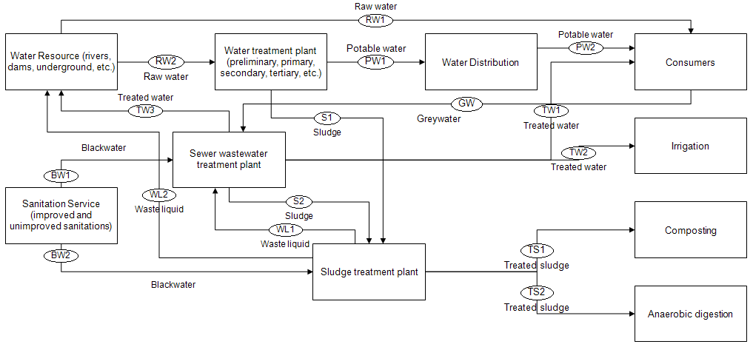

Figure 1: Superstructure of the water and sanitation network

* 1. Model formulation

A deterministic model is selected since the solution of this model gives decision makers good insights for making better choices. First, a mono-objective optimization model, which intends to minimize the total ecocost (a cost associated with the environmental burden of a product/service on the basis of prevention of that burden) of the water and sanitation supply chain, is developed. Then, an economic model that intends to minimize the investment and operation costs of the supply chain is developed and combined to the previous model, which results in an environmental-economic optimization model. Finally, a model that aims to maximize the job creation along the supply chain is combined to the previous model to result in environment-economic-social optimization model. The general approach for the optimization model formulation is depicted in Figure 2.



Figure 2: Model formulation approach

* 1. Case study

The optimization model developed in this study is applied to the water and sanitation sector of Sub-Saharan Africa (SSA) region. The SSA has the lowest global water and sanitation services coverage, in which only 30% and 21% of the region’s population uses safely managed drinking water and sanitation services respectively. On top of that, many SSA countries are predicted to show negative and sluggish progress in water and sanitation coverage by 2030 (Zerbo et al., 2021) against the Paris Agreement and 2030 Agenda for Sustainable Development (SDG6). The sluggish and negative progress is associated with several challenges, in which selection of inappropriate water and sanitation technologies is the major one. In SSA, around 30%-60% of the installed water and sanitation technologies and infrastructures are not properly functioning (Bouabid & Louis, 2015), which makes it a prevalent justification for the failure of the water, sanitation and hygiene (WASH) sector. Beside the failure on the technologies, the inappropriate supply chain network that suits the conditions and needs of the community and the is another challenge for the water and sanitation delivery process in the region..

* 1. Conclusion

After establishing a water and sanitation delivery process that considers a circular economy approach and performing an in-depth ELCA, this work developed an optimization-based decision support model. The multi-objective optimization model considers the three pillars of sustainability, namely environment, economic and social, by incorporating objectives of minimizing ecocost, capital cost and operating cost as well as maximizing the job creation of the entire supply chain. The decision support model developed here addresses the major challenges of SSA water and sanitation sector by providing the best supply chain network and water and sanitation delivery technologies that are customized to the circumstances and desires of the SSA community.

Future work will focus on improving the water and sanitation network superstructure, adding other strategic decisions than technology selection and assess the sensitivity of the optimization results to environmental, technical, economic, social and political factors.

References

Bouabid, A., & Louis, G. E. (2015). Capacity factor analysis for evaluating water and sanitation infrastructure choices for developing communities. *Journal of Environmental Management*, *161*, 335–343. https://doi.org/10.1016/j.jenvman.2015.07.012

Ddiba, D., Andersson, K., Dickin, S., Ekener, E., & Finnveden, G. (2023). A review of how decision support tools address resource recovery in sanitation systems. In *Journal of Environmental Management* (Vol. 342). Academic Press. https://doi.org/10.1016/j.jenvman.2023.118365

Zerbo, A., Castro Delgado, R., & Arcos González, P. (2021). Water sanitation and hygiene in Sub-Saharan Africa: Coverage, risks of diarrheal diseases, and urbanization. *Journal of Biosafety and Biosecurity*, *3*(1), 41–45. https://doi.org/10.1016/j.jobb.2021.03.004