Online Process Monitoring through Integration of Joint Recurrence Plot and Convolutional Neural Networks

Yiran Dong*, Jie Zhang, Chris O’Malley

School of Engineering, Merz Court, Newcastle University, Newcastle upon Tyne NE1 7RU, UK

y.dong15@newcastle.ac.uk

Abstract

This paper proposes a new method for online process fault diagnosis through integration of joint recurrence plot (JRP) and convolutional neural networks (CNN). JRP is used to extract features from the major principal component of the process operational data. The extracted features are used as the inputs to a CNN for fault diagnosis. To facility online fault diagnosis, a sliding window of the major principal components is used in generating JRP. The proposed method is demonstrated on a simulated continuous stirred tank reactor (CSTR). The results show that the proposed method can achieve diagnosis accuracy of 99.49% and 97.12% on the training and testing data sets respectively, higher than those of integrating recurrence plot and CNN.

**Keywords**: process control, fault diagnosis, principal component analysis, joint recurrence plot, convolution neural network.

* 1. Introduction

The enhancement of industrial processes such as efficiency, safety, profitability, stability through the utilization of industrial big data has drawn a lot of attention in the fourth industrial revolution. In this context, fault detection and diagnosis (FDD) play a crucial role. Through the continuous monitoring of the health conditions and offering diagnostic guidance of the operating procedures and machinery, FDD helps to maintain the manufacturing safety of the systems and preventing unwarranted production halts and safety incidents (Ye et al., 2023). Nowadays, many researchers are working on fault diagnosis based on the theory of ‘recurrence’. For instance, Huang et al. (2023) used the combination of recurrence plot (RP) and Bayesian convolutional neural networks to classify the multi-class of electroencephalogram-based motor imagery and real execution. Ziaei-Halimejani et al. (2021) applied joint recurrence quantification analysis and clustering in chemical processes for fault detection and diagnosis with missing data. However, a typical chemical process usually contains a large number of measured process variables and it will be a huge workload if JRP for all these variables are produced.

This paper proposes a process monitoring method through the integration of principal component analysis (PCA), JRP and convolutional neural networks. To overcome the high dimensionality of industrial process data, data dimension reduction through PCA is carried out before generating JRP. The major principal components (PCs) representing the majority of data variation are used for JRP. CNN is then used to classify the extracted features in JRP into normal and various faulty conditions. Sliding windows are used for online process monitoring.

The paper is organized as follows. Section 2 presents the proposed online fault diagnosis method and the employed techniques. Section 3 presents the application results to a simulated continuous stirred tank reactor system. Conclusions are drawn in Section 4.

* 1. Methodologies
     1. Joint Recurrence Plot
        1. Recurrence Plot

RP was proposed by Eckmann et al. (1987) to determine the recurrence of a dynamic system and provide practical information when they do not reach the demand level. It is a binary plot generated from a recurrence matrix. Consider the following *x*(*i*) constructed from the time series data *ui* for a process variable,

|  |  |
| --- | --- |
| $$x(i)=(u_{i }, u_{\left(i+τ\right)}, …,u_{\left(i+\left(d-1\right)τ\right)})$$ | (1) |

where $τ$ is the chosen suitable time delay and $d$ is the embedding dimension. The recurrence matrix can be constructed through Eq(2):

|  |  |
| --- | --- |
|  | (2) |

where $Θ\left(k\right)$ represents the Heaviside function, when *k $≥$*0, $Θ\left(k\right)=1$, when *k $<$*0, $Θ\left(k\right)=0$, $ε$ is the selected threshold parameter, $\left\|∙\right\|$ is the Euclidean distance/norm, *N* is the number of measurement points in the data series *x*(*i*). The RP will then be created through the corresponding recurrence matrix, when $R_{i,j}=1$, a black dot will be displayed, when $R_{i,j}=0$, a white dot will be displayed. Thus, the diagonal line in RP is constantly black and is called the line of identity (LOI) (Marwan et al., 2007) and an RP is symmetrical respecting to the LOI (Eckmann et al., 1987).

* + - 1. Joint Recurrence Plot

Joint recurrence plot (JRP) is an extension of recurrence plot and can examine two or more different time series in one plot. Eq(3) shows the formation of JRP matrix for two different time series $x_{i}$ and :

|  |  |
| --- | --- |
|  | (3) |

In Eq(3), $ε^{x}$ and $ε^{y}$ represent the selected thresholds for the time series *x* and *y* respectively. In JRP, patterns symbolize concepts that are distinct with RP. Unlike RP, the diagonal line in JRP indicates that the similarity of the two time series with their dynamical behaviour happens. The black dots represent the coincidental similarity, and the large region of black dots represent ongoing dynamic similarity. Moreover, the large region of white dots denote divergence in dynamic behaviour, and the recurring patterns represent the dynamic similarity during the specific operational periods (Ziaei-Halimejani et al., 2021).

* + 1. Convolutional Neural Network

Over the past a few decades, artificial neural network (ANN) has been extensively utilized for process fault detection and diagnosis (Kim, 2017). LeCun et al. (1989) first proposed CNN as a proficient deep neural network for learning and classifying images. CNN is an enhanced technology from ANN with additional capabilities and is an efficient tool for image recognition and classification. The visual cortex of the brain can be emulated for processing and recognition of images (Kim, 2017).

* + 1. Process Monitoring through Integrating JRP and CNN

Figure 1 shows the flow chart of the proposed online fault diagnosis method. The collected data sets are reduced in dimension using PCA. Then, sliding windows are created for the retained PCs and JRPs are generated for all the sliding windows and used as the inputs for CNN. Finally, CNN is trained and tested to build the diagnosis model. It is worth noting that CNN training is done off-line, and the diagnosis is done online after CNN has been trained.

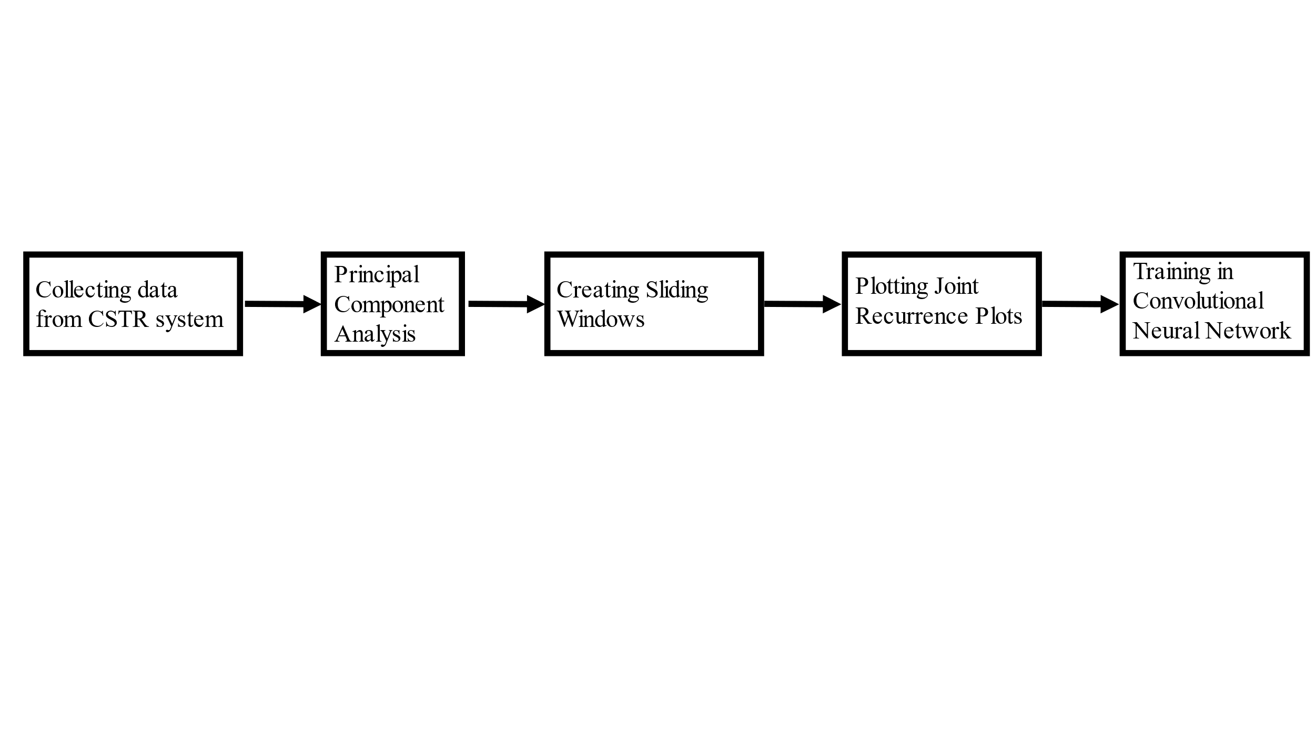Figure 1. Flow chart of the proposed method

* 1. Application to a CSTR System
     1. Experiment Data Collection

This simulated CSTR system shown in Figure 2 is used to generate data under normal and various faults scenarios. An irreversible exothermic reaction converting A to B occurs in the reaction vessel, with cooling provided by circulation of the reactor content through an external heat exchanger. Feedback control systems are employed to regulate the liquid level, temperature, and flow rate of the reactor (Zhang and Roberts, 1991).

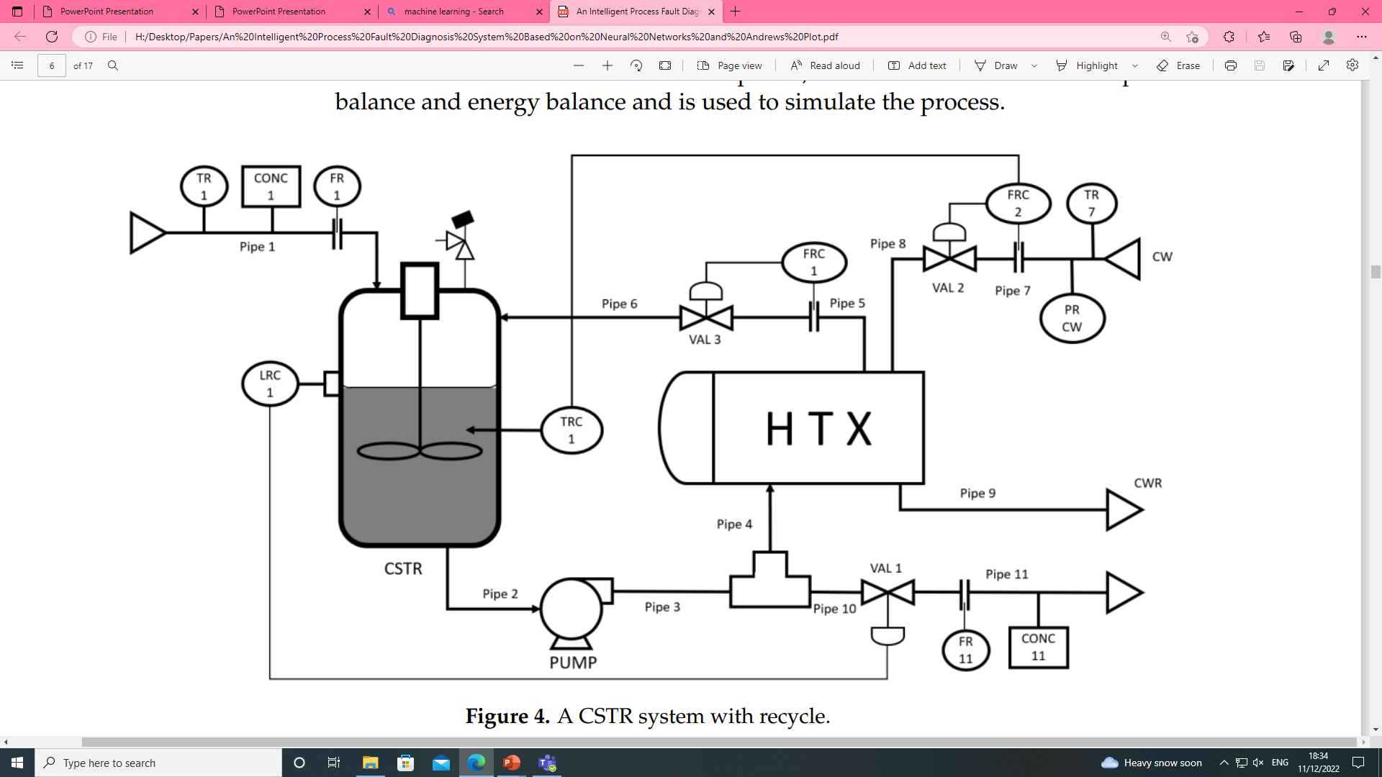

Figure 2. CSTR system (Wang and Zhang, 2021)

The data generated from the simulated CSTR system consist of one set of normal process operation data and 11 sets of different types of faulty process operation data. There are 13 variables including 10 measured process variables and 3 controller outputs. Measurement noises are added to the generated data. Table 1 gives the description of data sets with sample numbers.

* + 1. Data Pre-processing

PCA is applied to the collected normal process operation data set for dimension reduction. All variables are scaled to zero mean and unit variance to mitigate the effects of varying data magnitudes. The mean and standard deviation from the normal process operation data set are also utilized for scaling the faulty data when extracting the PCs. Figure 3 shows that 8 PCs are able to represent 89.9% of data information. Hence, the data dimension of the collected data can be reduced from 13 to 8. A sliding window with 35 samples, determined through experiment, is created for each of the retained PCs as shown in Figure 4.

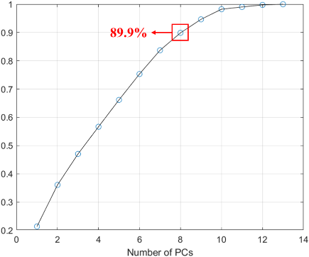

Figure 3. Cumulative data variations explained by PCs

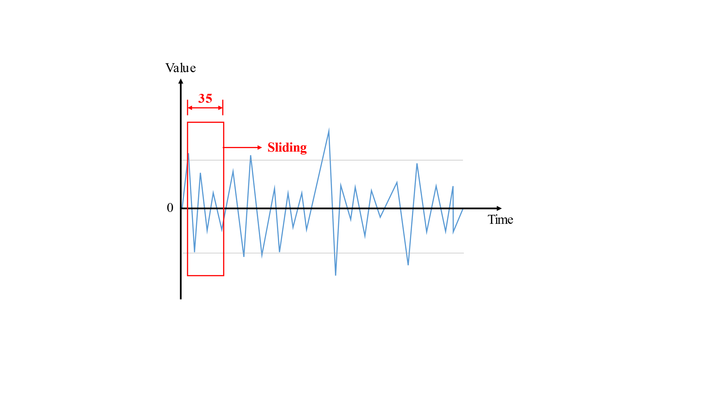

Figure 4. Sliding windows

Table 1. Simulated data sets

|  |  |  |
| --- | --- | --- |
| Data Types | Description | Samples |
| Normal | Process under normal operation (no fault) | 148 |
| Fault 1 | Pipe 1 blockage | 148 |
| Fault 2 | External feed-reactant flow rate too high | 148 |
| Fault 3 | Pipe 2 or 3 is blocked or pump fails | 148 |
| Fault 4 | Pipe 10 or 11 is blocked or control valve 1 fails low | 148 |
| Fault 5 | External feed-reactant temperature abnormal | 148 |
| Fault 6 | Control valve 2 fails high | 148 |
| Fault 7 | Pipe 7, 8, or 9 is blocked or control valve 2 fails low | 148 |
| Fault 8 | Control valve 1 fails high | 148 |
| Fault 9 | Pipe 4, 5, or 6 is blocked or control valve 3 fails low | 148 |
| Fault 10 | Control valve 3 fails too high | 148 |
| Fault 11 | External feed-reactant concentration too low | 148 |

* + 1. Joint Recurrence Plot

A JRP is created for each of the sliding windows of the retained PCs. In the current study, the first two retained PCs (i.e. PC1 and PC2) are used for creating JRP. The parameters for generating joint recurrence matrix are important, so the first step is to define the parameters. With the intention of maintaining the unity of the two time series, they will share the value of embedding dimension *d*, time delay *t*, and the type of norm. The embedding dimension *d* is set to 3 and the time delay *t* is set to 1. In RP and JRP, three types of frequently used norms are L∞-norm (maximum norm or supremum norm), L2-norm (Euclidean norm), and L1-norm (Sankararaman, 2022). All these three norms are evaluated, and the findings indicate that the L∞-norm for each condition deliver the most optimal performance. The threshold parameter for PC1 time series has been set to 0.5 times of the standard deviation of PC1 of the normal process operation data, and the threshold parameter for PC2 time series has been set to 0.5 times of the standard deviation of PC2 of the normal process operation data.

Figure 5 shows the JRPs of the 100th sliding window (i.e., samples from 100 to 134 in both time series) with the situation of normal process operation and faulty process operation under faults 2, 5, and 8. It can be seen that these JRPs are quite different, hence, can be used for fault diagnosis.

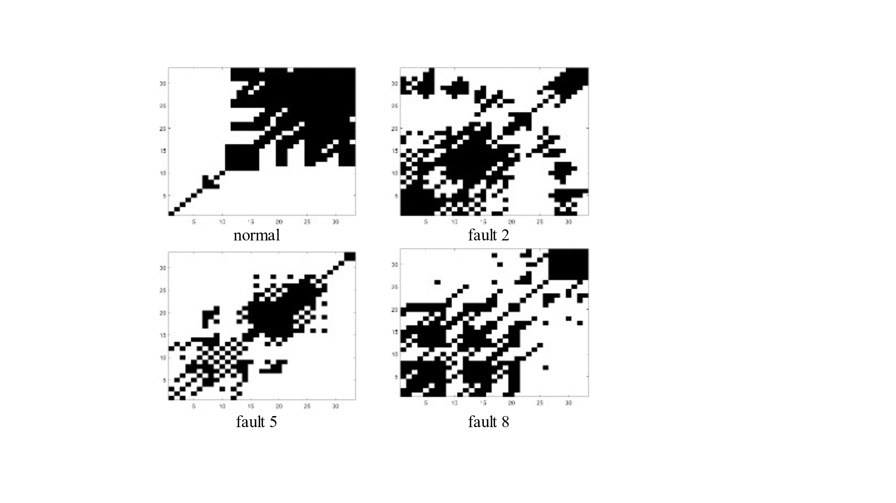

Figure 5. JRPs for the 100th sliding window (samples 100~134) for normal data and data under faults 2, 5, and 8

* + 1. Convolutional Neural Network

Although the JRPs have shown distinct patterns for different process conditions, it is very challenging for a process control personnel to recognize and classify them manually. Here CNN is used to classify the generated JRPs. When building the CNN model, the obtained JRPs from historical process data are split randomly into training data set and testing data set with a ratio of 7:3. In the developed CNN, three convolutional layers have been established. The classification layer has 12 classes representing the normal condition and the 11 faults. The rectified linear unit (ReLU) is used as the activation function in this CNN model. Also, L2 regularization and a dropout layer are added to reduce the problem of overfitting.

Figures 6 and 7 show the CNN training and testing confusion charts of JRP for PC1 and 2, RP for PC1, and RP for PC2. Table 2 shows the comparison of their training and testing accuracy. It can be seen clearly that although the CNN training and testing accuracy for RP with PC1 and PC2 is high, the JRP with both PC1 and PC2 has higher accuracy. This is because JRP contains two times series so it can extract more information.

Table 2. Comparison of RPs and JRPs

|  |  |  |
| --- | --- | --- |
| RP/JRP | Training Accuracy | Testing Accuracy |
| JRP (PC1*PC2) | 99.49% | 97.12% |
| RP (PC1) | 97.36% | 92.41% |
| RP (PC2) | 99.70% | 94.50% |

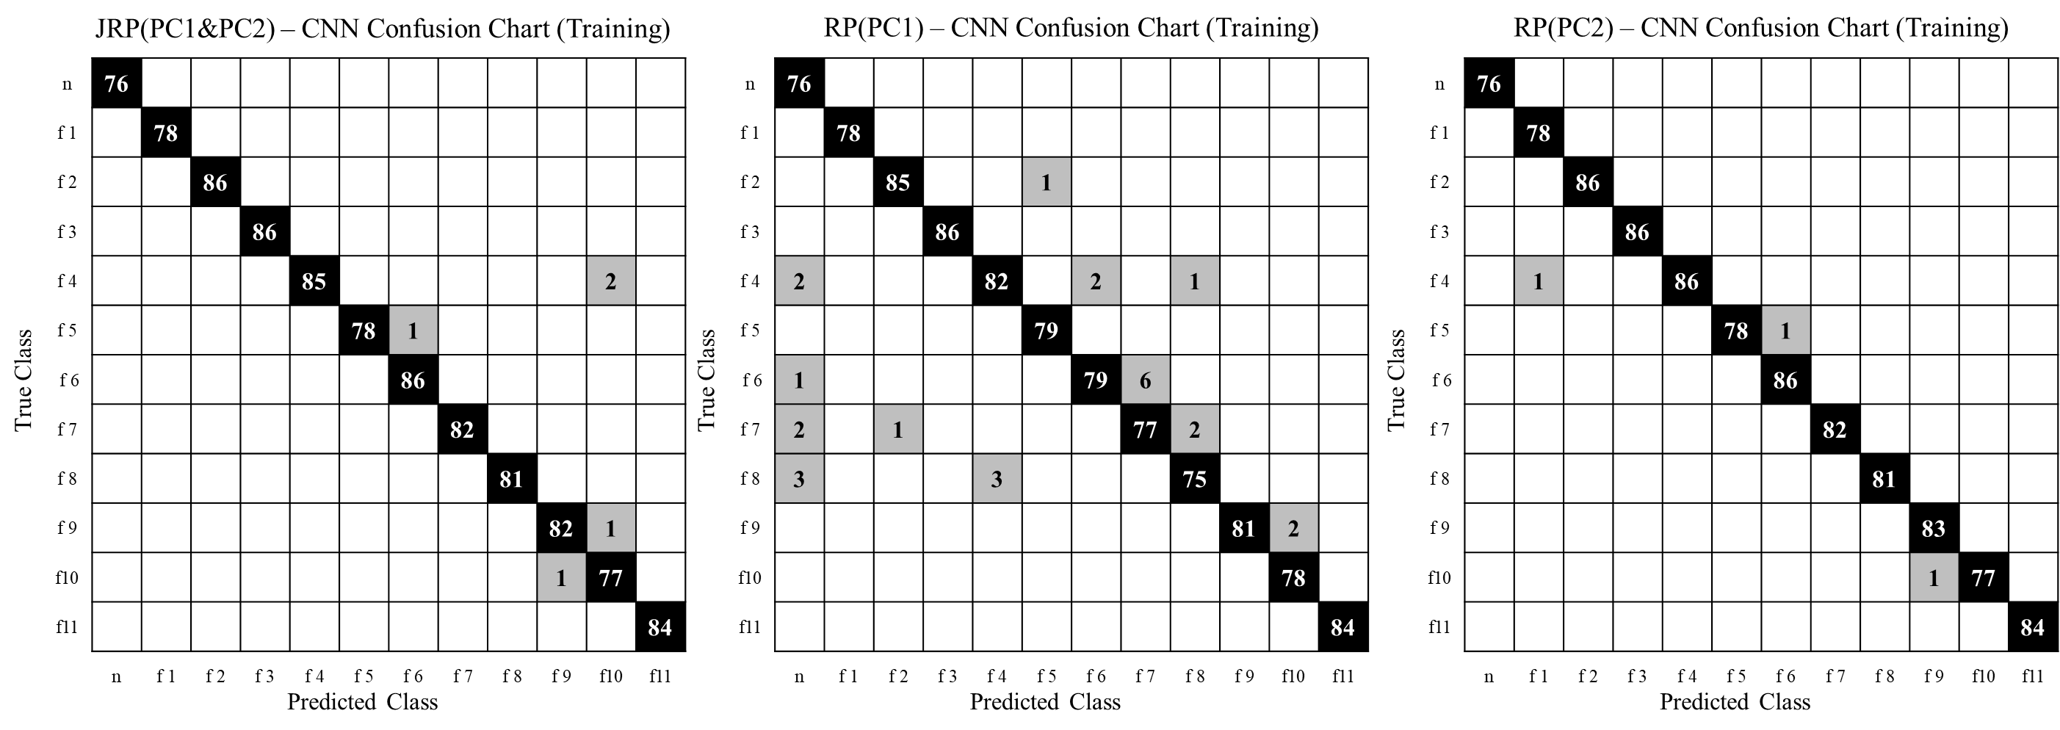

Figure 6. Confusion charts of JRP-CNN and RP-CNN models for training data

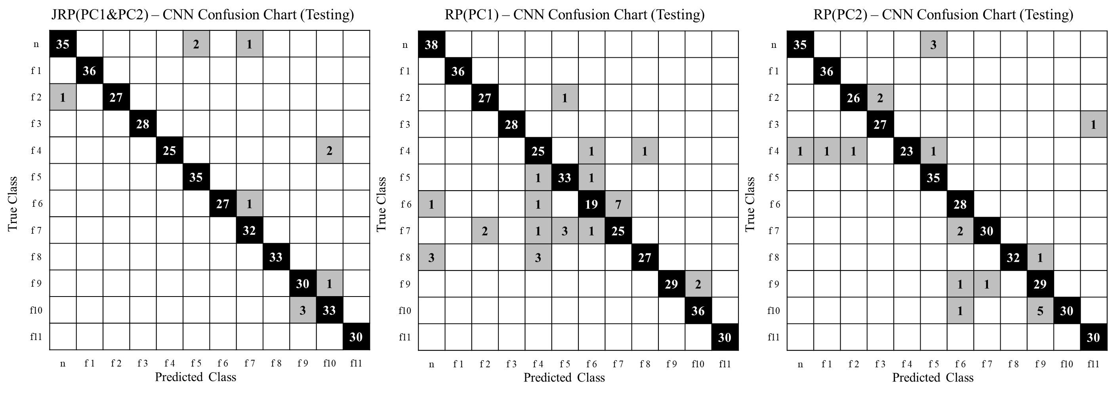

Figure 7. Confusion charts of JRP-CNN and RP-CNN models for testing data

* 1. Conclusion

The proposed online fault diagnosis method through the integration of JRP and CNN has been shown to be effective on a simulated CSTR system. The results show that the integration of JRP with CNN gives better performance than the integration of RP with CNN under the same condition. This is because JRP contains two time series with more information. In the future work, more time series for generating JRP and optimized data pre-processing methods will be explored.

References

J.-P. Eckmann, S.O. Kamphorst, and D. Ruelle, 1987, Recurrence plots of dynamical systems, Europhysics Letters, 4(9), pp. 973-977.

W. Huang, G. Yan, W. Chang, Y. Zhang, and Y. Yuan, 2023, EEG-based classification combining Bayesian convolutional neural networks with recurrence plot for motor movement/imagery, Pattern Recognition, 144, 109838.

P. Kim, 2017, MATLAB Deep Learning: With Machine Learning, Neural Networks and Artificial Intelligence, Apress, New York.

Y. LeCun, L.D. Jackel, B. Boseer, J.S. Denker, H.P. Graf, I. Guyon, D. Henderson, R.E. Howard, and W. Hubbard, 1989, Handwritten digit recognition: applications of neural network chips and automatic learning, IEEE Communications Magazine, 27(11), pp.41-46.

N. Marwan, M.C. Romano, M. Thiel, and J. Kurths, 2007, Recurrence plots for the analysis of complex systems, Physics Reports, 438, pp.237-329.

S. Sankararaman, 2022, Recurrence network and recurrence plot: A novel data analytic approach to molecular dynamics in thermal lensing, Journal of Molecular Liquids, 366(2022), 120353.

S. Wang and J. Zhang, 2021, An intelligent process fault diagnosis system based on neural networks and andrews plot, Process, 9(9), 1659.

L. Ye, H. Wu, Y. Chen, and Z. Fei, 2023, Interpret what a Convolutional Neural Network learns for fault detection and diagnosis in process systems, Journal of Process Control, 131, 103086.

J. Zhang and P. D. Roberts, 1991, Process fault diagnosis with diagnostic rules based on structural decomposition, Journal of Process Control, 1(5), pp.259-269.

H. Ziaei-Halimejani, N. Nazemzadeh, R. Zarghami, K.V. Gernaey, M.P. Andersson, S.S. Mansouri, and N. Mostoufi, 2021, Fault diagnosis of chemical process based on joint recurrence quantification analysis, Computer & Chemical Engineering, 155, 107549.

H. Ziaei-Halimejani, R. Zarghami, and N. Mostoufi, Joint recurrence based root cause analysis of nonlinear multivariate chemical processes, 2021, Journal of Process Control, 103, pp.19-33.