Unveil the Subconscious Optimum: Near-Pareto-Optimal Design Alternatives for Industrial Energy System Transformation

Hendrik Schrickera, Conrad Lukaa, Christiane Reinerta, Dörthe Franzisca Hagedorna, Niklas von der Assena,*

a Institute of Technical Thermodynamics, RWTH Aachen University, Schinkelstraße 8, 52062 Aachen, Germany

[niklas.vonderassen@ltt.rwth-aachen.de](mailto:niklas.vonderassen@ltt.rwth-aachen.de)

Abstract

Industrial decision-makers face challenges in identifying suitable transformations towards low-carbon energy systems due to multiple, often elusive, stakeholder decision criteria. Advanced optimization techniques can support the decision-making process: when facing multiple stakeholder criteria, multi-objective optimization identifies a set of Pareto-optimal alternatives. In addition, exploring near-optimal solutions provides insights into decision flexibilities.

In our work, we combine both approaches to identify near-Pareto-optimal energy system design alternatives. First, we determine Pareto-optimal alternatives using the augmented epsilon-constraint method. Second, we holistically explore the near-Pareto-optimal design space for a chosen Pareto-optimal alternative with the Modeling All Alternatives method, ensuring near-optimality in all objective values. Finally, we cluster representative design alternatives from the set of near-Pareto-optimal design alternatives to reduce decision complexity.

In a case study, we identify 5576 near-Pareto-optimal design alternatives for a multi-energy system to minimize annualized cost, investments, and energy import dependency. Moreover, we reduce the overall decision complexity to four representative designs. Our findings provide industrial decision-makers with a refined toolset for informed energy infrastructure investments amidst competing objectives.

**Keywords**: mixed-integer linear programming, decision support systems, modeling all alternatives, utility systems, decarbonization.

* 1. Introduction: Addressing current challenges in energy system modeling

Planning the transition towards low-carbon energy systems is a multifaceted decision-making challenge. Energy system optimization models can provide guidance for such decisions. Yet, most energy system optimization model formulations are limited to single-objective formulations and thus sideline the heterogeneity of preferences and subconscious preferences in the decision-making processes (DeCarolis et al., 2017). Consequently, relying solely on single-objective optimization often falls short, especially when key objectives and the inherent uncertainties of the model are neglected.

In response to the limitations, recent research trends in energy system modeling have pivoted toward more holistic modeling approaches, e.g., by integrating multiple objective functions, accommodating a range of parameter scenarios, and intensifying the exploration of near-optimal solutions to reveal subconscious preferences, which are not explicitly modeled (Chang et al., 2023). Combining these modeling approaches further increases insights for decision-makers: recent studies addressed parametric uncertainty in multi-objective optimization (Mores et al., 2023) and in near-optimal solution exploration (Grochowicz et al., 2023), and investigated near-optimal solutions in the face of multiple objectives (Dubois et al., 2023).

However, methods for exploring near-optimal solutions often focus on maximally distinct solutions in the near-optimal solution space (Jing et al., 2019) and thus potentially introduce bias towards solutions near the boundaries of the near-optimal solution space. The Modeling All Alternatives (MAA) method proposed by Pedersen et al. (2021) computes a geometric representation of the near-optimal solution space and thus enables complete and unbiased coverage. However, the applicability of MAA is hampered in industrial contexts, as MAA deals with continuous design variables, neglecting that many supply technologies come in specific, discrete capacity steps. Furthermore, MAA has so far only been applied to single-objective optimization problems.

Building upon the MAA method, our prior research introduced a method to sample all discrete alternatives from the continuous, near-optimal design space (Schricker et al., 2023). In this work, we extend our method for multi-objective optimization problems. To the extent of our knowledge, our work is the first MAA-based method, which identifies discrete design alternatives in the face of multiple objectives. Moreover, we apply clustering methods to the near-Pareto-optimal design alternatives to identify representative design alternatives analogously to Prina et al. (2023). Thus, we enable decision-makers to understand the inherent flexibilities in investment decisions.

* 1. Method: Identifying representative, near-Pareto-optimal design alternatives

In this section, we present the general problem statement for identifying representative, near-Pareto-optimal design alternatives in industrial energy systems and describe our methodological approach. The problem statement of our method is as follows: Given

* the existing infrastructure of an industrial energy system,
* a temporally resolved exogenous energy demand,
* a set of technology investment options, each with given discrete capacity expansion steps, and
* a set of $n$ objective functions $z=(z_{j})$, where $j=1…n$,

the task is to identify a set of representative energy system design alternatives, which are near-Pareto-optimal, i.e., representative alternatives, which are proximate to the Pareto-optimal design preferred by decision-makers. We consider the design of potential energy conversion and storage units by the discrete capacity expansion $d∈D$ and the operation of existing and newly installed units $o∈O$ as decision variables.

In the first step of our method, we identify Pareto-optimal design alternatives by solving the multi-objective optimization problem. We then select one Pareto-optimal alternative and explore all near-Pareto-optimal design alternatives close to the chosen alternative (cf. Section 2.1). In the second step, we identify representative design alternatives to reduce the decision complexity (cf. Section 2.2). Our method equips decision-makers with a representative selection of near-Pareto-optimal design alternatives and thus enables informed investment decisions.

* + 1. Step 1: Exploration of discrete, near-Pareto-optimal design alternatives

To derive Pareto-optimal design alternatives, we employ a multi-objective mixed-integer linear program with the objective $\min_{d∈D,o∈O}{z(d,o)}$. We solve the multi-objective problem with the augmented epsilon-constraint method by Mavrotas (2009).

Next, to span the near-Pareto-optimal design space, we choose the best compromise solution according to the min-max-criterion (Li and Zio, 2018) by default. However, our method can be applied with any Pareto-optimal alternative $i$. We define the near-Pareto-optimal design space $W_{ε}^{P}(i)$ with respect to the Pareto-optimal alternative $i$ with its objective function values :

|  |  |
| --- | --- |
| . | (1) |

Here, the parameter $ε=\left(ε_{j}\right), j=1…n$, represents the allowed relative slack for the objective function $j$. Thus, near-optimality is guaranteed for all objective   
functions $j=1…n$.

Our method then follows the Modeling All Alternatives method considering discrete capacity steps by Schricker et al. (2023). First, we relax the discrete character of the design variables and iteratively span the continuous, near-Pareto-optimal design space. We systematically explore new search directions $n$ to obtain vertices $v$ of the near-Pareto-optimal design space by solving $v=\max_{d∈W_{ε}^{P}}{n^{T}d}$. Subsequently, we reintroduce the discrete capacity expansion steps. We employ the recursive polytope discretization algorithm introduced by Schricker et al. (2023) to identify all discrete, near-Pareto-optimal design alternatives $d_{k}∈W_{ε}^{P}(i)$, where $k=1…m$ within the convex hull defined by the vertices .

* + 1. Step 2: Reduction to representative design alternatives

As a result of Step 1, the number of identified discrete, near-Pareto-optimal design alternatives can be large. To reduce decision complexity, we determine representative near-Pareto-optimal design alternatives from the set of near-Pareto-optimal design alternatives $W_{ε}^{P}$. For this purpose, we use the FasterPAM implementation of the k-medoids algorithm by Schubert and Lenssen (2022) and segment the design alternatives into $k$ distinct clusters. For each cluster, we identify the medoid as the representative design alternative. Thus, we ensure that only feasible design alternatives are selected as cluster representatives. We measure the validity of clustering structures by the overall average silhouette width (Rousseeuw, 1987)​. We then choose the most suitable number of clusters $k$ according to the elbow criterion (Syakur et al., 2018). Our method provides decision-makers with manageable sets of design alternatives, which are representative of the complete near-Pareto-optimal design space. Thus, we significantly reduce the decision-making complexity in energy system expansion problems.

* 1. Case study: Decision support for a multi-energy system expansion

We apply our methodology to examine near-Pareto-optimal energy system design alternatives for a case study from Reinert et al. (2023), based on a real-world system (cf. Figure 1). The installed capacities of the existing energy system are taken from Kämper et al. (2021) and marked in blue, whereas all other shown capacities can be built during capacity expansion. We consider annualized cost, investments, and energy import dependency as objective functions. The energy import dependency is defined as the total amount of purchased energy. The multi-energy system is designed to serve temporally resolved electricity ($P_{el}$), heating (${\dot{Q}}_{heat}$), and cooling (${\dot{Q}}_{cool}$) demands. Natural gas and electricity are available for purchase from the grid with temporally resolved prices. The price for CO2 certificates for direct emissions remains constant. The existing energy system predominantly relies on fossil fuels. We evaluate photovoltaic systems, wind turbines, electrode boilers, high-temperature heat pumps, organic Rankine cycles, and storage technologies as technology investment options for the energy system expansion. Each of these technologies is modeled using techno-economic data, e.g., specific investment costs and technical efficiencies, as well as data on operational CO2-emissions. We assume specific capacity expansion steps and a maximum installable capacity for each technology.

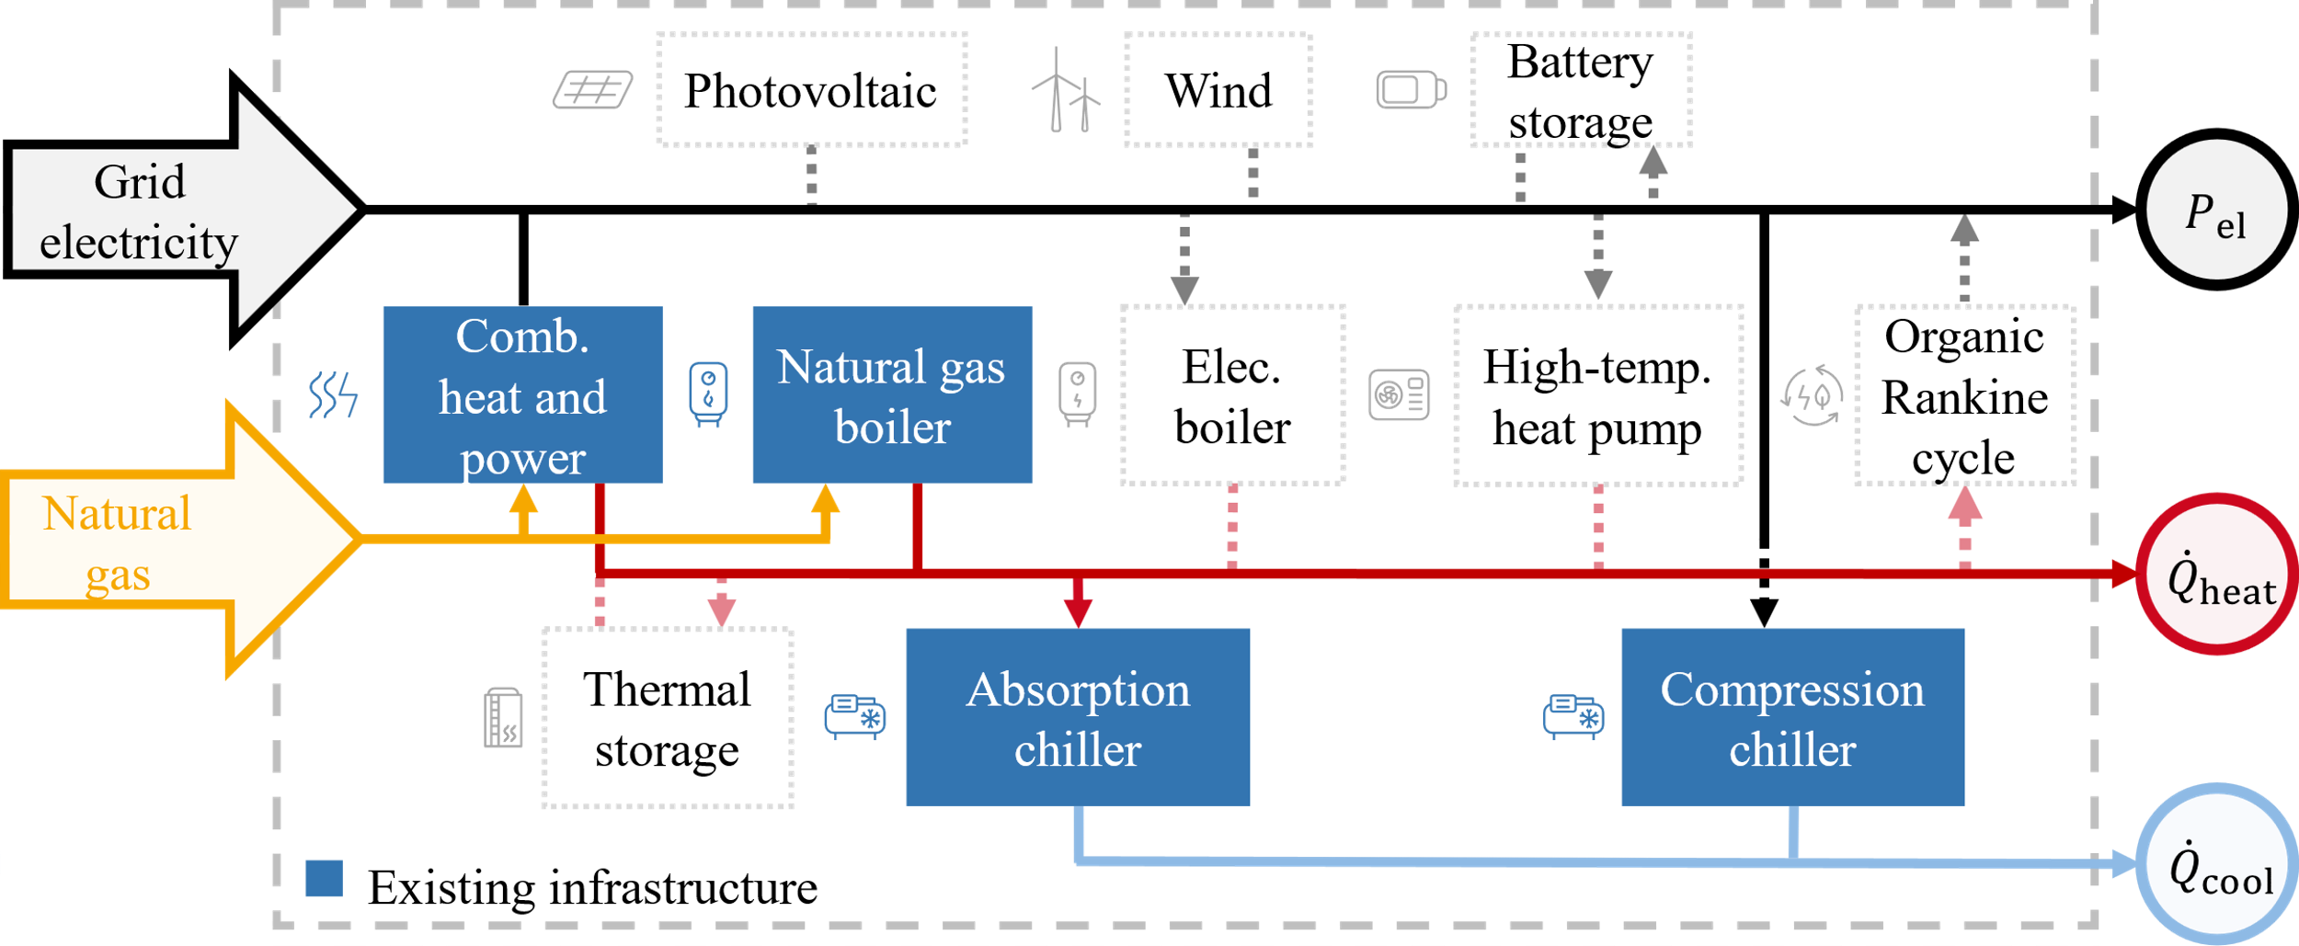

**Figure 1.** Superstructure of the multi-energy system case study taken from Reinert et al. (2023). The existing infrastructure is highlighted in blue.

We integrate our method into the energy system optimization framework SecMOD (Reinert et al., 2022). When exploring the Pareto- and near-Pareto-optimal design alternatives, we optimize one year of operation, aggregated into eight typical days with hourly resolution, resulting in 192 time steps. We assume a maximum storage period of 24 hours for the battery and the thermal storage unit. We set a relative objective slack of $ε_{j=1…3}=5 \%$ for all three objective functions compared to the best compromise solution. Furthermore, we scale the design decision variables with the specific investment costs before clustering to obtain representative design alternatives in terms of investment allocation.

In total, we identify 5576 near-Pareto-optimal design alternatives. The resulting capacity distributions (cf. Figure 2) reveal ranges of investment flexibility in terms of installable capacity for decision-makers. Specifically, we observe the largest flexibility in the design of the thermal storage unit, the electrode boiler, and the photovoltaic system.

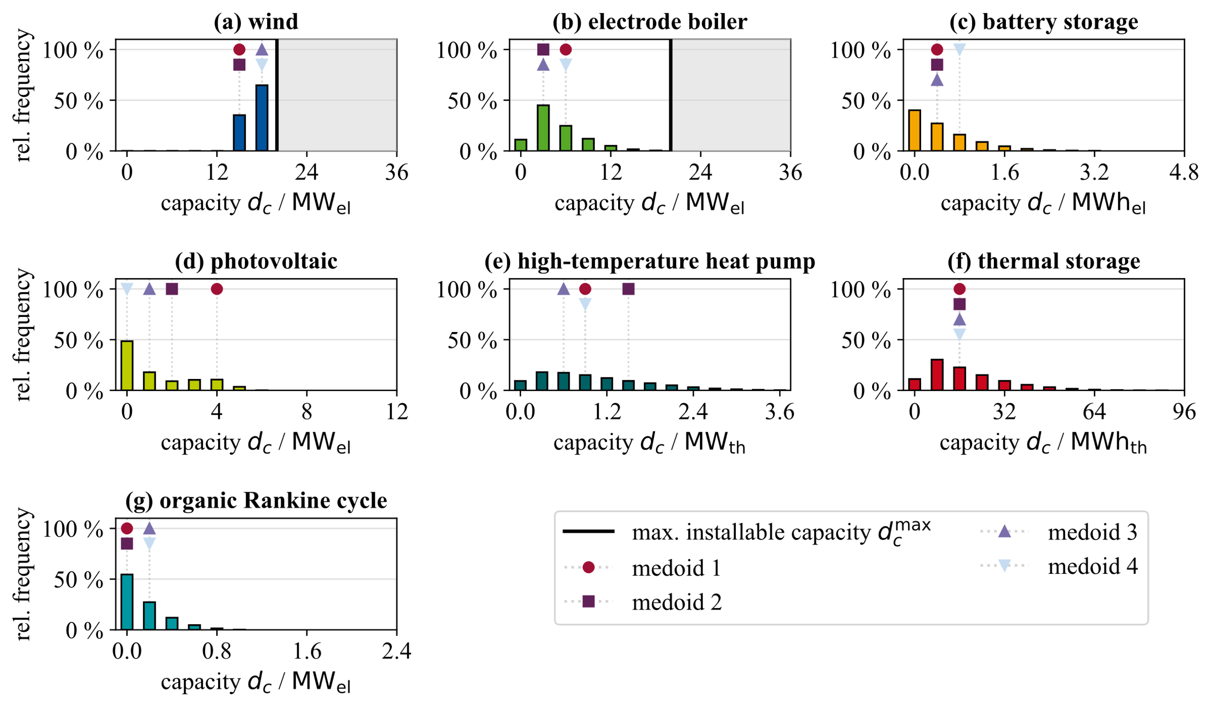

**Figure 2.** Capacity distributions for all technologies across the 5576 identified near-Pareto-optimal design alternatives. We highlight the capacities of the four representative design alternatives (the cluster medoids) and the maximum installable capacity if it lies in the range of the capacity axis.

The thermal storage unit enables electricity-driven operation of the existing combined heat and power plants. Electrifying the heat supply via electrode boilers or heat pumps is crucial for reducing natural gas imports. The installation of wind turbines with a capacity of at least 15 MWel is a must-have decision for near-Pareto-optimality because wind turbines are crucial for reducing electricity imports. Collectively, the near-Pareto-optimal design alternatives facilitate the integration of renewable electricity sources and enable flexible system operation according to current energy carrier prices compared to the existing system.

We choose a clustering structure with four representative design alternatives according to the overall average silhouette width and the elbow criterion (cf. Section 2.2). The identified representative design alternatives show trade-offs in the renewable electricity source (wind turbine vs. photovoltaic system) and in the allocation of investments for the electrode boiler, high-temperature heat pump, and the organic Rankine cycle.

* 1. Conclusions

Acknowledging the intricacies and multifaceted challenges during the design optimization of energy systems, we introduce an extended version of the Modeling All Alternatives method incorporating multiple objective functions for industrial energy systems. First, we solve the underlying multi-objective design optimization problem to identify Pareto-optimal design alternatives using the augmented epsilon-constraint method. We then systematically explore the near-Pareto optimal design space around the Pareto-optimal alternative preferred by decision-makers and sample all contained design alternatives taking into account the discrete character of design decisions for industrial systems. Finally, we incorporate the k-medoids algorithm to reduce the decision complexity emerging from the potentially large amount of identified design alternatives. Our work combines multi-objective optimization with the exploration of near-optimal solutions to simultaneously increase insights from energy system models beyond single-objective considerations and beyond optimal solutions. We streamline the decision-making process to reduce decision complexity and to support informed decision-making in industrial energy system transformations.

Acknowledgments

This study is funded by the Ministry of Economics, Industry, Climate Protection and Energy of North-Rhine Westphalia (EFO 0133E). Simulations were performed with computing resources granted by RWTH Aachen University under project ID 1493.

References

Chang, M., Lund, H., Thellufsen, J.Z., Østergaard, P.A., 2023. Perspectives on purpose-driven coupling of energy system models. Energy 265, 126335.

DeCarolis, J., Daly, H., Dodds, P., Keppo, I., Li, F., McDowall, W., Pye, S., Strachan, N., Trutnevyte, E., Usher, W., Winning, M., Yeh, S., Zeyringer, M., 2017. Formalizing best practice for energy system optimization modelling. Applied Energy 194, 184–198.

Dubois, A., Dumas, J., Thiran, P., Limpens, G., Ernst, D., 2023. Multi-objective near-optimal necessary conditions for multi-sectoral planning. Applied Energy 350, 121789.

Grochowicz, A., van Greevenbroek, K., Benth, F.E., Zeyringer, M., 2023. Intersecting near-optimal spaces: European power systems with more resilience to weather variability. Energy Economics 118, 106496.

Jing, R., Kuriyan, K., Kong, Q., Zhang, Z., Shah, N., Li, N., Zhao, Y., 2019. Exploring the impact space of different technologies using a portfolio constraint based approach for multi-objective optimization of integrated urban energy systems. Renewable and Sustainable Energy Reviews 113, 109249.

Kämper, A., Leenders, L., Bahl, B., Bardow, A., 2021. AutoMoG: Automated data-driven Model Generation of multi-energy systems using piecewise-linear regression. Computers & Chemical Engineering 145, 107162.

Li, Y.-F., Zio, E., 2018. Rams Optimization Principles, in: Möller, N., Hansson, S.O., Holmberg, J.-E. (Eds.), Handbook of safety principles. Wiley, Hoboken, NJ, USA, pp. 514–539.

Mavrotas, G., 2009. Effective implementation of the ε-constraint method in Multi-Objective Mathematical Programming problems. Applied Mathematics and Computation 213 (2), 455–465.

Mores, W., Nimmegeers, P., Hashem, I., Bhonsale, S.S., van Impe, J.F., 2023. Multi-objective optimization under parametric uncertainty: A Pareto ellipsoids-based algorithm. Computers & Chemical Engineering 169, 108099.

Pedersen, T.T., Victoria, M., Rasmussen, M.G., Andresen, G.B., 2021. Modeling all alternative solutions for highly renewable energy systems. Energy 234, 121294.

Prina, M.G., Johannsen, R.M., Sparber, W., Østergaard, P.A., 2023. Evaluating near-optimal scenarios with EnergyPLAN to support policy makers. Smart Energy 10, 100100.

Reinert, C., Nolzen, N., Frohmann, J., Tillmanns, D., Bardow, A., 2023. Design of low-carbon multi-energy systems in the SecMOD framework by combining MILP optimization and life-cycle assessment. Computers & Chemical Engineering 172, 108176.

Reinert, C., Schellhas, L., Mannhardt, J., Shu, D.Y., Kämper, A., Baumgärtner, N., Deutz, S., Bardow, A., 2022. SecMOD: An Open-Source Modular Framework Combining Multi-Sector System Optimization and Life-Cycle Assessment. Front. Energy Res. 10, 884525.

Rousseeuw, P.J., 1987. Silhouettes: A graphical aid to the interpretation and validation of cluster analysis. Journal of Computational and Applied Mathematics 20, 53–65.

Schricker, H., Schuler, B., Reinert, C., v.d.Aßen, N., 2023. Gotta catch ‘em all: Modeling All Discrete Alternatives for Industrial Energy System Transitions. URL: <<https://doi.org/10.48550/arXiv.2307.10687>>.

Schubert, E., Lenssen, L., 2022. Fast k-medoids Clustering in Rust and Python. JOSS 7 (75), 4183.

Syakur, M.A., Khotimah, B.K., Rochman, E.M.S., Satoto, B.D., 2018. Integration K-Means Clustering Method and Elbow Method For Identification of The Best Customer Profile Cluster. IOP Conf. Ser.: Mater. Sci. Eng. 336 (1), 12017.