Implementing a Model Library for Wastewater Treatment Plants in an Equation-Oriented Simulator: Numerics and Architecture
Jochen Steimel^{a,*} , Sahand Iman Shayan^{b}
ªAVEVA, Mainzer Landstraße 178-190, 60327 Frankfurt, Germany
^{b}AVEVA, 920 Memorial City Way, Suite 1200, Houston, TX 77024, USA
jochen.steimel@aveva.com
Abstract
This contribution discusses the lessons we have learned during the development of a library of models for municipal wastewater treatment plants in AVEVA Process Simulation, an equation-oriented next-generation process simulator, capable of both steady-state and dynamic simulation.
While available models in the literature for activated sludge processes and anaerobic digestion commonly used in wastewater treatment plants are structurally straight-forward, they exhibit characteristics that make solving them reliably a challenge. Especially the existence of multiple steady states can be hard to overcome for an equation-solving system.
Two approaches have been identified as helpful in determining a valid and desired steady-state operating point for these kinds of processes.
- Repeated solution of embedded steady-state problems (or homotopy continuation) from a known operating point to the actual operating point.
- Seamless switching to dynamic simulation mode, using the integrator to drive the system closer to the good steady state, and then directly solving the equations to the desired operating point.
This article will discuss the challenges in solving these models, give concrete examples generated with the software AVEVA Process Simulation, and provide recommendations to handle these problems in general.
Keywords: Wastewater Treatment, Simulation, Numerical Methods, Modeling
  - Introduction
Municipal wastewater treatment plants have been the subject of modeling for a long time. In the last 30 years, efforts have been made to standardize the nomenclature and model formulations by publishing reference models such as for activated sludge (ASM1, ASM2, ASM3, Henze 2000) or anaerobic digestion (ADM1, Batstone 2002) through the International Water Association. If possible, these models are expressed as explicit ordinary differential equations, and algebraic loops are avoided. One example is the ADM1 model (Batstone 2002), for which 2 formulations are provided, one as an ordinary differential equation system and one as a differential algebraic equation system.
Implementers can use these models with suitable equipment models (such as continuously stirred tank reactors) to describe entire treatment plants. The models describe the mass and energy balance of the treatment plant and can be used for answering design and operability questions.
Many of the reaction models exhibit aspects that might provide a challenge for solving these models:
- Multiple solutions: Many of the reaction rate expression are proportional to both the concentration of a substrate and of a biomass species that catalyses the reaction. For reactions of these kind, two solutions are mathematically valid, the desired productive state and the wash-out state. When calculating a steady-state solution from an arbitrary initial point, equation-based solvers can get stuck in the trivial solution.
- Very slow reactions and fast hydraulics: Many reactions involved in biological treatment are very slow and take place over several days (or even weeks). In contrast, the hydraulic residence time is smaller (often in the range of minutes to hours), so the integration time step needs to be fine enough to correctly model the mass flows and accumulation terms, but also be fast enough to simulate the entire duration.
- High demand for customizability: Even though considerable research went into the development of the ASM type models, practitioners still must tune and calibrate a model to their plant. This often involves tuning stoichiometric factors and rate-expressions or adding new conversion processes for species (i.e., adding completely new reactions).
Any simulation environment for wastewater treatment plants should be aware of these challenges and take measures to address them, so that the resulting plant simulation models provide results quickly, reliably, and correctly. In the following we will discuss the measures taken in the development of the Wastewater library for AVEVA Process Simulation to address the challenges discussed above.
  - Open-equation modeling for extending activated sludge models
It appears that two major approaches for modeling wastewater treatment plants are used in the literature. On the one hand, academic research often focuses on modeling and simulation, and uses programming languages like MATLAB or Python, to directly encode the differential equations. For example, the benchmark simulation models library WWT (Gernaey 2014) is implemented in C and used as an external function in MATLAB.
On the other hand, industry-focused contributions are often implemented in commercial, special purpose simulation programs. These tools are often graphical, flowsheet-based, interactive and implement the reaction models natively in their source-code. These tools offer extensibility via Petersen/Gujer matrix editors which allow users to modify the stoichiometric coefficients and rate-expressions of the involved processes. While this approach offers a considerable amount of flexibility, users are still confined to the limitations of the matrix formalism and often do not have access to the actual equations as they would have in for example a MATLAB-based implementation.
In AVEVA Process Simulation, every model is represented in a tabular modeling language, that allows the user to see and modify each variable, parameter, and equation. The entire Wastewater library is visible to the user, and it is easy to copy and modify a library model to represent a specific process or phenomenon. A screenshot of the model editor showing some variables and equations of the ASM3 model are shown in Fig. 1.
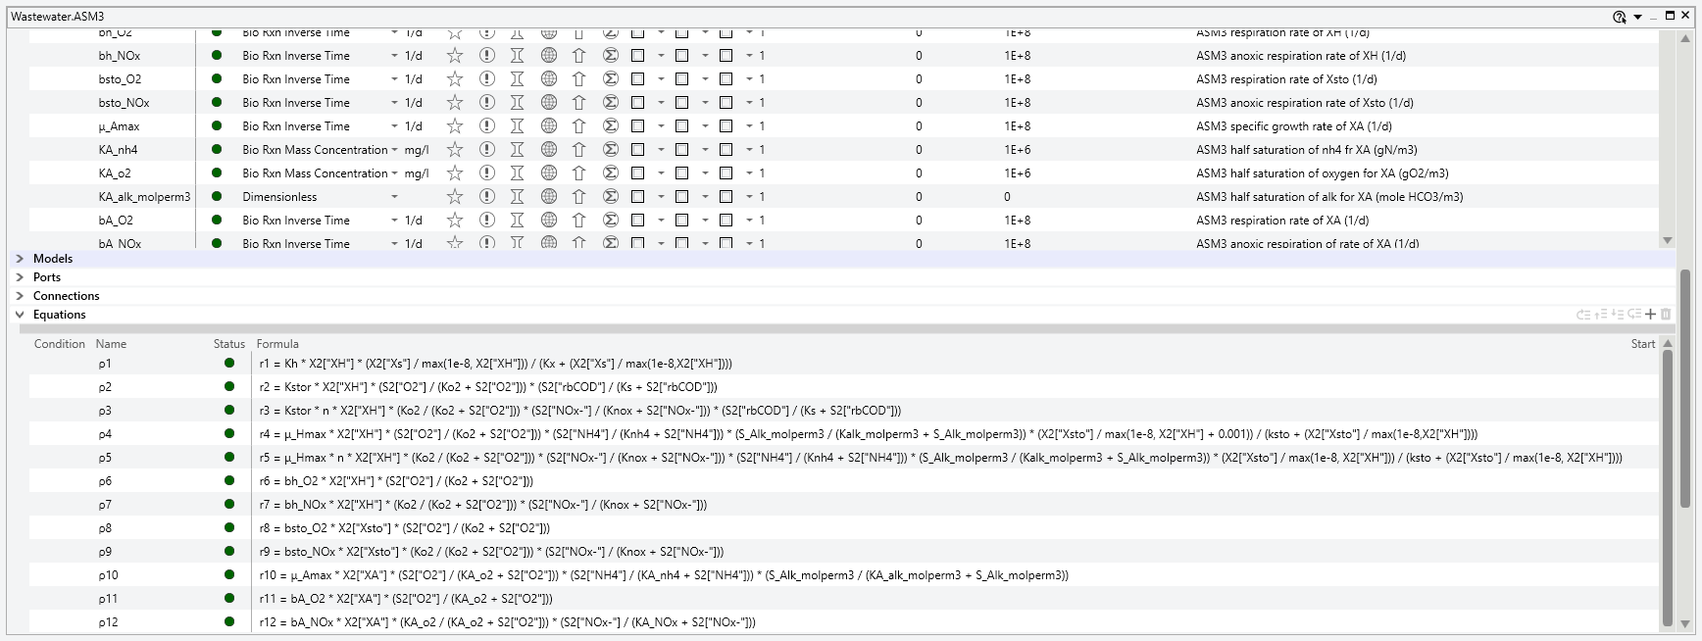
Figure 1: Selected variables and equations of the ASM3 model
Later, a simulation builder can put these models onto a flowsheet and assemble larger simulations representing entire plants from the building blocks. An example of such a flowsheet can be seen in Fig. 2. AVEVA Process Simulation combines the expressivity of modeling languages and the ease of assembling larger system of flowsheeting tools.
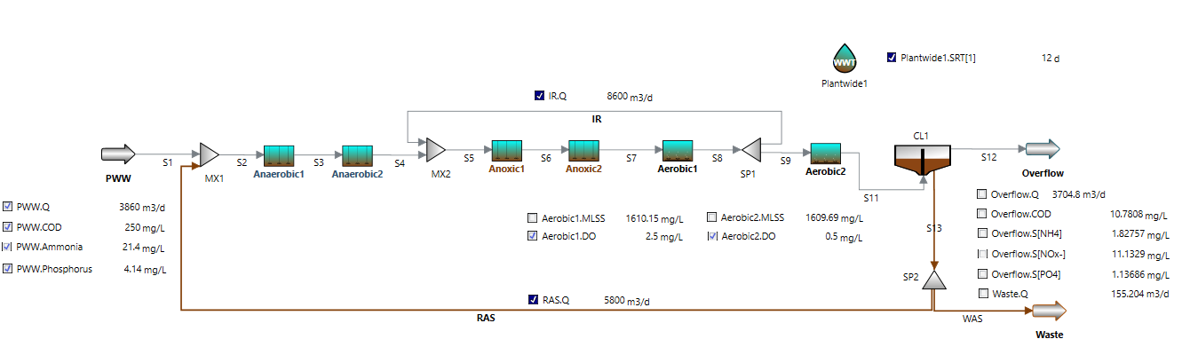
Figure 2: Screenshot of a wastewater treatment plant as modelled in AVEVA Process Simulation
  - Transient initialization of the anaerobic digester model
The problem of finding the desired steady-state solution out of all the possible solutions (Bornhöft 2013) of the anaerobic digester is caused by the formulation of the rate expressions. For example, we will consider the process of update of acetate (Rosen 2005):
$$ρ_{11}=k_{m,ac}\frac{S_{ac}}{K_{s,ac}+S_{ac}}X_{ac}I_{11}$$ | (1)
Where S_{ac} is the concentration of acetate, X_{ac} is the concentration of acetate degraders (micro-organisms), I₁₁ is an inhibition term and k_{m,ac} and K_{s,ac} are rate constants.
Even when acetate is present in the feed stream, the resulting reaction rate might still be zero when there are no degraders (X_{ac}=0) in the initial state. As the growth of degraders is also linked to this reaction, there is a strong attraction to the trivial (wash-out) steady-state solution if initial values are not chosen carefully and a Newton-type method is used for solving the equation set.
One approach to overcome the challenge of finding a steady-state solution from a trivial starting point is to use transient (or pseudo-transient) models to provide a continuous solver path (Pattison 2014). We can apply this technique to solve the steady-state version of the anaerobic digester model.
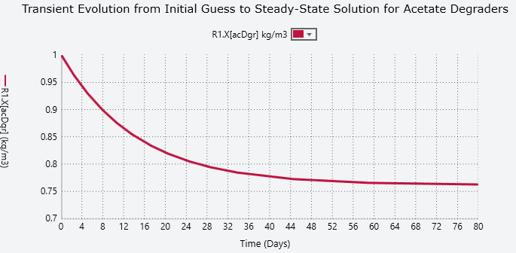
Figure 3: Transient evolution of acetate degraders towards the steady-state solution
In Fig. 3 a transient is shown that illustrates the development of the concentration of a particulate species (X_{ac}, which is labeled X[acDgr] in the implementation) over time, starting from an initial seed value to the actual steady-state solution. By starting from an initial seed, a well-defined steady-state solution is approached, as the species is produced by the sludge to balance the loss of material through dilution. The dynamic integration requires to simulate 80 days to approach the steady-state solution for an arbitrary starting point of 1 kg/m³. Depending on the integrator chosen and the initial values, this approach (while quite robust) can be very time consuming.
  - Using homotopy continuation for initializing ADM1 in steady-state mode
To speed up the evolution from an initial value to the desired productive operating state, completely inside a steady-state solver, homotopy continuation can be applied. In eq. 2, the modified mass-balance equation for the particulate species is shown:
$$\frac{dX}{dt}=ζ_{H}\left(\frac{1}{HRT} ∙\left(X_{in}-X\right)+R\right)+(1-ζ_{H}) ∙(X-X_{seed})$$ | (2)
where HRT is the hydraulic residence time, X is the concentration of particulate species inside the digester, $X_{in}$ is the concentration in the feed, R is the reaction rate, $ζ_{H}$ is the homotopy factor and X_{seed} is the initial concentration.
In addition to the usual terms (in/out flows and reaction), a second term was added that forces the steady-state value of X to be equal to X_{seed} when $ζ_{H}=0$. For $ζ_{H}=1$ the differential equation is used, and the initial values are ignored. Once the anaerobic digester has been solved for fixed values of X_{seed}, the homotopy factor can be moved towards 1, providing a smooth convergence path for X even when X_{in} is equal to zero.
Using this approach, the tedious integration over days or weeks of simulation time can be avoided and convergence to the steady-state solution is typically achieved in a handful of homotopy steps. Fig. 4 shows a typical homotopy evolution for a few selected concentrations. For illustrative purposes, the maximum variable move in each homotopy iteration was limited to 5%. Over 20 iterations, the solution transitioned from the trivial solution to the desired solution.
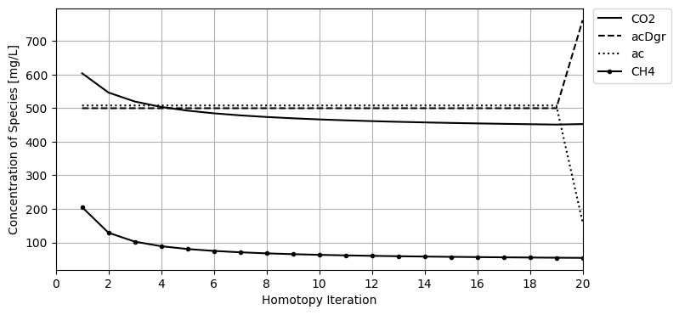
Figure 4: Illustrative homotopy path for selected variables of the ADM1 model
  - Solving for the real steady-state solution of the discretized settler
The last example is concerning the discretized settler, as described in (Takacs 1991). For any given feed concentration and flow split a steady-state profile of solids along the layers of the discretized model will manifest. In (Verdickt 2002) numerical analysis of this model was performed and the results were shown in Fig. 6 in that article. When we tried to reproduce these results, we found that for Xf=5300 mg/L different solutions could be obtained depending on the solution method. Our results are shown in Fig. 5.
The line labelled Xf=5300 represents the steady-state solution found by direct solution of the equation system with a Newton-type method, whereas the line labelled Xf=5300 (t=500h) represents the apparent steady-state solution after running a dynamic integration for 500h. The latter line is also matching the results of (Verdickt 2002). When we let the integration run for longer times, we observe profiles that are slowly approaching the steady-state profile. As details for the calculation method are not given in the reference article, we assume that they terminated the integration too early and assumed a steady-state, as the longest time reported for a profile evolution is given as 200 hours (in their Fig.7). Note that we were not able to reach the steady-state profile even after 2000 hours.
These results illustrate the need for both dynamic integration and direct solution for simulations of Wastewater treatment plants. Due to the very slow processes involved, using only a dynamic integrator can be misleading or be very time consuming.
  - Conclusions
In this article, we have highlighted and discussed three major challenges inherent in the simulation of Wastewater plants and proposed methods to overcome them, giving examples on their implementation and shown numerical results to ground our claims.
The three tools and methods that we recommend are:
- Model extensibility on the equation level to be able to calibrate the model to a real plant and extend reaction schemes for new/unknown species.
- Use of transient initialization and / or homotopy continuation to solve challenging multiple-solution problems.
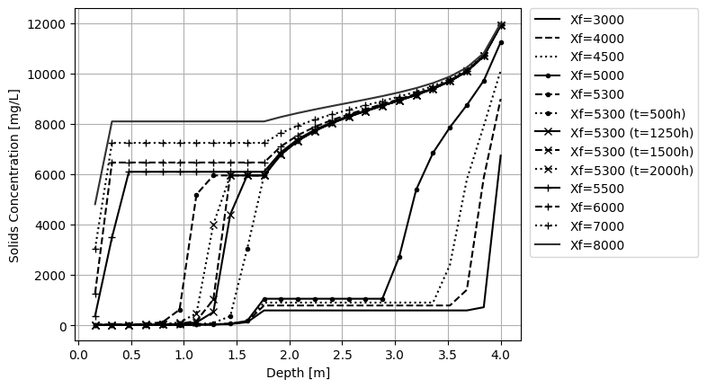
Figure 5: Solid concentration profiles of a settler for different feed concentrations. Solutions are calculated from steady-state, except those marked (t=…h), which are obtained by integration.
- Use of both dynamic integration and direct solve to steady-state to be able to capture both dynamic transients and find the true steady-state of extremely slow processes.
While we did not invent any of the methods discussed here, we combined them and applied them to create a new library of models that were validated against literature data. The library is made available in AVEVA Process Simulation 2024, and the user can combine all the platform features such as Sensitivity Analysis, Scenarios and Optimization with Wastewater simulations. In summary, we can recommend any practitioner to consider using the discussed methods and tools in their simulations of Wastewater treatment plants.
References
Henze, M., Gujer, W., Mino, T., van Loosdrecht, M. C. M., 2000, Activated sludge models ASM1, ASM2, ASM2d and ASM3, reprint ed., IWA Publishing Company
Batstone, Damien J., Keller, J. Angelidaki, I., Kalyuzhnyi, S.V. Pavlostathis, S.G., Rozzi, A., Sanders, W.T.M., Siegrist, H. Vavilin, V.A., 2002, The IWA anaerobic digestion model no 1 (ADM1), Water Science and technology 45.10, 65-73.
Bornhöft, A., Hanke-Rauschenbach, R. & Sundmacher, K., 2013, Steady-state analysis of the Anaerobic Digestion Model No. 1 (ADM1). Nonlinear Dyn 73, 535–549
Gernaey, K. V., Jeppsson, U., Vanrolleghem, P. A., & Copp, J. B. (Eds.), 2014, Benchmarking of Control Strategies for Wastewater Treatment Plants. Scientific and Technical Report No. 23, IWA Publishing
Pattison R.C., Baldea, M., 2002, Equation-oriented flowsheet simulation and optimization using pseudo-transient models, AIChe Journal 60, 4104-4123
Rosén, C., Jeppsson, U., 2005, Aspects on ADM1 Implementation within the BSM2 Framework. (TEIE; Vol. 7224). Department of Industrial Electrical Engineering and Automation, Lund Institute of Technology. http://www.iea.lth.se/publications/Reports/LTH-IEA-7224.pdf
Takács, I., Patry G.G., Nolasco, D., 1991, A dynamic model of the clarification-thickening process. Water Research, 25, 1263-1271.
Verdickt L. B., Van Impe, J. F., 2002, Simulation Analysis of a one-dimensional sedimentation model, IFAC Proceedings, 35, 1, 473-478

