Hybrid Optimization Strategy Applied to an Industrial Natural Gas Processing Plant

Roymel R. Carpioa,*, Carlos R. Paivaa, Thamires A. L. Guedesa, Bruno V. Pinhoa, Tayná E. G. Souzab, Letícia C. Santosb, Leonardo D. Ribeirob, Argimiro R. Secchia

aChemical Engineering Program, COPPE, Universidade Federal do Rio de Janeiro (UFRJ), Rio de Janeiro - RJ, Brazil

bPetróleo Brasileiro S.A. (PETROBRAS), Rio de Janeiro - RJ, Brazil

*roymel@peq.coppe.ufrj.br

Abstract

This study introduces an integrated simulation and hybrid optimization framework to identify the optimal operating condition for an industrial natural gas processing plant. To achieve this goal, a comprehensive simulation of the plant was developed in Aspen Hysys. A bidirectional communication connection between Aspen Hysys and Python was established to automate and oversee the optimization framework. The adopted optimization strategy comprises two sequential stages: (1) Global optimization employing the Particle Swarm Optimization method to identify a promising region near to the global optimum and (2) Local optimization with the Powell method to fine-tune the results obtained from the preceding global optimization stage. Surrogate Gradient Boosting models for both the objective function and constraints were developed, training them using data derived from process simulations. During the global optimization phase, these surrogate models were employed instead of running Aspen Hysys simulations. In contrast, the local optimization stage employed Aspen Hysys simulations to ensure that the final optimal solution adheres to all the constraints. The optimization problem involves five decision variables, an economic objective function and five inequality constraints. Meanwhile, the Aspen Hysys simulation ensures the fulfillment of equality constraints by accounting for the physical and chemical equations governing the process. The hybrid optimization proved to be more efficient compared to isolated approaches for several reasons: (1) when applying only the local optimization method, the outcome resulted in a local optimum with a less favorable objective function value; (2) employing just the global optimization method led to a near-global optimum, but with a lower objective function value than that achieved by the combined strategy; and (3) the utilization of surrogate models during the global optimization stage reduced computing time by over 78 %.

**Keywords**: global optimization, gradient boosting, surrogate optimization.

* 1. Introduction

Natural gas processing facilities receive raw natural gas from oil extraction platforms and produce mainly three products: (1) Sales Gas (SG), (2) Liquefied Petroleum Gas (LPG), and (3) a stream with components heavier than C4 (C5+). The market conditions, especially sale prices, for each of these products are highly dynamic, often resulting in a shift of the most valued from one product to another. This frequently changing behaviour on sale prices in addition to the operational possibility of prioritizing the production of some products could often lead to suboptimal operating conditions. Hence, it is crucial to adeptly adjust the operational parameters of the plant in response to the prevailing market conditions (Souza et al., 2023).

Some previous studies have dealing with optimization on natural gas processing plants (Bullin and Hall, 2000; Bullin and Chipps, 2005; Zheng et al., 2010; Campos et al., 2012; Sobhi and Elkamel, 2015; Zhang et al., 2016; Souza at al., 2023), however none of them assessed the using of surrogate models during the global optimization stage. In this work, a hybrid global - local optimization framework, which considers surrogate models for the global optimization stage is proposed.

* 1. Methodology
     1. Process modelling and simulation

The natural gas processing plant was modelled and simulated using Aspen Hysys considering first principles and steady state approaches. The simulation encompasses two key units: a Dew Point Plant (DPP), responsible for receiving the vapour phase from the slug catchers, and a Liquid Fractionating Unit (LFU), which handled the condensate from slug catchers, as well as the lighter condensate from the DPP. In addition to the primary condensate transfer line from DPP to LFU, another interconnection exists between these units in the form of recycle gas streams that flows from the LFU to the DPP. Therefore, both units are highly interdependent, as depicted in Figure 1.

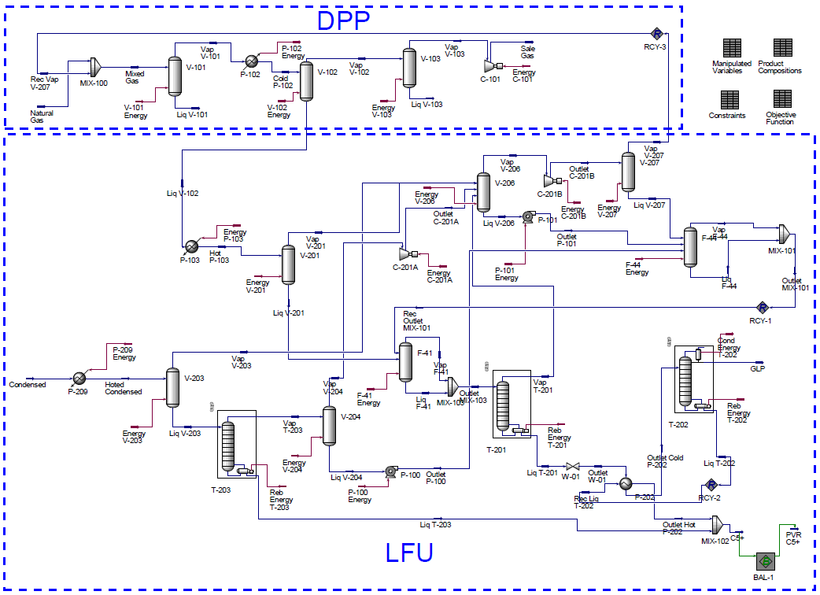

Figure 1. Aspen Hysys PFD of the natural gas processing plant.

Auxiliary units like the propane refrigeration cycle were deliberated excluded from the simulation, since the target of this study is the overall optimization of the plant. Consequently, the limitations of these auxiliary units were considered as operating constraints in the optimization problem. The unit operations considered on the process simulation are mainly: distillations columns, flash separators, heat exchangers, compressors and pumps. A total of 16 distinct components were included in the simulation: 14 alkanes (ranging from methane to n-dodecane, accounting for both normal and iso forms), nitrogen and carbon dioxide. While Peng-Robinson equation of state was employed as the thermodynamic model.

The operating conditions used for the base case simulation are based on the average values observed during a 60 minutes period on January 28, 2023, along with was detected an approximated steady-state condition of the plant.

* + 1. Process optimization framework

After a pre-screening process, to identify controlled variables with certain flexibility on setpoint, and a local sensitivity analysis, to pinpoint the most influential variables, five operating variables were selected as decision variables for the optimization problem. In addition to the setting bounds for the decision variables, additional five quality constraints were considered. The codification and description of decision variables and inequality constraints are outlined in Table 1. It is worth mentioning that the equality constraints of the optimization problem, accounting for mass and energy balances and constitutive relations, are guaranteed by the Aspen Hysys simulation.

Table 1. Decision variables and inequality constraints of the optimization problem

|  |  |  |  |
| --- | --- | --- | --- |
| Code | Decision variables | Code | Inequality constraints |
| x1 | Temp. on separation vessel of LRU | C1 | Methane in SG |
| x2 | Bottom temp. of deethanizer column | C2 | Ethane in LPG |
| x3 | Bottom temp. of debutanizer column | C3 | Ethane/Pentanes ratio in LPG |
| x4 | Bottom temp. of stabilizer column | C4 | Pentanes in LPG |
| x5 | Reflux ratio of debutanizer column | C5 | Reid vapour pressure in C5+ |

The objective function (OF) in this context aims to maximize economic profit. This profit is defined as the total income generated from the sale of various products, subtracting the associated expenses, which encompass operating costs such as electricity and fuel gas (see Equation 1).

|  |  |
| --- | --- |
| $$Profit=\sum_{i=1}^{NP}{\left[{LHV}_{i}{ F}_{i }P_{i}\right]}-\left[E_{cons}E_{cost}+F_{cons}F_{cost}\right]$$ | (1) |

where $NP$ is the number of products (1 for SG, 2 for LPG, and 3 for C5+); $LHV$ is the lower heating value [MMbtu/kmol] and $F$ is the molar flowrate [kmol/h] of the product stream; $P$ is the sale price [$/MMbtu] of the specific product; $E_{cons}$ and $E_{cost}$ are the consumption [kW] and cost [$/(kW.h)] of electricity; $F_{cons}$ and $F_{cost}$ are the consumption [MMbtu/h] and cost [$/MMbtu] of fuel gas.

The intrinsic non-linearity of the process model and the existence of several non-linear constraints generated non-convexities. Thus, the use of a global optimization algorithm is recommended to avoid get trapped on a local optimum near to the base case. On the other hand, applying global optimization on rigorous model simulations is typically computational-time expensive. For that reason, a hybrid optimization strategy was adopted. This strategy comprises two sequential stages: (1) global optimization using surrogate models, to fast identification of a promising region containing the global optimum and (2) local optimization utilizing the rigorous simulation to fine-tune the results obtained from the preceding global optimization stage while ensuring that the final optimal solution adheres to all the constraints.

Gradient Boosting models (Friedman, 2001) of the objective function and the constraints were trained using data derived from 100 process simulations. Then, these surrogate models were employed with Particle Swarm Optimization (PSO) algorithm (Kennedy and Eberhart, 1995) in the global optimization stage. On the other hand, Powell method (Powell, 1964) was applied direct into the simulation for the local optimization. A penalized objective function was defined for considering the quality and operational inequality constraints.

The optimization framework, which is totally automated by a Python script, including a bidirectional communication connection with Aspen Hysys, is depicted in Figure 2.

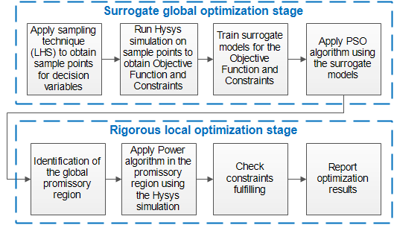

Figure 2. Schematic representation of the optimization framework.

* 1. Results and discussion

In order to asses the advantages of the proposed hybrid optimization framework, the result of isolated local/global approaches are shown on Table 2. Notice that the results achieved by the isolated local optimization correspond to a local optimum far from the optimum found by the isolate global optimization. It is worth to mention the relatively high computational time demanded by the global optimization since it is acting directly on the Aspen Hysys simulation. Summarizing the results of Table 2, the local optimization algorithm was trapped by a local optimum and the global optimization algorithm probably found a near global optimum but with a high computational cost.

Considering these findings, the proposed hybrid strategy was applied to solve the optimization problem, achieving the results detailed on Table 3. Notice that the time for the global optimization was reduced in more than 78 % by using surrogate models. It is worth mentioning that the reported time involves the whole process, i.e., running 100 simulations for obtaining the training data, train the surrogate models and executed the surrogated global optimization itself. Despite off the OF value in this case was lower than the obtained by the rigorous global optimization, it corresponds to a promising region near to the global optimum and was used as an initial guess for the local optimization stage.

Table 2. Optimization results when using isolated approaches

|  |  |  |  |  |  |  |  |
| --- | --- | --- | --- | --- | --- | --- | --- |
| Code | Type | UoM | Base  Case | Rigorous  Local  Optim. | Rigorous  Global  Optim. | LB | UB |
| x1a | Decision | - | 0.56 | 0.04 | 0.02 | 0 | 1 |
| x2a | Decision | - | 0.61 | 0.66 | 0.36 | 0 | 1 |
| x3a | Decision | - | 0.52 | 0.03 | 0.45 | 0 | 1 |
| x4a | Decision | - | 0.53 | 0.65 | 0.61 | 0 | 1 |
| x5a | Decision | - | 0.46 | 0.38 | 0.33 | 0 | 1 |
| OFa | Objective | - | 100 | 102.47 | 102.87 | - | - |
| C1 | Constraint | % mol | 82.08 | 83.02 | 83.33 | 80 | - |
| C2 | Constraint | % vol | 10.69 | 8.21 | 11.98 | - | 12 |
| C3 | Constraint | - | 6.565 | 12.36 | 10.23 | - | 16 |
| C4 | Constraint | % vol | 1.628 | 0.66 | 1.17 | - | 2 |
| C5 | Constraint | kPa | 60.13 | 74.88 | 61.63 | - | 76 |
| Time | - | s | - | 66.81 | 458.23 | - | - |

aIn order to preserve proprietary information, the profit and decision variables are normalized.

Table 3. Optimization results when applying the hybrid strategy

|  |  |  |  |  |  |  |  |
| --- | --- | --- | --- | --- | --- | --- | --- |
| Code | Type | UoM | Base  Case | Surrogate  Global  Optim. | Rigorous  Local  Optim. | LB | UB |
| x1a | Decision | - | 0.56 | 0.03 | 0.02 | 0 | 1 |
| x2a | Decision | - | 0.61 | 0.51 | 0.44 | 0 | 1 |
| x3a | Decision | - | 0.52 | 0.06 | 0.00 | 0 | 1 |
| x4a | Decision | - | 0.53 | 0.82 | 0.67 | 0 | 1 |
| x5a | Decision | - | 0.46 | 0.20 | 0.24 | 0 | 1 |
| OFa | Objective | - | 100 | 102.72 b | 102.88 | - | - |
| C1 | Constraint | % mol | 82.08 | 83.19 b | 83.26 | 80 | - |
| C2 | Constraint | % vol | 10.69 | 10.31 b | 11.15 | - | 12 |
| C3 | Constraint | - | 6.565 | 7.16 b | 10.55 | - | 16 |
| C4 | Constraint | % vol | 1.628 | 1.44 b | 1.06 | - | 2 |
| C5 | Constraint | kPa | 60.13 | 72.23 b | 75.56 | - | 76 |
| Time | - | s | - | 97.46 | 76.57 | - | - |

aIn order to preserve proprietary information, the profit and decision variables are normalized. bValues obtained by Hysys simulation using the solution of the surrogate global optimization.

In this case, the result of the surrogate global optimization fulfilled all the constraints, but it is not guaranteed for all the cases. Therefore, the rigorous local optimization stage is necessary.

Notice that the final optimum obtained by the hybrid strategy was better, and represent 2.88 % improvement on profit. In addition, the total time consumption of the proposed framework was 174.03 s, a 62 % lower than the computational time demanded by the isolated rigorous global optimization.

* 1. Conclusions

The hybrid optimization framework demonstrated to be robust and efficient, successfully finding a feasible operating condition that improves the objective function on approximately 2.9 %. It has proven to be more efficient compared to isolated approaches for several compelling reasons: (1) when applying only the local optimization method, the outcome resulted in a local optimum with a less favourable objective function value; (2) employing just the global optimization method led to a near-global optimum, but with a lower objective function value than that achieved by the combined strategy; and (3) the utilization of surrogate models during the global optimization stage substantially reduced computing time by over 78 %.

**Acknowledgements**

Financial support from Petróleo Brasileiro S.A. (PETROBRAS) is gratefully acknowledged.

**References**

S. A. Al-Sobhi, A. Elkamel, 2015. Simulation and optimization of natural gas processing and production network consisting of LNG, GTL, and methanol facilities. J. Nat. Gas Sci. Eng. 23 (2015), 500–508.

K. A. Bullin, J. Chipps, 2005. Optimization of natural gas gathering systems and gas plants. In: Proceedings of the GPA Annual Convention Proceedings. ISSN: 00968870.

K. A. Bullin, K. R. Hall, 2000. Optimization of natural gas processing plants including business aspects. In: Proceedings of the GPA Annual Convention Proceedings, pp. 1–12. ISSN: 00968870.

M. Campos, M. Gomes, A. Souza, A. Barros, 2012. Optimisation of natural gas plant – Gains in profitability, stability and energy efficiency. In: Proceedings of the International Gas Union World Gas Conference Papers, 3, pp. 2089–2120.

J. Kennedy, R. Eberhart, 1995, Particle swarm optimization. IEEE International Conference on Neural Networks - Conference Proceedings, 4, pp. 1942-1948.

M. J. D. Powell, 1964. An efficient method for finding the minimum of a function of several variables without calculating derivatives. The Computer Journal 7: 155-162.

T. E. G. Souza, A. R. Secchi, L. C. Santos, 2023, Modeling and economic optimization of an industrial site for natural gas processing: A nonlinear optimization approach, Digital Chemical Engineering, 6, 100070.

B. J. Zhang, Q. L. Chen, J. Li, C. A. Floudas, 2016. Operational strategy and planning for raw natural gas refining complexes: process modeling and global optimization. AlChE J. 63 (2), 652–668.

Q. P. Zheng, S. Rebennack, N. A. Iliadis, P. M. Pardalos, 2010. Optimization models in the natural gas industry. Handbook of power systems I, energy systems. Springer, Berlin, pp. 121–148.

J. Friedman, 2001. Greedy Function Approximation: A Gradient Boosting Machine, The Annals of Statistics, Vol. 29, No. 5.