Scenario Reduction Methods for Risk-Averse Demand Response Scheduling under Price Uncertainty
Sonja H. M. Germscheid,^{a,b} Alexander Mitsos,^{c,a,d} Manuel Dahmen^{a,}*
ªForschungszentrum Jülich GmbH, Institute of Energy and Climate Research, Energy Systems Engineering (IEK-10), Jülich 52425, Germany
^{b}RWTH Aachen University, Aachen 52062, Germany
^{c}JARA-CSD, Jülich 52425, Germany
^{d}RWTH Aachen University, Process Systems Engineering (AVT.SVT), Aachen 52074, Germany
*m.dahmen@fz-juelich.de
Abstract
Risk-averse demand response scheduling of power-intensive production processes can reduce financial risk resulting from electricity price uncertainty but is computationally expensive. Only few works discuss scenario reduction methods tailored to risk-averse optimization. In this work, we compare four scenario reduction methods from the literature and a heuristic sequential scheduling approach from our prior work. For the comparison, we schedule a continuous process by means of a generalized model for optimal simultaneous participation on both day-ahead and intraday electricity markets where uncertain intraday prices are modeled by a set of scenarios. We evaluate the performance of the scenario reduction methods by comparing cost and risk of the reduced and original problem. We find that k-means clustering outperforms the other three scenario reduction methods. Furthermore, the heuristic sequential scheduling appears best suited for participation on both markets while avoiding a computationally expensive stochastic scheduling.
Keywords: Risk-averse scheduling, scenario reduction, conditional value-at-risk, price uncertainty
  - Introduction
Risk-averse demand response scheduling under price uncertainty has shown great potential to significantly reduce financial risk with a small increase of expected cost in comparison to both risk-neutral stochastic scheduling and deterministic scheduling, see, e.g., Zhang et al. (2016) and Germscheid et al. (2022). In general, the necessary stochastic scheduling is connected to a high computational burden due to the large number of optimization variables arising from the consideration of many scenarios, calling for the use of scenario reduction methods to keep the optimization tractable.
Most scenario reduction approaches focus on risk-neutral stochastic programming (SP), i.e., optimization of the expected cost, see, e.g., Heitsch and Römisch (2003). In contrast, only few works (Alkhaleel et al., 2022; Arpón et al., 2018; Fairbrother et al., 2018, 2022; García-Bertrand and Mínguez, 2014; Pineda and Conejo, 2010) discuss scenario reduction methods for risk-averse approaches such as minimization of the conditional value-at-risk (CVaR), i.e., the expected cost of a certain percentage of worst-case scenarios. Importantly, while scenario reduction decreases computational times, it can lead to suboptimal solutions and thus a higher risk in risk-averse scheduling compared to the original risk-averse problem. This trade-off calls for a comparison of the existing approaches in the context of a particular application.
We compare four scenario reduction methods from the literature for which implementations are available, i.e., the methods proposed by Heitsch and Römisch (2003), Pineda and Conejo (2010), and Alkhaleel et al. (2022), and k-means clustering (Lloyd, 1982). Additionally, we consider the heuristic sequential scheduling approach proposed in our prior work (Germscheid et al., 2023). We consider the risk-averse demand response scheduling of a generalized, continuous process for simultaneous participation on both day-ahead and intraday electricity markets introduced in Germscheid et al. (2022). Here, day-ahead decisions must be made while intraday electricity prices are subject to uncertainty. We evaluate the performance of the reduction methods by solving the stochastic problem with a reduced set of scenarios and comparing expected cost and risk to the respective solution values of the original risk-averse problem. Note that in Germscheid et al. (2023) we already demonstrated that scenario reduction leads to strong computational benefits and that our proposed sequential scheduling is faster than the stochastic scheduling.
The remainder of this paper is structured as follows: In Section 2, we review existing risk-averse scenario reduction approaches. In Section 3, we specify our evaluation approach. In Section 4, we compare the reduction methods and Section 5 concludes the findings.
  - Risk-averse scenario reduction methods
Risk-neutral scenario reduction can be based on probability distances, i.e., metrics that describe the closeness between probability distributions. Dupačová et al. (2003) suggest choosing scenarios such that the probability distance of the original and the reduced set of scenarios is minimal:
$${\hat{μ}}_{c}\left(P,\tilde{P}\right)=\min_{η_{i,j}}{ \sum_{i=1}^{N}{\sum_{j=1}^{M}{c\left(p_{i}, {\tilde{p}}_{j}\right)η_{i,j}}}}$$  $$s.t. \left\{η_{i,j}≥0, \sum_{i=1}^{N}{η_{i,j}=π_{j}}, \sum_{j=1}^{M}{η_{i,j}={\tilde{π}}_{j}}\right\} ∀ i,j$$ | (1)
In Eq. (1), ${\hat{μ}}_{c}(P,\tilde{P})$ is the optimal distance for the probability distributions $P=\sum_{i=1}^{N}{π_{i}δ_{p_{i}}}$ and $\tilde{P}=\sum_{i=1}^{M}{{\tilde{π}}_{i}δ_{{\tilde{p}}_{i}}}$, with scenarios $\left\{p_{1}, …, p_{N}\right\}$ and $\left\{{\tilde{p}}_{1}, …, {\tilde{p}}_{M}\right\}$ and probabilities $π_{i}$ and ${\tilde{π}}_{i}$, respectively. $δ_{p}$ denotes the Dirac measure. The function $c\left(p_{i}, {\tilde{p}}_{j}\right)$ is continuous, symmetric, and gives $c\left(p, \tilde{p}\right)=0$ iff $p= \tilde{p}$. The optimization variables $η_{i,j}$ add up to the probabilities $π_{i}$ and ${\tilde{π}}_{i}$, respectively. Based on the probability distance, Heitsch and Römisch (2003) suggest algorithms for scenario reduction with implementations available in the tools SCENRED and SCENRED2 of GAMS (GAMS Development Corporation, 2022). In the following, we refer to the approach of Heitsch and Römisch (2003) as risk-neutral approach.
Risk-averse SP can be tackled with minimization of CVaR, i.e., the expected cost of the $(1-α)$ worst-case scenarios (Rockafellar and Uryasev, 2000, 2002):
$$\min_{x_{i},Ψ,ϕ_{i}}{CVaR } s.t. CVaR=ψ+\sum_{i=1}^{N}{\frac{π_{i}ϕ_{i}}{\left(1-α\right)}},\left\{f\left(x_{i},p_{i}\right)-ψ≤ϕ_{i},ϕ_{i}≥0\right\} ∀i$$ | (2)
In Eq. (2), $CVaR$ is determined for the confidence level $α$ and the objective function $f$ with the decision variables $x_{i},$ the continuous auxiliary variables $ϕ_{i}$ and $ψ$, and $N$ scenarios $p_{i}$. Note that only the $(1-α)$ worst-case scenarios have non-zero values for $ϕ_{i}$, i.e., they affect the objective value.
Pineda and Conejo (2010) and Alkhaleel et al. (2022) tailored scenario reduction to risk-averse SP by adjusting the probability distance-based reduction approach. Specifically, Pineda and Conejo (2010) suggested to replace the scenarios $\left\{p_{1}, …, p_{N}\right\}$ in the probability distance with information from the expectation of expected value (EEV) solution that is obtained by optimizing with a mean-valued scenario followed by solving the original problem with fixed first-stage decisions. To this end, they used values of the auxiliary variables $\left\{ϕ_{1}, …, ϕ_{N}\right\}$of the EEV solution. Apart from that, Pineda and Conejo (2010) used the scenario reduction of Heitsch and Römisch (2003) to solve the risk-averse problem. In contrast, Alkhaleel et al. (2022) suggested to apply the scenario reduction of Heitsch and Römisch (2003) to a pre-selected set of scenarios, i.e., the $\left(1-α\right)$-worst case scenarios of the wait-and-see (WS) solution that is obtained by optimizing the scenarios separately assuming perfect foresight. Consequently, they assumed that the reduced set would represent only worst-case scenarios and applied risk-neutral SP in the final step as suggested by García-Bertrand and Mínguez (2014). In the following, we refer to the approaches of Pineda and Conejo (2010) and Alkhaleel et al. (2022) as EEV-based and WS-based approach, respectively.
It should be noted that further risk-averse reduction methods have been proposed, i.e., by García-Bertrand and Mínguez (2014), Arpón et al. (2018), and Fairbrother et al. (2018, 2022). These approaches build on repeatably solving the stochastic program with a small subset of scenarios. However, the respective algorithm implementations are not publicly available and thus considered beyond the scope of this paper.
  - Model specification and evaluation approaches
For comparison, we consider the generalized continuous process introduced by Schäfer et al. (2020) that considers generalized process characteristics, i.e., oversizing, minimal part load, ramping, storage capacity, efficiency losses, and temporary shutdowns. As introduced in Germscheid et al. (2022), we optimize the demand response scheduling considering simultaneous market participation on both the day-ahead and the intraday electricity market, i.e., considering known day-ahead and uncertain intraday electricity prices. For the analysis, we consider the same reference process and the same 201 intraday price scenarios as in Germscheid et al. (2022). We solve the stochastic program by means of the deterministic equivalent and Gurobi 9.1.1 with default settings on an Intel Core i7-9700 processor and 32GB RAM. For CVaR, we consider the confidence level $α=0.9$. For probability distance-based scenario reduction, we use the fast forward scenario reduction by Heitsch and Römisch (2003) implemented in SCENRED2 by GAMS (GAMS Development Corporation, 2022).
We compare the approaches listed in Table 1. As a further reduction approach, we consider k-means clustering using the scikit-learn module in Python (Pedregosa et al., 2011). Additionally, we compare the stochastic scheduling to a heuristic approach that we have previously introduced (Germscheid et al., 2023) and that is tailored to the simultaneous market participation. In particular, our heuristic sequential day-ahead and intraday scheduling optimizes the day-ahead schedule neglecting the intraday market and then solves the original problem with fixed day-ahead decisions. Thus, the sequential scheduling results in improved or equal expected cost and financial risk compared to day-ahead-only scheduling and simultaneously avoids the computational cost of the stochastic scheduling. In contrast, scenario reduction methods cannot guarantee such a specific upper bound of expected cost or risk but they can be applied to any stochastic
problem.
Similar to our prior work (Germscheid et al., 2023), we evaluate the reduction methods by, first, solving the stochastic problem with the reduced set of scenarios, followed by an optimization of the stochastic program with the full set of scenarios but fixed first-stage decisions. We compare the results of the reduced problem to the results of the full problem, i.e., the original problem optimizing the CVaR with the full set of scenarios, by evaluating the relative differences in the CVaR. Additionally, we evaluate the relative difference in expected cost of the reduced compared to the full problem. Note that the expected cost is not the objective of the risk-averse problem but a key measure to evaluate the profitability of scheduling under uncertainty.

Table 1: Overview of the considered methods.
Reduction methods with use of stochastic scheduling
Risk-neutral approach | Probability distance-based reduction by Heitsch and Römisch (2003) using the distance of intraday electricity price scenarios
Risk-averse EEV-based approach | Probability distance-based reduction by Pineda and Conejo (2010) using the distance of auxiliary variable $ϕ_{s}$ of EEV solution
Risk-averse WS-based approach | Probability distance-based reduction by Alkhaleel et al. (2022) using distance of scenario cost of $(1-α)$ worst-case WS solutions
K-means clustering | Use centroids from clustering as scenarios
Sequential scheduling | See Germscheid et al. (2023)
  - Results
Figure 1 shows the relative difference in CVaR and relative difference in expected cost of all methods compared to the full problem. A positive value of either measure indicates an impairment of CVaR or expected cost, respectively, due to the scenario reduction. Note that an improvement of expected cost, i.e., a negative value, is possible at the cost of an impaired risk. Furthermore, note that for risk-neutral and EEV-based reduction, SCENRED2 of GAMS reduces the 201 original scenario to at most 126 scenarios due to an automatic reduction of SCRENRED2. In case of WS-based reduction, there are at most 20 scenarios due to the pre-selection of the worst-case scenarios.
Figure 1 reveals that for risk-neutral reduction, the difference in risk shows a monotonic trend, i.e., with an increasing number of scenarios the difference asymptotically approaches zero. In contrast, the EEV-based approach shows a pronounced kink for a reduced set with 25 scenarios leading to a significant impairment of both risk and expected cost. The WS-based approach shows an overall large difference in risk and is outperformed by both the k-means clustering and the risk-neutral reduction. Interestingly, k-means clustering has the lowest difference in expected cost and risk compared to the other reduction methods. It, however, shows an erratic behavior with respect to the difference in expected cost.
Figure 1a) -1d) show the relative difference in CVaR and expected cost of the sequential scheduling by means of a dashed line. Sequential scheduling and risk-averse stochastic scheduling are very similar with respect to both measures, i.e., the relative difference of both CVaR and expected cost is rather low in comparison to the other reduction methods. This behavior can be explained by similar day-ahead purchases, i.e., first-stage decisions, for both risk-averse scheduling and sequential scheduling, which were already noted in Germscheid et al. (2022).

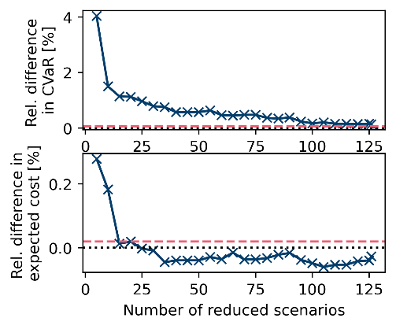  Figure 1a) Risk-neutral approach | 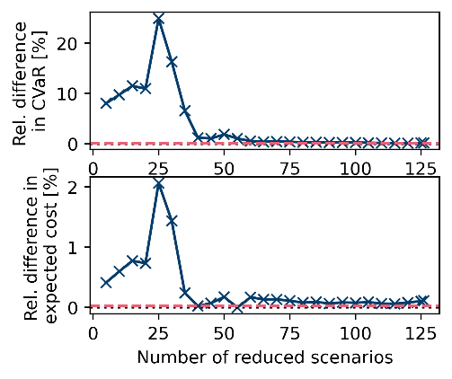Figure 1b) EEV-based approach
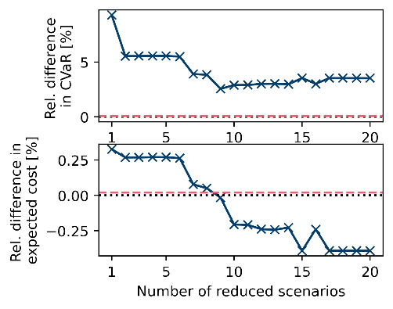  Figure 1c) WS-based approach | 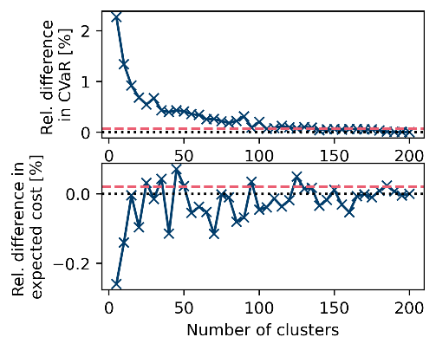  Figure 1d) K-means clustering
Figure 1: Comparison of the reduction methods: Figures a) to d) each consider a scenario reduction method. Each subfigure shows both the difference in CVaR (upper part) and in expected cost (lower part) of the reduction methods relative to the solutions of the original risk-averse problem. In all figures, the dashed lines correspond to the relative difference in CVaR and in expected cost, respectively, of the sequential scheduling approach introduced in Germscheid et al. (2023). Additionally, each figure contains a dotted, horizontal line at value zero for visual guidance.

Overall, k-means clustering leads to the lowest difference in both expected cost and risk compared to the other reduction methods. Compared to all reduction methods, the sequential scheduling shows particularly low differences in both expected cost and risk and appears to be a promising heuristic to bound financial risk and expected cost for this particular application.
  - Discussion and conclusion
In this work, four scenario reduction methods are compared for risk-averse stochastic demand response scheduling of a power-intensive process for combined day-ahead and intraday electricity market participation. Additionally, the previously introduced sequential day-ahead and intraday scheduling approach is considered. In the case study, the heuristic risk-averse reduction methods are outperformed by risk-neutral scenario reduction and k-means clustering. Furthermore, the sequential scheduling approach yields expected cost and CVaR that are very similar to those of the original problem due to highly similar day-ahead decisions.
  - Acknowledgment
This work was funded by the Helmholtz Association of German Research Centers through program-oriented funding (PoF) and under the grant Uncertainty Quantification – From Data to Reliable Knowledge (UQ) (grant number: ZT-I-0029). This work was performed as part of the Helmholtz School for Data Science in Life, Earth and Energy (HDS-LEE).
References
B.A. Alkhaleel, H. Liao, K.M. Sullivan, 2022, Risk and resilience-based optimal post-disruption restoration for critical infrastructures under uncertainty, Eur. J. Oper. Res. 296, 174–202.
S. Arpón, T. Homem-de-Mello, B. Pagnoncelli, 2018, Scenario reduction for stochastic programs with Conditional Value-at-Risk, Math. Program. 170, 327–356.
J. Dupačová, N. Gröwe-Kuska, W. Römisch, 2003, Scenario reduction in stochastic programming. Math. Program. 95(3), 493–511.
J. Fairbrother, A. Turner, S.W. Wallace, 2018, Scenario generation for single-period portfolio selection problems with tail risk measures: Coping with high dimensions and integer variables, INFORMS J. Comput. 30, 472–491.
J. Fairbrother, A. Turner, S.W. Wallace, 2022, Problem-driven scenario generation: An analytical approach for stochastic programs with tail risk measure. Math. Program. 191(1):141–182.
GAMS Development Corporation, 2022. General algebraic modeling system (GAMS) release 40.4.0, accessed 25th Oct 2022. https://www.gams.com/download/.
R. García-Bertrand, R. Mínguez, 2014, Iterative scenario based reduction technique for stochastic optimization using conditional value-at-risk, Optim. Eng. 15, 355–380.
S.H.M. Germscheid, A. Mitsos, M. Dahmen, 2022, Demand response potential of industrial processes considering uncertain short‐term electricity prices, AIChE J. 68, e17828.
S.H.M. Germscheid, F.T.C. Röben, H. Sun, A. Bardow, A. Mitsos, M. Dahmen, 2023, Demand response scheduling of copper production under short-term electricity price uncertainty, Comput. Chem. Eng., 108394.
H. Heitsch, W. Römisch, 2003, Scenario reduction algorithms in stochastic programming. Comput. Optim. Appl. 24(2):187–206.
S. Lloyd, 1982, Least squares quantization in PCM, IEEE Trans. Inf. Theory. 28, 129–137.
F. Pedregosa, G. Varoquaux, A. Gramfort, V. Michel, B. Thirion, O. Grisel, M. Blondel, P. Prettenhofer, R. Weiss, V. Dubourg, J. Vanderplas, A. Passos, D. Cournapeau, M. Brucher, M. Perrot, E. Duchesnay, 2011. Scikit-learn: Machine learning in Python. J Mach Learn Res 12, 2825–283
S. Pineda, A.J. Conejo, 2010, Scenario reduction for risk-averse electricity trading, IET Gener. Transm. Distrib. 4, 694.
R. T. Rockafellar, S. Uryasev, 2000, Optimization of conditional value-at-risk, J. Risk 2(3), 21–41.
R. T. Rockafellar, S. Uryasev, 2002, Conditional value-at-risk for general loss distributions, J. Bank. Financ. 26(7), 1443–1471.
P. Schäfer, T.M. Daun, A. Mitsos, 2020, Do investments in flexibility enhance sustainability? A simulative study considering the German electricity sector, AIChE J. 66, 1–14.
Q. Zhang, J.L. Cremer, I.E. Grossmann, A. Sundaramoorthy, J.M. Pinto, 2016, Risk-based integrated production scheduling and electricity procurement for continuous power-intensive processes, Comput. Chem. Eng. 86, 90–105.

