Prototyping cloud application for regional green transformation supported by prospective life cycle assessment

Yuichiro Kanematsu,a* Shoma Fujii,bc Yuko Oshita,b Satoshi Ohara,bc Atsushi Komori,d Daisuke Shimotoku,e Katsura Iizuka,e Junya Kawase,e Hiroki Kobayashi,e Yasunori Kikuchiabc

aPresidential Endowed Chair for “Platinum Society”, The University of Tokyo, 113-8656 7-3-1 Hongo, Bunkyo-ku, Tokyo, Japan

bInstitute for Future Initiatives, The University of Tokyo, 113-8654 7-3-1 Hongo, Bunkyo-ku, Tokyo, Japan

cDepartment of Chemical System Engineering, The University of Tokyo, 113-8656 7-3-1 Hongo, Bunkyo-ku, Tokyo, Japan

dEngineering Advancement Association of Japan, 106-0041 1-11-9 Azabudai, Minato-ku, Tokyo, Japan

eInformation Technology Center, The University of Tokyo, 277-0882 6-2-3 Kashiwanoha, Kashiwa-shi, Chiba, Japan

kanematsu@platinum.u-tokyo.ac.jp

Abstract

Regional green transformation (GX) requires collaborative planning among local entities, integrating various technologies and life cycle thinking. A cloud-based information system prototype was developed in this study to expedite GX planning through prospective life cycle assessment (LCA), incorporating simulators, visualization tools, and local databases. The information system's conceptual design includes separate activity and data models. These models focus on the regional system's basic design, allowing planners to configure device installations, simulate mass/energy balances, and generate inventory data for LCA. Rationales are derived from previous case studies involving prospective LCA. The activity model covers local supply-demand analysis, alternative generation, mass & energy simulation, evaluation, and installation planning. The data model defines essential datasets for simulators used in prospective LCA of emerging technologies. The information system's function requirements, including prototypes for applications like GIS-based visualizers and energy flow diagrams, were defined using activity and data models. Datasets were integrated from statistical open data, and a technology database was created for matching technology with regional supply/demand. Simulators for specific technologies are being developed on a local server with plans for cloud integration, and the simulation results can used as the data to perform LCA. The entire system architecture based on an academic cloud infrastructure was discussed and the tools mentioned above will be integrated into a holistic application in near future.

**Keywords**: Life cycle assessment, Renewable energy, Local resource circulation

* 1. Introduction

Global and national targets and statements have been set for the promotion of carbon neutrality and resource circulation, and efforts at the regional level are essential to achieve these goals. While a few regions have made progress in introducing advanced technologies and mechanisms, many regions have only stated targets and are struggling to come up with concrete plans for installing the technologies needed to achieve these targets. Prospective life cycle assessment (LCA) is effective and necessary for the proof of concept of emerging technologies (Arvidsson *et al.*, 2018) required for carbon neutrality and resource circulation. Although there are an increasing number of studies of prospective LCA in academic research, there exists many challenges in the actual applications (Bergerson *et al.*, 2020). In order to achieve the implementation of the technology in a large number of regions, a mechanism to support and significantly accelerate the implementation of prospective LCA is needed, and the use of information technology is one of the essential elements. In this study, cloud-based information system was prototyped to accelerate the planning of regional GX based on prospective LCA, by integrating simulators, visualization tools and databases for local resources, energies and green technologies.

* 1. Methods
     1. Conceptual Design of Information System for Supporting Regional GX

As a base of conceptual design of the information system, activity model and data model were separately developed to structurally visualize the planning procedure and the data relations. These models focus on the basic design phase of the regional system that the planner can determine the major configurations of devices to be installed into the region and can simulate the mass/energy balances in the system, which can be used as the inventory data for LCA. The rationales of the models were extracted from the previous case studies of system design based on prospective LCA such as combined heating and power using woody biomass (Kanematsu *et al*., 2017a), mobile heat storage system with zeolite boiler (Fujii *et al*., 2022), and the trial of their regional implementation (Kikuchi et al, 2020). The IDEF0 functional modeling method and UML class diagrams had been applied for the activity model and data model respectively in our previous research (Kanematsu *et al.*, 2017b), and improved through the current research activities.

* + 1. Prototyping of the Modules of Cloud Application: RE-CODE

Based on the activity and data models, the function requirements of the information system were defined, and the entire system architecture were conceptually designed. Several prototypes of the modules required to functionalize the information system for accelerating regional GX were developed. It was identified that the cloud-based system is suitable for the entire system architecture in order to realize the required functions and promote the co-creation between the developers, system users and involved stakeholders. The system were named as RE-CODE, there “RE” involving the means region, resource, renewables, revitalize and so on, with “CODE” means co-design and program code. The prototype modules in RE-CODE were designed and developed supposing to build on the cloud-based information infrastructure.

* 1. Results and Discussions
     1. Defined Functional Requirements and the Conceptual Design of RE-CODE

The activity model was defined as consisting of four planning tasks: local supply-demand analysis, alternative generation, mass/energy simulation, and evaluation, with entire management and review. The data model defined the datasets for simulators, which are essential for prospective LCA of emerging technologies. Figure 1 conceptually shows the activity model and required datasets.

Based on these models, we identified the need for tools to support each of the four activities included in the planning task, and organized into the following four main modules: *View, Match, Sim*, and *Value*. *View* is a tool for analyzing and visualizing regional supply and demand, and integrates data from multiple data sources, including supply potential of resources, industrial and residential demand, and their future estimates. *Match* is a tool for matching technologies and regions. This tool proposes elemental technologies and their combinations that can contribute to solving problems by taking advantage of the strengths of the region, based on the analysis results of *View*. *Sim* is a simulation tool for material/energy balance, which simulates the changes in material and energy flows when multiple combinations of technologies proposed by *Match* are introduced to a region as candidates. *Value* is an evaluation tool that uses the simulation results from *Sim* as inventory data for LCA and Input-Output Analysis (IOA).

Additionally, we found it desirable to configure the entire system as a cloud-based system. It is because the datasets required for planning are dispersed among various owners, such as energy demand data by residents or industries, unused wasted resources from agriculture, or state-of-the-art technology specifications from device developers. Timely, “mdx” (https://mdx.jp/), an academic cloud system jointly developed by several Japanese research institutes for the purpose of promoting transdisciplinary researches and activities, has been operational in 2022. We started to use mdx as the infrastructure for the development and operation.

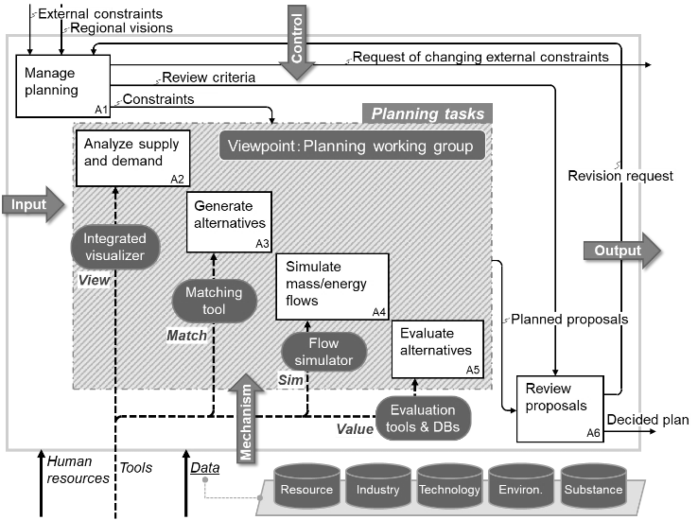

Figure 1. Activity model and related data sets for planning installation of GX technologies

* + 1. Developed Prototypes for Modules of RE-CODE
       1. RE-CODE View: Regional Supply-Demand Analyzer and Visualizer

Prototype web system that integrates open data on renewable resource potential and facility installation records published by different ministries, such as the Ministry of Environment and the Ministry of Economy, Trade and Industry, and visualizes them on a single web interface (Figure 2-a). In addition, a portion of the data can be visualized on Geographic Information System (GIS). A visualization combining bubble maps and pie charts were applied so that the characteristics of each municipality can be seen at a glance. (Figure 2-b) As a visualization tool for the demand side, we constructed a tool to calculate the actual statistical energy consumption at the basic municipality level and visualize it as a Sankey flow diagram. In Japan, energy consumption statistics are only available on a prefectural basis. A program was developed that can estimate energy consumption in minimum municipality level by combining population statistics with industry statistics such as the number of employees and production volume.

* + - 1. RE-CODE Match: Matching Tool Between Region and Technology

*RE-CODE Match* aims to propose technologies that match the characteristics of a region using the results of a supply-demand analysis by *RE-CODE View*. We identified that this tool should have functions to search and propose environmental technologies and their combination that can utilize resources in which the region has strengths or contribute to improve the energy consumption structure. Technology database in which the device development companies can register their own technologies including premature ones, will be developed and combined. Comprehensive and systematic categorization of technology categories is important for efficient storage and searching of technology data. In addition, to promote future decarbonization and resource recycling, it is important to consider the installation of technologies that are still under development. In this purpose, technology readiness level (TRL) can be an indicator for determining when they can be installed. Therefore, information on technology categories and TRLs was organized with reference to the Clean Energy Technology Guide by IEA Energy Technology Perspective (IEA, 2023), which has both exhaustive categorizations including future technologies and information on TRLs.

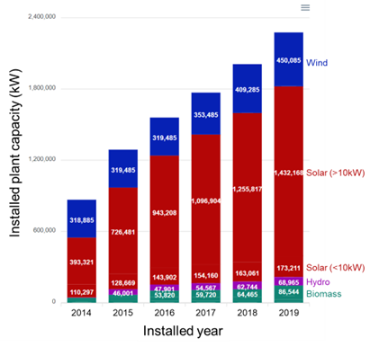

(b)

(a)

Figure 2. Prototyped web interface of *RE-CODE View*. (a) Installation history of renewable power plant of each municipality, (b) Renewable energy potential

Figure 3. Major entities and data attributions considered in supply/demand matching and simulation

* + - 1. RE-CODE Sim and Value: Region-level Simulation and Evaluation Tool for Technology Installation Planning

*RE-CODE Sim* is a tool to calculate changes in mass/energy flows when various sets of technologies proposed by *Match* are installed to a region. It enables regional simulation by connecting multiple process unit models, similarly with chemical process simulators, including resource acquisition, transport, energy/material conversion, storage, demand-side entities and so on. *RE-CODE Value* performs LCA based on the mass/energy balance information calculated by *Sim*, and evaluates environmental and economic impacts at the regional level. Premature technologies often change in scale and performance due to their development stage. Prospective LCA should be possible by constructing model structures that can treat such technological parameters as variables in the simulation, though conventional LCA have treated these parameters as given ones based on inventory data from actual operating process. For this purpose, the technology database described in previous section is being designed to store parameters and their changes as well. Figure 3 shows the major entities and data attributions considered in supply/demand technology matching and simulation.

The simulator for woody biomass CHP (Combined Heating and Power), which had been prepared for our own LCA research and were not designed for external users, were re-programmed for integration into a cloud system. As a test of the effect of the simulator, the application of the reconstructed woody biomass CHP simulator to a LCA in different regions resulted in a significant speed-up. While the initial case study required a total of more than 6 months for basic investigation, data collection, model construction, and visualization, the application to a different region allowed the same LCA to be performed in only 3 days, it is approximately 60 times faster. To support the combined simulation of multiple technologies, commonization of the model structure that enables seamless connection between various technology unit models is required and under construction.

* 1. Conclusion

A conceptual design was conducted for a cloud system to facilitate the planning of technology installation to the region based on prospective LCA and IOA, and some of the elemental modules of the system were prototyped. Through the repeat of prototyping and review, issues in data aggregation and simulator construction became apparent. For example, methods for collecting local data and estimating missing data are urgent issues. Open data on renewable energy is increasingly released, but it is limited to major solar, wind, and small/medium-sized hydropower. For resources derived from agriculture and forestry and unutilized industrial waste heat, which can be important for regional resource recycling, data acquisition has not even progressed yet. support tools and mechanisms for data collection at the local level is needed. As one of the countermeasures, we have started to study the combination of aerial photography by satellite or drone and AI image analysis, as well as a system that enables easy data registration including location data from personal smartphones.

In addition, while the cooperation with device developers is essential for enriching the contents of the technical database, through communication with them we have reaffirmed the importance of ensuring confidentiality, especially with regard to cutting-edge technologies. We plan to implement measures to ensure from both of software and hardware issues, that is confidentiality in data processing and security on the infrastructure side. It is also found to be necessary to design incentives for data providers so that they can benefit from the data.

Acknowledgements

This work is supported by MEXT/JSPS KAKENHI (JP21K17919) and JST COI-NEXT (JPMJPF2003). Activities of the Presidential Endowed Chair for “Platinum Society” at the University of Tokyo are supported by Mitsui Fudosan Corporation, Sekisui House, Ltd., the East Japan Railway Company, and Toyota Tsusho Corporation.

References

R. Arvidsson, A. M. Tillman, B. A. Sandén, M. Janssen, A.Nordelöf, D. Kushnir, S. Molander, 2018, Environmental Assessment of Emerging Technologies: Recommendations for Prospective LCA. Journal of Industrial Ecology 22, 1286−1294

JA. Bergerson, A. Brandt, J. Cresko, M. Carbajales-Dale, H. L. MacLean, H. S. Matthews, S. McCoy, M. McManus, S. A. Miller, W. R. Morrow III, I. D. Posen, T. Seager, T. Skone, S. Sleep, 2020, Life cycle assessment of emerging technologies: Evaluation techniques at different stages of market and technical maturity. Journal of Industrial Ecology 24, 11–25

S. Fujii, T. Nakagaki, Y. Kanematsu, Y. Kikuchi, 2022, Prospective life cycle assessment for designing mobile thermal energy storage system utilizing zeolite, Journal of Cleaner Production, 365, 132592

IEA, ETP Clean Energy Technology Guide, https://www.iea.org/data-and-statistics/data-tools/etp-clean-energy-technology-guide, last accessed on 28/12/2023

Y. Kanematsu, K. Oosawa, T. Okubo, Y. Kikuchi, 2017a, Designing the scale of a woody biomass CHP considering local forestry reformation: A case study of Tanegashima, Japan, Applied Energy, 198, 160-172

Y. Kanematsu, T. Okubo, Y. Kikuchi, 2017b, Activity and Data Models of Planning Processes for Industrial Symbiosis in Rural Areas, Kagaku Kōgaku Ronbunshū, 43(5), 347-357 (in Japanese)

Y. Kikuchi, M. Nakai, Y. Kanematsu, K. Oosawa, T. Okubo, Y. Oshita, Y. Fukushima, 2020, Application of technology assessments to co-learning for regional transformation: a case study of biomass energy systems in Tanegashima, Sustainability Science, 15, 1473-1494