Integrated design and location of a green hydrogen production chain from waste biomass. A case study in western Andalusia.

Silvia Moreno*, Laura R. Piñeiro, Alicia Ronda, Bernabé A. Fariñas,   
Pedro Haro.

Department of Chemical and Environmental Engineering.   
Escuela Técnica Superior de Ingniería. Universidad de Sevilla.   
Camino de los Descubrimientos. Seville, Spain.

[*spuerta@us.es](mailto:*spuerta@us.es)

Abstract

Green hydrogen is a promising energy vector for decarbonising the industrial, transport, and heating sectors. The foremost renewable technology used to produce it is nowadays electrolysis. Nevertheless, there are some problems related to this technology. Among them, the use of pure water, the need of large solar and wind power plants, and the seasonality of this kind of resources. Within this context, the use of residual biomass to produce green hydrogen can be essential to face these problems. However, when using residual biomass as a feedstock, one of the main challenges is the definition of a supply chain at the local level ensuring the economic and environmental viability of this resource. Against this background, the application of holistic models that analyse the availability and composition of raw materials and their relationship to process design is crucial. Therefore, the objective of this study is to apply a holistic systematic model to determine the value chain of biomass as a green hydrogen feedstock. Hence, different alternatives have been studied for the valorisation of waste biomass in western Andalusia. Waste biomass from olive groves without assigned use, burnt, or deposited in landfills has been selected as raw material. The results show that using the proposed methodology, the emissions when using hubs for coprocessing do not lead to a significant increase in emissions. Figure 1 shows the system boundaries of the analysed base case proposed in this work.

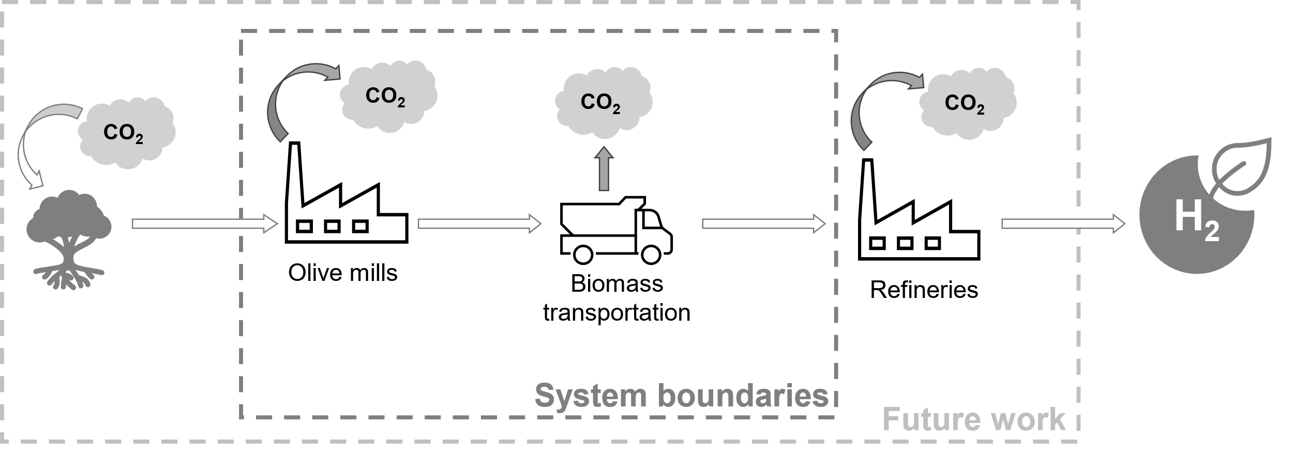

Figure 1. System boundaries of present and future work.

**Keywords**: Value chain model, location-allocation problem, waste biomass, hydrogen.

* 1. Introduction

Life cycle analysis (LCA) represents one of the best methods used to study the sustainability of projects. However, in these analyses, the calculation of emissions due to transport is usually carried out in a generalised way to allow it to be applied to a wider number of geographical areas (Freer, 2022). In the case of biomass, emissions, and costs due to transport have a strong influence, so the LCA for a specific project involving the use of biomass in a specific location needs another kind of analysis. Furthermore, the location of raw material hubs not only affect the cost of production, but also has an environmental impact associated with the production of the final product (Taifouris et al., 2020). For this reason, an in-depth analysis in addition to LCA is needed when biomass is involved to study the environmental, social, and economic impact in a specific area.

According to the Andalucian government, this community has a great potential for biomass, especially olive grove biomass. Due to the large amount of olive pruning waste, for example, its management consists of burning it on site or chipping it. In both cases, the CO2 stored in the tree during its growth is returned to the atmosphere (Galán-Martín et al., 2022). Valorisation of this type of residues producing green hydrogen can have a great impact to decarbonise the energy system and also to reduce issues associated to its current management, but alternatives should be studied in-depth in order to guarantee its environmental, economic and social benefits.

* 1. Methodology
     1. Waste biomass

Biomass selection was based on a previous work in which an analysis of potential biomass (to produce green hydrogen through thermochemical process) and availability in western Andalusia was carried out. Of a total list of 43 possible residual biomasses generated in the area, only three have been selected. The filters used for that were based on the total amount generated, the hydrogen yield of each biomass, and the consideration of other current uses of this biomass. Once the filters have been applied, the available biomasses are olive-tree pruning, olive stone, and olive pomace. After selecting the biomasses to be used in the process, different paths for the supply chain have been proposed, as shown in Figure 2. The path in bold shows one of the possible supply chain routes. The proposed scheme to define the value chain implies that hydrogen will be produce directly in the refinery, so in this work, only biomass transport will be evaluated. This is owing to the risk associated to hydrogen transport (Li et al., 2022).

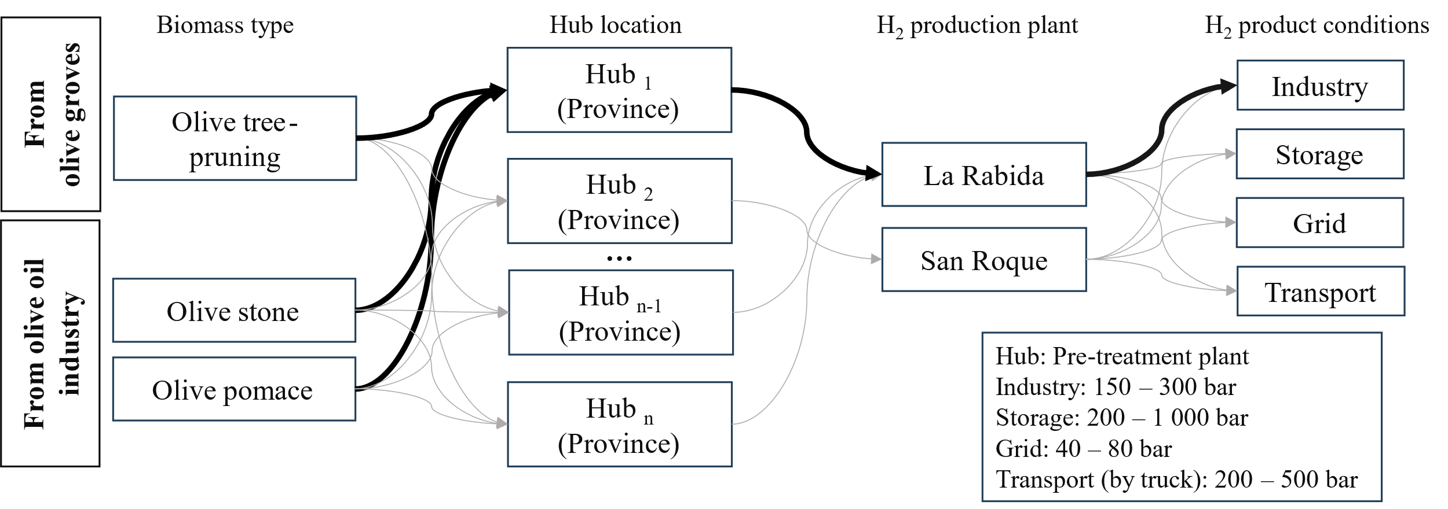

Figure 2. Possible pathways for the supply chain

Considering that the selected biomass is generated in oil mills, the location of the hubs will be based on the existing sites of the oil mills in the study area. For this purpose, a manual compilation was made of the active mills in the region, as well as their geographical coordinates. As the data concerning the amount of biomass generated is allocated to the municipalities, a GIS approximation has been made to assign each amount of biomass to its nearest olive mill. A total of 116 oil mills have been considered in the work.  
Regarding the energy efficiency of the selected biomasses, it has been estimated using the yield of hydrogen production by gasification and the low heating value (LHV) of hydrogen and biomass on a dry basis.

* + 1. Biomass transportation

Biomass transport will be approached in two possible ways: i) a base case in which biomass will be transported from each olive mill to the nearest refinery and ii) considering that some olive mill will be used as hubs in which a pretreatment of biomass will be applied before it is transported to the refineries. It has also been considered that each olive mill should produce at least 11.4 tonnes of biomass. This amount is based on the useful load capacity of a commercial dump truck. The volume that can be transported with the selected truck is 19.32 m3. According to the literature, most of the biomass supply chains are small and have radii between 50 and 386 km. Rail and maritime transport is often used for more distributed supply chains, where distances range from 100 to 1 500 km (Freer et al., 2021).

A polygon restriction shape has been included to verify whether the areas where biomass facilities will be installed are available for this purpose. This shape contains data about airports, watercourses, mining extraction areas, wetlands and marshes, sand flats, livestock trails, or railway, among others.

* + 1. Environmental impact

To calculate the environmental impact, the carbon footprint has been used to measure the direct effect on the atmosphere of the greenhouse gases (GHG) of each of the raw materials considered. To evaluate this, the distances between the suppliers and the chemical poles considered must be considered. Emissions in the mass of CO2, CH4 and N2O per kilometre travelled for road transport by lorries were obtained from the Ministry of Ecological Transition and Demographic Challenge (Ministerio para la transición ecológica y el reto demográfico, 2023). To compare the three emissions, GWP 100 (Global Warming Potential) has been used (IPCC, 2023).

Emissions associated with the transport of biomass to the pretreatment hubs and from the hubs to the industrial hydrogen production plants have been calculated from Eq. (1)

|  |  |
| --- | --- |
| $${Emission}_{hub}={distance}_{hub}·kg{CO}_{2 eq}/km (∀hub)$$ | (1) |

Where:

CO2 eq is the sum of CO2, CH4 and N2O emissions using the GWP 100

However, the emission calculated with the above equation does not consider the number of travels necessaries according to the amount of biomass and its density and the load capacity of the selected truck. Regarding the unit emission associated with transport (considering the unit emission as the emission generated in one single path, that is, the way from the olive mill to the refinery), it is calculated according to equations Eq. (2) and Eq. (3).

|  |  |
| --- | --- |
| $$EmissionU_{hub}=\frac{{Emission}_{hub}}{Loading capacity} (∀hub)$$ | (2) |
| $$EmissionT_{ye,hub}=EmissionU_{hub}·\sum_{i}{{av}_{ye,i,hub} } (∀hub)$$ | (3) |

Where:

avye,i,hub is the available volume of the dry residual biomass *i* from the hub *hub* in the year ye (/year)

* 1. Results
     1. Waste biomass

Given the biomasses used in the study and their location, the distances from the different points of origin to the possible destinations were calculated. For this purpose, a road transport by dump truck has been used. The results obtained for one of the clusters are presented in Table 1. Each olive mill has been represented with a number to anonymise the study.

Table 1. Distances for analysis in a cluster in Case 2

|  |  |  |
| --- | --- | --- |
| **Olive mill** | **Hub** | **Distance (km)** |
| 18 | 47 | 101 |
| 32 | 47 | 40 |
| 33 | 47 | 12 |
| 37 | 47 | 32 |
| 41 | 47 | 25 |
| 47 | 47 | 1211 |

*1Distance between the hub and the refinery considered in this work.*

Energy efficiency is shows in Figure 3 using a Sankey diagram.

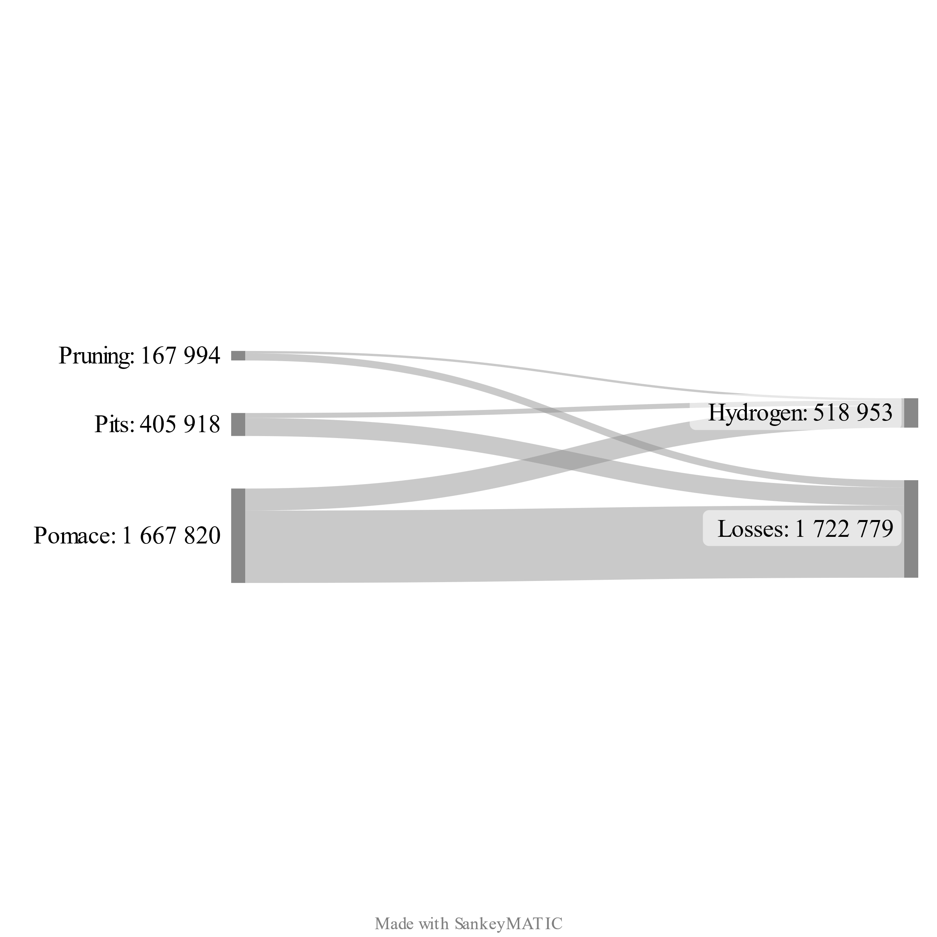

Figure 3. Energy efficiency of hydrogen production (MWh, LHV basis)

* + 1. Biomass transportation

Based on the literature consulted, the type of transport selected is the road. This decision is reinforced by a study carried out in Andalusia in which it was found that there is an absolute predominance of road over rail for distances of less than 200 km (Caceres-Sanchez & Ruiz De Alarcón-Quintero, 2014). According to the area proposed for this study (which includes the provinces of Cadiz, Seville, and Huelva), the maximum distance by road between the biomass generation point and the hydrogen production hubs is 169 km. Furthermore, there are logistical and accessibility reasons, as the areas where biomass is generated are easily accessible by road.

To study the effects of creating pretreatment hubs, three cases have been proposed:

1. Base case. Biomass is transported from each olive mill to the refinery without pretreatment.
2. Case 1. The biomass is pelletised in each olive mill and then transported to the refinery.
3. Case 2. The mills are grouped into clusters, and the one with the largest amount of biomass is selected as the hub for pretreatment before being transported to the refinery.

Figure 3 shows the study area with the location of the refineries and olive mills considered in this study. Each cluster is indicated with a different symbol and the hub where the biomass will be pelletised in the case 2 is indicated with a circle surrounding the selected points.

Clusters were calculated using the restricted Delaunay triangulation in ArcGIS Pro with a cluster size restriction that guarantees the minimum availability of biomass in each cluster so that the selected truck can be fully loaded.

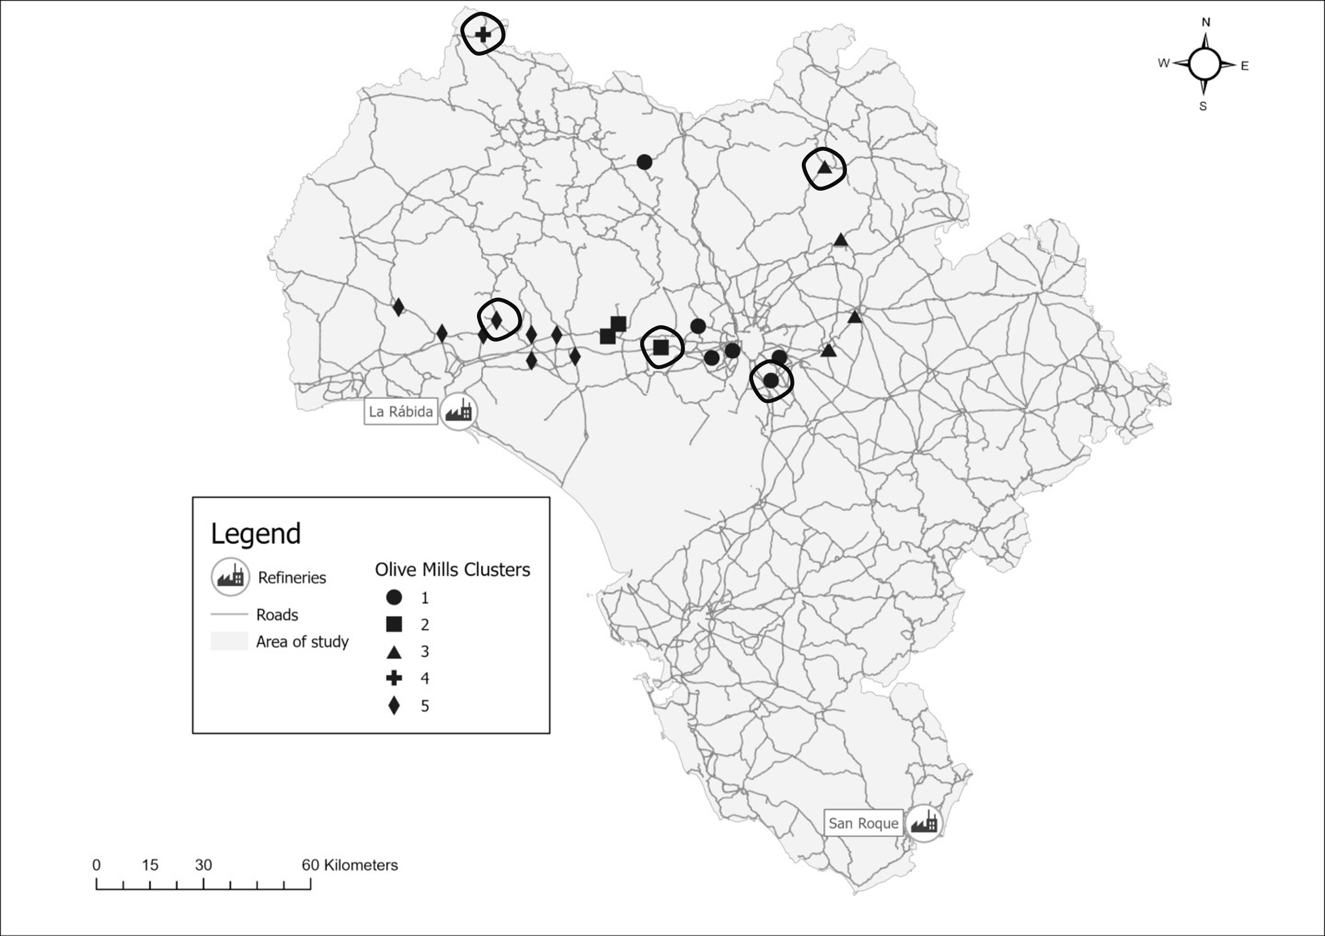

Figure 4. Olive mill cluster and refinery’s location

* + 1. Environmental impact

The selected value for the greenhouse gases emitted per kilometre travelled corresponds to the estimated value for N2 (good vehicle with maximum mass exceeding 3.2 t but not exceeding 12 t) and N3 (good vehicle with a maximum mass exceeding 12 t) diesel trucks. Table 2 shows the emission factor values per gas for the year in question.

Table 2. Greenhouse gas emission factors for road transport and GWP 100

|  |  |  |  |
| --- | --- | --- | --- |
| **2022** | **CO2 (kg/km)** | **CH4 (g/km)** | **N2O (g/km)** |
| **Diesel trucks** | 0.586 | 0.012 | 0.029 |
| **Gas trucks** | 0.673 | 0.140 | 0.006 |
| **GWP 100** | 1 | 27.9 | 273 |

The load capacity has been established at 19.32 m3. This factor has been selected in terms of volume because the main problem in biomass is its low density. Moreover, when calculating the final emissions of each hub in one year, the available volume of biomass is used instead of the mass amount. Consequently, in this study it will be compare the transport of raw biomass and its transport after a pretreatment.

The CO2 equivalent obtained in the three proposed cases is shown in Table 3.

Table 3. Greenhouse gases emissions in one year depending on the case of study.

|  |  |
| --- | --- |
| **Case Study** | **t CO2 eq/year** |
| **Base Case** | 210 |
| **Case 1** | 196 |
| **Case 2** | 199 |

* 1. Conclusions

The results show that pretreatment on site of biomass is crucial to reduce GHG emissions when transporting biomass. However, the selection of hubs for the coprocessing of biomass does not imply a significant increase in emissions if the methodology used in the study is followed. The establishment of hubs can, nevertheless, facilitate the technical and economic reduction when proposing the biomass value chain for its subsequent transformation into green hydrogen at the refinery. In order to continue with this approach, future work will include the analysis of the hubs for the other refinery in the study area, as well as the economic study that the proposed value chain would entail.

* 1. Acknowledgements

This study has been supported by grant PID2020-114725RA-I00 of the project GH2T funded by MCIN/AEI/10.13039/501100011033 and by the “European Union”. The Ph.D. grant of S. Moreno from Universidad de Sevilla under VII PPIT-US is acknowledged.

References

Caceres-Sanchez, N., & Ruiz De Alarcón-Quintero, C. (2014). *Nueva Metodología para la Evaluación de la Demanda de Transporte de Mercancías Peligrosas Por Vía Férrea en la Comunidad Autónoma de Andalucía*. Universidad de Sevilla.

Forster, P., Storelvmo, T., Armour, K., Collins, W., Dufresne, J.-L., Frame, D., Lunt, D. J., Mauritsen, T., Palmer, M. D., Watanabe, M., Wild, M., & Zhang, H. (2023). The Earth’s Energy Budget, Climate Feedbacks and Climate Sensitivity. *Climate Change 2021 – The Physical Science Basis*, 923–1054. https://doi.org/10.1017/9781009157896.009

Freer, M. (2022). *Carbon-Efficient Transportation via Spatially Explicit Modelling of Large-Scale Bioenergy with Carbon Capture and Storage Supply Chains*. Tyndall Centre for Climate Change Research.

Freer, M., Gough, C., Welfle, A., & Lea-Langton, A. (2021). Carbon optimal bioenergy with carbon capture and storage supply chain modelling: How far is too far? *Sustainable Energy Technologies and Assessments*, *47*. https://doi.org/10.1016/j.seta.2021.101406

Galán-Martín, Á., Contreras, M. del M., Romero, I., Ruiz, E., Bueno-Rodríguez, S., Eliche-Quesada, D., & Castro-Galiano, E. (2022). The potential role of olive groves to deliver carbon dioxide removal in a carbon-neutral Europe: Opportunities and challenges. *Renewable and Sustainable Energy Reviews*, *165*, 112609. https://doi.org/10.1016/j.rser.2022.112609

Li, H., Cao, X., Liu, Y., Shao, Y., Nan, Z., Teng, L., Peng, W., & Bian, J. (2022). Safety of hydrogen storage and transportation: An overview on mechanisms, techniques, and challenges. *Energy Reports*, *8*, 6258–6269. https://doi.org/https://doi.org/10.1016/j.egyr.2022.04.067

Ministerio para la transición ecológica y el reto demográfico. (2023). *Factores de emisión. Registro de huella de carbono, compensación y proyectos de absorción de dióxido de carbono.*

Taifouris, M., Martín, M., Martínez, A., & Esquejo, N. (2020). On the effect of the selection of suppliers on the design of formulated products. *Computers and Chemical Engineering*, *141*. https://doi.org/10.1016/j.compchemeng.2020.106980