Hybrid Symbolic-Numeric Computation based on Resultant Theory for Process Simulation

Shuhui Zhang,a Fei Zhao,a* Xi Chena*

a **State Key Laboratory of Industrial Control Technology, College of Control Science and Engineering, Zhejiang University, Hangzhou, Zhejiang, China**

[xi_chen@zju.edu.cn](mailto:xi_chen@zju.edu.cn)**,** [zhaofeizju@zju.edu.cn](mailto:zhaofeizju@zju.edu.cn)

Abstract

Solving nonlinear equation systems stands as a fundamental challenge within the realm of process systems engineering (PSE). At present, numerical computation stands as the primary technical avenue for tackling these complexities. This approach boasts computational efficiency and has found extensive utility across numerous real-world scenarios, whereas limited by numerical instability. This article aims to leverage the characteristics of symbolic computation to address the inherent deficiencies of numerical computation. Drawing on the classical theories within the realm of symbolic computation, particularly the resultant theory, this study proposes a symbolic-numeric hybrid computational method tailored for nonlinear equation systems in the field of PSE. The proposed method primarily addresses the challenge of limitation to polynomial systems. The existing resultant theory is only applicable to polynomial equations. This proposed method summarizes a general model of the transcendental terms with respect to variables. Then symbolic representations are introduced for these terms, followed by triangularization of the original nonlinear system to obtain a new equivalent system. This enables solving the new system dimension-wise to enhance solution convergence and reduce initial-value dependency.

**Keywords**: symbolic-numeric computation, resultant theory, transcendental terms.

* 1. Introduction

The intricate nature of industrial processes demands robust solutions to nonlinear equation systems, as they are the mathematical backbone of process modeling. Numerical computation, with its efficiency and versatility, has long been the method of choice in PSE (Grossman and Westerberg, 2000). However, its limitations, including susceptibility to local solution traps and dependence on initial conditions, have spurred the exploration of alternative methodologies. Symbolic computation, rooted in mathematical logic and algebraic manipulation, emerges as a compelling alternative that holds the promise of overcoming the drawbacks associated with purely numerical approaches.

Motivated by the challenges of conventional numerical methods, this research seeks to introduce a paradigm shift in nonlinear equation system solving for PSE. By integrating symbolic computation, particularly leveraging resultant theory, the proposed hybrid approach aims to provide solutions that guarantee completeness and accuracy—qualities often elusive in purely numerical methods.

The resultant theory holds paramount significance in engineering, particularly in the analysis of equation systems. This mathematical framework plays a pivotal role in determining the combined effect of multiple forces or variables acting on a system. Engineers rely on resultant theory to simplify complex equations and streamline the solution process, enabling efficient problem-solving in various fields such as structural engineering, fluid dynamics, and control systems (Chiasson et al., 2003). The application of resultant theory enhances the understanding of system behavior and facilitates the design of robust and optimized engineering solutions.

However, the traditional utilization of resultant is confined to polynomial equations, posing a limitation in its utility for the diverse transcendental terms encountered in PSE. To overcome this limitation, the proposed method introduces a comprehensive model for transcendental terms, enabling their symbolic representation. This innovation facilitates the triangularization of the original nonlinear system, transforming it into an equivalent system that can be solved dimension-wise. The symbolic-numeric hybrid approach thus combines the accuracy of symbolic computation with the computational efficiency of numeric methods, providing a robust solution to the challenges posed by nonlinear equation systems in PSE.

The structure of this paper is designed to comprehensively present the proposed hybrid symbolic-numeric computational method. Section 2 provides a detailed exploration of the theoretical foundations of symbolic computation, focusing on resultant theory and its limitations. Section 3 outlines the methodology, describing the extension of resultant theory to transcendental terms by reformulating models appropriately and the subsequent solution of triangularized systems dimension by dimension. Section 4 presents the application of the proposed method to the Pressure-Enthalpy flash problem, illustrating the effectiveness of the method in real-world scenarios and discussing the obtained results through the hybrid method. Finally, Section 5 concludes the paper by summarizing key findings and discussing potential directions for future research.

* 1. Resultant theory for equation system

Resultant is a classic operation in symbolic computation, used to solve systems of polynomial equations. The resultant of two polynomials can be defined as follows while the property of resultant with two polynomials is presented subsequently in Property 1.

**Definition 1**. Resultant.

Given two multi-variate polynomials $f,g⊆R\left[x_{1}, ⋯,x_{n}\right]$, $f$ and $g$ can be formulated into the univariate polynomial with main variable $x_{n}$ as follows:

|  |  |
| --- | --- |
| $\begin{matrix}f\left(x_{1},…,x_{n}\right)=a_{m}x_{n}^{m}+a_{m-1}x_{n}^{m-1}+⋯+a_{0} \\ g\left(x_{1},…,x_{n}\right)=b_{l}x_{n}^{l}+b_{l-1}x_{n}^{l-1}+⋯+b_{0}\end{matrix}$ | (1) |

where $a_{i},b_{j}⊆R\left[x_{1},⋯,x_{n-1}\right]$, $i=0,⋯,m$, $j=1,⋯,l$. The resultant of $f$ and $g$ with respect to $x_{n}$ is thus the determinant of the Sylvester matrix (Chtcherba and Kapur, 2004).

**Property 1** (Gelfand et al., 2008): Given two multi-variate polynomials $f,g⊆R\left[x_{1},⋯,x_{n}\right]$, their resultant with respect to $x_{n}$ is denoted by $r⊆R\left[x_{1},⋯,x_{n}\right]$. If and only if $f$ and $g$ have a common root in the real domain $R\left[x_{n}\right]$, the resultant $r$ is equal to zero.

According to the property of resultants, we can deduce a chain of dimension reduction for a polynomial equation system, as shown in Figure 1. Given a polynomial system with $n$ equations and $n$ variables, the dimension of the equation system can be reduced by choosing a polynomial and a main variable to compute resultants with other polynomials with respect to the main variable. When the equations are homogeneous, the numbers of the variables and equations are consistent. The solutions in $n$ −dimensional space will be projected into the 1−dimensional space. Geometrically, the set of solutions forms a series of scatters distributed in projective space. However, it might occur that the excess components are deduced in the set of solutions. For example, only one equation is generated in $R\left[x_{1},x_{2}\right]$ describing a curve with infinite solutions. This scenario appears due to certain dependencies between the high−dimensional equations, which bothers the generalization of the resultant theory to solve equation systems. But for a process in reality, the physical attributes impel the solutions shrinking into exact points without aforementioned dependencies. This characteristic intensively motivates us to introduce the resultant to solve the process simulation problems by reducing the dimension of systems.

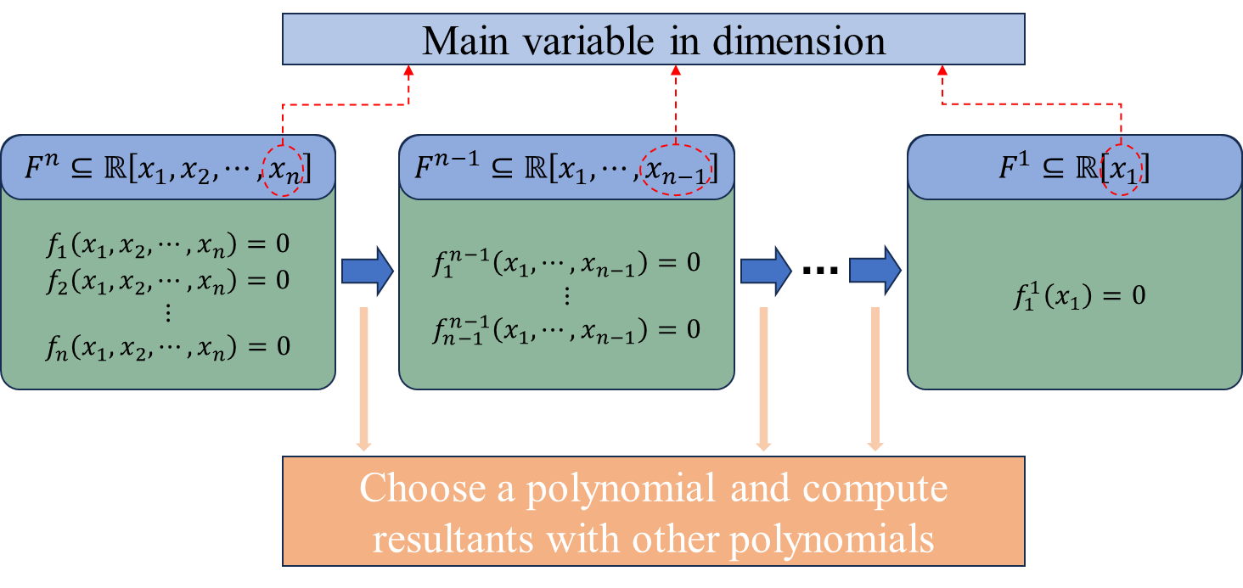

**Figure 1.** The chain of dimension reduction for a polynomial equation system.

* 1. Hybrid symbolic-numeric method

Based on the dimension-reducing chain presented in Figure 1, it is natural to apply the resultant theory to projecting high-dimensional equational systems into 1-dimensional systems and to solve the triangularized equations subsequently. In our previous work, the similar procedure has been proposed and applied to several cases through the CAD algorithm (Zhang et al., 2021). However, the primary obstacle in this procedure is that resultant operation is confined to polynomial systems. On the contrary, transcendental function terms are often involved in practical process systems. Therefore, resultant theory cannot be directly applied to such systems to reduce system dimensionality and enhance solution stability.

Nevertheless, we can leverage the capability of symbolic computation to manipulate symbolic entities. By introducing symbolic representations for transcendental function terms, we can reformulate the equation system into an algebraic form. Subsequently, employing knot theory allows us to execute dimensionality reduction operations on the reconstructed algebraic system, resulting in an equivalent system in trigonometric form, which is helpful to solve the system effectively and obtain solutions in a more manageable and interpretable format.

* + 1. Model reformulation

A process simulation problem can always be formulated into an equation system, denoted as $F\left(x\right)=0$. Given the presence of transcendental terms, it becomes imperative to treat the variables within these terms distinctly from other variables first. Building upon this distinction, symbolic representation is introduced to facilitate the model formulation, as shown as Eq. (2).

|  |  |
| --- | --- |
| $$F\left(x\right)=0⟺\hat{F}\left(y,z,T\left(z\right)\right)=0\underset{⇔}{ \text{Model reformulation} }P\left(y,z,M\right)=0$$ | (2) |

where $z⊆x$ represents the variable involved in transcendental terms and $y=x\backslash z$. Then by representing the transcendental terms $T\left(z\right)$ in $\hat{F}$ with new symbols denoted as $M$, a new algebraic system is generated with respect to variables $y$, $z$ and $M$.

In the sequel, the similar dimension-reducing procedure is executed as shown in Figure 1. Although the number of variables excesses the number of equations caused by introducing the new variables $M$, the resultant of two polynomials in $P$ can also be computed to reduce the dimension of system. However, the choice of main variables in every dimension cannot be casually determined since the new variables are related to the origin variables $z$ in essence. Thus, the order of main variables during the dimension-reducing procedure should be identified as the variables $y$ that have no concern with the transcendental terms. The $n$ −dimensional system $F$ can be reduced to $m$ −dimensional system by utilizing the appropriate model reformulation and applying the resultant theory into the new model assuming the variables $z$ include $m$ elements.

* + 1. Dimension-wise solution

In the above section, the model reformulation and dimensionality reduction are proposed to handle equation systems with transcendental terms by resultant theory. Then a lower−dimensional system with respect to $z$ and $M$, denoted as $P^{m}$, can be generated, which includes the introduced symbols $M$ representing the transcendental terms. The procedure is presented in the left part of Figure 2, as the first part of the proposed method. Thus, these terms can be substituted into $M$ in $P^{m}$ and a $m$ −dimensional equation system with respect to $z$, denoted as $\hat{P}$, can be solved to locate the solution of $z$.

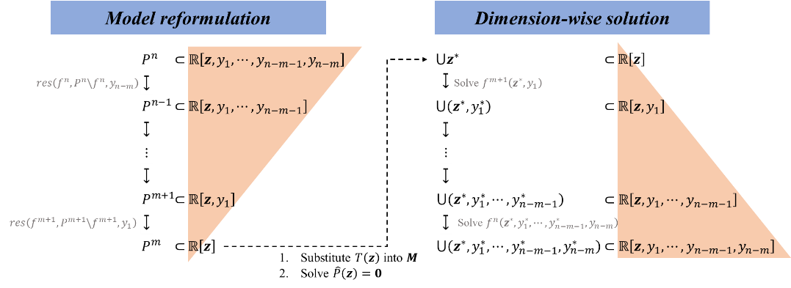

**Figure 2.** Procedure of the proposed hybrid symbolic-numeric method.

Subsequently, the solution $z^{*}$ can be substituted into the chosen polynomials in every dimension of $y$. For example, the chosen polynomial for $y_{1}$ −dimension is denoted as $f^{m+1}$. By solving $f^{m+1}\left(z^{*},y_{1}\right)$, which is a univariate polynomial with respect to $y_{1}$, the solution of $y_{1}$ can be rooted. The same steps of substitution and polynomial rooting are repeated dimension by dimension from $y_{1}$ to $y_{n-m}$. The all solutions exactly constitute the solution $x^{*}$ of the origin system $F\left(x\right)=0$ without the dependency on the whole initial value of $x$. The complete procedure of the proposed hybrid symbolic-numeric method is presented in Figure 2. In addition, it can be more stable to solve a lower-dimensional non-linear system while the univariate polynomials dimension by dimension can be solve without much effort.

* 1. Case study

A case of pressure-enthalpy flash in Figure 3, where *n*-Hexane (component 1) is separated from *n*-Octane is adopted to illustrate the hybrid symbolic-numeric method.

**Figure 3.** Diagram of pressure-enthalpy flash with involved variables.

The vapor-liquid equilibrium ratios can be determined utilizing the Antoine equation, while the molar enthalpies of individual compounds can be computed through empirical polynomials. Eq. (3) delineates the model for the pressure-enthalpy flash, in which *V*1 = 69 kmol/h, *x*11 = 0.331121, *HL* = 572658 cal/h and *P*2 = 760 mm Hg. Noted that the model contains two exponential terms on account of the Antoine equation. By introducing new variables $M_{1}$ and $M_{2}$ to represent the two exponential terms, Eq. (3) is reformulated into a polynomial equation system.

|  |  |
| --- | --- |
| $$\left\{\begin{matrix}H_{L2}=L_{2}\left(51.72x_{21}T_{2}+66.07x_{22}T_{2}\right) \\ V_{1}-V_{2}-L_{2}=0 \\ x_{11}V_{1}-L_{2}x_{21}-V_{2}x_{21}=0 \\ x_{21}+x_{22}=1 \\ y_{21}+y_{22}=1 \\ y_{21}-\frac{{10}^{\left(6.87776-\frac{1171.530}{\left(224.366+T_{2}\right)}\right)}}{P_{2}}×x_{21}=0 \\ y_{22}-\frac{{10}^{\left(6.92374-\frac{1355.126}{\left(209.517+T_{2}\right)}\right)}}{P_{2}}×x_{22}=0 \\ H_{V2}=V_{2}\left(y_{21}\left(7678+31.83T_{2}+0.0903T_{2}^{2}\right)+y_{22}\left(10444.7+41.836T_{2}+0.1218T_{2}^{2}\right)\right) \\ H_{V2}+H_{L2}=H_{L} \\ 50,0,0,0,0≤T_{2},x_{21},y_{21},x_{22},y_{22}≤150,1,1,1,1 \\ V_{2},L_{2}≥0,0\end{matrix}\right.$$ | (3) |

Through computing the resultants based on the reformulated model, an equation with $M_{1}$ and $M_{2}$ can be generated in $T_{2}$ −dimension. By substituting the exponential terms represented with $M_{1}$ and $M_{2}$, the deduced system is essentially an equation with respect to $T_{2}$. Due to the exponential terms, the initial value of $T_{2}$ have to be specified to solve the equation, which is initially given as 85 ℃. Then, once the solution of $T_{2}$ is obtained, the other variables can be solved dimension by dimension. Finally, the result is *T*2 = 88.0400 ℃, *x*21 = 0.474662, *y*21 = 0.838120, *x*22 = 0.525338, *y*22 = 0.161880, *V*2 = 32.2351 kmol/h, *L*2 = 36.7931 kmol/h, *HV*2 = 380704 cal/h, *HL*2 = 191954 cal/h. In addition, we compare the proposed hybrid symbolic-numeric method with other two methods as presented in Table 1, in which one is applied in SyPSE of our previous work via projection operation of CAD as another hybrid method and the other is a numeric method by iterations.

In contrast to the hybrid method in SyPSE, the proposed approach represents a significant advancement, particularly in the part of symbolic computation, contributed by the computational efficiency of resultant theory. Furthermore, the part of numeric computation by dimension-wise solution is consistent in time consumption. In comparison to purely numeric methods, the enhanced computational efficiency of solving triangularized systems dimension by dimension is noteworthy. Overall, the proposed method not only encompasses additional advantages when compared to existing approaches but also exhibits superior performance in computational efficiency.

**Table 1.** Time cost comparison of the proposed method with other methods.

|  |  |  |  |  |  |
| --- | --- | --- | --- | --- | --- |
| Methods | SyPSE (Zhang et al., 2021) | | Proposed method | | Numeric method*a* |
| Projection of CAD | Dimension-wise solution | Resultant theory | Dimension-wise solution |
| Time cost | 0.186 s | 5.92e-4 s | 1.37e-3 s | 5.92e-4 s | 5.23e-3 s |
| Total cost | 0.187 s | | 1.96e-3 s | | 5.23e-3 s |
| *a. The numeric method is to invoke “fsolve” function in Python.* | | | | | |

* 1. Conclusions

The primary contribution of this research lies in the development of a hybrid symbolic-numeric method that addresses the inherent deficiencies of traditional numerical approaches. By leveraging resultant theory, the proposed approach offers enhanced solution convergence and reduces reliance on initial value choices. The significance of this lies not only in the realm of theoretical advancements but also in practical applications within PSE.

The methodology is not only theoretically sound but also practical, as demonstrated through its application to the Pressure-Enthalpy flash problem. The results underscore the effectiveness of the proposed approach in providing solutions more robustly. Additionally, the method's utility extends to scenarios involving inequality constraints, showcasing its ability to expedite the elimination of infeasible solutions and thereby enhancing overall computational efficiency.

References

The authors gratefully acknowledge the Fundamental Research Funds for the Central Universities under Grant 226-2023-00109 and the financial support from the National Key Research and Development Program of China (2022YFB3305901).

References

J. Chiasson, L. Tolbert, K. McKenzie, 2003, Control of a Multilevel Converter Using Resultant Theory, IEEE Transactions on Control Systems Technology, 11(3), 345–354.

A. Chtcherba, D. Kapur, 2004, Constructing Sylvester-type resultant matrices using the Dixon formulation, Journal of Symbolic Computation, 38(1), 777-814.

I. Grossmann, A. Westerberg, 2000, Research Challenges in Process Systems Engineering, AIChE Journal, 46(9), 1700–1703.

I. Gelfand, M. Kapranov, A. Zelevinsky, 2008, Discriminants, Resultants, and Multidimensional Determinants, Springer Science & Business Media.

S. Zhang, F. Zhao, C. Zheng, L. Zhu, X. Chen, 2021, SyPSE: A Symbolic Computation Toolbox for Process Systems Engineering Part II─Design for PSE Applications, Ind. Eng. Chem. Res. 60(45), 16317–16329.