**Role of the Throughput Manipulator on Economic and Sustainable Process Operation**

Aayush Guptaa, Prakhar Srivastavaa, Nitin Kaisthaa*

a Department of Chemical Engineering, IIT Kanpur 208016,India

*nkaistha@iitk.ac.in

Abstract

This study investigates the pivotal role of the throughput manipulator (TPM) in designing the material balance control structure of an integrated plant. Two industrial processes, ester purification and acetone manufacturing, are assessed under three different regulatory control structures (CS1, CS2, CS3) with distinct TPM choices, fresh feed, first major unit inside the recycle loop, and the bottleneck capacity constraint. Economic impact is rigorously evaluated in two operational modes. Results underscore that locating the TPM at the bottleneck within the material recycle loop (CS3) yields substantial energy savings (9.72% and 4.24% in Mode I) and increased maximum throughput (5.8% and 4.67% in Mode II) compared to a conventional structure (CS1) for ester purification and acetone manufacturing process, respectively. This highlights the considerable economic and sustainability benefits associated with positioning the TPM inside the material recycle loop, particularly when bottleneck is identified and within the recycle loop.

**Keywords**: Quality control, Throughput maximization, Material balance control

* 1. Introduction

Liquid surge capacities, like the reflux drum or bottom sump in a distillation column, are essential in a plant for smoothing flow transients. Non-self-regulatory liquid hold-up (inventory) in a surge capacity requires an inventory controller to ensure long-term material balance closure (inflow equals outflow). Inventory (material balance) regulation emerges as a primary objective in integrated plants with multiple surge capacities, aiming to automatically close the material balance across individual plant units and the entire plant.

Considering total material balance control on an individual unit, often processing liquid for cost-effectiveness, a SISO (Single input single output) PI controller manipulates the connected process stream flow rate to maintain the total material inventory. However, this flow manipulation acts as a material balance disturbance to the connected unit, prompting adjustments in its inventory controller. This initiates the propagation of flow transients across a series-cascade of units. The severity of transients depends on the 'tightness' of inventory control and the MV-CV (manipulated variable - controlled variable) pairings on individual units, known as the material balance control structure (Buckley, 1964).

In designing the material balance control structure, the throughput manipulator (TPM) is a critical decision. The chosen independent flow rate becomes the TPM, setting the material processing rate (throughput) of the cascade. The location of the TPM affects the orientation of individual unit material balance controllers and the direction of transient propagation. The outwardly radiating control structure implies that flow transients move away from the TPM (Kaistha, 2021). This direction impacts the magnitude of flow variability experienced by different plant units.

Flow transients become particularly relevant in material recycle systems, where positive feedback due to recycle can amplify flow variability. This variability significantly contributes to variations in key process variables (PVs) constrained at maximum or minimum values for economic/sustainability optimization. Key PVs, such as guaranteed minimum product quality and bottleneck capacity constraints, require optimal operation close to these limits without violation, necessitating a back-off that represents an economic loss. Mitigating flow variability, a significant contributor to variability in key constraint PVs, reduces this back-off and economic loss (Downs & Skogestad., 2011).

This study explores the role of the material balance control structure with alternative TPM locations in mitigating flow variability and enhancing sustainable/economic operation performance. The major contribution is a quantitative demonstration that locating the TPM inside the material recycle loop results in significant energy savings (up to 9.7%) and higher production (up to 5.4%).

The article proceeds with detailed case studies on two integrated processes—an ester recovery process and an acetone manufacturing process—to quantitatively evaluate the impact of the material balance control structure on economic/sustainable process operation.

* 1. Process Case Studies

We conduct detailed case studies on the ester purification process (Ojasvi & Kaistha, 2016) and the acetone manufacturing process (Luyben, 2011) to assess the economic and sustainability benefits of a regulatory control structure at various TPM locations. Our focus is on mitigating product quality variability and addressing plant capacity bottleneck constraints to enhance throughput and sustainability. The analysis encompasses two operational modes: Mode I, featuring a specified nominal throughput with minimum product quality as the primary constraint, and Mode II, operating at the maximum achievable throughput with bottleneck equipment capacity as an additional constraint.

We explore three control structures at different TPM locations: (i) fresh feed, (ii) feed to the first unit operation inside the recycle loop, and (iii) bottleneck capacity constraint inside the recycle loop. To evaluate operational profitability, we introduce time-series and sinusoidal inputs at various plant locations. Economic metrics include total energy consumed in Mode I and maximum product rate in Mode II

* + 1. **Case Study 1: Ester Purification Process**

In the ester purification process, a ternary ethyl acetate-ethanol-water fresh feed, combined with an ester-rich recycle stream, is introduced at the bottom of a liquid-liquid extractor (LLX). Simultaneously, a water solvent stream is introduced at the LLX's top to extract alcohol, leaving the bottoms as the alcohol wash stream. The light organic raffinate stream exiting the LLX top is subjected to distillation column to obtain nearly pure ester product in the bottoms, and the distillate is recycled back to the LLX as shown in figure 1. The maximum production is constrained by the solvent rate to the LLX, and the distillation column approaches the flooding limit, serving as the bottleneck capacity constraint.

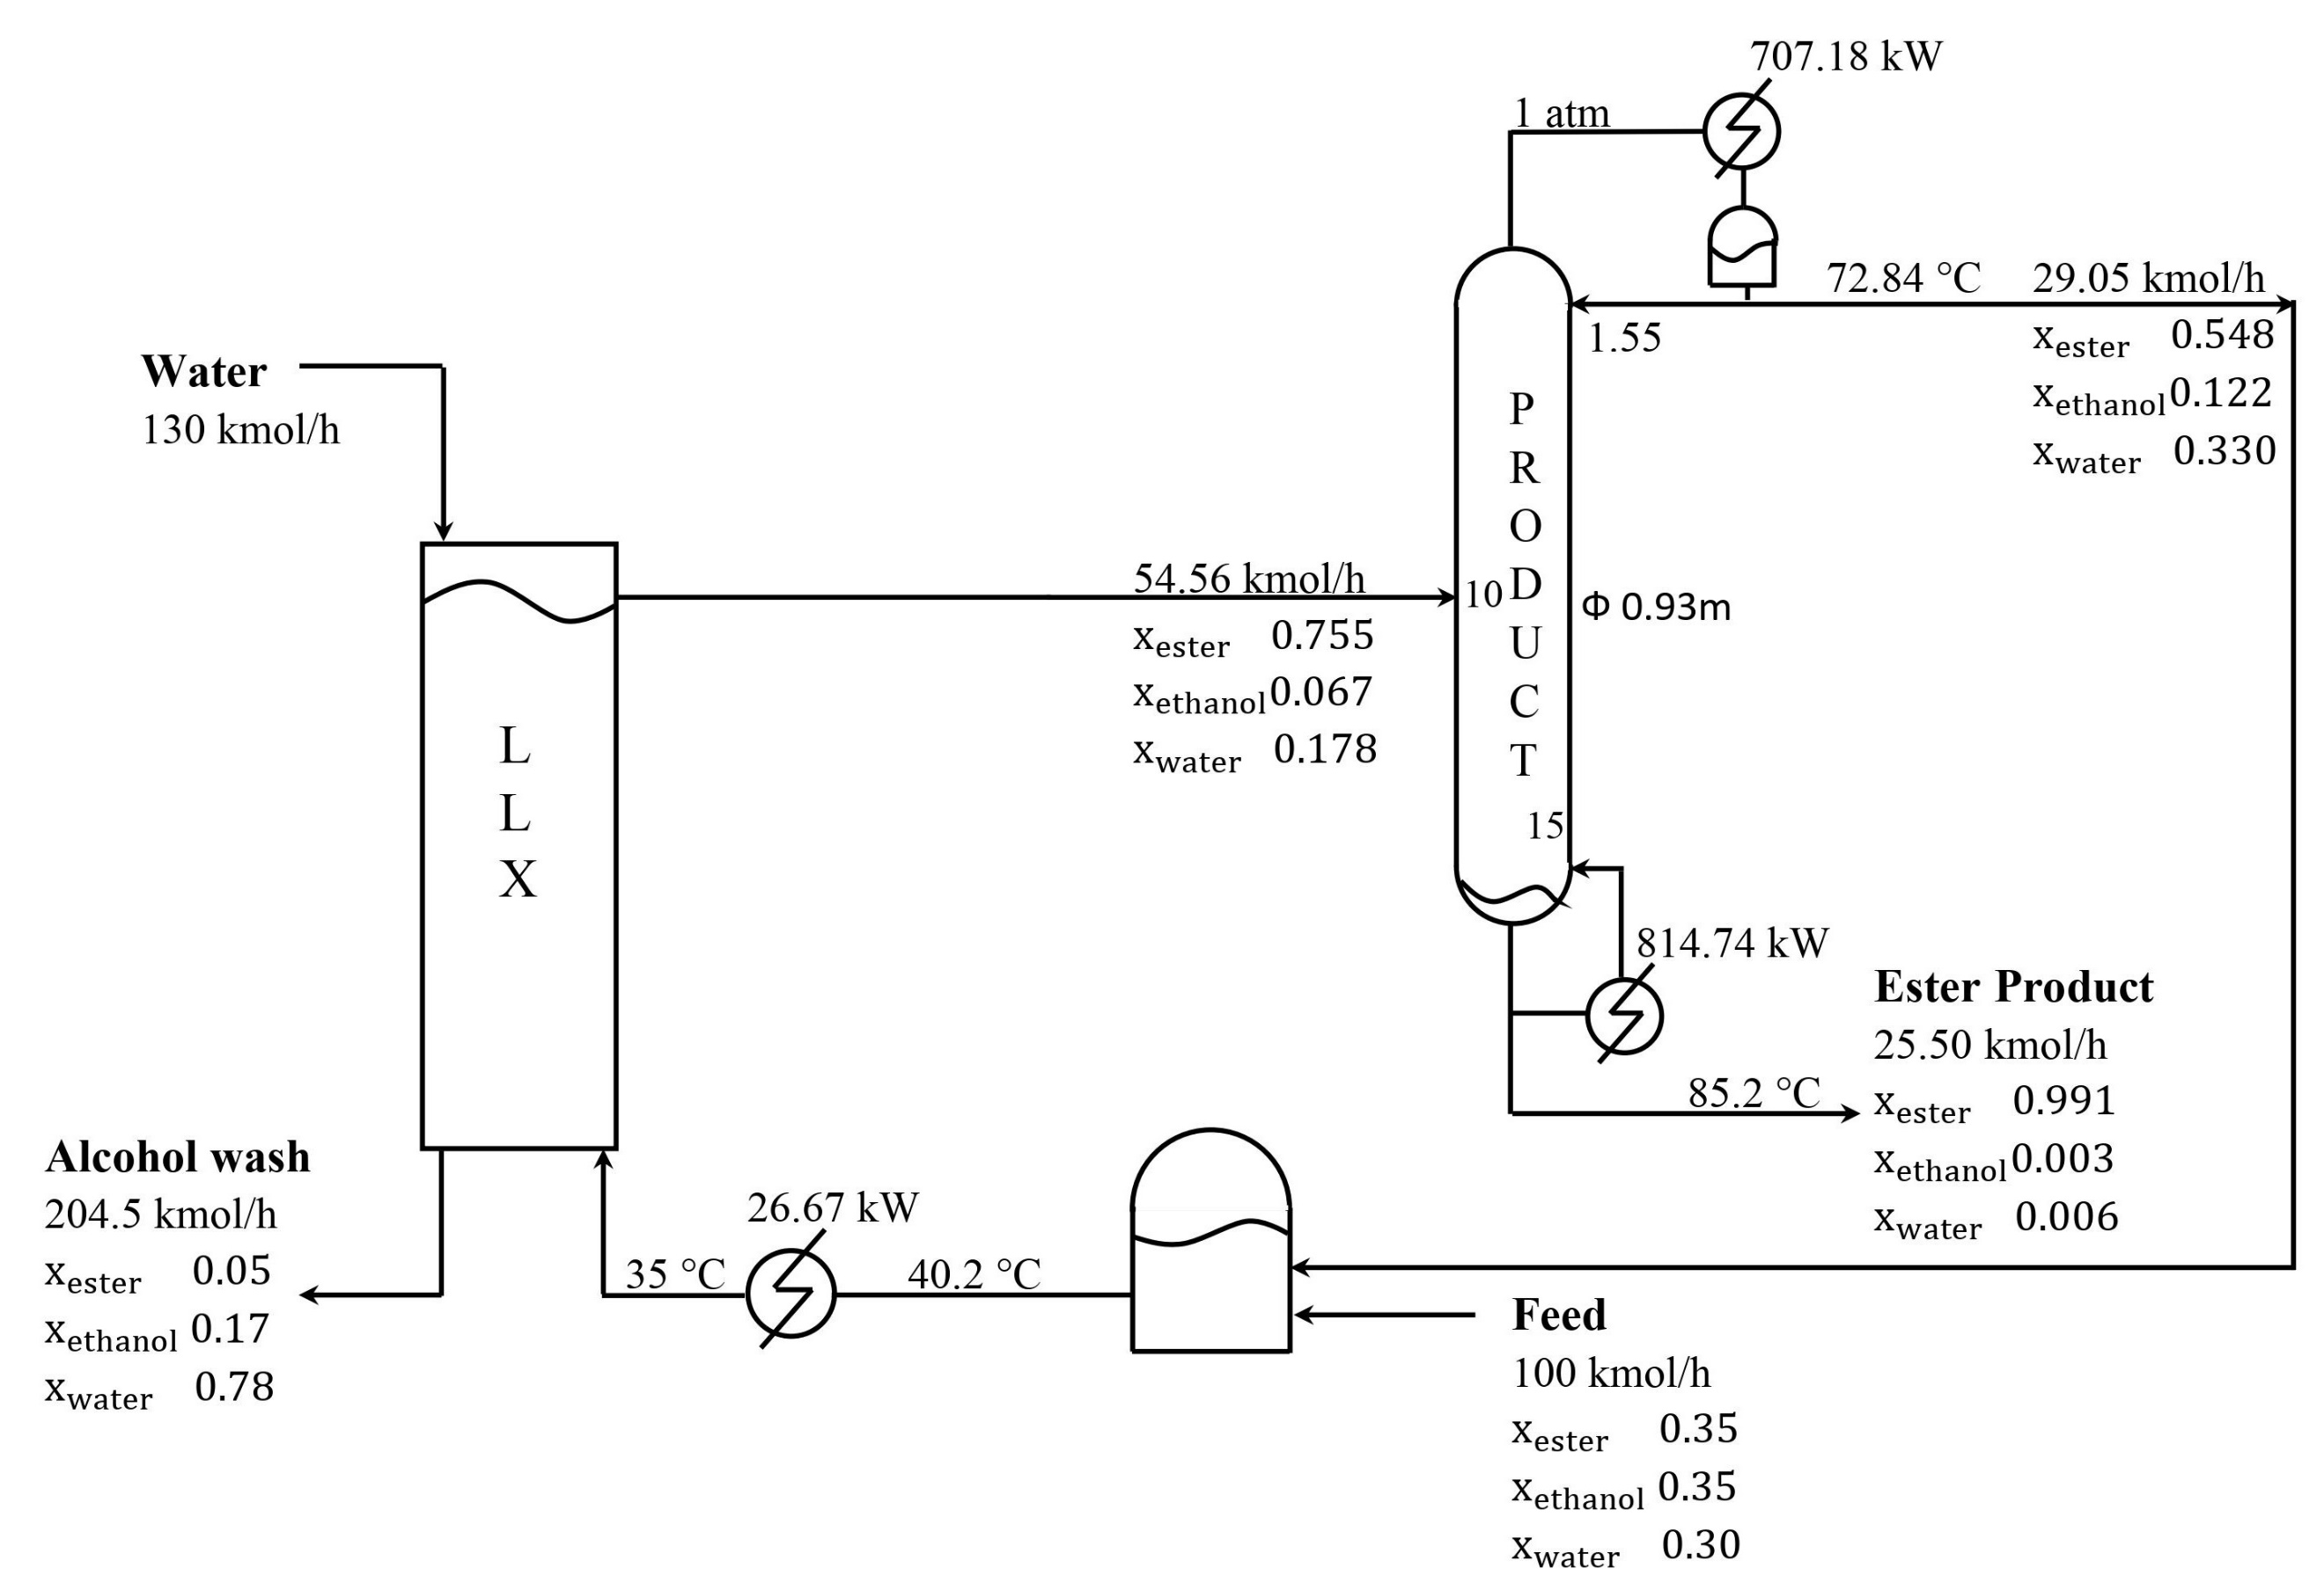

Figure 1: Nominal design and operating condition of ester purification process

Table 1: Mode 1 result for ester purification process

|  |  |  |  |
| --- | --- | --- | --- |
| **Control Structure** | **(10-3)** | **Qtot (kW)** | **Energy Savings (%)** |
| CS1 | 3.57 | 904.5 | 0.00 |
| CS2 | 2.62 | 854.4 | 5.54 |
| CS3 | 0.33 | 816.6 | 9.72 |
| * No back-0ff $x_{prod}^{min}$ =0.991 | | | |

Three alternative control structures, CS1 (TPM at the fresh feed), CS2 (TPM at the total feed (Ftot) to the LLX), and CS3 (TPM at the column boil up, U), are evaluated.

In CS1, the control strategy involves regulating the LLX feed tank level by manipulating the tank exit stream valve. The LLX feed stream temperature is maintained by adjusting the LLX feed cooler duty. The raffinate rate is adjusted to keep the organic-aqueous interface level near the top of the LLX, given the continuous nature of the aqueous phase in the LLX. On the distillation column, the column pressure is controlled by adjusting the condenser duty, while the bottom sump and reflux drum levels are managed by adjusting the bottoms and distillate rates, respectively. The reflux is maintained in ratio with the distillate, and the sensitive stripping tray 14 temperature is regulated by adjusting the column reboiler duty.

In CS2, with Ftot as the TPM, the LLX feed tank level is regulated by manipulating the fresh feed rate, while other control loops remain unchanged from CS1. In CS3, where the TPM is the column boil-up (U), tightly controlled by adjusting the column reboiler duty, Product column sensitive tray temperature is regulated by the column feed rate. The organic-aqueous interface in the LLX is controlled using Ftot, and the LLX feed tank level is adjusted by manipulating the fresh feed rate. The inventory control system upstream of the TPM operates in the reverse direction of process flow, but other loops are consistent with CS1.

In Mode I dynamic results, obtained for a continuous 48-hour operation at an average feed processing rate (throughput) of 100 kmol/h, the minimum back-off in the product column stripping tray temperature setpoint is ensured to avoid violating the minimum product purity constraint. Table 1 summarizes the backed-off average ester product purity (xprod), total duty (Qtot), and energy savings for the three control structures—CS1, CS2, and CS3. Among them, CS3 exhibits the lowest total duty (Qtot), followed by CS2 and then CS1. In comparison to the conventional CS1, CS2 and CS3 achieve energy savings of 5.54% and 9.72%, respectively.

Table 2: Mode II result for ester purification process

|  |  |  |  |  |
| --- | --- | --- | --- | --- |
| **Control Structure** | **(10-3)** | **U# (103 kg/h)** | **Fresh Feed (kmol/h)** | **Throughput benefit (%)** |
| CS1 | 4.27 | 9.65 | 105.2 | 0.00 |
| CS2 | 3.73 | 9.76 | 107.0 | 1.71 |
| CS3 | 0.43 | 10.3 | 111.3 | 5.80 |
| * No back-0ff $x_{prod}^{min}$ =0.991, #maximum boil-up Umax = 10340 kg/h | | | | |

For Mode II, focused on throughput maximization, results are obtained with minimum back-off in both xprod and the column boil-up U from the bottleneck capacity constraint Umax for CS1, CS2, and CS3. Table 2 summarizes the average values for xprod, U, and F. CS3 attains the highest maximum throughput, followed by CS2 and then CS1. Relative to CS1, CS2 and CS3 achieve higher maximum throughputs by 1.71% and 5.8%, respectively.

* + 1. **Case Study 2: Acetone Process**

Figure 2 shows the nominal and operating condition of the acetone process, which is produced via the dehydrogenation of isopropyl alcohol (IPA). A near-azeotropic IPA-water feed, combined with a similar recycle stream, undergoes vaporization and superheating before entering an oil-heated packed bed reactor. The endothermic dehydrogenation reaction occurs, producing acetone and hydrogen. The reactor effluent is cooled, and condensed, and the resulting condensate is collected in a flash drum. The H2-rich non-condensable gas is absorbed in an absorber using water solvent. The lean gas exits, while the absorber and flash drum liquids are mixed and fed to a product column, recovering pure acetone at the top. An overhead vapor vent release uncondensed H2 gas. The acetone-free bottom is further processed in a recycle column to separate wastewater, with the IPA-water azeotrope distillate recycled to the vaporizer. Three plantwide regulatory control structures, CS1, CS2, and CS3, are under consideration. CS1 employs a conventional approach with the TPM at the fresh IPA-water feed. Downstream inventory controllers follow the process flow direction. Key control points include manipulating heat duty for vaporizer level, adjusting reactor preheater duty for feed stream temperature, controlling reactor exit stream temperature by manipulating reactor heat duty, and adjusting cooling duties for reactor effluent two-stage cooling. Absorber pressure is maximized by keeping the flash drum vapor exit valve fully open, regulated by manipulating the absorber exit lean gas valve. All levels are controlled using liquid outflow valves, and condenser pressure is regulated by condenser duty on both columns. Sensitive stripping tray temperature is adjusted by manipulating the reboiler duty. Reflux is controlled in ratio with distillate on the product column and in ratio with column feed rate on the recycle column. Product purity on the product column is controlled through biasing the L/D ratio multiplier output.

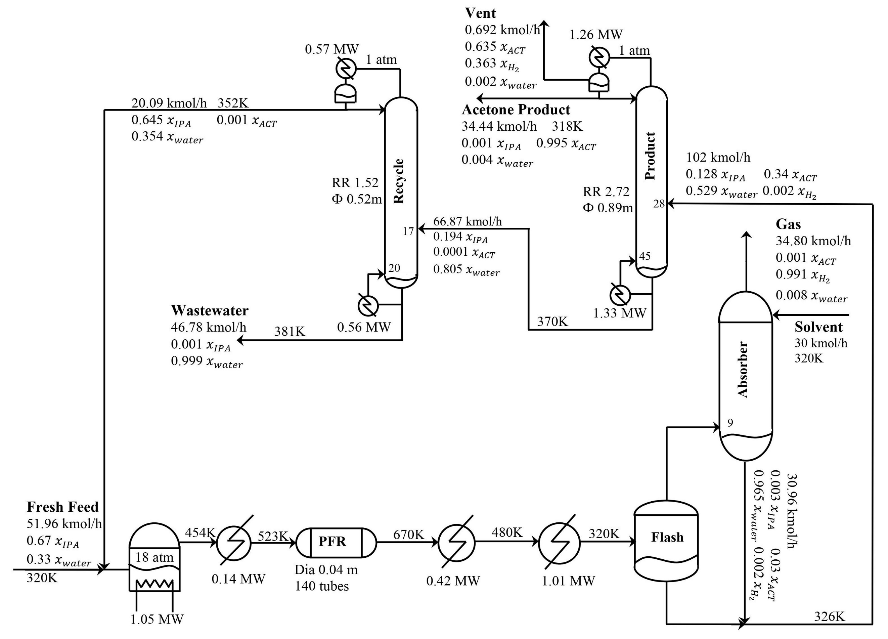

Figure 2: Nominal design and operating condition for acetone manufacturing process

Table 3: Mode I result for acetone manufacturing process

|  |  |  |  |
| --- | --- | --- | --- |
| **Control Structure** | **(10-3)** | **Qtot (kW)** | **Energy Savings (%)** |
| CS1 | 2.0 | 3112.6 | 0.00 |
| CS2 | 1.1 | 3005.2 | 3.45 |
| CS3 | 0.8 | 2980.5 | 4.24 |
| * No back-0ff $x_{prod}^{min}$ =0.995 | | | |

CS2 places the TPM at the total (fresh + recycle) feed to the vaporizer, controlled by manipulating the fresh feed rate. All other control loops mirror those of CS1.CS3 designates the product column pressure drop (∆Pcol1) as the TPM, tightly controlled by manipulating the product column reboiler duty. However, since the reboiler duty is unavailable for stripping tray temperature control, CS3 adjusts the sensitive stripping tray temperature by manipulating the upstream flash drum effluent control valve position. Vaporizer and flash drum levels are controlled by manipulating the fresh IPA feed and vaporizer duty, respectively. All inventory controllers upstream of the product column TPM are in the reverse direction of process flow, while the remaining control loops remain consistent with CS1.

In Mode I dynamic results, with minimal back-off from the minimum acetone product purity constraint ($x_{prod}^{min}$), CS1, CS2, and CS3 are evaluated for process operation. The chosen TPM setpoint value ensures an average feed processing rate of 51.96 kmol/h (nominal value). Table 3 outlines the average values of xprod, and total duty (Qtot) over a 48-hour operation period. In terms of energy consumption, CS1 performs the least favorably, while CS2 and CS3 achieve energy savings of 3.45% and 4.24%, respectively, compared to CS1.

For Mode II backed-off maximum throughput dynamic results, CS1, CS2, and CS3 are assessed by setting appropriate setpoint values for xprod and TPM to touch, but not violate, $x_{prod}^{min}$ and $ΔP_{col1}^{max}$ during transients. Table 4 summarizes average values of xprod, ∆Pcol1, and throughput (F). CS1 exhibits the lowest maximum throughput, while CS2 and CS3 achieve higher throughputs by 1.2% and 4.6%, respectively.

Table 4: Mode II result for acetone manufacturing process

|  |  |  |  |  |
| --- | --- | --- | --- | --- |
| **Control Structure** | **(10-4)** | **# (bar)** | **Fresh Feed (kmol/h)** | **Throughput benefit (%)** |
| CS1 | 4.1 | 0.96 | 58.41 | 0.00 |
| CS2 | 3.4 | 0.97 | 59.12 | 1.22 |
| CS3 | 3.0 | 1.02 | 61.14 | 4.67 |
| * No back-0ff $x_{prod}^{min}$ =0.995, #maximum pressure drop $ΔP_{col1}^{max}$ = 1.022 bar | | | | |

* 1. Conclusion

The economic and sustainable performance of three control structures, CS1 (TPM at fresh feed), CS2 (TPM at feed to the first major unit inside the recycle loop), and CS3 (TPM at the bottleneck capacity constraint inside the recycle loop), is assessed for ester purification and acetone manufacturing processes. In Mode I , CS2 demonstrates energy savings of 5.54% and 3.45% over CS1 for the two processes, while CS3 achieves savings of 9.72% and 4.24%, respectively. In Mode II (maximum throughput), CS2 achieves higher throughputs by 1.71% and 1.22%, and CS3 by 5.80% and 4.67%, compared to CS1. From an economic and sustainability perspective, both in Mode I and Mode II, the evaluated structures rank as CS3 > CS2 > CS1.CS2 and CS3 notably outperform CS1 in both modes, as the TPM inside the recycle loop transforms material balance flow transients out of the loop, mitigating flow variability and resulting in lower variability in product quality (in both modes) and the bottleneck capacity constraint (Mode II). The results underscore the significant impact of TPM location on the outwardly radiating material balance control structure, emphasizing the importance of strategic choices and tuning to maximize realized benefits.

# **References**

Buckley, Page S. "Techniques of process control." (1964).

Downs, James J., and Sigurd Skogestad. "An industrial and academic perspective on plantwide control." Annual Reviews in Control 35, no. 1 (2011): 99-110.

Kaistha, Nitin. "Liquid level control in a recycle loop." Journal of Process Control 104 (2021): 11-27.

Luyben, William L. "Design and control of the acetone process via dehydrogenation of 2-propanol." Industrial & engineering chemistry research 50, no. 3 (2011): 1206-1218.

Ojasvi, and Nitin Kaistha. "Plantwide control for maximum throughput operation of an ester purification process." Industrial & engineering chemistry Research 55, no. 47 (2016): 12242-12255.