Facilitating the Shift Toward an Environmentally Friendly Plastic Waste Management Economy through Mathematical Optimization
Oluwadare Badejo,ª Borja Hernández,^{ab} Marianthi G. Ierapetritou.^{a*}

a Department of Chemical and Biomolecular Engineering, University of Delaware, 150 Academy Street, Newark, Delaware 19716, USA.
b TECNUN Engineering School, University of Navarra, Manuel Lardizabal Ibibildea 13, San Sebastian 20018, Spain.
mgi@udel.edu
Abstract
This work presents a multiperiod mixed integer linear programming (MILP) problem for planning the decarbonization of plastic waste management. The problem includes multiple plastic waste management technologies, transportation modes, technology location, and number of facilities for planning the decarbonization transition in the East Coast of the United States. The optimization problem is solved considering two type of decarbonization policies: a tax based policy, and a carbon cap policy. The former, reduces the emissions by 34%, which is not sufficient to meet the decarbonization agreements. This requires a carbon cap policy approach that promotes the use of sustainable technologies (mechanical recycling, chemical recycling, hydrocracking); instead of upcycling technologies that generate valuable products, e.g., upcycling of plastic wastes to lube oils and aldehydes through pyrolysis.
Keywords: Plastic waste management decarbonization, plastic upcycling, planning, mathematical programming.
  - Introduction
Plastic waste, with 400 million metric tons produced yearly, has become a critical environmental issue. After its first use, most of this plastic is landfilled without generating any value. Only 9% of the plastic waste is mechanically recycled, and 16% is incinerated (OECD, 2022). However, mechanical recycling degrades plastic waste, limiting its infinite recycling(Dogu et al., 2021; Larrain et al., 2021). Alternatively, chemical recycling and upcycling have appeared as solutions to this problem. Chemical recycling has been performed in two ways: through a solvent-precipitation process or with thermochemical processing. In solvent-precipitation, monomers are separated from mix plastic waste streams(Walker et al., 2020), and recovered with intact properties. Thermochemical recycling employs pyrolysis produce olefins that can be cracked to increase the content of light olefins (ethylene or propylene) that are finally polymerized (Larrain et al., 2021; Somoza-Tornos et al., 2020). Upcycling consists of the use of plastic waste for generating high-value products. This may involve different thermochemical techniques like gasification to produce hydrogen, hydrothermal liquefaction and hydrocracking to produce fuels, hydrogenolysis for lube oil production, or pyrolysis that produces a mixture of paraffins, aromatics, and olefins(Li et al., 2022). In particular, olefins can be upgraded to valuable products like lube base oils, plastics, or aldehydes. Among all these options, the technology and the product generated have been demonstrated to be critical contributors in plastic waste treatment's emissions and economic performance (Hernández et al., 2023). However, the recommended process for each product is dependent on the desired trade-off between economics and environmental objectives. Upcycling technologies can generate significant value from plastic waste and can be alternatives to mechanical or chemical recycling. The recommendations from the superstructure/process design point of view have been extended to strategic supply chain level (O. A. Badejo et al., 2023; Erickson et al., 2023). The supply chain design has selected the same technologies: upcycling methods for economic objectives and mechanical recycling for environmental objectives (O. Badejo et al., 2023). The electrification of the transportation also showed that under environmental objectives upcycling technologies are implemented in more areas and manage higher fraction of plastic waste. However, a high penetration of them increases the emissions compared to mechanical recycling with increased global warming potential (GWP).
This increase in the GWP may put climate agreements at risk and prevent maintaining temperature increase below 1.5 ºC. To avoid this increase in the GWP, it is therefore necessary to implement decarbonization policies that promote recycling technologies instead of upcycling ones. However, there is a need for a systematic assessment of the roadmap of the technologies and timeline to achieve the required objectives posed by global treaties. To propose such a roadmap, deciding the technologies, location, transportation methods, and when to implement them, in this work, we propose using mathematical programming to formulate and solve this problem. The novelty of this work lies in integrating an optimization strategy with a decarbonization approach, which targets net-zero emissions by 2050.
  - Methodology
A multiperiod mixed-integer linear programming (MILP) model is developed to determine the decarbonization roadmap for the East Coast of the United States. The optimization reproduces the market dynamics to increase the profit extracted from plastic waste with the environmental policies introduced as constraints. More details of the framework are given in the subsequent subsections.

    - Description of the proposed optimization framework.
We consider a three-echelon supply chain as a graph network $G\left(n,e\right)$. The supplier nodes are the county centers, facility nodes are the potential facility locations, and the consumer nodes are the refineries and the cities to take in the final products. The edges are transportation networks connecting the nodes; they transfer materials from one node to another. Each edge has two modes corresponding to electrical and conventional transportation. The network is structured such that at every time period $t$, commodity flows from node $n$ to $n^{'}$, through a transportation mode $m$. The flow quantity $Q(k,n,n',m,t)$ captures commodity movement involving raw materials $r$ and products $p$, with collection cost $φ_{n}$, for raw materials. Flows incur cost $α\left(m\right)$and emissions $β(m)$. Facilities transform commodities with yield $γ(k,k^{'}),$ operating cost $c(τ)$, and emissions $e\left(τ\right)$. Storage at facilities has cost $h\left(k\right)$. The optimization goal is to determine facility location, technology type $τ$, and capacity $l$, optimal commodity flows and inventory, and the required transportation modes.

      - Model Formulation
The set of equations for each node includes the continuity, flow, and conservation equations. Each supplier node represents a county, where the capacity is limited to the maximum amount of plastic generated in the county. At the potential facility nodes, decisions determine the selection of facility location, type, and capacity; these are implemented with a piecewise formulation, equations (1a) – (1g).
$$\sum_{τ}{y\left(n,τ,l,t\right)≤1 ∀ n∈F , l∈L , t∈T }$$ | $$(1a)$$
$$\sum_{l}{y\left(n,τ,l,t\right)}≤1 ∀ n∈F , τ∈Τ , t∈T$$ | $(1b)$
$$\sum_{τ,l}{y\left(n,τ,l,t\right)} ≤1 ∀ n∈F , τ∈Τ , t∈T$$ | $(1c)$
$$cL\left(l-1\right)×y\left(n,τ,l ,t\right)≤cap\left(n,τ,l,t\right)≤cL\left(l\right)×y\left(n,τ,l,t\right)$$  $$∀ n∈F , τ∈Τ, l∈L , t∈T$$ | $(1d)$
$$fcap\left(n,τ,t\right)= \sum_{l}{cap\left(n,τ,l,t\right)} ∀ n∈F , τ∈Τ, t∈T$$ | $(1e)$
$$\sum_{k}{Q^{T}\left(k, τ,n,t\right)}≤fcap\left(n,τ,t\right) ∀ n∈F , τ∈Τ, t∈T$$ | $(1f)$
$$\sum_{k}{Inv\left(k, n,t\right)}≤Invcap\left(n,t\right)×\sum_{τ,l}{y\left(n,τ,l,t\right)} ∀ n∈F, t∈T$$ | $(1g)$
Equations $(2a) – (2d)$ computes the costs and emissions at each node and arc. Equations (2a) and (2b) compute node and transportation mode operating costs. Equations (2c) and (2d) calculate node and transportation mode emissions. The technology costs implemented have been reduced with linear and piecewise linear approaches from our previous work (O. Badejo et al., 2023).
$$ncost\left(n,t\right)=\sum_{τ,l}{y\left(n,τ,l,t\right)}×μ\left(τ,l\right) +\sum_{k,n^{'},m}{φ\left(n\right)× Q(k,n,n^{'},m,t)} + \sum_{τ}{{c\left(τ\right)×Q}^{T}\left(τ,k, n,t\right)} + \sum_{k}{h\left(k\right)×Inv\left(k,n,t\right) } ∀ n, t$$ | $$(2a)$$
$$mcost\left(m,t\right)= \sum_{n,n^{'}}{fc\left(m\right)×ntrucks\left(n,n^{'},m,t\right)}+\sum_{k,n,n^{'}}{c\left(m\right)×Q(k,n,n^{'},m,t)} ∀m∈M, t∈T$$ | $$(2b)$$
$$nEmm\left(n,t\right)= \sum_{\left(k,τ\right)}{{e\left(τ\right)×Q}^{T}\left(k,τ, n,t\right)} ∀ n∈N , t∈T$$ | $$(2c)$$
$$mEmm\left(m,t\right)= \sum_{k,n,n^{'}}{β\left(m\right)×Q(k,n,n^{'},m,t)} ∀m, t$$ | $$(2d)$$

Facilities and transportation fleet decarbonization investments are allowed in each period (Eqs. 3a–3d). Eq. (3a) calculates period investments, including technology and facility costs. Eqs. (3c)–(3d) compute the residual amount and include it in the next 'period' budget. Two objectives are considered: profit and total emissions.
$$Investment\left(t\right)= \sum_{n,τ,l}{y\left(n,τ,l,t\right)}×μ\left(τ,l\right) + \sum_{n,n^{'},m}{fc\left(m\right)×ntrucks\left(n,n^{'},m,t\right)} ∀t∈T$$ | $$(3a)$$
$$Investment\left(t\right)≤EffBudget\left(t\right) ∀t∈T$$ | $$(3b)$$
$$Res\left(t\right)= EffBudget\left(t\right) -Investment\left(t\right) ∀t∈T$$ | $$(3c)$$
$$EffBudget\left(t\right) =Budget\left(t\right) +Res\left(t-1\right) ∀t∈T$$ | $$(3d)$$

The profit is shown in $(4a),$ and the emissions in $(4b)$.

$$profit=\sum_{k,n,n^{'},m,t}{pr\left(p(k\right))×Q\left(p\left(k\right),n,n^{'},m,t\right)}- \sum_{n,t}{ncost\left(n,t\right)}- \sum_{m,t}{mcost\left(m,t\right)} ∀ m, t$$ | $$(4a)$$
$$Emm\left(t\right)= \sum_{n}{nEmm\left(n,t\right)}+\sum_{m}{mEmm\left(m,t\right)} ∀t∈T$$ | $$(4b)$$

To solve the multi-objective problem, we cast the problem to a single objective by implementing the environmental policy as a constraint. In this way, we achieve the environmental objective while maximizing the profit of the entire network. This is explained in the next section.

      - Implementation of CO₂ Policies as Constraints.
Decarbonization policies are integrated as constraints in the multiperiod optimization model. The first policy involves CO₂ taxes, penalizing plastic waste treatment based on the GWP of the management technology. The penalty term is added to the objective function Eq. (5a) as $C^{tax}\left(t\right)$ representing penalties on emissions. Carbon tax policies are defined in the range of $10/ton_{CO2} to $50/ton_{CO2,} with an extrapolation through the years given by the estimated increase in the gross domestic product per person.
$$Obj=profit- \sum_{t}{C^{tax}\left(t\right)×Emm\left(t\right)}$$ | $(5a)$
The second decarbonization policy adopts carbon cap policies, setting an annual emission limit that gradually decreases towards a final target at the last period. A new constraint, Eq. $5(b)$, is included to ensure annual emissions stay below the specified target. The carbon cap target is set as a reduction of 50% in the Global Warming Potential (GWP) for 2030 as defined in the Paris Agreement(Chamas et al., 2020; New UN' 'roadmap' shows how to drastically slash plastic pollution | UN News, 2023).
$$Emm\left(t\right)≤TargetEmm\left(t\right) ∀t∈T$$ | $$\left(5b\right)$$

      - Case study
The MILP problem is applied to design the decarbonization roadmap for the plastic waste industry, evaluating three scenarios: (i) the first one considers no action on the system and aims to maximize the profit; (ii) the second case is using a carbon tax policy, and (iii) the third one considers a carbon cap policy with a constant reduction every year so the system can meet the 50% 'emissions' reduction by 2030.
  - Results
- Computational analysis
The optimization models were solved using GAMS/CPLEX on a PC with an Intel Core i7-10510U, 2.30GHz, and 16GB RAM. The algorithm was set to terminate at 10% optimality gap or 1000 seconds.

- Economic and environmental results of the system.
For the no-action case, the problem was solved to an 8% optimality gap, focusing on profit maximization and identifying 35 locations primarily employing pyrolysis and mechanical recycling. This approach, illustrated in Figure 1(a), processed 20 million metric tons of plastics annually, yielding a substantial $80 million profit. The high GWP of 2.7 kg_{CO2}/kg_{Plastic} reflected the reliance on conventional transportation modes over the 3-year investment period. Under the carbon tax scheme, Figure 1(b), the problem reached a 4% optimality gap, with penalties influencing technology distribution across 32 locations. Incorporating electric transportation modes and emphasizing pyrolysis in lubricant oil production contributed to a reduced $62 million profit. The lower GWP of 1.8 kg_{CO2}/kg_{Plastic} reflects the system's response to carbon taxes compared to the no-action case. In the context of the carbon cap scenario, Figure 1(c), the solution achieved a 7.5% optimality gap. Technologies such as pyrolysis, hydrocracking, and mechanical recycling were strategically distributed across 30 locations over a 5-year investment period, processing 21 million metric tons annually. The resulting profit of $39 million and a lower GWP of 1.3 kg_{CO2}/kg_{Plastic} was due to further decarbonization and stringent temporal environmental limits.
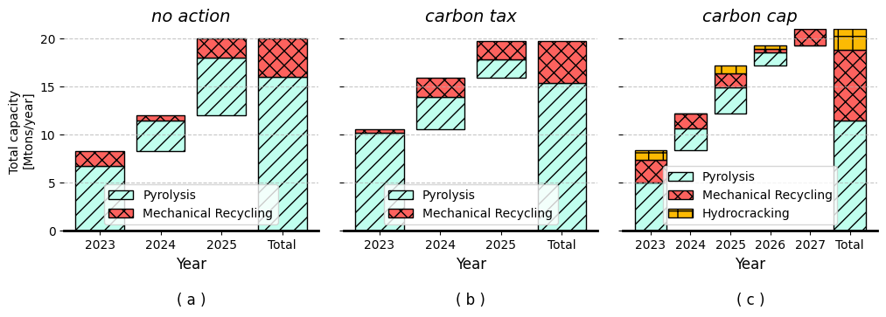
Fig 1: Temporal investment technologies; (a) no action; (b) carbon tax; (c) carbon cap

Comparing the operational outcomes, the results indicate that the carbon tax policy proves more profitable, while the carbon cap policy demonstrates greater potential for reducing carbon emissions. It is crucial to recognize that these policies operate from distinct perspectives: the carbon tax aims to incentivize stakeholders (consumers, manufacturers, and other actors) to minimize emissions and avoid penalties, making stakeholders the driving force behind emission reductions. Conversely, the carbon cap approach establishes emission goals, with stakeholders determining the cost of achieving those goals. This fundamental difference is evident at the operational level, as illustrated in Figure 2(a)-(c). Fig. (2a) demonstrates higher profits with a carbon tax scheme, albeit showing a temporal decline due to annual tax increases. In contrast, Fig. (2b) depicts the carbon cap's emission temporal decline, signaling effective emissions reduction through technology choices. Overall results (Fig 2c ) indicate the carbon tax's profitability, while the carbon cap successfully achieves decarbonization agreements, reducing emissions to less than 70%.
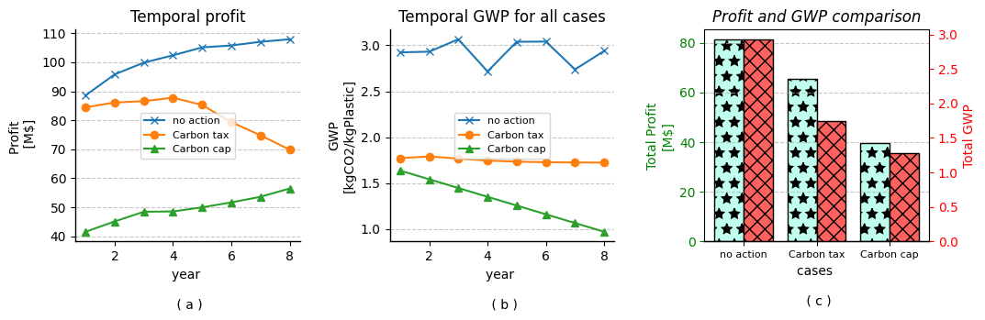
Fig 2: Operational results; (a) temporal profit profile; (b) temporal GHG profile;
(c) overall profit and GHG
  - Conclusions
This work has presented a framework for designing the decarbonization roadmap for the plastic waste industry. The novelty lies in integrating an optimization strategy with a pragmatic decarbonization approach aligned with the Paris Agreement, targeting a 50% reduction in current emissions by 2030 and net-zero emissions by 2050. The framework is based on developing a multiperiod MILP optimization problem that is solved by employing two types of policies: carbon tax and carbon cap policies. The comparison of the two policies shows that the carbon cap is more effective in reducing emissions than carbon tax and it promotes the introduction of sustainable plastic waste management practices. The technologies included in this management are mechanical recycling, hydrocracking, and chemical recycling through pyrolysis. On the other hand, carbon tax policies are less effective in promoting sustainable technologies, with a significant fraction of plastic waste diverted to the upcycling of plastic waste to other chemicals through pyrolysis. Future work will integrate a carbon trading scheme to boost carbon cap policy profitability. This enables trading surplus carbon between technologies while adhering to overall carbon cap limits.
Acknowledgments
The authors acknowledge financial support from the National Science Foundation, award numbers OIA – 2119754 and 2217472.

References
O. Badejo, B. Hernandez, DG. Vlachos M. Ierapetritou. Design of supply chains for Managing Plastic Waste: A Case Study for Low Density Polyethylene. Available at SSRN 4516671 2023.
A. Chamas, H. Moon, J. Zheng, Y. Qiu, T. Tabassum, JH Jang et al. Degradation Rates of Plastics in the Environment. ACS Sustainable Chem Eng. 2020; 8: 3494-511. https://doi.org/10.1021/acssuschemeng.9b06635
O. Dogu, M. Pelucchi, R. Van de Viver, PHM Van Steenberge, DR D’Hooge, A. Cuoci et al. The chemistry of chemical recycling of solid plastic waste via pyrolysis and gasification: State-of-the-art, challenges, and future directions. Progress in Energy and Combustion Science 2021;84:100901. https://doi.org/10.1016/j.pecs.2020.100901.
E. Erickson, J. Ma P. Tominac, H. Aguirre-Villegas, V. Zavala. Evaluating the Economic and Environmental Benefits of Deploying a National-Scale, Thermo-Chemical Plastic Waste Upcycling Infrastructure in the United States 2023. https://doi.org/10.26434/chemrxiv-2023-96xng
B. Hernandez, P. Kots, E. Selvam, DG Vlachos, MG Ierapetritou. Techno-Economic and Life Cycle Analyses of Thermochemical Upcycling Technologies of Low-Density Polyethylene Waste. ACS Sustainable Chem Eng 2023;11:7170–81. https://doi.org/10.1021/acssuschemeng.3c00636.
M. Larrain, S. Van Passel, G. Thomassen, B. Van Gorp TT Nhu, S. Huysveld et al. Techno-economic assessment of mechanical recycling of challenging post-consumer plastic packaging waste. Resources, Conservation and Recycling 2021;170:105607. https://doi.org/10.1016/j.resconrec.2021.105607.
H. A. Li H. Aguirre-Villegas, R.D. Allen, X. Bai, C. Benson, G.T. Beckham, et al. Expanding plastics recycling technologies: chemical aspects, technology status and challenges. Green Chemistry 2022;24:8899–9002. https://doi.org/10.1039/D2GC02588D
New UN' 'roadmap' shows how to drastically slash plastic pollution | UN News. 2023. https://news.un.org/en/story/2023/05/1136702 (accessed May 26, 2023).
ECD. Global Plastics Outlook: Policy Scenarios to 2060. Paris: Organisation for Economic Co-operation and Development; 2022.
A.Somoza-Tornos A. Gonzalez-Garay, C. Pozo, M. Graells, A. Espuña, G. Guillén-Gosalbez, Realizing the Potential High Benefits of Circular Economy in the Chemical Industry: Ethylene Monomer Recovery via Polyethylene Pyrolysis. ACS Sustainable Chem Eng 2020;8:3561–72. https://doi.org/10.1021/acssuschemeng.9b04835.
TW. Walker, N. Frelka, Z. Shen, AK. Chew, J. Banick, S. Grey, et al. Recycling of multilayer plastic packaging materials by solvent-targeted recovery and precipitation. Science Advances 2020;6:eaba7599. https://doi.org/10.1126/sciadv.aba7599.

