Investigating the Reliability and Interpretability of state-of-the-art Machine Learning Frameworks for Chemical Retrosynthesis
Friedrich Hastedt,ª Klaus Hellgardt,ª Sophia Yaliraki,ª Antonio del Rio Chanona,^{a*} Dongda Zhang^{b*}
ªImperial College London, Exhibition Rd, South Kensington, London SW7 2BX, UK
^{b}University of Manchester, Oxford Rd, Manchester M13 9PL, UK
a.del-rio-chanona@imperial.ac.uk, dongda.zhang@manchester.ac.uk
Abstract
The discovery of synthesis routes for novel molecules with machine-learning (ML) tools has shown tremendous success in the field of retrosynthesis. Despite this achievement, inconsistent performance evaluation of existing models and the lack of black-box interpretability slow down the adoption within real-life applications and conceal model shortcomings. To address these challenges, we present an automated benchmarking pipeline for model evaluation and introduce an original interpretability study. Our results indicate that purely data-driven models suffer from infeasible reaction predictions and limited model interpretability. Particularly, for simple molecules, we observe that Graph Neural Networks identify critical functional groups within the product molecule, while the popular Transformer architecture fails to recognize the groups. As the molecule increases in complexity, we show that both models propose unfeasible disconnections without providing an interpretable explanation. Conversely, we find that ML frameworks, based on chemical reaction rules, exhibit the best model performance with inherent interpretability. We emphasize the importance of chemically meaningful descriptors as an input to deep-learning models. Our research offers valuable insights that can guide the future advancement of retrosynthesis frameworks within the scientific community.
Keywords: Chemical Retrosynthesis, Machine Learning, Interpretable AI, Graph Neural Networks, Transformers.
  - Introduction
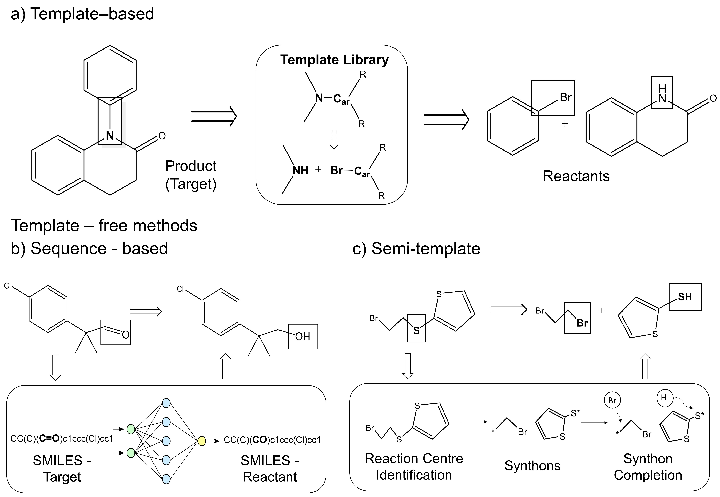
The synthesis of novel molecules is both a costly and time-consuming process. Finding synthesis routes to the target molecule is traditionally carried out by experienced chemists in a retrosynthetic setting. Herein, retrosynthesis refers to the detection of possible disconnection sites in the target molecule to find suitable precursors in a backward fashion. As the number of discovered molecules increases, manual synthesis planning becomes impractical. Corey & Wipke (1969) proposed leveraging computational tools, by encoding reaction rules for automated retrosynthesis. Despite their effectiveness, these expert-based tools face scalability issues, limiting their applicability to handle the growing number of reactions and novel molecules. Segler et al (2017). overcame the limitations of hand-encoded reaction rules by leveraging machine-learning to learn directly from existing chemical reactions within the literature. Their model is capable of directly identifying the best reaction rule (template) from literature precedent. Since their publication, three distinct branches of ML retrosynthesis have emerged: i) Template-based classification (Chen & Jung, 2021), ii) Template-free sequence translation (Liu et al, 2017), and iii) Semi-template graph edit (Sacha et al.,2021). As the naming suggests, the different architectures differ depending on the inclusion or exclusion of reaction templates. Template-based models follow the principle suggested by Segler et. al., that is to assign a specific template to the product molecule (Fig. 1a). Template-free models treat retrosynthesis as a SMILES-to-SMILES translation problem. Nowadays, this is achieved using the Transformer architecture (Fig. 1b). Finally, semi-template models perform edits on the molecular graph to arrive at the reactant molecules. The model identifies the most probable disconnection site (i.e., bond to break) within the molecule, known as the reaction center. This process yields chemically invalid fragments, namely synthons, which are transformed into reactants in the synthon completion step (Fig. 1c).
Figure 1: Overview of the three different retrosynthesis architectures.
Whilst each category holds its merit, performance comparison between frameworks has been difficult due to the absence of a robust and impartial evaluation metric. The current evaluation metric, top-k accuracy, biasedly rewards models that effectively recall the reaction provided in the existing dataset. However, it does not measure the ability of retrosynthesis models to propose chemically feasible reactions for unseen molecules. Despite this acknowledged shortcoming, recent research papers continue to utilize the top-k accuracy (due to ease of accessibility) to advertise the superiority of their work over existing models Furthermore, the lack of black-box interpretability conceals current model limitations. This work aims to overcome these challenges by introducing an automated open-source benchmarking pipeline to compare the performance of twelve state-of-the-art frameworks within the three retrosynthesis categories. The pipeline is complemented by an innovative interpretability study with the aim of revealing the extent of chemical knowledge acquired by popular deep-learning architectures.
  - Methodology
2.1 Benchmark Pipeline
The case study for the benchmarking pipeline is based on the open-source USPTO-50k dataset, which is commonly used for evaluating ML-based retrosynthesis frameworks. The benchmarking pipeline comprises several metrics as shown in Figure 2. Each metric measures a different desired property of the framework. While the current metric (top-k accuracy) only checks for the presence of the database (recall), we assess the model’s predictions for chemical feasibility, diversity, and validity.
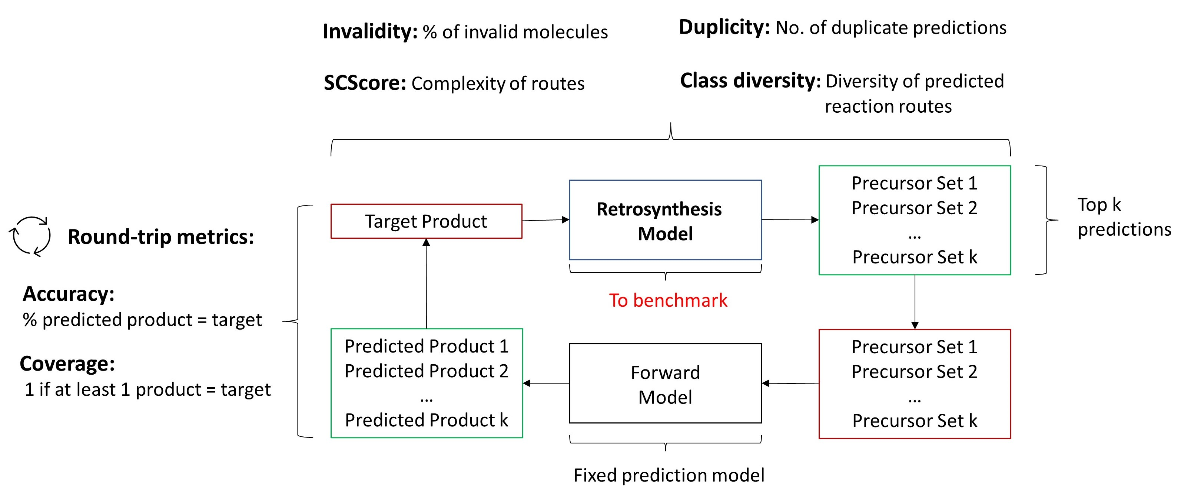
Below we outline the different evaluation metrics employed. As a note, the retrosynthesis model returns $k$ predictions (precursors) per target molecule $t$. Therefore, the total number of predictions for the test database is $T∙k$, where $T$ is the number of molecules within the database ($T=5007$ molecules). Within this work, $k$ is taken to equal ten.
Figure 2: Evaluation metrics for algorithmic benchmarking. The round-trip metrics utilize a forward synthesis model to compare the target product to the predicted products.

Round-trip - To check the chemical feasibility of a reaction, experimental validation is desired. However, this is not realisable for $T∙k$ reactions. Instead, we employ a fixed synthesis prediction model (inverse problem to retrosynthesis), to predict the reaction outcome for a given precursor set. This ad-hoc replacement allows us to check the cycle-consistency of a reaction. In short, if the target product $t$ is the same as the reaction outcome $p$ for a given precursor set $i$, the reaction prediction is assumed to be feasible when tested experimentally (Figure 2). The round-trip is scored through the rt-accuracy which measures the percentage of precursor predictions, given set $i$ is cycle-consistent:
$$Acc_{rt,k}=\frac{1}{Tk}\sum_{1}^{T}{\sum_{1}^{k}{1_{P}} (1)}$$ | $$Dup=\frac{1}{T}\sum_{1}^{T}{\frac{z_{idv}-1}{k-1}} (2)$$
Diversity - For retrosynthesis frameworks designed for synthetic chemists, it is crucial that the system can offer a broad range of reactions covering various fundamental chemical transformations. To measure the diversity of a model’s prediction, we classify each reaction per target molecule into ten diverse reaction superclasses from the reaction ontology (RXNO). For each target, the number of diverse reactions is counted, and an average is calculated over all reactions in the database to obtain the diversity metric.
Duplicity - A good retrosynthesis framework should not propose the same reaction twice as this reduces the number of reaction predictions returned by the model. The number of duplicate reactions is calculated through Eq. (2), where $z_{idv}$ equals the number of unique reactions per target molecule:
Invalidity - Similar to duplicate prediction, a retrosynthesis model should not return predictions where the reactant molecules within precursor set $i$ are invalid e.g., violating valency requirements. The invalidity is measured in a similar fashion to Eq. (1), where the indicator function $1_{P}$ assumes a value of 1, if all reactant molecules within set $i$ are valid; otherwise, it assumes a value of 0.
Route Complexity – To measure the model’s ability to propose less complex and more accessible reactants for a given product target, we utilize a synthetic accessibility metric. Particularly, the metric (SCScore) assigns a higher value to more complex molecules. A good retrosynthesis framework should (in general) reduce the SCScore when going from product to reactants. The final metric is calculated through Eq. (3), where $SC_{t}$ and $SC_{set i}$ are the scores for the target molecule and precursor set $i$, respectively:
$$Δ\overline{SC}=\frac{1}{k}\sum_{1}^{k}{\left(SC_{t}-max{\left(SC_{set i}\right)}_{k}\right)}$$ | (3)
2.2 Black-box Interpretability
While template-based models are inherently interpretable due to the inclusion of reaction rules from literature precedent, the other two retrosynthesis categories are not. For template-free models, the Transformer architecture is utilized for SMILES sequence translation. For semi-template models, Graph Neural Networks are employed to predict the reaction centre as shown in Fig. 1c. We unravel the black-box nature of these models by gauging whether they can identify critical functional groups that lead to thermodynamic stabilization of the reaction product over the reactant precursors on six case studies (with two studies presented herein). Below, the methodologies are outlined.
2.2.1 Graph Neural Networks (GNNs)
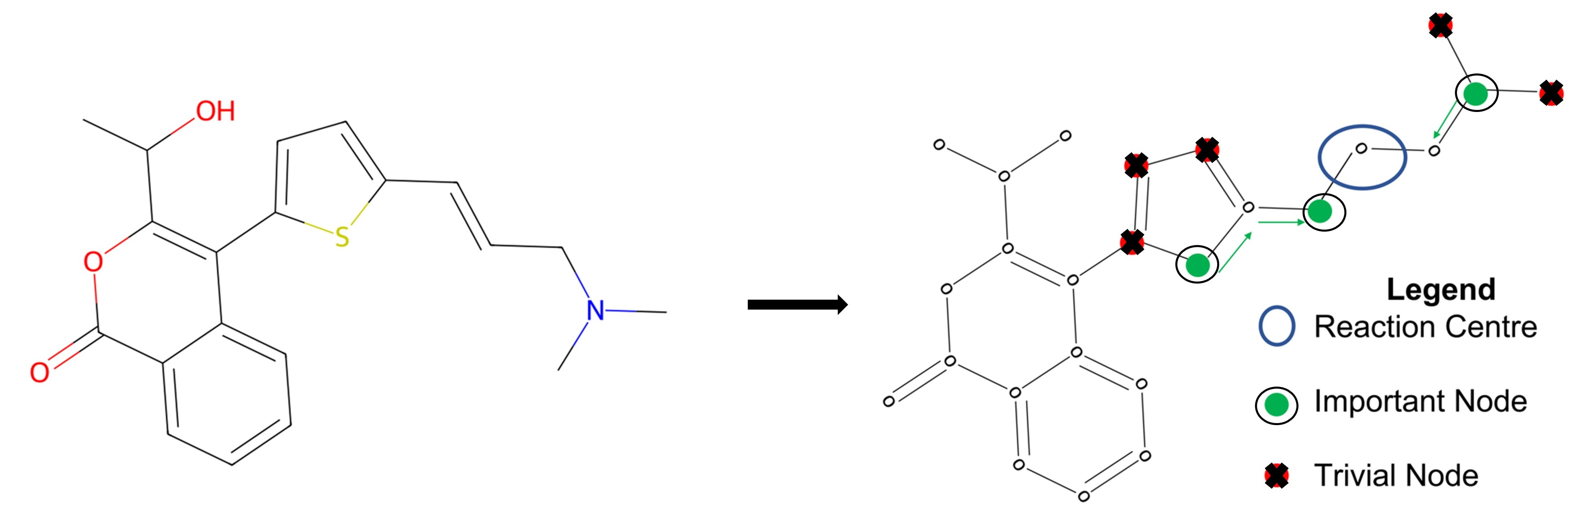
We train two state-of-the-art GNN architectures, namely D-MPNN and EGAT, to identify the reaction center within the product molecule. To find important functional groups that contribute significantly to the model’s prediction, we utilize a graph masking algorithm (GNNExplainer - Ying et al., 2019). The Explainer identifies nodes (atoms) in the molecule as shown in Figure 3.
Figure 3: Node importance as identified by the GNNExplainer.
2.2.2 Transformers
To obtain the atom importance from the Transformer, we extract the attention weights from the two different Transformer models, namely vanilla attention, and masked attention. The attention weights hold the importance between tokens (atoms) in product and reactant SMILES sequences. These weights are usually visualised as attention maps in a 2-dimensional space. We plot the attention weights directly on the molecule and infer the atom's importance visually (see Figure 5).
  - Results and Discussion
The benchmarking results are presented in Table 1. Analysing and optimizing each metric individually is unfeasible. Instead, we seek to optimize the rt-accuracy and place soft-constraints on all other metrics given by: $Div ≥2.5$, $Dup ≥0.8$, $Inv≤10 \%$ and $Δ\overline{SC}≥0.35$. It is observed that no category performs best for all metrics. However, template-based models are seen to have (overall) the highest rt-accuracy with very low number of invalid and duplicate predictions. Semi-template models have competitive rt-accuracy; however, they suffer from a larger number of invalid predictions. Template-free models exhibit on average the lowest rt-accuracy with low reaction diversity. To reason the inferior performance of semi- and template-free models, we uncover the black-box nature within the interpretability study below.
Table 1: Performance comparison for the retrosynthesis categories. Algorithms in bold are 2 best within category. Underlined values violate constraints by ≤ 10%. Double-underlined by > 10%
Algorithms | Rt-Accuracy | Diversity | Invalidity | Duplicity | SCScore
Semi-template
MEGAN | 0.78 | 3.02 | 10.2 | 0.90 | 0.36
GraphRetro | 0.77 | 1.90 | 7.4 | 0.47 | 0.35
RetroXpert | 0.46 | 2.67 | 18.6 | 0.91 | 0.42
G2Retro | 0.69 | 3.06 | - | 0.98 | 0.32
Template-free
Chemformer | 0.86 | 1.23 | 0.7 | 0.12 | 0.47
Graph2Smiles | 0.43 | 2.29 | 35.8 | 0.90 | 0.46
Retroformer | 0.68 | 2.44 | 8.0 | 0.83 | 0.43
GTA | 0.72 | 2.37 | 6.3 | 0.76 | 0.47
TiedTransformer | 0.69 | 2.85 | 6.0 | 0.93 | 0.39
Template-based
GLN | 0.85 | 2.30 | 0.2 | 0.64 | 0.41
LocalRetro | 0.81 | 3.0 | 0.5 | 0.95 | 0.4
MHNReact | 0.78 | 3.17 | 0.5 | 1.0 | 0.3

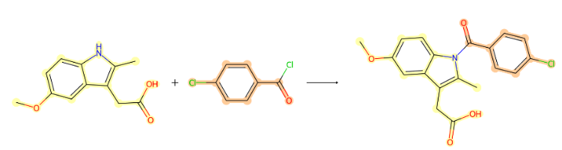
The first case study of the interpretability study is a simple amide bond formation (Figure 4, S.1). This amide bond is particularly stabilized due to electron conjugation of the amide group with the carbonyl in the reaction center. The second case study (S.2) is an S_{N}2 reaction which is stabilized by the stronger C-N bond compared to the C-Br bond. The molecule in S.2 is more complex and contains several possible disconnection sites.
S.2
S.1
Figure 4: Interpretability Case Studies. S.1 – Amide Bond, S.2 – Substitution Reaction.
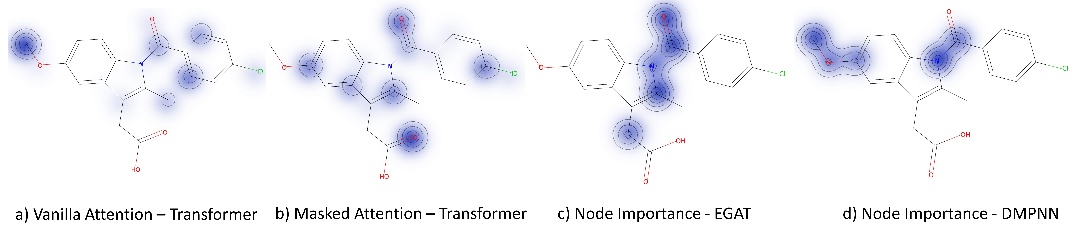
Figure 5: S.1 - Atom importance for different model architectures.
From Figure 5, it is seen that both GNN models can identify the stabilizing functional group (C-N bond, subplots c/d) whereas the Transformer models do not (subplots a/b). For S.2, no model can provide adequate reasoning for their prediction (Figure 6). In fact, both GNN models propose different disconnection sites compared to Figure 4, S.2. The EGAT model suggests an inefficient benzene ring attachment (subplot e), whereas the D-MPNN suggests a C-C bond formation without providing much interpretability for its prediction (subplots d & f). This shows that when the molecule increases in complexity, purely data-driven models struggle, possibly due to a lack of chemical awareness.
Figure 6: S.2 - Atom importance and reaction center prediction for different architectures.
  - Conclusions
In this work, we present an automated benchmark pipeline for ML-based retrosynthesis frameworks. The pipeline is provided in open-source format to facilitate straightforward model evaluation and comparison for the scientific community. We benchmarked a vast selection of frameworks on the pipeline and uncovered the black-box nature of popular deep-learning methods. The performance evaluation revealed that “simpler” template-based classification models currently outperform purely data-driven deep-learning frameworks. Furthermore, the GNN and Transformer architectures lack interpretable explanations for their predictions. Future work within the field should therefore focus on the incorporation of chemically aware descriptors in the data-driven ML models such as bond energy or electronegativity. This would render the model more interpretable and likely improve reaction feasibility.
References
Chen, S., & Jung, Y. (2021). Deep Retrosynthetic Reaction Prediction using Local Reactivity and Global Attention. JACS Au, 1(10), 1612–1620.
Corey, E. J., & Wipke, W. T. (1969). Computer-Assisted design of complex organic syntheses. Science, 166(3902)
Liu, B., Ramsundar, B., Kawthekar, P., Shi, J., Gomes, J., Luu Nguyen, Q., Ho, S., Sloane, J., Wender, P., & Pande, V. (2017). Retrosynthetic reaction prediction using neural sequence-to-sequence models. ACS Central Science, 3(10), 1103–1113.
Sacha, M., Błaż, M., Byrski, P., Dąbrowski-Tumański, P., Chromiński, M., Loska, R., Włodarczyk-Pruszyński, P., & Jastrzębski, S. (2021). Molecule edit graph attention network: Modeling chemical reactions as sequences of graph edits. Journal of Chemical Information and Modeling, 61(7), 3273–3284.
Segler, M. H. S., Kogej, T., Tyrchan, C., & Waller, M. P. (2017). Generating focused molecule libraries for drug discovery with recurrent neural networks. ACS Central Science, 120–131.
Ying, R., Bourgeois, D., You, J., Zitnik, M., & Leskovec, J. (2019). GNNExplainer: Generating Explanations for Graph Neural Networks. Arxiv.

