|  |  |
| --- | --- |
| cetlogo ***CHEMICAL ENGINEERING TRANSACTIONS***  ***VOL. xxx, 2025*** | A publication of  aidiclogo_grande |
| The Italian Association  of Chemical Engineering  Online at [www.cetjournal.it](http://www.cetjournal.it) |
| Guest Editors:  Copyright © 2025, AIDIC Servizi Srl .  **ISBN** 979-12-81206-11-3 ; **ISSN** 2283-9216 | |

Characterization of Semi-ripened Cheese with Probiotics

Gloria O. Bustamante- Cárdenas a, \*, Friedman J. Orihuela -Carhuallanqui b, Gustavo A. Espinoza- Calderón a

a Faculty of Agricultural Sciences, National University of Huancavelica, Huancavelica, Peru.

b Faculty of Food Industry Engineering, National University of Central Peru, Junín, Peru

\*gloria.bustamante@unh.edu.pe

The evolution of demanding consumers regarding the consumption of healthy foods is increasing, and foods with the presence of probiotics do not escape this reality. This research aimed to evaluate and compare the microbial profile, viability and proliferation of probiotic microorganisms, and sensory acceptability of semi-ripened cheeses made with the incorporation of different probiotic cultures. To make the cheese, pasteurized milk was used with high temperature heat treatment (72 to 75°C), in short times (20 sec), obtaining three types of cheese, two with different probiotic cultures and one without probiotic culture. Microbial growth was estimated with respect to pathogens such as *Staphylococcus* aureus, *Listeria monocytogenes*, *Salmonella* sp.; and the presence of beneficial microorganisms such as *Lactobacillus, Bifidobacterium* and *Streptococcus*. Likewise, acceptability was evaluated considering the attributes of texture, flavor, color and smell of the cheeses obtained. The results showed that cheeses with probiotic cultures had a low count of pathogenic microorganisms, being suitable for human consumption, with high growth of beneficial microorganisms (probiotics) being acceptable by the evaluating panelists. In conclusion, the cheeses obtained with added probiotics developed flavor, texture and growth of microorganisms beneficial to health.

* 1. Introduction

Cheese is the most widely produced dairy product in the world, and Europe is the region where the most cheese is produced (Domingos et al., 2016). In 2023, Germany became the world's leading exporter of cheese, followed by the Netherlands and Italy (Zheng, Shi, and Wang, 2021; Statista, 2025). Ripened cheeses result from a complex synergy of milk, lactic acid bacteria, enzymes, and ripening processes. The evolution of cheese production and diversity is driven by the desire to improve its sensory profile and nutritional properties. One of the most recent developments in the cheese industry is the use of probiotic cultures to improve cheese's functional properties (Mohammadzadeh, Moayedi, Khomeiri, and Zareie, 2025). These cultures include specific strains of beneficial bacteria and yeasts that contribute to desirable sensory characteristics and offer health benefits, especially for gut microbiota (Campos et al., 2021).

Probiotics are live microorganisms, such as bacteria and yeasts, that provide health benefits when consumed. They are naturally present in some fermented foods, added to certain food products, and available as dietary supplements (Guarner et al., 2017). Probiotics are involved in preventing and treating acute infectious digestive diseases, chronic intestinal diseases, and chronic liver diseases. They act on host immune function and intestinal homeostasis and can modulate the intestinal microbiota (Castañeda, 2018). Lactic acid bacteria have diverse applications; one main application is fermenting foods such as milk, meat, and vegetables to produce yogurt, cheese, pickles, and sausages. Additionally, these microorganisms are used as starter cultures due to their role in producing lactic acid and inhibiting pathogen development (Cobo et al., 2019). They also contribute to the biopreservation of foods, improving their sensory characteristics (eg, taste, odor, and texture) and increasing their nutritional quality. Most probiotics belong to the lactic acid bacteria family and are used in the food industry to promote health (Maftei et al., 2024). In addition to their nutritional value, fermented milk is recognized as functional foods, also known as probiotic foods. These foods contain live bacteria that can provide additional health benefits when ingested in adequate amounts. The main objective of this study is to evaluate and compare the physicochemical properties, microbial content, and acceptability of semi-ripened cheese made with probiotic cultures.

* 1. Methodology

2.1 Sample and cultivation preparation

The research was conducted in the city of Concepción, the sample (fresh milk) was collected from two producers in the area, two types of products (SACCO System and VIVOLAC Infuze) were used as probiotic culture.

2.2 Cheese production

Semi-cured cheese was produced using probiotic cultures (SACCO System and VIVOLAC Infuze), added at 2% (De Cangas Morán et al., 2019), and without cultures. This was carried out following the flow chart shown in Figure 1, which details the stages of the production process from receiving the raw materials to ripening the final product. This procedure enabled the effects of adding probiotic cultures on the cheese's microbiological and sensory characteristics to be compared.

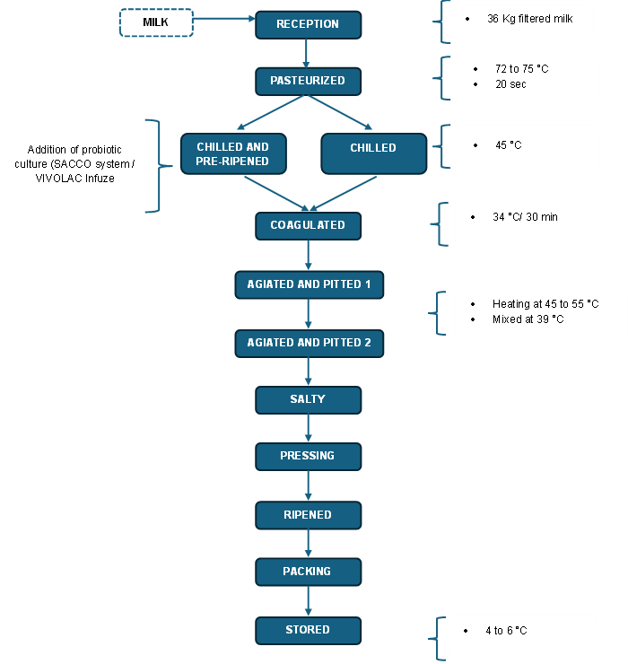

Figure 1: Flow chart to produce cheese

2.3 Microbiological evaluation

To ensure the safety of the ripened cheese, a thorough microbiological analysis of the finished product was conducted. This included determining key hygiene indicators and pathogens such as total coliforms, *Staphylococcus* aureus, *Listeria* *monocytogenes* and *Salmonella* sp.Each analysis was performed with five independent replicates, providing a robust database for subsequent statistical analysis. Including multiple replicates ensured the reliability and consistency of the results and allowed for an analysis of variance (ANOVA) to determine if there were significant differences in the microbial load of the three treatments (semi-ripened cheese without culture, semi-ripened cheese with the SACCO System, and semi-ripened cheese with the VIVOLAC Infuze.

2.4 Probiotic microorganisms

A thorough microbiological analysis was carried out to ensure and quantify the growth of probiotic microorganisms after inoculating the semi-mature cheese with culture. This analysis included determining key indicators, such as the presence of *Lactobacillus, Bifidobacterium*, and *Streptococcus*. Each analysis was performed with five independent replicates, providing a solid database for subsequent statistical analysis. Including these multiple replicates was essential to ensure the reliability and consistency of the results. Likewise, this methodology permitted the application of an analysis of variance (ANOVA) to determine significant differences in microbial load among the three treatments evaluated: semi-mature cheese with the SACCO System culture, and semi-mature cheese with the VIVOLAC Infuze culture.

2.5 Sensory evaluation

For the sensory evaluation of the semi-ripened cheese, the organoleptic attributes of color, smell, texture, flavor, and appearance were evaluated as response variables. A Completely Randomized Block (CRB) experimental design was used, where 30 untrained panelists served as the blocks. The acceptability of each attribute was quantified using a hedonic scale from 1 to 5 to determine the panelists' overall preference. The sensory data collected were subsequently adjusted to the linear additive model Eq (1), enabling analysis of treatment influence on the cheese's sensory characteristics.

$Yij=ai+Tj+εij$ (1)

Yij = Sensory acceptability (color, smell, texture, flavor and appearance)

μ = Effect of the general mean

α i = Blocks, where i = 1 to 30

Tj = Treatments, where j = 1 to 3

Εij = effect of random error.

ANOVA was used to analyze the results. In instances where significant differences were observed between treatments, Duncan's multiple range test was subsequently applied at a 5% level of significance.

* 1. Results and discussions

3.1 Results of the microbiological evaluation of semi-ripened cheese with probiotic cultures

Microbiological analyzes were carried out for the three treatments of semi-ripened cheese, which included the counts of colony-forming units (CFU/g) for coliforms, *Staphylococcus* aureus, *Listeria monocytogenes* and *Salmonella* sp., as indicators of microbial contamination. The results obtained showed the absence of pathogens such as *Listeria monocytogenes* and *Salmonella* sp., while the levels of coliforms and *Staphylococcus aureus* were within the limits established by food safety regulations. A statistical analysis was performed on the results obtained from the microbiological evaluation of the presence of coliforms in semi-cured cheeses with and without culture, as shown in the following table:

Table 1: Means and standard deviations of coliform counts and Staphylococcus aureus (log CFU/g) in semi-cured cheeses without culture, with SACCO System culture, and with VIVOLAC Infuze culture.

|  |  |  |  |  |
| --- | --- | --- | --- | --- |
| Treatments | Mean | Standard deviation | Mean | Standard deviation |
|  | Coliforms | | *Staphylococcus aureus* | |
| SACCO System | 0.849 | 0.158 | 0.849 | 0.158 |
| VIVOLAC Infuze | 0.969 | 0.066 | 0.969 | 0.066 |
| Without Culture | 1,063 | 0.159 | 1,063 | 0.159 |

Statistical analyses revealed no significant differences in the coliform or *Staphylococcus* aureus loads of the different semi-cured cheese treatments. However, a clear trend emerged: the cheese without culture addition had the highest coliform concentration, this was followed by cheese made with the VIVOLAC Infuze culture, which exhibited lower levels. Finally, cheese made with the SACCO System culture showed the lowest levels of coliforms and *Staphylococcus* aureus, suggesting a progressive reduction in microbial contamination. These results align with existing literature reporting that lactic acid bacteria in probiotic cultures inhibit the growth of pathogenic strains. Specifically, Wong-Villarreal et al. (2021) document this ability, consistent with the results of Rivera et al. (2017), who also reported that lactic acid bacteria can suppress the proliferation of pathogenic microorganisms in dairy products.

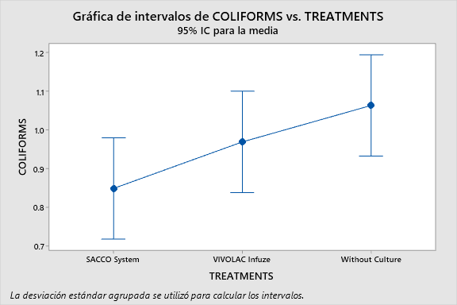

Interval plot of *Coliforms* (log CFU/g) vs. treatments

(95% confidence interval for the mean).

*The pooled standard deviation was used to calculate the intervals.*

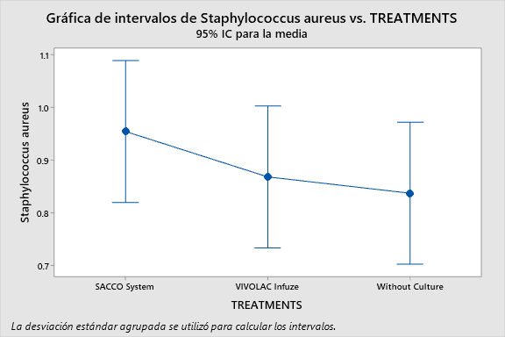

Interval plot of *Staphylococcus aureus* (log CFU/g) vs. treatments

(95% confidence interval for the mean).

*The pooled standard deviation was used to calculate the intervals.*

a

b

Figure 2 a-b: Interval plot of coliforms (log CFU/g) versus treatments (95% confidence interval for the mean) (a). Interval plot of Staphylococcus aureus (log CFU/g) versus treatments (95% confidence interval for the mean) (b).

Figure 2a-b illustrates the 95% confidence interval plot of the coliform and *Staphylococcus* aureus load (expressed in log CFU/g) across the various treatments applied to the semi-cured cheese. The cheese without culture addition showed the highest mean value for both coliforms and *Staphylococcus* aureus, suggesting a higher initial microbial load or lower intrinsic control capacity. In contrast, the VIVOLAC Infuze culture appears to have reduced the load, while the SACCO System culture exhibited the lowest means and the narrowest interval, which could indicate greater consistency and better suppression of these microorganisms.

**3.2 Results of the presence of probiotic microorganisms**

An analysis of variance (ANOVA) using a randomized complete block design revealed statistically significant differences in Lactobacillus proliferation between cheese treatments (p = 0.013). Lactobacillus density varied significantly between cheeses made with the VIVOLAC Infuze culture and those made with the SACCO System. Specifically, as detailed in Table 2, the semi-mature cheese made with the SACCO System culture promoted greater Lactobacillus proliferation. This suggests that the SACCO System is more effective at establishing or growing this key probiotic strain under the conditions of this study. In contrast, the analysis of Bifidobacterium showed no statistically significant differences between treatments (p = 0.392). This suggests that VIVOLAC Infuze and SACCO System cultures have comparable abilities to promote Bifidobacterium growth in semi-cured cheese.

Similarly, the statistical analysis of Streptococcus revealed a significant difference in proliferation (p=0.04). Growth of Streptococcus differed markedly between cheeses inoculated with the VIVOLAC Infuze culture and those inoculated with the SACCO System, with greater proliferation observed in the latter. These results suggest that under the study conditions, the SACCO System culture may have promoted a more favorable environment or contained more viable Streptococcus strains than the VIVOLAC Infuze culture. This could have led to greater proliferation of the probiotic in the final product.

Table 2: The mean and standard deviation results for quantifying Lactobacillus, Bifidobacterium, and Streptococcus (log CFU/g) in different semi-cured cheese treatments.

|  |  |  |  |  |  |  |
| --- | --- | --- | --- | --- | --- | --- |
| Treatments | Mean | Standard deviation | Mean | Standard deviation | Mean | Standard deviation |
|  | *Lactobacillus* | | *Bifidobacterium* | | *Streptococcus* | |
| SACCO System | 2.492 | 0.076 | 2.924 | 0.530 | 1.301 | 0.000 |
| *VIVOLAC Infuze* | 2.355 | 0.060 | 2.642 | 0.453 | 1.120 | 0.165 |

Overall, analyzes of the microbiological count revealed a higher total concentration of probiotic microorganisms in cheeses inoculated with the SACCO System culture. However, both treatments with probiotic cultures resulted in the presence of these beneficial microorganisms in the final product. These findings are significant, considering the range of beneficial effects associated with probiotics, as highlighted by Vasquez-Lopez (2019). These effects include suppression of pathogen growth, control of serum cholesterol levels, modulation of the immune system, improved lactose digestion, vitamin synthesis, increased mineral bioavailability, and potential anticancer activity. To experience these benefits, one must consume at least 108 live probiotic bacteria daily, which is equivalent to a 45-gram serving of cheese (approximately two slices). Our results, particularly those obtained with the SACCO System culture, suggest that these cheeses have promising potential to achieve such levels in the final product.

**3.3 Sensory evaluation results**

The sensory analysis of the semi-ripened cheese with probiotics was carried out in order to evaluate the influence of the use of probiotic cultivations on organoleptic characteristics such as: flavor, color, texture and general acceptability, with a scale of one (minimum score) to five (maximum score) to determine the best treatment according to the acceptability of the taster; The same was made up of 30 untrained panelists. The samples were presented in identical containers, coded with 3-digit random numbers. Each treatment had a different code.

Table 3: Average results of the sensory evaluation of semi-ripened cheese with and without cultivation.

|  |  |  |  |  |  |  |
| --- | --- | --- | --- | --- | --- | --- |
| Sample | Color | Smell | Texture | Flavor | Appearance | P |
| T1 (Cheese without culture) | 3.60 | 3.47 | 3.67 | 3.83 | 3.50 | 3.61 |
| T2 (Cheese with SACCO System culture) | 4.13 | 3.87 | 4.13 | 4.17 | 3.87 | 4.03 |
| T3 (Cheese with VIVOLAC Infuze culture) | 4.07 | 3.67 | 3.83 | 3.87 | 3.83 | 3.85 |

In Table 3, the texture and flavor stand out when tasting the semi-ripened cheese with probiotic cultivations and comparing these results agree with what was said by Castillo-Escandon et al. (2019), where it is stated that probiotics, in addition to contributing to the preservation of food, improve sensory characteristics such as flavor, smell, texture and increase its nutritional quality, and when consumed by humans and animals in adequate quantities, they improve health. In addition, Vasquez-Lopez et al. (2019) mention that the most studied probiotics are Lactobacillus and Bifidobacterium and their applications in dairy products and non-dairy environments as adjuncts for the development of new flavors, which have shown interest since these strains can secrete more catabolic enzymes for amino acids than industrial catalysts.

Table 4: Results of the analysis of variance for the attributes of color, odor, texture, flavor, and overall appearance.

|  |  |  |  |  |  |
| --- | --- | --- | --- | --- | --- |
| Source of variation | Color | Smell | Texture | Taste | General appearance |
| Treatments | SD | SD | SD | SD | NSD |
| Panelists | SD | SD | NSD | NSD | NSD |
| *SD: significant difference/ NSD: No significant difference* | | | |  |  |

Analysis of variance (ANOVA) revealed distinct results in the panelists' evaluations for each sensory attribute. No significant differences were found in the evaluations of texture, flavor, or overall appearance. These results indicate high consistency and homogeneity in the panelists' evaluations, confirming that the differences observed between treatments for these attributes are not due to variability between evaluators. In contrast, color and aroma analyzes showed statistically significant differences in the panelists' evaluations. These results suggest greater heterogeneity or subjectivity in the evaluators' perception and rating of these attributes.

Furthermore, analyses of variance (ANOVAs) revealed significant differences among the three treatments for the sensory attributes of color, odor, texture, and flavor. Given this overall significance, a Duncan multiple comparison analysis was performed to identify specific differences between the groups. The Duncan test results indicated that no significant differences were observed in terms of color and overall appearance between the semi-cured cheeses that incorporated the SACCO System culture and the VIVOLAC Infuze culture. However, both cultured cheeses showed significant differences in these attributes compared to the uncultured cheese. Regarding odor, the Duncan test revealed a significant difference between cheese cultured with the SACCO System and unfermented cheese. Interestingly, no significant differences were found between the unfermented cheese and the cheese cultured with VIVOLAC Infuze. A similar pattern of differences was observed for texture and flavor as was observed for odor. SACCO System-cultured cheese differed significantly from uncultured cheese, while uncultured cheese and VIVOLAC Infuze-cultured cheese did not differ significantly.

* 1. Conclusions

The results obtained regarding the count of pathogenic bacteria, such as Coliforms, *Staphylococcus* aureus, *Listeria monocytogenes* and *Salmonella* sp. (log CFU/g), were found consistently below the maximum limits established by NTP 202.194 - 2010 in all treatments carried out with Probiotic cultures were added. This result guarantees the microbiological safety of the final product, which is of utmost importance to guarantee the health of the consumer. Probiotic microorganisms such as *Lactobacillus, Bifidobacterium*, and *Streptococcus* exhibited significant inhibitory effects on the growth of pathogenic bacteria. These probiotics not only contribute to the overall safety of the cheese but also play a role in the preservation of the product by preventing the proliferation of harmful microorganisms, improving shelf life and ensuring its quality over time. Furthermore, the semi-cured cheese produced with probiotic cultures from the SACCO System showed a higher level of sensory acceptability across various characteristics, including flavor, texture, color, appearance, and smell. The cheese achieved an average rating of 4.03 on the hedonic scale, which indicates a "like" preference, and was significantly more favorable than both the semi-cured cheese without probiotic cultures and the cheese ripened with the VIVOLAC Infuze probiotic culture. This suggests that probiotic cultures not only enhance the sensory appeal of the product but also increase consumer satisfaction, making it a more attractive option in the competitive dairy market. In conclusion, the incorporation of probiotic cultures in the production of semi-ripened cheeses represents a promising strategy that goes beyond just improving the sensory characteristics of the product. Probiotic cultures, such as those from SACCO System and VIVOLAC Infuze, offer benefits in terms of enhancing the functionality of dairy foods, especially by promoting gut health and contributing to overall well-being. These microorganisms facilitate the production of dairy products with added health benefits, positioning them as a powerful tool in addressing the growing demand for functional foods. The potential of probiotics in cheese production aligns with current consumer trends favoring healthy, functional, and high-quality food options. Furthermore, these innovations are likely to contribute significantly to the evolution of the dairy industry, as they offer new opportunities for product differentiation and cater to a more health-conscious consumer base. Ultimately, the use of probiotics in cheese production represents not only a valuable advancement in dairy technology but also a key element in the ongoing development of the functional food market.

* 1. References

Campos GZ, Lacorte GA, Jurkiewicz C, Hoffmann C, Landgraf M, Gombossy FBD, Pinto UM, 2021, Microbiological characteristics of canastra cheese during manufacturing and ripening, Food Control, 121.

Castañeda C, 2018, Probiotics, update, Cuban Journal of Pediatrics, 90 (2):286-98 (in Spanish).

Castillo-Escandón V, Fernández-Michel SG, Cueto-Wong MC, Ramos-Clamont MG, Technological criteria and strategies for the incorporation and survival of probiotics in fruits, cereals and their derivatives, Journal specializing in chemical and biological sciences, 22: e173 (in Spanish).

Cobo R, Rosas R, Gálvez D, Adriano L, Vázquez A, 2019, Native lactic acid bacteria as a starter culture to produce Mexican cream cheese, Mesoamerican Agronomy, 30(3): 855-870 (in Spanish).

De Cangas R, Llavona A, Lopez-Sela P, Aguirre S, Hernández A, 2019, Development of a fresh cheese with probiotic cultures and plant-based ingredients. Chemical Technology, 39(1), 49-64.

Domingos J, Martinez G, Scoma A, Bertin L, Reis M, Fava F, 2016, Development of a Continuous Biofilm-Based Process for the Bioconversion of Cheese Whey into Volatile Fatty Acids, Chemical Engineering Transactions, 46, 193-198.

Guarner F, Sanders ME, Eliakim R, Fedorak R, Gangl A, Garisch J, Kaufmann P, Karakan T, Khan A, Kim N, De Paula JA, Ramakrishna B, Shanahan F, Szajewska H, Thomson A, Le Mair A, 2017, Probiotics and prebiotics, World Gastroenterology Organization.

Maftei NM, Raileanu CR, Balta AA, Ambrose L, Boev M, Marin DB, Lisa EL, 2024, The Potential Impact of Probiotics on Human Health: An Update on Their Health-Promoting Properties. Microorganisms,12(2):234.

Mohammadzadeh M, Moayedi A, Khomeiri M, Zareie Z, 2025, Exploring the probiotic properties of *Lactiplantibacillus pentosus* and gamma-aminobutyric acid production for cheese development, Applied Food Research, 5(1), 100817.

Rivera JF, Villegas A, Miranda L, García J, 2017. Identification of lactic acid bacteria antagonistic to *Salmonella* enterica var. Typhimurium isolated from artisanal cheese. Mexican Journal of Agricultural Sciences, 8(4): 785-797 (in Spanish).

Statista, 2025, Leading exporters of cheese worldwide in 2024, www.statista.com/statistics/827446/top-exporters-0f-cheese-global, accessed 27.05.2025.

Vasquez-Lopez VM, Gomez-Cruz LA, Lopez-Zuniga EJ, Garcia-Parra E, Vela-Gutierrez G, 2019, Optimization of the process for making and viability of probiotic bacteria in a spreadable type of ricotta, International Journal of Technological Research and Innovation, 6,36.

Wong-Villarreal A, Corzo-González H, Hernández-Núñez E, González-Sánchez A, Giacoman-Vallejos G, 2021, Characterization of lactic acid bacteria with antimicrobial activity isolated from cream cheese from Chiapas, Mexico, Technological University of the Selva, 15(2): 144-155.

Zheng X, Shi X, Wang B, 2021, A review on general cheese processing technology, biochemical pathways of flavor, and the influence of yeasts in cheese, Front Microbiol., 12:703284.​​