|  |  |
| --- | --- |
| cetlogo ***CHEMICAL ENGINEERING TRANSACTIONS***  ***VOL. , 2025*** | A publication of  aidiclogo_grande |
| The Italian Association  of Chemical Engineering  Online at www.cetjournal.it |
| Guest Editors: Laura Piazza, Francesco Donsì, Giorgia Spigno  Copyright © 2025, AIDIC Servizi S.r.l. **ISBN** 979-12-81206-19-9; **ISSN** 2283-9216 | |

Optimization of an Extruded Formulation to Enhance Protein Content in Corn Grits-Based Products Using Quinoa and Its By-products

Diego A. Villa-Valdiviesoa,\*, Kelly K. Beltrán-Borbora, Cindy Espinalesb, Diana L. Tinoco-Caicedoa

aESPOL Polytechnic University, Escuela Superior Politécnica del Litoral, Facultad de Ciencias Naturales y Matemáticas (FCNM), Campus Gustavo Galindo Km 30.5 Vía Perimetral, P.O. Box 09-01-5863, Guayaquil, Ecuador

bESPOL Polytechnic University, Escuela Superior Politécnica del Litoral, Facultad de Ingeniería en Mecánica y Ciencias de la Producción (FIMCP), Campus Gustavo Galindo Km 30.5 Vía Perimetral, P.O. Box 09-01-5863, Guayaquil, Ecuador

kbeltran@espol.edu.ec

Quinoa by-products remain an underutilized and valued alternative in developing protein-enriched extruded cereals, while maize grit-based formulations often lack sufficient protein content. To address both challenges, this study aimed to optimize the formulation of an extruded cereal by incorporating corn grits, quinoa flour, and quinoa agro-industrial residues, leveraging quinoa’s high protein content and adding value to its by-products. The extreme vertices mixture design method was applied using Minitab® 2019 for statistical modeling. The independent variables included corn grits, quinoa flour, and agro-industrial residues, while the dependent variables were protein content, expansion index, bulk density, and extrudate hardness. The optimal formulation was identified through a desirability test based on fitted regression models, maximizing protein content and expansion index while minimizing hardness and bulk density. The optimal composition consisted of 57.17 % corn grits, 34.3 % quinoa flour, and 8.5 % agro-industrial residue. The physicochemical analysis of this optimized formulation revealed a protein content of 10.83 %, an expansion index of 3.04, a bulk density of 0.193 g/cm3, and a hardness of 22.31 N. These findings suggest that incorporating quinoa by-products into extruded cereal formulations enhances the nutritional profile without significantly compromising key physicochemical properties such as expansion index and bulk density.

**Keywords:** Quinoa by-products, Extrusion, Protein fortification, Mixture design, Product Development.

* 1. Introduction

Extruded cereals are widely consumed around the world due to their convenience and ability to incorporate essential nutrients. However, achieving an optimal balance of macronutrients, particularly protein, remains a significant challenge in their formulation (Pérez et al., 2017). Maize (*Zea mays*) is a predominant ingredient in extruded cereal products due to its high starch content, physicochemical properties, low cost, and versatility in food development. However, its low protein content limits its capacity to meet consumer dietary requirements (Zhang et al., 2023). To overcome this limitation, pseudocereals such as quinoa have been explored as a strategy to enhance the protein content and nutritional value of extruded formulations. Quinoa (*Chenopodium quinoa Willd*) is rich in high-quality proteins, essential amino acids, and minerals, making it a valuable gluten-free alternative for individuals with celiac disease (Hassan et al., 2024). In 2023, global quinoa production reached 112,250 metric tons, with Peru as the leading producer. However, only 20 % of the total plant biomass corresponds to the marketed grain, implying that approximately 470,000 metric tons of agro-industrial residues, primarily quinoa stalks, are discarded annually (Rosas Vega et al., 2023).

Recent research has demonstrated that quinoa stalks can be effectively valorized through hydrothermal and enzymatic hydrolysis processes, resulting in the production of fermentable sugars and xylo-oligosaccharides (XOS). XOS are emerging as promising prebiotics because they selectively stimulate the growth of *Bifidobacterium adolescentis* and promote the production of short-chain fatty acids (SCFAs), including acetate, lactate, propionate, formate, and butyrate, which are essential for gut health (Salas-Veizaga et al., 2021). Furthermore, Rosas Vega et al. (2023) reported that fermenting quinoa stalk residue results in the production of carotenoids, which have strong antioxidant properties. The XOS reached a maximum yield of 79 mg/g of biomass, while 4.1 mg of carotenoids/g of dry cell weight were produced using this method, demonstrating the potential of quinoa stems as a source of valuable biomolecules. Although these studies highlight the bioactive potential of quinoa stalks, their use in extruded cereal formulations is mainly unknown. Recent studies using other agro-industrial residues, such as barley bagasse, have reported an increase in the content and antioxidant activity of phenolic compounds after the extrusion process (Beltrán-Borbor et al., 2025). A previous study has evaluated quinoa flour's impact on baked products (Burbano et al., 2025) and its effect on protein digestibility and antioxidant capacity after extrusion (Muñoz-Pabon et al., 2022). However, Rolandelli et al. (2020) showed that the incorporation of quinoa flour in corn-based extruded products can negatively influence key physicochemical parameters such as hardness, expansion ratio, and starch gelatinization, attributed to the fiber-rich matrix of quinoa. These findings highlight the necessity for an in-depth study of ingredient interactions and their implications for extrusion performance and product acceptance.

Since no previous research has explored the incorporation of quinoa stalks into maize-based extruded formulations to improve protein content, this study represents a novel approach to maximizing the value of agro-industrial by-products in food applications. The use of a mixture design method provides a systematic way of evaluating the impact of ingredient proportions, allowing the development of an optimum formulation that increases protein content while maintaining desirable physicochemical and sensory properties. Therefore, this study aims to develop and optimize a protein-enriched extruded maize-based cereal incorporating quinoa and quinoa stalks through a mixture design approach, contributing to the advancement of sustainable, functional food formulations and aligning with the circular bioeconomy principles.

* 1. Materials and methods
     1. Materials

Corn grits (CG) were supplied by Grupo Sima, Ecuador. Quinoa grains were obtained from Chimborazo and provided by the commercial brand “COPROBICH”. Quinoa by-products (QBP) were provided by Cerquié S.A.S. after processing expanded quinoa. The quinoa grains were milled and sieved to obtain quinoa flour (QF). The resulting flour was stored in laminated bags at room temperature. The QBP were manually selected, cleaned, and sieved to remove pollutants before being packed and stored under similar conditions. The CG was used without further processing and stored in laminated bags.

* + 1. Proximate analysis

The proximate composition of QF, CG, and QBP was determined using standard AOAC methods, assessing protein, moisture, fat, crude fiber, and ash content. Carbohydrates were calculated by difference. Table 1 summarizes the proximate composition of the raw materials.

Table 1: Proximate composition of QF, CG, and QBP.

|  |  |  |  |
| --- | --- | --- | --- |
|  | QF | CG | QBP |
| Protein | 12.99 | 7.73 | 42.76 |
| Moisture | 9.77 | 12.04 | 4.14 |
| Fat | 7.25 | 4.34 | 25.96 |
| Ash | 2.65 | 1.33 | 7.62 |
| Crude fiber | 1.93 | 7.05 | 3.49 |
| Carbohydrates | 65.41 | 74.56 | 19.49 |

* + 1. Extrusion processing

A mixture design approach using an Extreme Vertices model in Minitab 2019 was employed to evaluate the combined effect of QF, CG, and QBP on protein content, expansion index, bulk density, and hardness. Component constraints were set as follows: QBP (0-20 %), QF (20-40 %), and CG (50-60 %). The mixture design included nine formulations (Table 2), each adjusted to 15% moisture before extrusion. These formulations were stored in laminated bags at room temperature for 24 hours before processing.

Extrusion was performed using a lab-scale Brabender® single-screw extruder operating at 220 RPM. The barrel temperatures were set at 90°C, 140°C, and 160°C across different sections of the extruder. A 4 mm diameter die was used. The extruded cereals were then packed in hermetically sealed aluminum bags and stored at room temperature.

* + 1. Expansion ratio and bulk density

The expansion ratio (ER) was determined using a TRUPER Model CALDI-6MP stainless steel digital vernier caliper, calculated as the ratio of extrudate diameter to die diameter. Bulk density (BD) was measured as the ratio of sample weight to the volume displaced in a graduated cylinder. Both measurements were performed in triplicate for all nine formulations.

* + 1. Texture analysis

The mechanical properties of the extrudates were assessed using a BROOKFIELD® CT3 4500 texture analyzer with TexturePro CT V1.1 Build 7 software. A 4 mm diameter probe penetrated the sample to a deformation of 4-7 mm, depending on the extrudate diameter, at a loading speed of 60 mm/min and a preload of 0.98 N. Hardness measurements were performed for all nine formulations, including the optimal one.

* + 1. Statistical analysis

All statistical analyses were performed using Minitab 2019. The statistical significance of the response variables was evaluated through Analysis of Variance (ANOVA) at a significance level of α = 0.05. Differences among treatments were determined using LSD Fisher's test (p < 0.05). All graphs were also generated using Minitab 2019.

* 1. Results and discussion
     1. Effect of product formulation on PC

The protein content (PC) in the different formulations of the extruded snacks ranged from 7.94 - 15.44 % (Table 2). Formulation 4 exhibited the highest PC, whereas Formulation 3 recorded the lowest. The increase in PC was primarily influenced by the QBP content, followed by QF, as these components contribute the most protein.

Table 2: Physicochemical properties of extrudates

|  |  |  |  |  |  |  |  |
| --- | --- | --- | --- | --- | --- | --- | --- |
| Formula | CG (%) | QF (%) | QBP (%) | PC (%) | ER | BD (g cm-3) | Hardness (N) |
| 1 | 60 | 20 | 20 | 15.32 | 2.5 | 0.129 | 44.86 |
| 2 | 50 | 40 | 10 | 11.42 | 1.9 | 0.37 | 24.88 |
| 3 | 60 | 40 | 0 | 7.94 | 2.85 | 0.086 | 14.94 |
| 4 | 50 | 30 | 20 | 15.44 | 1 | 0.38 | 45.42 |
| 5 | 55 | 32.5 | 12.5 | 14.2 | 2.4 | 0.275 | 35.48 |
| 6 | 57.5 | 26.25 | 16.25 | 13.92 | 1.4 | 0.228 | 40.91 |
| 7 | 52.5 | 36.25 | 11.25 | 13.59 | 1.9 | 0.32 | 30.43 |
| 8 | 57.5 | 36.25 | 6.25 | 10.5 | 2.25 | 0.183 | 20.15 |
| 9 | 52.5 | 31.25 | 16.25 | 14.39 | 2.34 | 0.33 | 41.29 |

The highest PC values were observed in formulations with the highest QBP content, as illustrated by the dark green region in the contour plot (Figure 1a) and the elevated region in the surface plot (Figure 1b). This confirms that QBP has the greatest impact on PC among the three ingredients.

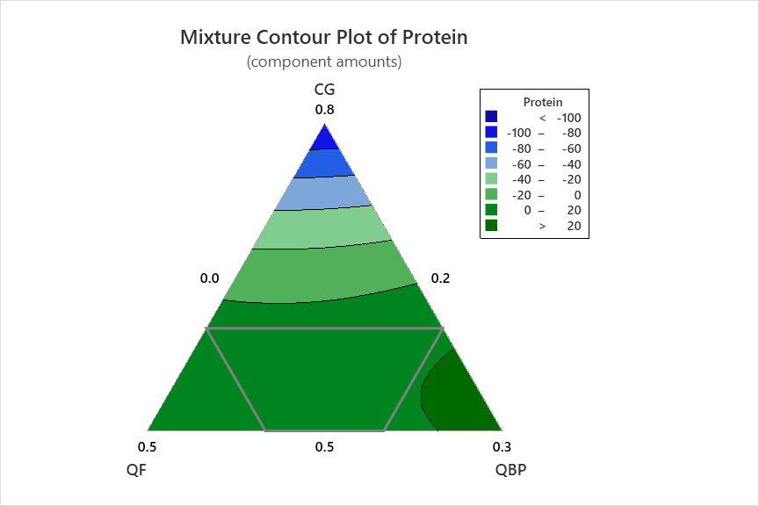

b)

a)

*Figure 1: a) Response contour plot, b) response surface plot for protein content.*

* + 1. Effect of product formulation on ER

As shown in Table 2, the ER values ranged from 1.0 to 2.95 across all formulations. These values are relatively low, comparable to those reported by Kowalski et al. (2016) for quinoa extrudates (1.19-1.67) and significantly lower than the ER of commercial corn starch (4.0). The reduced ER is attributed to the higher protein, fiber, and fat content in QF compared to conventional cereals. Obradović et al. (2015) suggested that insoluble fibers disrupt cell walls, preventing air bubble expansion, while proteins compete with starch for available water. This trend is visually represented in the contour plot (Figure 2a), and the response surface (Figure 2b) visually illustrates this, showing that ER increases with higher CG content (dark green region).

**

b)

a)

Figure 2: a) Response contour plot, b) response surface plot for expansion ratio.

* + 1. Effect of product formulation on BD

The observed BD values ranged from 0.086 to 0.380 g/cm3, which aligns with the results obtained by Potter et al. (2013) for fruit flour formulations. BD increased in formulations with higher QF and QBP concentrations, while those with higher CG exhibited lower values (Table 2). The higher crude fiber content in QF and QBP likely contributed to this effect. Castro-Mendoza et al. (2019) highlighted that BD is closely related to expansion and is a key quality parameter in extruded products. Figures 3a and 3b confirm the inverse relationship between CG concentration and BD, opposite to the trend observed for ER. As CG levels increase in the mixture, BD decreases.

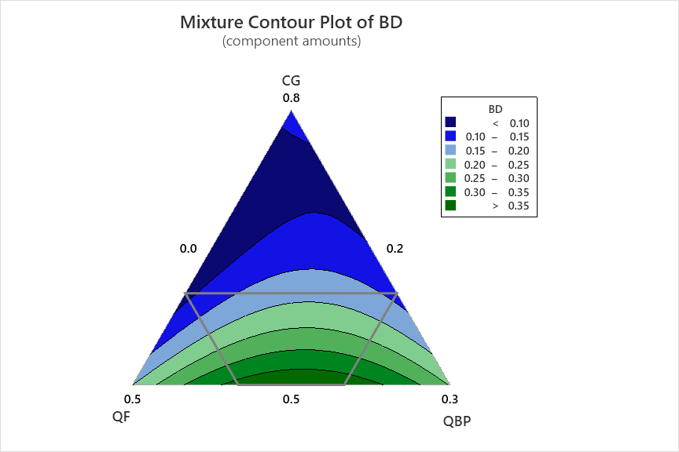

b)

a)

Figure 3: a) Response contour plot, b) response surface plot for bulk density.

* + 1. Effect of product formulation on hardness

Hardness ranged from 14.94 N to 45.42 N with lower values observed in formulations containing lower proportions of QBP. According to Oliveira et al. (2015), increasing protein content and reducing starch content has a direct relationship with ER and hardness values of extrudates. This would explain why a higher proportion of QBP in the formulation increases the hardness of the extrudate, while a higher proportion of CG and QF decreases the hardness (Figure 4a and 4b).

b)

a)

Figure 4: a) Response contour plot, b) response surface plot for hardness.

* + 1. Product optimization

The F-test analysis showed that the quadratic models were significant for PC, hardness, and BD, whereas the special cubic model best described ER (p < 0.05). However, the coefficients of determination (R2) and adjusted coefficient of determination (R2 adj) were lower for ER. The model for the expansion ratio (ER) shows a lower R² compared to others, but it provided the best fit specifically for this variable, as models with higher R² values did not adequately explain ER behaviour. While the current model is appropriate, we acknowledge that its fit could be improved in future studies by including process variables such as the temperature of the different barrel zones of the extruder, the die head temperature, and the screw speed. Table 4 summarizes the mathematical models proposed for each variable.

Table 4: Mathematical models for each response variable

|  |  |  |  |
| --- | --- | --- | --- |
| Response variable | Equation | Model | R2 (%) |
| PC (%) |  | Quadratic | 97.65 |
| ER | $$Y_{ER}=72X_{1}-353X_{2}-2228X_{3}$$ | Special cubic | 84.27 |
| BD (g cm-3) |  | Quadratic | 99.67 |
| Hardness (N) | $$Y_{H}=-898X_{1}-1148X_{2}-339X_{3}$$ | Quadratic | 98.87 |

Optimization was carried out by superimposing the contour plots that met the established constraints. As a result, a global solution was obtained, which is presented in Table 5, together with its respective compositions and characteristics. The optimum formulation has an acceptable desirability value, offering considerable protein content and low hardness. This study did not include sensory analysis or shelf-life evaluation, as the tested formulation is not intended for final consumption. The focus was placed on the nutritional properties of the product, and future studies are planned to address consumer acceptance and product stability.

Table 5: Mixture obtained after simultaneous response optimization

|  |  |  |  |  |  |  |  |
| --- | --- | --- | --- | --- | --- | --- | --- |
| Composition | | | Parameter | | | | |
| CG (%) | QF (%) | QBP (%) | PC (%) | ER | BD (g cm-3) | Hardness (N) | Composite desirability |
| 57.2 | 34.3 | 8.5 | 10.83 | 3.04 | 0.193 | 22.31 | 0.746 |

* 1. Conclusions

A high-protein content extruded cereal was successfully developed using a mixture of CG, QF, and QBP. The optimal formulation, consisting of 57.2 % CG, 34.3 % QF, and 8.5 % QBP, resulted in a final product with a protein content of 10.83 %, an ER of 3.04, a BD of 0.193 g/cm3, and a hardness of 22.31 N. These results confirm the effectiveness of the mixture design approach in optimizing the physicochemical properties of extruded snacks while maintaining desirable textural and nutritional attributes. Given the promising role of QBP in enhancing protein content, further research should explore its detailed composition, particularly the presence of fermentable sugars and potential prebiotic compounds such as XOS, which could contribute to gut health benefits. Additionally, studying the interactions between QBP and starch during extrusion, as well as its effects on expansion behavior and digestibility, would provide valuable insights for product innovation. Future studies should also investigate the influence of extrusion parameters—such as temperature, screw speed, and moisture content—on the retention of bioactive compounds and the overall functional properties of the final product. This will enable a more comprehensive understanding of QBP's potential in the development of high-protein, fiber-rich extruded products with enhanced nutritional and sensory appeal. It is recommended to add a flavouring agent and apply drying to improve organoleptic properties, enabling sensory and shelf-life analysis, which are essential for assessing its commercial viability and consumer acceptance.

**Nomenclature**

BD – bulk density, g/cm3

CG – corn grits, -

ER – expansion ratio, -

PC – protein content, %

QF – quinoa flour

QBP – quinoa by-product, -

R2 – coefficient of determination, %

XOS – xylo-oligosaccharides, -

References

Beltrán-Borbor, K.K., Ortega-Suasnavas, A.D., Ordóñez-Pazmiño, M.V. & Tinoco-Caicedo, D.L., 2025. Utilization of Brewer's Spent Grain in Extrusion Processing: A review, 2-11

Burbano, J. J., Di Pierro, J. P., Camacho, C., Vidaurre-Ruiz, J., Repo-Carrasco-Valencia, R., Iglesias, F. A., Sánchez, M., Ospina, Y. A. M., Igartúa, D. E., Correa, M. J., & Cabezas, D. M., 2025, Extruded Quinoa Flour Applied for the Development of Gluten-Free Breads: a Technological, Sensory and Microstructural Approach, Plant Foods for Human Nutrition, 80, 33.

Castro-Mendoza, M. P., Palma-Rodriguez, H. M., Heredia-Olea, E., Hernández-Uribe, J. P., López-Villegas, E. O., Serna-Saldivar, S. O., & Vargas-Torres, A., 2019, Characterization of a Mixture of Oca (Oxalis tuberosa) and Oat Extrudate Flours: Antioxidant and Physicochemical Attributes, Journal of Food Quality, 2019, 1–10.

Hassan, Z. M. R., El-Sayed, H. S., & Saad, S. A., 2024, Assessment of functional cheese properties, Biocatalysis and Agricultural Biotechnology, 59, 103241.

Kowalski, R. J., Medina-Meza, I. G., Thapa, B. B., Murphy, K. M., & Ganjyal, G. M., 2016, Extrusion processing characteristics of quinoa (Chenopodium quinoa Willd.) var. Cherry Vanilla, Journal of Cereal Science, 70, 91–98.

Muñoz-Pabon, K. S., Roa-Acosta, D. F., Hoyos-Concha, J. L., Bravo-Gómez, J. E., & Ortiz-Gómez, V., 2022, Quinoa Snack Production at an Industrial Level: Effect of Extrusion and Baking on Digestibility, Bioactive, Rheological, and Physical Properties, Foods, 11, 3383.

Obradović, V., Babic, J., Šubaric, D., Jozinovic, A., & Ackar, D., 2015, Physico-chemical Properties of Corn Extrudates Enriched with Tomato Powder and Ascorbic Acid, Chemical and Biochemical Engineering Quarterly, 29, 335–342.

Oliveira, C. T., Roel Gutierrez, É. M., Caliari, M., Pereira Monteiro, M. R., Labanca, R. A., & Carreira, R. L., 2015, Development and Characterization of Extruded Broken Rice and Lupine (&amp;lt;i&amp;gt;Lupinus albus&amp;lt;/i&amp;gt;), American Journal of Plant Sciences, 06, 1928–1936.

Pérez, K., Elías, C., & Delgado, V., 2017, High-protein snack: an extruded from quinoa (Chenopodium quinoa Willd.), tarwi (Lupinus mutabilis Sweet), and sweet potato (Ipomoea batatas L.), Scientia Agropecuaria, 8, 377–388.

Potter, R., Stojceska, V., & Plunkett, A., 2013, The use of fruit powders in extruded snacks suitable for Children’s diets, LWT - Food Science and Technology, 51, 537–544.

Rolandelli, G., García-Navarro, Y. T., García-Pinilla, S., Farroni, A. E., Gutiérrez-López, G. F., & Buera, M. del P., 2020, Microstructural characteristics and physical properties of corn-based extrudates affected by the addition of millet, sorghum, quinoa and canary seed flour, Food Structure, 25, 100140.

Rosas Vega, F. E., Sanchez Muñoz, S., Severo Gonçalves, I., Terán Hilares, F., Rocha Balbino, T., Soares Forte, M. B., da Silva, S. S., dos Santos, J. C., & Terán Hilares, R., 2023, Carbohydrates valorization of Quinoa (Chenopodium quinoa) stalk in xylooligosaccharides and carotenoids as emergent biomolecules, Industrial Crops and Products, 194, 116274.

Salas-Veizaga, D. M., Bhattacharya, A., Adlercreutz, P., Stålbrand, H., & Karlsson, E. N., 2021, Glucuronosylated and linear xylooligosaccharides from Quinoa stalk xylan as potential prebiotic source for growth of Bifidobacterium adolescentis and Weissella cibaria, LWT, 152, 112348.

Zhang, Y., He, Z., Xu, M., Zhang, X., Cao, S., Hu, Y., & Luan, G., 2023, Physicochemical properties and protein structure of extruded corn gluten meal: Implication of temperature, Food Chemistry, 399, 133985.