|  |  |
| --- | --- |
| cetlogo ***CHEMICAL ENGINEERING TRANSACTIONS***  ***VOL. , 2025*** | A publication of  aidiclogo_grande |
| The Italian Association  of Chemical Engineering  Online at www.cetjournal.it |
| Guest Editors: Laura Piazza, Francesco Donsì, Giorgia Spigno  Copyright © 2025, AIDIC Servizi S.r.l. **ISBN** 979-12-81206-19-9; **ISSN** 2283-9216 | |

Impacting colonic microbiota trajectories through food structures: Can chitin from edible Crickets or amyloid-like fibrils act as novel prebiotics?

Gil Refaela, Gabriela Amirama, Eilon Barneab, Carmit Shani Levia, Sondra Turjemanc, Meytal Landaub,d, Omry Korenc and Uri Lesmesa

aDepartment of Biotechnology and Food Engineering, Technion – Israel Institute of Technology, Haifa, Israel

bDepartment of Biology, Technion-Israel Institute of Technology, Haifa, Israel

cAzrieli Faculty of Medicine, Bar Ilan University, Safed, Israel

dCentre for Structural Systems Biology (CSSB), and European Molecular Biology Laboratory (EMBL), 22607 Hamburg, Germany

[lesmesu@bfe.technion.ac.il](mailto:lesmesu@bfe.technion.ac.il)

Processed foods and alternative food sources have been at the heart significant debate due to their intersections with human health and wellbeing. This work will overview the main findings of two published studies seeking to elucidate the unchartered digestive fate of chitin or proteinaceous nano-architectures that may form during food processing. Results of these studies will first demonstrate evidence from anaerobic human fecal fermentations (n=10 healthy volunteers) of powders from crickets (*Acheta domestica*), silkworm pupae (*Bombyx mori*) or isolated chitin structures. Findings suggest chitin significantly (p<0.05) supports biodiversity measures (e.g., alpha diversity) and may stimulate symbionts like members of the Ruminococcaceae and Lachnospiraceae families and the genera *Faecalibacterium* and *Roseburia*. Secondly, processing will be shown to induce fibrilization of whey and egg proteins into amyloid-like fibrils. In turn, fibrils or their progenitor proteins were fed to colonic models followed by 16S rRNA gene sequencing and bioinformatic analysis using QIIME2. These show fibrilization preserves colonic microbial diversity, low Firmicutes/Bacteroidetes ratio and protect butyrate producing genera, namely *Roseburia* and *Clostridium*, similarly to prebiotic fructooligosaccharides. In addition, PICRUSt2 *in silico* metabolic pathway predictions support that fibrils divert microbiota metabolic trajectories towards those observed in fermentation of prebiotics. Thus, this work will raise the question whether food processing can help fabricate ingredients with macromolecular assemblies that divert human colonic microbiota with relevance to food safety and wholesomeness.

* 1. Introduction

Food processing offers great opportunities to unlock the safety, resilience, diversity, sustainability, and healthfulness of food sources, with recent efforts also delving into food’s digestibility (Floros et al., 2010; Gibney et al., 2017; Ordoñez-Araque & Egas-Montenegro, 2021; Orlien et al., 2021; van Boekel et al., 2011; Van Huis, 2017). However, food processing and food formulation efforts are also confronted by a vivid debate over the possible roles of processed foods in the etiology of diet-related morbidities, such as obesity, diabetes and even some cancers (Levine & Ubbink, 2023; Zhang & Giovannucci, 2022). From nutritional and environmental perspectives, proteins and dietary fibers have been at the heart of numerous food and nutrition studies. Proteins play a significant role in food caloric intake, satiety and delivery of important amino acids and bioactives (Chen et al., 2006; Gosby et al., 2011; Livney, 2010; Martinez-Cordero et al., 2012; Raubenheimer & Simpson, 2019) while dietary fibers, commonly sources in fruits and vegetables shape the gut microbiota which is a key driver of human health (Poutanen et al., 2017).

Although less common, dietary fiber can also be sourced in edible insects in the form of chitin, a 𝛽-(1–4)-N-acetyl-D-glucosamine water insoluble polysaccharide (Khoushab & Yamabhai, 2010; Van Huis, 2017). It is a highly packed polymer that composes the exoskeleton of insects and is generally considered indigestible (Khoushab & Yamabhai, 2010; Stull et al., 2018). The consumption of edible insects can significantly reduce carbon footprint, waste and pollution, in respect to the current conventional meat industry. With feed-conversion ratios that outperform those of conventional livestock, edible insects give higher yields for less input and waste (Van Huis, 2017). While chitin is naturally indigestible, the question remains unanswered for the thermodynamically stable protein assemblies, also known as amyloid-like fibrils (Cao & Mezzenga, 2019). As protein becomes more excessively consumed, it is vital to consider the implications of protein reaching the gut microbiota. It is also well understood that amyloid-like fibrils can form during conventional food processing, such as spray drying, and are currently considered possibly hazardous to human health (Cao & Mezzenga, 2019; Iadanza et al., 2018). Thus, this overview delves into the possible ramifications of ingested but undigested food components to divert the trajectory of the gut microbiota.

The first overviewed work explores the potential of edible insects (Refael et al., 2022). It builds on a recent double-blind randomized crossover trial (Stull et al., 2018) that showed consumption of crickets (*A. Domestica*) supported selective growth of *Bifidobacterium animalis* and reduced plasma TNF-α levels. This gave rise to the notion that chitin, the most abundant renewable biopolymer on earth, could underlie these observations. Concomitantly, protein amyloids detected in some processed foods raised concern due to amyloid implication in the pathogenicity of human diseases, such as Alzheimer’s and Parkinson’s disease (Cao & Mezzenga, 2019; Iadanza et al., 2018). The second overviewed paper investigates the gut fermentability of amyloid fibrils from egg and milk, versus the native non-structured proteins (Refael et al., 2024). Thus, the overall goal of the overviewed studies was to underpin the link between chitin or protein amyloids to their impact on the composition of the gut microbiota and its metabolic activity.

* 1. Key findings and discussion
     1. Impact of Chitin from edible insects on the human microbiota

Edible insects have a foreseen increase in human consumption, particularly as it pertains to the western diet. Therefore, this study explored the possible ramifications of insect consumption on the gut microbiome using a human colonic model, based on anaerobic reactors inoculated with freshly collected human feces coupled to 16S rRNA next-generation sequencing (**Figure 1**). These enabled monitoring the fermentability of chitin, along with dried and ground cricket and silkworm pupae (SWP) and prebiotic fructooligosaccharides (FOS), over 24 hours of parallel anaerobic fermentation. The negative control consisted of digestive effluents solely (mainly, enzymes and bile). Two data sets of the total 10 fermentations were eliminated from further analysis due to significantly lower diversity scores at the baseline (t=0 hr), therefore results presents 8 data sets (n=8).

Diving into these analyses, revealed chitin significantly (p<0.05) supported an increase in biodiversity measures (e.g., alpha diversity using the Shannon index) more than whole insect powders, even when compared to silkworm pupae. LEfSe (Linear discriminant analysis Effect Size) results of chitin fermentation show it can induce the growth of symbionts like members of the RuminococcaceaeandLachnospiraceaefamilies and the genera *Faecalibacterium* and *Roseburia.* GC-MS of short chain fatty acid production did not establish any pronounced differences in the concentrations of acetic, propionic or butyric acid, indicating a selective growth of specific bacteria with no divergence in the overall metabolic SCFAs production. Interestingly, Bacteroidetes to Firmicutes ratio (F/B) and other microbiota diversity metrics were found to resemble those observed in the fermentation of FOS, a known and widely used prebiotic fiber. Overall, this study suggests that chitin from insects may be a potential novel prebiotic, however further research is needed to ascertain this notion (Refael et al., 2022).

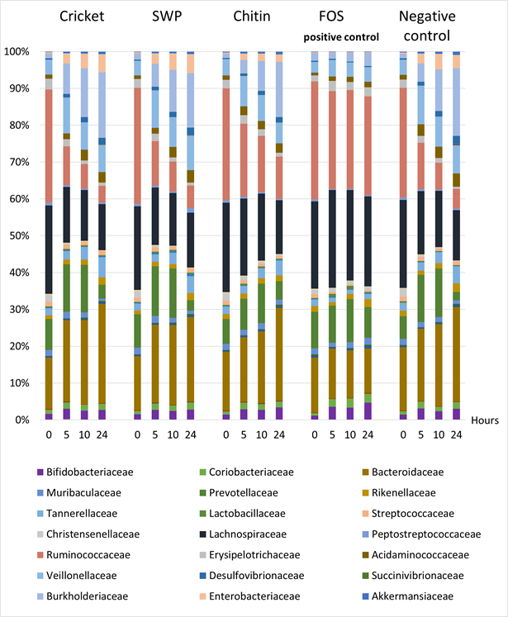

**Figure 1: Stacked bars** **chart of family level gut microbiota composition** over the course of 24hr anaerobic fermentation performed adult (20-40y, n=8) human feces. All bioreactors were grown on chemostat media and 1% w/v of digested cricket, SWP or chitin powders as well as FOS and water-based digesta as positive and negative controls. Figure adapted from (Refael et al., 2022).

* + 1. Impact of protein amyloid fibrils on the human microbiota

In foods, fibrillar amyloids may be detected in a variety of processed products, however little is known of their digestive fate and possible implications to health (Cao & Mezzenga, 2019). Thus, this overviewed study focused on the gastro-intestinal and colonic fate of a set of controlled and well characterized amyloid fibrils (AF) produced from beta-lactoglobulin (BLG) and egg ovalbumin (OVA).

Like previous work, human faeces were also used to inoculate anaerobic reactors in which the impact of amyloids could be assessed and compared to FOS as a positive control. First, BLG-AF and OVA-AF were not found to markedly affect colonic microbial diversity, however, OVA-AF was found to attenuate the known antimicrobial impact of OVA on alpha-diversity. Delving into specific shifts in phyla and genera abundances revealed a decrease in the ratio of Firmicutes/Bacteroidetes (F/B) which was found to decrease drastically for native and fibrillar OVA to ratios of 0.5±0.2 and 1.0±0.5 accordingly. While low F/B ratios are increasingly viewed as a positive hallmark of microbiota diversity and high values considered biomarkers of gut dysbiosis, the maximal F/B value in this study did not exceed 4 (An et al., 2023; Di Pierro, 2021; Grigor’eva, 2021; Indiani et al., 2018; Magne et al., 2020). These results suggest amyloid fibrils to be overall safe to human consumption, concurring with previous work (Xu et al., 2023).

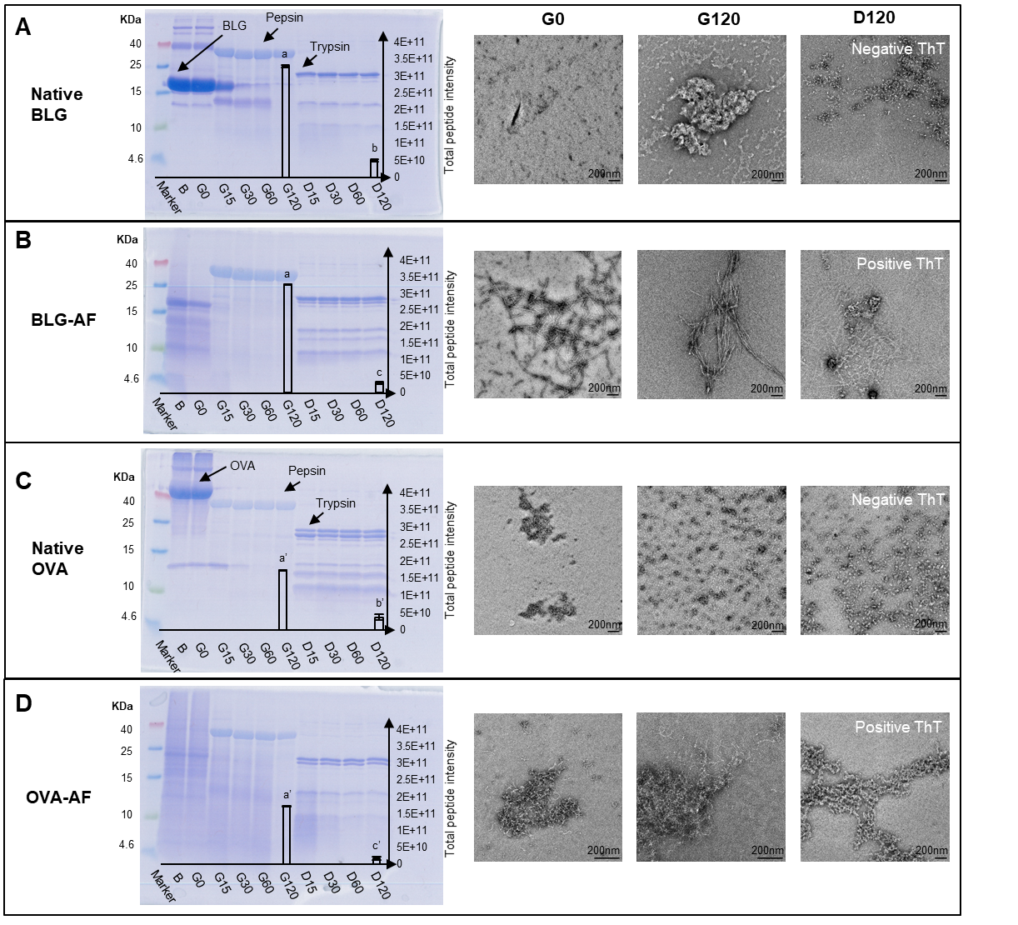

**Figure 2: BLG and OVA amyloid fibrils are resistant to proteolysis during digestion. *In vitro* semi-dynamic physiological digestion samples analyzed with various methods.** Abbreviations: G0, G120 and D120 stands for end of oral, gastric and duodenal digestion, respectively. **(A-D)** SDS-PAGE gel scans of digestion samples are presented and annotated, overlaid with proteomic analysis of total peptide intensity analyzed with LC-MS/MS in the respective lanes, correlated to total peptide abundance of fractions ranging roughly 600-2200 Da. Following them are TEM images evaluating BLG and OVA nanostructures of native forms **(A,C)** and amyloid forms **(B,D)** throughout digestion. Scale bar is 200nm for all images. Figure adapted from (Refael et al., 2024).

* 1. Conclusions

In a health-conscious era when food processing and innovation are under strict scrutiny, it is imperative to generate systematic and robust evidence into the possible digestive fate of foods. This science and evidence-based approach should be practiced carefully when developing future foods or foods that undergo significant reformulation and/or extensive processing. This is a particular responsibility of food professionals, when facing novel moieties that can infiltrate the human diet, like chitin from insects of process-induced amyloid fibrils. Here, we overview two systematic studies that coupled advanced *in vitro* fermentation models with various analytics (e.g. 16S rRNA sequencing, GC-MS and *in silico* metabolic analyses) and bioinformatic pipelines to elucidate the mechanisms of digestive breakdown of such novel moieties. In the case of chitin from insects and amyloid-like fibrils, evidence indicates a possible prebiotic activity which should be further explored, as prebiotics are of favorable health outcomes. Secondly, evidence herein alleviates concerns that amyloid fibrils may have a deleterious effect on gut microbiota and human health.

**Acknowledgments**

The authors acknowledge the funding of the Israel Science Foundation grant 1749/22 and the Russel Berrie Nano-technology Institute at the Technion.

**References**

An, J., Kwon, H., & Kim, Y. J. (2023). The Firmicutes/Bacteroidetes Ratio as a Risk Factor of Breast Cancer. *Journal of Clinical Medicine*, *12*(6). https://doi.org/10.3390/jcm12062216

Cao, Y., & Mezzenga, R. (2019). Food protein amyloid fibrils: Origin, structure, formation, characterization, applications and health implications. In *Advances in Colloid and Interface Science* (Vol. 269, pp. 334–356). Elsevier B.V. https://doi.org/10.1016/j.cis.2019.05.002

Chen, L., Remondetto, G. E., & Subirade, M. (2006). Food protein-based materials as nutraceutical delivery systems. In *Trends in Food Science and Technology* (Vol. 17, Issue 5, pp. 272–283). https://doi.org/10.1016/j.tifs.2005.12.011

Di Pierro, F. (2021). Gut microbiota parameters potentially useful in clinical perspective. In *Microorganisms* (Vol. 9, Issue 11). MDPI. https://doi.org/10.3390/microorganisms9112402

Floros, J. D., Newsome, R., Fisher, W., Barbosa-Cánovas, G. V., Chen, H., Dunne, C. P., German, J. B., Hall, R. L., Heldman, D. R., Karwe, M. V., Knabel, S. J., Labuza, T. P., Lund, D. B., Newell-McGloughlin, M., Robinson, J. L., Sebranek, J. G., Shewfelt, R. L., Tracy, W. F., Weaver, C. M., & Ziegler, G. R. (2010). Feeding the world today and tomorrow: The importance of food science and technology. *Comprehensive Reviews in Food Science and Food Safety*, *9*(5), 572–599. https://doi.org/10.1111/j.1541-4337.2010.00127.x

Food Protein Amyloid Fibrils: Origin, Structure, Formation, Characterization, Applications and Health Implications, 269 Advances in Colloid and Interface Science 334 (2019).

Gibney, M. J., Forde, C. G., Mullally, D., & Gibney, E. R. (2017). Ultra-processed foods in human health: A critical appraisal. *American Journal of Clinical Nutrition*, *106*(3), 717–724. https://doi.org/10.3945/ajcn.117.160440

Gosby, A. K., Conigrave, A. D., Lau, N. S., Iglesias, M. A., Hall, R. M., Jebb, S. A., Brand-Miller, J., Caterson, I. D., Raubenheimer, D., & Simpson, S. J. (2011). Testing protein leverage in lean humans: A randomised controlled experimental study. *PLoS ONE*, *6*(10). https://doi.org/10.1371/journal.pone.0025929

Grigor’eva, I. N. (2021). Gallstone disease, obesity and the firmicutes/bacteroidetes ratio as a possible biomarker of gut dysbiosis. In *Journal of Personalized Medicine* (Vol. 11, Issue 1, pp. 1–18). MDPI AG. https://doi.org/10.3390/jpm11010013

Iadanza, M. G., Jackson, M. P., Hewitt, E. W., Ranson, N. A., & Radford, S. E. (2018). A new era for understanding amyloid structures and disease. In *Nature Reviews Molecular Cell Biology* (Vol. 19, Issue 12, pp. 755–773). Nature Publishing Group. https://doi.org/10.1038/s41580-018-0060-8

Indiani, C. M. D. S. P., Rizzardi, K. F., Castelo, P. M., Ferraz, L. F. C., Darrieux, M., & Parisotto, T. M. (2018). Childhood Obesity and Firmicutes/Bacteroidetes Ratio in the Gut Microbiota: A Systematic Review. In *Childhood Obesity* (Vol. 14, Issue 8, pp. 501–509). Mary Ann Liebert Inc. https://doi.org/10.1089/chi.2018.0040.

Khoushab, F., Yamabhai, M. (2010). Chitin Research Revisited. *Marine Drugs*. 8(7), 1988-2012. https://doi.org/10.3390/md8071988.

Levine, A. S., & Ubbink, J. (2023). Ultra-processed foods: Processing versus formulation. *Obesity Science & Practice*, *9*(4), 435–439. https://doi.org/10.1002/OSP4.657

Livney, Y. D. (2010). Milk proteins as vehicles for bioactives. *Current Opinion in Colloid and Interface Science*, *15*(1–2), 73–83. https://doi.org/10.1016/j.cocis.2009.11.002

Magne, F., Gotteland, M., Gauthier, L., Zazueta, A., Pesoa, S., Navarrete, P., & Balamurugan, R. (2020). The firmicutes/bacteroidetes ratio: A relevant marker of gut dysbiosis in obese patients? In *Nutrients* (Vol. 12, Issue 5). MDPI AG. https://doi.org/10.3390/nu12051474

Martinez-Cordero, C., Kuzawa, C. W., Sloboda, D. M., Stewart, J., Simpson, S. J., & Raubenheimer, D. (2012). Testing the Protein Leverage Hypothesis in a free-living human population. *Appetite*, *59*(2), 312–315. https://doi.org/10.1016/j.appet.2012.05.013

Ordoñez-Araque, R., & Egas-Montenegro, E. (2021). Edible insects: A food alternative for the sustainable development of the planet. In *International Journal of Gastronomy and Food Science*. https://doi.org/10.1016/j.ijgfs.2021.100304

Orlien, V., Aalaei, K., Poojary, M. M., Nielsen, D. S., Ahrné, L., & Carrascal, J. R. (2021). Effect of processing on in vitro digestibility (IVPD) of food proteins. *Critical Reviews in Food Science and Nutrition*, *0*(0), 1–50. https://doi.org/10.1080/10408398.2021.1980763

Poutanen, K. S., Dussort, P., Erkner, A., Fiszman, S., Karnik, K., Kristensen, M., Marsaux, C. F. M., Miquel-Kergoat, S., Pentikäinen, S. P., Putz, P., Slavin, J. L., Steinert, R. E., & Mela, D. J. (2017). A review of the characteristics of dietary fibers relevant to appetite and energy intake outcomes in human intervention trials. *American Journal of Clinical Nutrition*, *106*(3), 747–754. https://doi.org/10.3945/ajcn.117.157172

Raubenheimer, D., & Simpson, S. J. (2019). Protein Leverage: Theoretical Foundations and Ten Points of Clarification. In *Obesity* (Vol. 27, Issue 8, pp. 1225–1238). Blackwell Publishing Inc. https://doi.org/10.1002/oby.22531

Refael, G., Engelberg, Y., Romano, A., Amiram, G., Barnea, E., Shani Levi, C., Turjeman, S., Landau, M., Koren, O., & Lesmes, U. (2024). Digestive fate of milk and egg-derived amyloids: Attenuated digestive proteolysis and impact on the trajectory of the gut microbiota. *Food Hydrocolloids*, *151*. https://doi.org/10.1016/j.foodhyd.2024.109820

Refael, G., Riess, H. T., Levi, C. S., Magzal, F., Tamir, S., Koren, O., & Lesmes, U. (2022). Responses of the human gut microbiota to physiologically digested insect powders or isolated chitin thereof. *Future Foods*, *6*. https://doi.org/10.1016/j.fufo.2022.100197

Stull, V. J., Finer, E., Bergmans, R. S., Febvre, H. P., Longhurst, C., Manter, D. K., Patz, J. A., & Weir, T. L. (2018). Impact of Edible Cricket Consumption on Gut Microbiota in Healthy Adults, a Double-blind, Randomized Crossover Trial. *Scientific Reports*, *8*(1), 1–13. https://doi.org/10.1038/s41598-018-29032-2

van Boekel, M., Fogliano, V., Pellegrini, N., Stanton, C., Scholz, G., Lalljie, S., Somoza, V., Knorr, D., Jasti, P. R., & Eisenbrand, G. (2011). A review on the beneficial aspects of food processing. *Mol Nutr Food Res*, *54*(9), 1215–1247. https://doi.org/10.1002/mnfr.200900608

Van Huis, A. (2017). New sources of animal proteins: Edible insects. In *New Aspects of Meat Quality: From Genes to Ethics* (pp. 443–461). Woodhead Publishing. https://doi.org/10.1016/B978-0-08-100593-4.00018-7

Xu, D., Zhou, J., Soon, W. L., Kutzli, I., Molière, A., Diedrich, S., Radiom, M., Handschin, S., Li, B., Li, L., Sturla, S. J., Ewald, C. Y., & Mezzenga, R. (2023). Food amyloid fibrils are safe nutrition ingredients based on in-vitro and in-vivo assessment. *Nature Communications 2023 14:1*, *14*(1), 1–14. https://doi.org/10.1038/s41467-023-42486-x

Zhang, Y., & Giovannucci, E. L. (2022). Ultra-processed foods and health: a comprehensive review. *Critical Reviews in Food Science and Nutrition*, *63*(31), 10836–10848. https://doi.org/10.1080/10408398.2022.2084359