 CHEMICAL ENGINEERING TRANSACTIONS  VOL. , 2025 | A publication of  
The Italian Association
of Chemical Engineering
Online at www.cetjournal.it

Guest Editors: Laura Piazza, Francesco Donsì, Giorgia Spigno
Copyright © 2025, AIDIC Servizi S.r.l.
ISBN 979-12-81206-19-9; ISSN 2283-9216

Scaling Up Micronization Techniques for Enhanced Bioactive Recovery from Rucola leaves: from High-Pressure Homogenization to Disc Mill

Fatemeh Mojarradi ª, Francesco Donsì ^{a,b*}
ªDepartment of Industrial Engineering, University of Salerno, Fisciano (SA), Italy
^{b}ProdAl scarl, University of Salerno, Fisciano (SA), Italy
*fdonsi@unisa.it

Micronization techniques like High pressure homogenization (HPH) and Disc milling (DM) are mechanical, high-shear processes used to reduce food particle size to the micron scale. These cell disruption technologies are widely used to complement green extraction processes for bioactive compound extraction, reducing the need for high temperature or organic solvents. However, while effective in disrupting cell structures and enhancing mass transfer, some techniques face scalability limitations. Identifying scalable alternatives is essential for reproducing small-scale results in industrial applications.
This study investigates DM as a viable technique for scaling up HPH and promoting the extraction in water of bioactive molecules from rucola. High shear mixing (HSM) was utilized as a benchmark. Rucola was treated with HPH and DM in distilled water at ratios of 1:10 and 1:3 (w/v), respectively. The number of passes varied from 5 to 10 for HPH and 1 to 5 for DM. Extraction efficiency was evaluated using ferric-reducing antioxidant power (FRAP) for the extracts collected in the supernatant, along with total phenolic compounds (TPC) and total flavonoid compounds (TFC) analyses. Particle size distribution and microscopy assessed the extent of cellular disruption.
Results indicate that DM up to five passes achieved significant particle size reduction, comparable to HPH, with d(0.1), , d(0.5) , and d(0.9) reduced to 70.3 µm, 334.2 µm, and 825.7 µm, respectively, suggesting complete cell disruption. Consequently, TPC, TFC, and FRAP values significantly increased compared to HSM- and HPH-treated samples. Moreover, DM's lower operational temperature and milder mechanical forces likely contributed to enhanced compound preservation and higher antioxidant activity. Overall, DM proves to be an effective technique for HPH scaling up, improving bioactive compound extraction and antioxidant activity in rucola, and offering a sustainable approach to agrifood residue valorization.

- Introduction
Agri-food residues, wastes and various biomasses serve as valuable sources of bioactive compounds, including proteins, polysaccharides, fibres, flavour compounds, phytochemicals and antioxidants (Awad et al., 2021; Kumar et al., 2017; Panzella et al., 2020). Many of these compounds exhibit antioxidative, anti-cancer, anti-inflammatory, and antimicrobial properties (Azmir et al., 2013; Galanakis, 2021). Nowadays, the demand for natural bioactive compounds has increased due to their beneficial effects on human health (Awad et al., 2021).
These bioactive compounds have promising applications in the food, cosmetics, and pharmaceutical industries.
Efficient extraction techniques are therefore essential for recovering these compounds and valorizing their antioxidant activity. This is crucial for their utilization in value-added product development, and for assessing their potential in preventing cellular damage and mitigating disease progression, including neurodegenerative disorders (Mojarradi et al., 2024; Panzella et al., 2020).
The efficiency of an extraction technique significantly affects the release of intracellular bioactive compounds. Optimal methods enhance cellular disruption while preserving bioactive compounds, leading to higher extraction yields and improved antioxidant activity. High-pressure homogenization (HPH) is a well-established technique that utilizes intense mechanical forces to micronize samples, such as leafy vegetables in suspension, thereby facilitating intracellular compounds release and increasing extraction efficiency (Carpentieri et al., 2023a). Over the past decade, HPH has been widely explored for extracting and enhancing the functionality of bioactive compounds (Yong et al., 2021). Its advantages over conventional extraction methods include reduced processing time and lower energy consumption (Mesa et al., 2020).
Several key parameters influence HPH efficiency, including applied pressure, which determines the intensity of mechanical forces; processing temperature, which affects compound stability; and the number of passes, which determines the extent of cell disruption through repeated mechanical stress (Carpentieri et al., 2023a; Patrignani and Lanciotti, 2016). While HPH is effective for cell disruption and mass transfer enhancement, its scalability remains a challenge, particularly in large-scale applications, because of relatively low concentrations that can be processed (approximately 1% of dry solids), risk of clogging of pressure intensifier and homogenization valve, and investment costs for large-scale equipment.
Disc milling (DM) is an alternative mechanical extraction technique that applies grinding shear forces, yielding effects comparable to HPH in terms of cell disruption and extraction efficiency. DM technique combines the comminution principles used by Hammer Mill and Roller Mill technologies, and has been mostly utilized in different studies with the aim of reduction of particle size of different materials from biomass to rocks (Alvin R Womac et al., 2007; Nandiyanto et al., 2020). Importantly, DM offers a scalable solution for processing large biomass quantities at high concentration efficiently.
This study aims to evaluate the potential of DM technology as a reliable extraction method for scaling up the HPH and enhancing the aqueous extraction of bioactive molecules from rucola.
- Material and methods
- Material
All chemicals and standards involved in the analyses were supplied by Sigma Aldrich (Steinheim, Germany). Fresh rucola was purchased from a local market in Fisciano, Italy.
- High pressure homogenization (HPH) extraction
Fresh rucola was mixed with distilled water at a 10 % (w/w) ratio and pretreated using a high-shear mixer (HSM) (Ultra Turrax T-25, IKA Labortechnik, Staufen, Germany) equipped with an S25-N18 G rotor. The mixture was processed at 20,000 rpm for 5 min, in an ice bath to maintain the sample temperature. HPH-assisted extraction was then performed using a custom-built HPH unit, equipped with a 200 µm orifice valve (model WS1973, Maximator JET GmbH, Schweinfurt, Germany). Samples were processed at 80 MPa for 5 and 15 passes. A tube-in-tube heat exchanger maintained the suspension temperature at 25°C during homogenization.
Immediately after HSM or HPH treatments, the aqueous suspensions of micronized rucola were left to macerate for 1 h at room temperature. Subsequently, the suspensions were centrifuged (PK121R model, ALC International, Cologno Monzese, Milan, Italy) at 6000 rpm at 18°C for 15 min. The resulting were collected for further analyses.
- Disc mill extraction
Fresh rucola was processed using a disc mill (Granomat JP 150, Fuchs, Switzerland) with continuous addition of distilled water to maintain a sample-to-solvent ratio of 1:3 (w/v). DM was conducted at a speed of 5, with the disc gap set at 0.0 mm. The process was performed up to 5 passes.
Immediately after DM treatment, the aqueous suspensions of rucola were left to macerate for 1 h at room temperature, before centrifugation and analysis.
- Total phenolic compounds (TPC)
The total phenolic content (TPC) of rucola extracts was determined using the Folin-Ciocalteu reagent (FCR) following the method of Carpentieri et al. (2023). Briefly, 0.5 mL of extract was mixed with 2.5 mL of 10% (v/v) FCR, followed by the addition of 2.5 mL of a 7.5% carbonate sodium (Na₂CO₃) solution. The mixture was incubated in the dark at room temperature for 60 min, and absorbance was measured at 765 nm using a UV/Vis spectrophotometer (V-650, Jasco Inc. Easton, MD, USA) against a reagent blank.
TPC was quantified using a gallic acid standard and expressed as mg gallic acid equivalents (GAE) per gram of dry matter (DM) rucola. All measurements were performed in triplicate and reported as mean ± standard deviation (Carpentieri et al., 2023b).
- Total flavonoid compounds (TFC)
The total flavonoid content (TFC) of rucola extracts was determined using the aluminum-chloride colorimetric assay, following the method reported by Carpentieri et al. (2022). Briefly, 1 mL of extract was mixed with 4 mL of distilled water, followed by the sequential addition of 0.3 mL of 5% (w/v) sodium nitrite and 0.3 mL of 10% (w/v) of aluminum chloride hexahydrate (AlCl₃·6H₂O). The mixture was incubated in the dark for 5 min after each reagent addition. Subsequently, 2 mL of 1.0 M NaOH was added, and the mixture was diluted to 10 mL with distilled water. Absorbance was measured at 510 nm with the UV/Vis spectrophotometer against the reagent blank.
TFC was quantified using a quercetin standard curve and expressed as mg quercetin equivalent (QE) per gram of dry matter (DM) rucola (Carpentieri et al., 2022).
- Ferric reducing antioxidant power (FRAP)
The ferric reducing antioxidant power (FRAP) assay was performed as described by Carpentieri et al. (2022). Briefly, 0.5 mL of diluted extract was mixed with 2.5 mL of freshly prepared FRAP working solution and incubated at ambient temperature for 10 min. Absorbance was measured at 593 nm using a UV/Vis spectrophotometer. FRAP values were expressed as mg ascorbic acid equivalents (mg AAE) per gram of DM rucola (Carpentieri et al., 2022).
- Particle size analysis
Particle size distribution of the suspensions processed using HSM, HPH or DM, was measured by laser diffraction using a Malvern Mastersizer 2000 (Malvern Instruments Ltd., UK), following the method of Pirozzi et al. (2021). The diameters corresponding to the 10th, 50th and 90th percentile of the cumulative distribution (d(0.1), d(0.5) and d (0.9), respectively), were determined. Additionally, the volume-based mean diameter (D[4,3]), and the surface-based mean diameter (D[3,2]) were calculated.
Measurements were performed in triplicate, and the analysis was conducted at 25 ± 0.5°C (Pirozzi et al., 2021).
- Light microscopy analysis
The microscopic structure of the suspensions processed using HSM, HPH or DM, was analyzed in situ using an inverted optical microscope (Nikon Eclipse TE 2000S, Nikon instruments Europe B.V., Amsterdam, The Netherlands), with 10× objective. Image capture and analysis were performed using a DS Camera Control Unit (DS-5M-L1, Nikon Instruments Europe B.V.).
For microscopy, 100 µL of the sample was placed on a glass slide and enclosed with a cover glass. The microstructure of the sample was visualized and recorded using camera unit’s imaging function.

- Results and discussion
- Total polyphenols, flavonoids and antioxidant activity
The TPC, TFC, and antioxidant activity of the supernatant from water-based extracts were analyzed, and the results are presented in Table. 1. Increasing the number of HPH passes led to higher TPC and TFC in comparison to HSM treated samples. However, DM-treated samples exhibited significantly higher TPC and TFC than both HPH and HSM treatments. Additionally, antioxidant activity, as measured by the FRAP assay, was notably enhanced in DM-treated samples. Specifically, after 5 DM passes, TPC increased significantly from 14.56 ± 0.34 mg GAE/gDM (HSM), and 20.8 ± 0.17 mg GAE/gDM (HPH) to 34.3 ± 0.01 mg GAE/gDM. A similar trend was observed for TFC. Furthermore, the antioxidant activity increased from 5.21 ± 0.00 mg AAE/g DM (HSM) and 8.22 ± 0.17 mg AAE/gDM (HPH) to 24.5 ± 0.28 mg AAE/gDM in DM-treated samples.
HPH enhances the extraction of bioactive compounds by applying intense mechanical forces, such as cavitation, turbulence, shear, and elongational stresses to micronize plant tissues, while DM uses grinding shear forces to achieve similar effects (Carpentieri et al., 2023a). Both techniques improve the bioaccessibility of intracellular antioxidant compounds. However, as the number of passes increases, HPH treatment leads to a reduction in TPC, TFC, and FRAP values, as observed at both 5 and 15 passes. This decrease is likely due to the degradation of bioactive compounds caused by the local intense hot spots generated by cavitation phenomena (bubble collapse), which are non-negligible during HPH treatment (Coccaro et al., 2018).
In contrast, DM proved more effective than HPH in disrupting cell structures and increasing compound release, making it a promising alternative for large-scale applications. Additionally, DM concentrates the mechanical forces on shear stress alone, minimizing heating effects and better preserving thermolabile compounds from degradation. This results in higher preservation of bioactive compounds while maintaining high efficiency in cell disruption. The criterion for statistical significance was p value ≤ 0.005. Table 1 presents the results of the ANOVA analysis, where different letters indicate significant differences (P ≤ 0.005) for each test.
Table. 1. The concentration of TPC, TFC, and antioxidant activity (FRAP) of rucola samples treated by HSM (control), HPH (5 and 10 passes), and DM (5 passes).
Sample | TPC  (mg GAE/g DM) | TFC  (mg QE/g DW) | FRAP  (mg AAE/g DM)
HSM | 14.56 ± 0.34c | 0.43 ± 0.07c | 4.19 ± 0.11c
HPH - 5 passes | 20.76 ± 0.17b | 0.82 ± 0.14b | 8.22 ± 1.77b
HPH - 15 passes | 18.29 ± 0.37b | 0.45 ± 0.00c | 7.43 ± 0.01b
DM - 5 passes | 34.33 ± 0.01a | 1.31 ± 0.07a | 24.53 ± 2.88a
Different letters indicate significant differences at p value ≤ 0.005.
- Particle size distribution and microscopy analysis
Table 2 presents the particle size distribution of rucola suspensions, characterized by the diameters d(0.1), d(0.5), d(0.9), D[4,3], and D[3,2], highlighting the effect of different extraction techniques. The results indicate that both the choice of extraction technique and the number of processing passes significantly influence the particle size of the rucola suspension. The particle size distribution parameters d(0.1), d(0.5), and d(0.9), were notably reduced when the extraction method shifted from HSM to HPH and DM. Furthermore, an increasing number of passes contributed to the particle size reduction. In HPH-treated samples, after 5 and 15 passes, d(0.1) and d(0.9) decreased from 61.7 μm and 1165 μm to 10.5 μm and 132.0 μm, respectively. A similar reduction trend was observed for the median diameter d(0.5), the volumetric-weighted mean diameter (D[4,3]) and surface-weighted mean diameter (D[3,2]), confirming the effectiveness of these techniques in reducing particle size. It is remarkable that DM causes a significant decrease in particle size, as shown by the main characteristic diameters, acting mainly on larger particles, differently from HPH. This is evident because, while d(0.1) is similar to HPH (5 passes), the values of d(0.5) and d(0.9) are significantly lower for DM. Especially in biomass disruption, this is sufficient to break down cell structures, typically on the order of hundreds of micrometers (Gali et al., 2020), and cause the release of intracellular material, as shown in Section 3.1, while not excessively stressing the material and preserving thermolabile compounds. These findings position DM as a promising and reliable alternative for scaling up the HPH technique. Figure 1 shows the rucola DM treated after five passes and untreated samples.

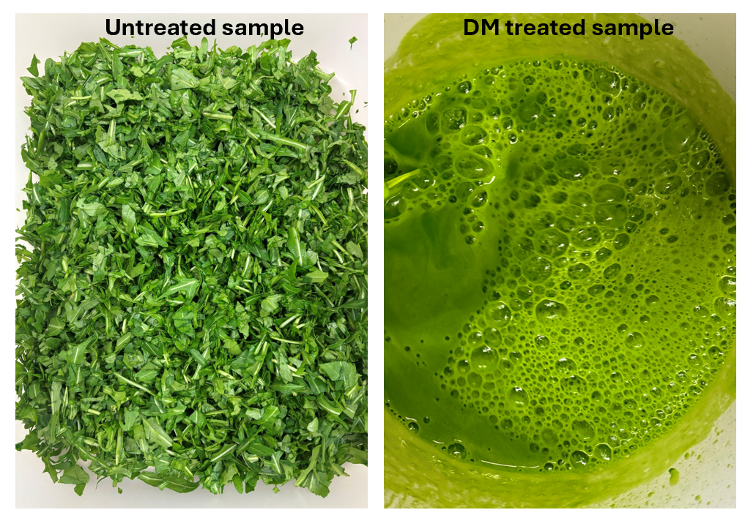
Figure 1. Untreated and DM treated rucola after five passes

Table. 2. Characteristic diameters (μm) of the particle size distribution of the rucola suspensions treated by HSM, HPH (5 and 10 passes), and DM (5 passes).
Sample | Surface Weighted Mean  D[3,2] ($μ$m) | Vol. Weighted Mean  D[4,3] ($μ$m) | d(0.1)  ($μ$m) | d(0.5)  ($μ$m) | d(0.9)  ($μ$m)
HSM | 346.6 | 634.7 | 192.4 | 580.9 | 1144
HPH- 5 passes | 89.4 | 614.6 | 61.7 | 587.1 | 1165
HPH-  15 passes | 19.2 | 70.6 | 10.5 | 52.4 | 132.0
DM- 5 passes | 81.9 | 400.2 | 70.3 | 334.2 | 825.7

These observations align with the microscopic analysis presented in Figure 2, which shows that HPH and DM treated samples had comparable cell disruption effects, and both techniques demonstrated significant efficacy in cell disruption compared to HSM.

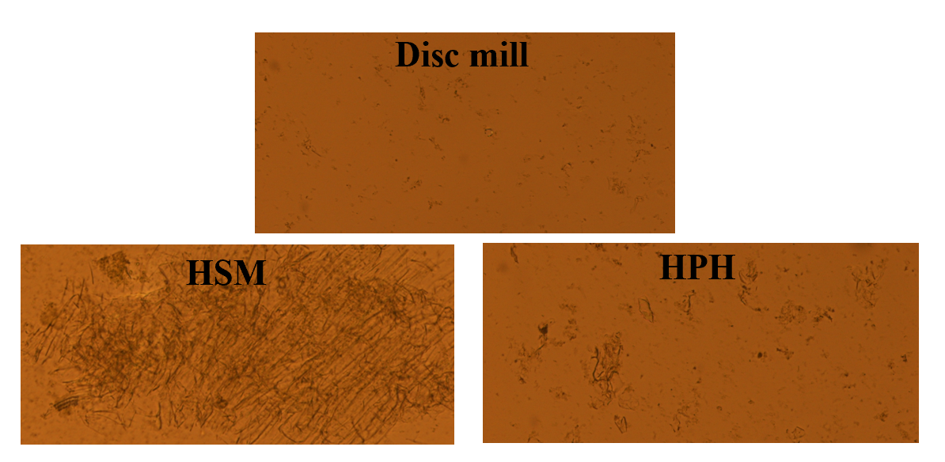
Figure 2. Microscopy analysis of the rucola suspensions treated by HSM, HPH (5 and 10 passes), and DM (5 passes).
- Conclusion
The choice of the extraction technique plays a crucial role in bioactive compound extraction from agri-food residues, with scalability being a key factor for industrial application. In this study, the Disc Mill (DM) technique was compared with High-Pressure Homogenization (HPH) to evaluate its efficiency and reliability as an alternative for scaling up HPH. The results show that DM (after five passes) yields comparable or higher efficiency than HPH (after five passes) in terms of cell disruption and the release of total phenolic compounds, flavonoids, and antioxidant activity. Notably, DM’s ability to concentrate mechanical forces on shear stress while minimizing heating effects contributes to better preservation of thermolabile compounds, resulting in higher bioactive compound retention.
These findings highlight the potential of DM as a promising, scalable alternative to HPH for bioactive compound extraction, offering advantages in industrial applications.
Acknowledgments
This study was carried out within the Agritech National Research Center and received funding from the European Union Next-GenerationEU (Piano Nazionale di Ripresa E Resilienza (Pnrr)—Missione 4 Componente 2, Investimento 1.4—D.D. 1032 17/06/2022, CN00000022).
References
Alvin R Womac, C Igathinathane, Prasad Bitra, P Miu, T Yang, S Sokhansanj, S Narayan, 2007, Biomass Pre-Processing Size Reduction with Instrumented Mills, 2007 ASAE Annual Meeting. American Society of Agricultural and Biological Engineers, p. 1.
Awad, A.M., Kumar, P., Ismail-Fitry, M.R., Jusoh, S., Ab Aziz, M.F., Sazili, A.Q., 2021, Green Extraction of Bioactive Compounds from Plant Biomass and Their Application in Meat as Natural Antioxidant, Antioxidants, 10 (9), 1465.
Azmir, J., Zaidul, I.S.M., Rahman, M.M., Sharif, K.M., Mohamed, A., Sahena, F., Jahurul, M.H.A., Ghafoor, K., Norulaini, N.A.N., Omar, A.K.M., 2013, Techniques for extraction of bioactive compounds from plant materials: A review, Journal of food engineering, 117(4), 426-436.
Carpentieri, S., Ferrari, G., Donsì, F., 2023a, High-Pressure Homogenization for Enhanced Bioactive Recovery from Tomato Processing By-Products and Improved Lycopene Bioaccessibility during In Vitro Digestion, Antioxidants, 12 (10), 1855.
Carpentieri, S., Ferrari, G., Donsì, F., 2023b, All-natural wheat gliadin-gum arabic nanocarriers for encapsulation and delivery of grape by-products phenolics obtained through different extraction procedures, Food Chem 424, 136385.
Carpentieri, S., Ferrari, G., Pataro, G., 2022, Optimization of Pulsed Electric Fields-Assisted Extraction of Phenolic Compounds From White Grape Pomace Using Response Surface Methodology, Frontiers in Sustainable Food Systems, 6, 854968.
Coccaro, N., Ferrari, G., Donsì, F., 2018, Understanding the break-up phenomena in an orifice-valve high pressure homogenizer using spherical bacterial cells (Lactococcus lactis) as a model disruption indicator. J Food Eng 236, 60–71.
Galanakis, C.M. (Ed.), 2021, Nutraceutical and functional food components: Effects of innovative processing techniques, Academic Press.
Gali, L., Bedjou, F., Velikov, K.P., Ferrari, G., Donsì, F., 2020, High-pressure homogenization-assisted extraction of bioactive compounds from Ruta chalepensis. Journal of Food Measurement and Characterization 14, 2800–2809.
Kumar, K., Yadav, A.N., Kumar, V., Vyas, P., Dhaliwal, H.S., 2017, Food waste: a potential bioresource for extraction of nutraceuticals and bioactive compounds, Bioresources and Bioprocessing, 4, 1-14.
Mesa, J., Hinestroza-Córdoba, L.I., Barrera, C., Seguí, L., Betoret, E., Betoret, N., 2020, High Homogenization Pressures to Improve Food Quality, Functionality and Sustainability, Molecules, 25(14), 3305.
Mojarradi, F., Bimakr, M., Ganjloo, A., 2024, Effect of bio-edible coating based on Lallemantia iberica seed mucilage incorporated with Malva sylvestris leaf bioactive compounds on oxidative stability of turkey meat, Journal of Food Measurement and Characterization, 18, 402–412.
Nandiyanto, A.B.D., Ragadhita, R., Sukmafitri, A., Bilad, M.R., Aziz, M., Yunas, J., 2020, Mechanical Impact in Disk Mill for Producing Controlled Rice Husk Particle Size by Changing Impactor Shapes and Disk Rotation Speeds, Sains Malays 49, 2927–2940.
Panzella, L., Moccia, F., Nasti, R., Marzorati, S., Verotta, L., Napolitano, A., 2020, Bioactive Phenolic Compounds From Agri-Food Wastes: An Update on Green and Sustainable Extraction Methodologies, Frontiers in nutrition, 7, 60.
Patrignani, F., Lanciotti, R., 2016, Applications of High and Ultra High Pressure Homogenization for Food Safety, Frontiers in Microbiology, 7, 1132.
Pirozzi, A., Capuano, R., Avolio, R., Gentile, G., Ferrari, G., Donsì, F., 2021, O/W pickering emulsions stabilized with cellulose nanofibrils produced through different mechanical treatments, Foods, 10(8), 1886.
Yong, S.X.M., Song, C.P., Choo, W.S., 2021, Impact of High-Pressure Homogenization on the Extractability and Stability of Phytochemicals. Frontiers in Sustainable Food Systems, 4, 593259.

