 CHEMICAL ENGINEERING TRANSACTIONS  VOL. , 2025 | A publication of  
The Italian Association
of Chemical Engineering
Online at www.cetjournal.it

Guest Editors: Laura Piazza, Francesco Donsì, Giorgia Spigno
Copyright © 2025, AIDIC Servizi S.r.l.
ISBN 979-12-81206-19-9; ISSN 2283-9216

The Future of Nutritional Foods Education: Challenges and Opportunities in Management and Decision Makings

Kriss Melody Calla Vásquezª, Julia Lizet Torres Rivera^{b}, Cristian Félix Rojas Huamán^{c}, Gerald Rogelio Cuzcano Ortiz^{d}

ªFacultad de Ciencias Sociales y Humanidades, Universidad Enrique Guzman y Valle, Perú
^{b}Facultad de Humanidades, Universidad Tecnológica del Perú, Lima, Perú
^{c}Departamento de Estudios Generales, Instituto Superior Tecnológico Tecsup, Lima, Perú
^{d}Departamento de Estudios Generales, Instituto Superior Tecnológico Tecsup, Lima, Perú
crojas@tecsup.edu.pe

Nutritional Food Education (NFE) plays a significant role in promoting healthy eating habits among every population. Over time, nutritional challenges have intensified due to global phenomena such as globalization, climate change, public health policies, and technological advances. These factors have made management and decision making in this field increasingly critical. This systematic review article aims to explore emerging trends in NFE, to identify the most relevant challenges and opportunities, and to reflect on the strategies needed to integrate these elements into future management and decision-making processes. This article gathers studies about nutritional foods that have been published in the past ten years, which focus on management and decision making. Different academic databases, such as PubMed, Scopus, and Google Scholar, were used to collect data. The selected studies were based on inclusion criteria that required the articles to be peer-reviewed and to cover topics such as nutrition management, emerging technologies, public policies, and decision making. Likewise, these studies were chosen regarding their relevance and methodological quality. In conclusion, the future of Nutritional Foods Education faces complex challenges arising from factors such as globalization, climate change, and chronic diseases increase. However, there are also multiple opportunities like digitalization and public policies that can be leveraged to improve the population’s nutritional health. In this regard, it is recommended to promote evidence-based public health education policies, to encourage continuous training of nutrition professionals, and to integrate innovative technologies into nutrition education.

Keywords: Nutritional Education, Public Health, Food Globalization, Climate Change and Nutrition, Educational Technology in Nutrition.

Introduction
In recent decades, food and nutrition have gained increasing relevance in the field of public health due to their close relationship with quality of life and sustainable development. The World Health Organization (WHO) warns that malnutrition, in all its forms, represents one of the greatest challenges of the 21st century, affecting millions of people worldwide. From undernutrition to obesity, dietary problems not only impact individual health but also influence the social and economic development of nations.

In this context, food and nutrition education (FNE) emerges as a key strategy to promote healthy habits and improve dietary decision-making. However, its effective implementation faces several difficulties, such as a lack of integration into educational systems, unequal access to reliable information, and the influence of advertising on consumption patterns. As digital technologies advance and new pedagogical methodologies emerge, a panorama of opportunities opens up to strengthen nutrition education and improve food information management.

This article aims to analyze the future of nutrition education from a comprehensive perspective, identifying the main challenges and opportunities in management and decision-making. Through systematic literature review, emerging trends, innovative strategies, and the impact of technology on nutrition education will be explored, with the aim of proposing approaches that contribute to its strengthening and effectiveness.

Nutrition education (NEE) plays a fundamental role in promoting healthy habits and preventing diet-related diseases. In a global context marked by the increase in non-communicable diseases, food insecurity, and unequal access to nutritional information, NEE is presented as a key pillar for informed decision-making both at the individual level and in public policy management.

The advancement of technology, the digital transformation in education, and the growing interdisciplinary approach in the field of nutrition open up new opportunities and challenges in the teaching and dissemination of food knowledge. However, barriers that hinder its effective implementation persist, such as the lack of curricular integration in educational systems, resistance to change in pedagogical approaches, and the digital divide among vulnerable populations.

This systematic review provides a novel perspective by analyzing the challenges and opportunities in management and decision-making in food and nutrition education (FNE) in the context of digital transformation and recent changes in public policy. Unlike previous reviews, this study focuses on the impact of digitalization, artificial intelligence, and multisectoral integration on FNE, aspects that have been little explored in recent literature. Furthermore, it emphasizes the importance of evidence-based management and informed decision-making, key elements for the design and implementation of effective educational programs. The relevance of this approach lies in its potential to guide both public policymakers and education and health professionals, thus contributing to the development of innovative and sustainable strategies in the field of nutrition. Finally, recommendations will be discussed to strengthen nutritional education in different contexts and ensure its effectiveness in promoting healthy lifestyles.

Methodology
The systematic review was conducted using a qualitative approach based on the thematic synthesis or meta-synthesis model. This approach allows for the analysis, interpretation, and synthesis of information from previous studies using an interpretive approach. According to Grant and Booth (2009), a qualitative systematic review is an approach that "synthesizes qualitative findings from different studies to develop broader interpretations of a particular phenomenon" (p. 99).

This type of review not only gathers information but also looks for patterns and conceptual relationships in the reviewed literature. To conduct this type of review, it is recommended to follow the PRISMA (Preferred Reporting Items for Systematic Reviews and Meta-Analyses) guideline, adapted for qualitative studies (PRISMA-Q), which facilitates transparency and rigor in the collection and analysis of information (Page et al., 2021).

The review should include a structured search in academic databases such as Scopus, Web of Science, PubMed, or SciELO. Keywords and Boolean operators (AND, OR, NOT) can be used to refine the results (Sandelowski & Barroso, 2007). Inclusion and exclusion criteria should be clearly defined to ensure the relevance and quality of the selected studies.

Qualitative data analysis can be performed using thematic synthesis, which allows for "identifying, analyzing, and interpreting patterns within qualitative data" (Braun & Clarke, 2006, p. 79). This approach involves three main phases: initial coding (identification of key concepts in the reviewed studies); clustering of themes; organizing codes into thematic categories; and interpretive synthesis (construction of a narrative that integrates the findings). Another recommended method is meta-aggregation, which "focuses on integrating findings from multiple qualitative studies to generate applied knowledge" (Hannes & Lockwood, 2011, p. 145).

To assess the quality of the included studies, the Critical Appraisal Skills Programme (CASP) tools were used, which provide specific criteria for assessing the reliability and validity of qualitative studies (Long et al., 2020). CASP is an internationally recognized tool for assessing the methodological quality of qualitative studies, considering aspects such as clarity of objectives, appropriateness of design, rigor in data collection, and validity of results.

In summary, the systematic review was conducted following the PRISMA guidelines adapted for qualitative studies (PRISMA-Q), which ensured transparency and methodological rigor in the collection and analysis of information. A structured search was conducted in academic databases such as Scopus, Web of Science, PubMed, and SciELO, using combinations of keywords and Boolean operators to refine the results. The inclusion criteria included peer-reviewed studies published between 2023 and 2025 that addressed NSE in relation to management and decision-making. To assess the methodological quality of the selected studies, the Critical Appraisal Skills Programme (CASP) tool was used, which evaluates aspects such as clarity of objectives, appropriateness of design, rigor of data collection, and validity of results. Data analysis was conducted through thematic synthesis, identifying patterns and conceptual relationships in the findings reported by the included studies.

Discussion of Results
Regarding "The Future of Nutritional Education: Challenges and Opportunities in Management and Decision-Making," following the PRISMA method involves a series of structured steps to ensure transparency and reproducibility of the research. The key steps are detailed below, and eight relevant articles indexed in academic databases such as Scopus, Web of Science, PubMed, and SciELO are presented. Nutritional education plays a crucial role in promoting healthy habits and preventing diet-related diseases. However, it faces various challenges in its management and decision-making for its effective implementation. This systematic review aims to analyze the main challenges and opportunities in this field, using the PRISMA method to ensure a rigorous and structured analysis.

Studies published between 2023 and 2025 in academic databases indexed in Scopus, Web of Science, PubMed, and SciELO were included. The selection criteria were: Studies addressing nutritional education in the context of management and decision-making, publications in Spanish and English, and peer-reviewed studies.

Studies with undefined methodology and narrative reviews without an empirical basis were excluded. A structured search was conducted in Scopus, Web of Science, PubMed, and SciELO using keywords such as "nutrition education," "food program management," "nutrition decision-making," and "public food policies."

Following the PRISMA flowchart, 250 articles were identified, of which 50 were selected after eliminating duplicates. After a review of titles and abstracts, 20 articles were selected for full review. Finally, 8 relevant studies were included:

- Mexico weighs, measures, and monitors the health of 12 million schoolchildren in a country with obesity and diabetes problems. (2025, March 13).
- The school cafeteria decree will require that 45% of fruits and vegetables be seasonal and 5% organic. (2025, March 12).
- Who tells Spanish children that "nuggets" don't grow in the supermarket? (2024, September 13).
- From obese children to sick adults: Keys to reversing medical evidence. (2024, December 23).
- Nutri-Score is the system that classifies the most dishes as unhealthy, according to a study by the UPV/EHU. (2025, March 1).
- Luis Cañada: "We can't talk about educating our children if we ignore what they are eating at school." (2025, February 5).
- One-third of school cafeterias in Spain offer too many fried foods and too few vegetables. (2025, February 4).
- Implementation of public policies to promote healthy eating habits in schools: a systematic review. (2023).
The reviewed studies agree in pointing to the lack of teacher training as a recurring barrier, while digitalization presents a cross-cutting opportunity to improve access and personalization of food education. However, the influence of the food industry on educational content remains a structural challenge, especially in contexts of high socioeconomic inequality.

The studies identified several obstacles to food and nutrition education, including: lack of teacher training in nutrition, difficulties in implementing public policies, influence of the food industry on educational programs, and inequalities in access to healthy foods in school settings.

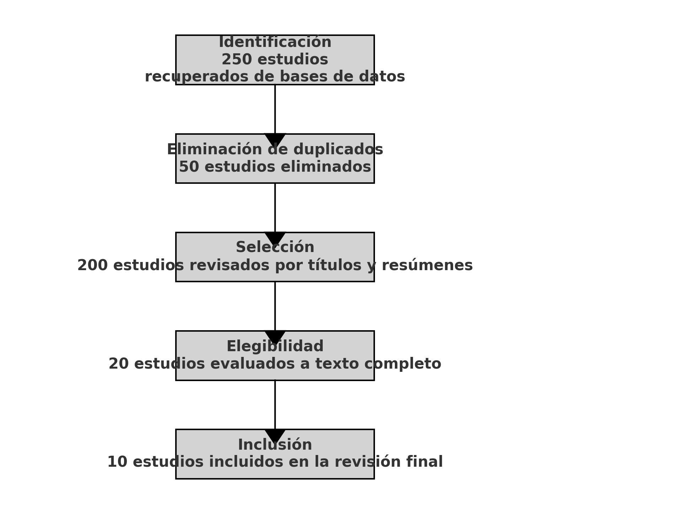
Figure 1: Prism flow diagram

The studies highlighted several opportunities to improve nutrition education: incorporating digital technologies for nutrition teaching, developing partnerships between governments, academic institutions, and civil society, implementing teacher training programs in nutrition education, and designing policies based on scientific evidence. The findings indicate that, while significant barriers exist, there are also opportunities for innovation and improvement in nutritional education. The integration of technologies and multisectoral participation are key factors in addressing these challenges and strengthening management and decision-making in this field.

The findings of this systematic review reveal that, although nutritional education faces multiple barriers, there are also significant opportunities for improvement. The analysis of the selected studies reveals that the lack of teacher training in nutrition and the difficulty in implementing public policies remain recurring barriers to the effectiveness of NFE. This situation is exacerbated in contexts of high socioeconomic inequality, where access to resources and technologies is limited. Likewise, the influence of the food industry on educational content represents an ethical and structural challenge, requiring stricter regulations and greater transparency in educational policymaking.

Furthermore, the reviewed studies agree that digitalization and the use of technological tools can be viable solutions to improve the teaching and accessibility of nutritional education. The positive impact of online platforms and interactive applications has been demonstrated in various studies, highlighting their potential to personalize learning and expand the reach of educational programs.

On the other hand, the influence of the food industry on educational content represents an ethical and structural challenge that must be addressed through stricter regulations and greater transparency in policymaking. The literature reviewed suggests that multisectoral collaboration, including the public, academic, and private sectors, can be an effective strategy to mitigate this influence and ensure the independence of educational programs.

Finally, equity in access to quality food education remains a central concern. The gap between communities with different socioeconomic levels highlights the need for inclusive policies that ensure adequate resources for all educational institutions, especially in vulnerable areas. The implementation of evidence-based nutrition education models adapted to each cultural and social context can contribute to reducing these inequalities.

In short, nutritional education has great potential to positively impact public health, provided that educational policies are strengthened, teacher training is promoted, and technological advances are leveraged to improve its effectiveness and reach.

Conclusions

This systematic review contributes to the field of nutrition education by offering an updated analysis geared toward management and decision-making in the context of digital transformation and changes in public policy. The findings highlight the need to strengthen teacher training, foster multisectoral collaboration, and leverage technological tools to improve the effectiveness and reach of NNE. Furthermore, this work provides a solid foundation for future research and the development of evidence-based public policies, with the goal of ensuring sustainability and equity in nutrition education initiatives.

The research highlights the need for comprehensive strategies to improve nutritional education. It is essential to strengthen teacher training, promote inclusive public policies, and utilize technological tools for greater effectiveness in nutrition teaching. Similarly, it demonstrates that nutritional education faces multiple challenges yet offers opportunities for strengthening. It is concluded that a lack of teacher training and the limited implementation of effective policies are critical barriers that require immediate attention. Digitalization and specialized teacher training are promising strategies for improving nutritional education. Collaboration between the public, academic, and private sectors can enhance the effectiveness of nutrition education programs. The development of evidence-based policies is essential to ensure the sustainability and effectiveness of nutrition education initiatives.

The findings of this review provide a solid foundation for future research and policymaking in the field of nutrition education.

References

Braun, V., & Clarke, V., 2006, Using thematic analysis in psychology. Qualitative Research in Psychology, vol. 3, núm. 2, pp. 77-101.
Cañada, L., 2025, "No podemos hablar de educar a nuestros hijos si ignoramos lo que están comiendo en los colegios", Cadena SER, <//cadenaser.com/aragon/2025/02/05/luis-canada-no-podemos-hablar-de-educar-a-nuestros-hijos-si-ignoramos-lo-que-estan-comiendo-en-los-colegios-ser-aragon-oriental/>. (in Spanish).
Deleuze, I., 2024, ¿Quién les cuenta a los niños españoles que los 'nuggets' no crecen en el supermercado? Cadena SER. <//cadenaser.com/nacional/2024/09/13/quien-le-cuenta-a-los-ninos-espanoles-que-los-nuggets-no-crecen-en-el-supermercado-cadena-ser/> accessed 10.03.2025. (in Spanish).
Grant, M. J., & Booth, A., 2009, A typology of reviews: An analysis of 14 review types and associated methodologies. Health Information & Libraries Journal, vol. 26, núm. 2, pp. 91-108.
Hannes, K., & Lockwood, C., 2011, Pragmatism as the philosophical foundation for the Joanna Briggs meta-aggregative approach to qualitative evidence synthesis. Journal of Advanced Nursing, vol. 67, núm. 7, pp. 1632-1642.
Implementación de políticas públicas para la promoción de hábitos alimentarios saludables en escuelas: una revisión sistemática, 2023, Revista de Salud Pública, vol. 25, núm. 3, pp. 345-356. (in Spanish).
Long, H. A., French, D. P., & Brooks, J. M., 2020, Optimising the value of the Critical Appraisal Skills Programme (CASP) tool for qualitative research appraisal: A qualitative study. BMC Medical Research Methodology, vol. 20, núm. 1, pp. 1-9.
Medina, M., 2025, El decreto de comedores escolares exigirá que el 45% de las frutas y hortalizas sean de temporada y el 5% ecológicas, El País, <//elpais.com/educacion/2025-03-12/el-decreto-de-comedores-escolares-exigira-que-el-45-de-las-frutas-y-hortalizas-sean-de-temporada-y-el-5-ecologicas.html> accessed 12.03.2025. (in Spanish).
Medina, M., 2025, Un tercio de los comedores escolares en España ofrecen demasiadas frituras y pocas verduras, El País <elpais.com/educacion/2025-02-04/un-tercio-de-los-comedores-escolares-en-espana-ofrecen-demasiadas-frituras-y-pocas-verduras.html> accessed 03.02.2025. (in Spanish).
Morán, C., 2025, México pesa, mide y revisa la salud de 12 millones de escolares en un país con problemas de obesidad y diabetes, El País <elpais.com/mexico/2025-03-13/mexico-pesa-mide-y-revisa-la-salud-de-12-millones-de-escolares-en-un-pais-con-problemas-de-obesidad-y-diabetes.html> accessed 12.03.2025. (in Spanish).
Nutri-Score es el sistema que más platos califica como no saludables según un estudio de la UPV/EHU, 2025, Cadena SER <cadenaser.com/euskadi/2025/03/01/nutri-score-es-el-sistema-que-mas-platos-califica-como-no-saludables-segun-un-estudio-de-la-upvehu-radio-san-sebastian/> accessed 01.03.2025. (in Spanish).
Page, M. J., McKenzie, J. E., Bossuyt, P. M., Boutron, I., Hoffmann, T. C., Mulrow, C. D., ... & Moher, D., 2021, The PRISMA 2020 statement: An updated guideline for reporting systematic reviews. BMJ, 372.
Sandelowski, M., & Barroso, J., 2007, Handbook for synthesizing qualitative research. Springer Publishing Company, New York.

