|  |  |
| --- | --- |
| cetlogo ***CHEMICAL ENGINEERING TRANSACTIONS***  ***VOL. xxx, 2025*** | A publication of  aidiclogo_grande |
| The Italian Association  of Chemical Engineering  Online at [www.cetjournal.it](http://www.cetjournal.it) |
| Guest Editors: Fabrizio Bezzo, Flavio Manenti, Gabriele Pannocchia, Almerinda di Benedetto  Copyright © 2025, AIDIC Servizi S.r.l. **ISBN** 979-12-81206-17-5; **ISSN** 2283-9216 | |

Energy modelling of a continuous MW pilot plant for the disinfestation of chickpeas

Antonia Tamborrinoa, Alessandro Leonea, Roberto Romaniellob, Claudio Peroneb, Cosimo Damiano Dellisantia, Domenico Tarantinoa, Karine Sophie Leheche Ouetteb, Antonio Berardia,\*

aDepartment of Agricultural and Environmental Science, University of Bari Aldo Moro, Via Amendola 165/A – 70126 Bari, ITALY

bDepartment of the Science of Agriculture, Food and Environment, University of Foggia, Via Napoli, 25 – 71100 Foggia, ITALY

corresponding. antonio.berardi@uniba.it

The energy sustainability of food transformation processes is a continuous subject of research.

Numerical modelling is often used, as in the present work, to validate application models; specifically, a numerical model was validated against experimental data, demonstrating improved energy efficiency consumption of the MW prototype for chickpea disinfestation.

MW technology is based on a physical process which is a valid alternative to treatments with fumigants and chemical dusts to guarantee 100% mortality of pest insects at different life stages during the post-harvest storage phase, as already investigated with previous studies.

Experimental tests were carried out on the continuous MW pilot plant to measure the electrical consumption in different operating conditions, a function of the overall electrical power supplied by the system (range 2.25-7.50 kW) and the mass flow rate of the plant range (130-340s).

The present work has therefore generated and developed an energy mathematical model, based on the results of the experimental tests and capable of predicting and validating the possible energy consumption of the plant in the different operating process conditions for chickpea disinfestation, identifying the conditions to work with energy efficinecy for the pilot plant and highlighted the possibility of reducing electricity consumption by up to approximately 20% for the magnetron electrical consumption.

* 1. Introduction

In the agri-food industry, the problem of insect infestations of foodstuffs during the storage phase in warehouses (Gautam et al., 2018; Chenlo et al., 2009; Wang et al., 2010) is a widespread and well-recognized issue as it causes huge losses in terms of unusable product which translates into economic losses for producers and distributors (Heather et al., 2008).

The traditional remedy for this phenomenon is the control of pest insects (Patil et al., 2020; Gao et al., 2010) through the use of chemical products (dusts and gases): pesticides and fumigants which, although effective, release residues of chemical substances on the product that are harmful to human health and which raise serious concerns about food safety and environmental sustainability, in addition to the high costs of purchasing plant protection products to carry out the treatment.

Valid alternatives to these treatments are the new technologies, the subject of recent research, based on physical principles, which involve the use of hot air, controlled atmospheres, low pressure conditions and cold storage; these processes present viable solutions but often involve high investment and operational costs (Wang et al., 2001) and biological control (Grieshop et al. 2006).

The need for a physical, effective, easy-to-implement and highly environmentally sustainable technology has materialized in the process that involves the use of microwaves (MW). Scientific studies have shown that treatment with MW guarantees 100% mortality (Mescia et al., 2022), preserving the nutritional quality of the treated products and respecting international environmental standards (Mescia et al., 2024) and reduced energy consumption (Tamborrino et al., 2021). The scale-up of the pilot plant does not require high investments and operating costs for the execution of treatments, compared to other physical processes tested up to now.

The present work, starting from the results obtained on almonds infested by Mediterranean flour moth (Ephestia kuehniella Zeller) (Tamborrino et al., 2023), carried out a study on a pilot plant with continuous MW technology to evaluate the performance of the treatment on chickpeas infested by Callosobruchus maculatus, with treatment exposure times included in a range of 130-340s, with temperatures between 46°C and 55°C, measured on the external surface of the product in the download point of the MW plant. During the experimental tests, measurements of the electrical consumption of the system were also carried out; the measured data were used to create an energy model to predict electricity consumption (Perone et al., 2023), allowing for more efficient and sustainable treatment (Romaniello et al., 2024). The study of the optimization of electrical consumption with the administration of constant Specific Energy values ​​with MW technology demonstrates the sustainability of the process (Moirangthem and Baik, 2021), confirms its potential application in the commercial sector and lays the foundations for the scale-up of the pilot plant for industrial use.

* 1. Materials and methods
     1. MW PILOT PLANT

The pilot plant was designed to perform continuous MW microwave treatments on seeds. The design was carried out using numerical modeling with 3D simulation software Dassault Systemes CST STUDIO SUITE® 2022 (Mescia et a., 2024) in order to guarantee a uniform distribution of Specific Energy and therefore temperature inside the treatment chamber (Tamborrino et al., 2023).

The system consists of a loading area connected to a microwave filter that feeds a hollow cylindrical treatment chamber made of polyethylene (PE) 3000 mm long with an internal diameter of 91 mm. The treatment chamber is equipped with five magnetrons equipped with a power generator of 1.5 kW each (7.5 kW overall) operating at 2.45 GHz and arranged equidistant along the axis. The mixing and advancement of the product in the treatment chamber is guaranteed by a circular-section metal spiral driven by a 0.37 kW electric motor coupled to a reducer gear.

The system is equipped with sensors for detecting the incoming and outgoing product in order to prevent operation in the absence of product in the treatment chamber; furthermore, a digital thermometer is installed at the exit point of the product.

The control, the regulation of the operating parameters (ON/OFF, regulation of the electric power of the magnetrons and regulation of the residence time based on the frequency of the electric motor that drives the spiral) and the interface with the sensors and measurement instruments of the pilot plant take place via a PLC (Programmable Logic Controller). The regulation and control algorithm of the plant allows the product to be processed at constant values ​​of Specific Energy, monitoring the operating parameters and ensuring functionality and safety in the operation of the plant.

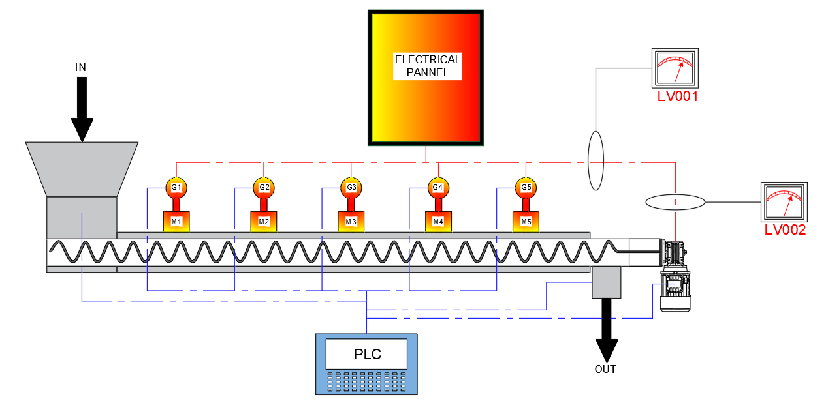

Figure 1: MW pilot plant longitudinal section

The measurement of electricity consumption on the plant was carried out using a Yokogawa branch current and voltage datalogger, model CW121 with a capacity of up to 450V and 1000A to measure the electrical parameter in real time, with a frequency of 1s during the treatment of the MW in the different test conditions with standard accuracy is ±0.04%.

* + 1. Raw material

Homogeneous batches of chickpeas (Cicer arietinum), harvested in 2023, were used for the experimental tests. After mechanized harvesting, the chickpeas were sun-dried and stored at a controlled temperature (18°C) in Foggia, Puglia, Italy.

* + 1. Experimental procedure to investigate operative and electrical parameters

An experimental plan was drawn up which contains six different operating configurations of the machine defined with specific values ​​of residence time and mass flow rate regulated by the electrical frequency of the motor that drives the metal spiral inside the treatment chamber, replicated seven times each. Table 1 shows the operating parameters of the system which were measured with experimental tests in order to be able to outline the operating curves of the machine.

The six configurations were replicated for eight different electrical power values ​​of the MW magnetrons: 2.25 – 3.00 – 3.75 – 4.50 – 5.25 – 6.00 – 6.75 – 7.50 kW, thus generating forty-eight test operating conditions that allow a complete mapping of the pilot plant.

*Table 1 – Operating parameters of the continuous microwave pilot plant for chickpeas*

|  |  |  |
| --- | --- | --- |
| Electric motor frequency [Hz] | Mass flow rate [kg min-1] | Residence time [s] |
| 30 | 3.932±0.129 | 340.2±20.7 |
| 40 | 4.791±0.114 | 266.6±17.8 |
| 45 | 6.541±0.121 | 235.2±16.9 |
| 50 | 6.790±0.111 | 208.2±15.1 |
| 60 | 7.796±0.108 | 178.3±13.7 |
| 80 | 8.763±0.105 | 130.9±10.3 |

Mean ± standard deviation (SD)

For each operating condition, a specific energy value supplied to the product inside the treatment chamber and the related electrical consumption can be expressed by monitoring for fifteen minutes and recording the electrical energy consumption every 5 s of the MW system in operation.

The value detected relating to electrical consumption corresponds to the sum of the variable consumption (2.25-7.50kW) attributable to the electrical power set up for the operation of the magnetrons and the constant consumption of the system attributable to the electric motor that drives the metal spiral for mixing and advancing the product and to all the auxiliary systems with which the system is equipped (0.37kW).

A model for the analysis and prediction of the system's energy consumption was created and for the identification of the optimal electricity consumption curve based on the data collected.

* 1. Results and discussion
     1. Operating curves of microwaves pilot system

The Specific Energy provided by the pilot plant to the product during the MW treatment was correlated with the measured values ​​of overall electrical consumption (electrical power of the magnetrons and electrical power of the electric motor for the advancement of the product) and represented in the graph of Fig. 2.

For each Specific Energy value, the different electrical consumptions of the pilot plant can be determined and the interpolation of the points allows you to determine the operating curves and the related third-order polynomial mathematical equations that regulate the trend with R2 values ​​that tend to 1.

The generated curves overlap, thus allowing it to be possible to hypothesize the use of the pilot plant in different (electrical power) for each Specific Energy value.

Since the equation is known, it is possible to mathematically predict the energy behavior of the machine. By comparing the electrical power required for defined and constant Specific Energy values, it is possible to create the graph shown in Figure 3 to show the percentage of electrical energy saving which in the MW treatment on chickpea can reach up to 20% Energy saving.

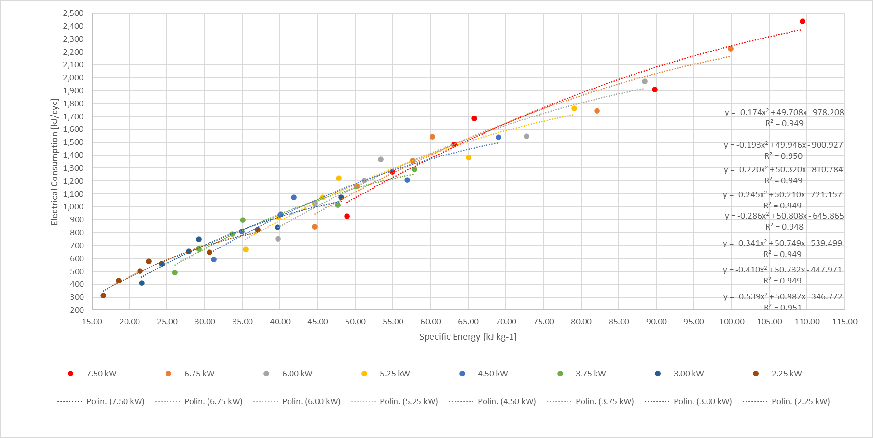

Figure 2: Trend of Specific Energy and Electrical Consumption

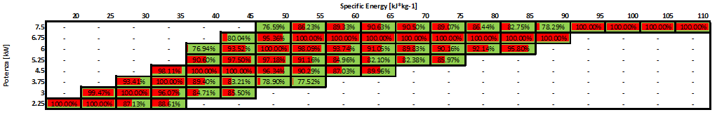

Figure 3: Energy saving graph of microwaves pilot system

The graph shown in Figure 4 shows the optimal operating values ​​of the microwave pilot system with the lowest electrical consumption for each Specific Energy value. The optimal operating conditions calculated with the mathematical model can be diagrammed with a fourth order polynomial mathematical curve with R2 values ​​close to 1.

The generated mathematical model is relevant exclusively to the type of product analyzed with this work (chickpea).

Finally, it should be noted that in the electrical measurements performed and in the mathematical model, the influence of the consumption of the electric motor that drives the metal spiral can be easily neglected since it is of the order of approximately 5-15% of the overall consumption of the system.

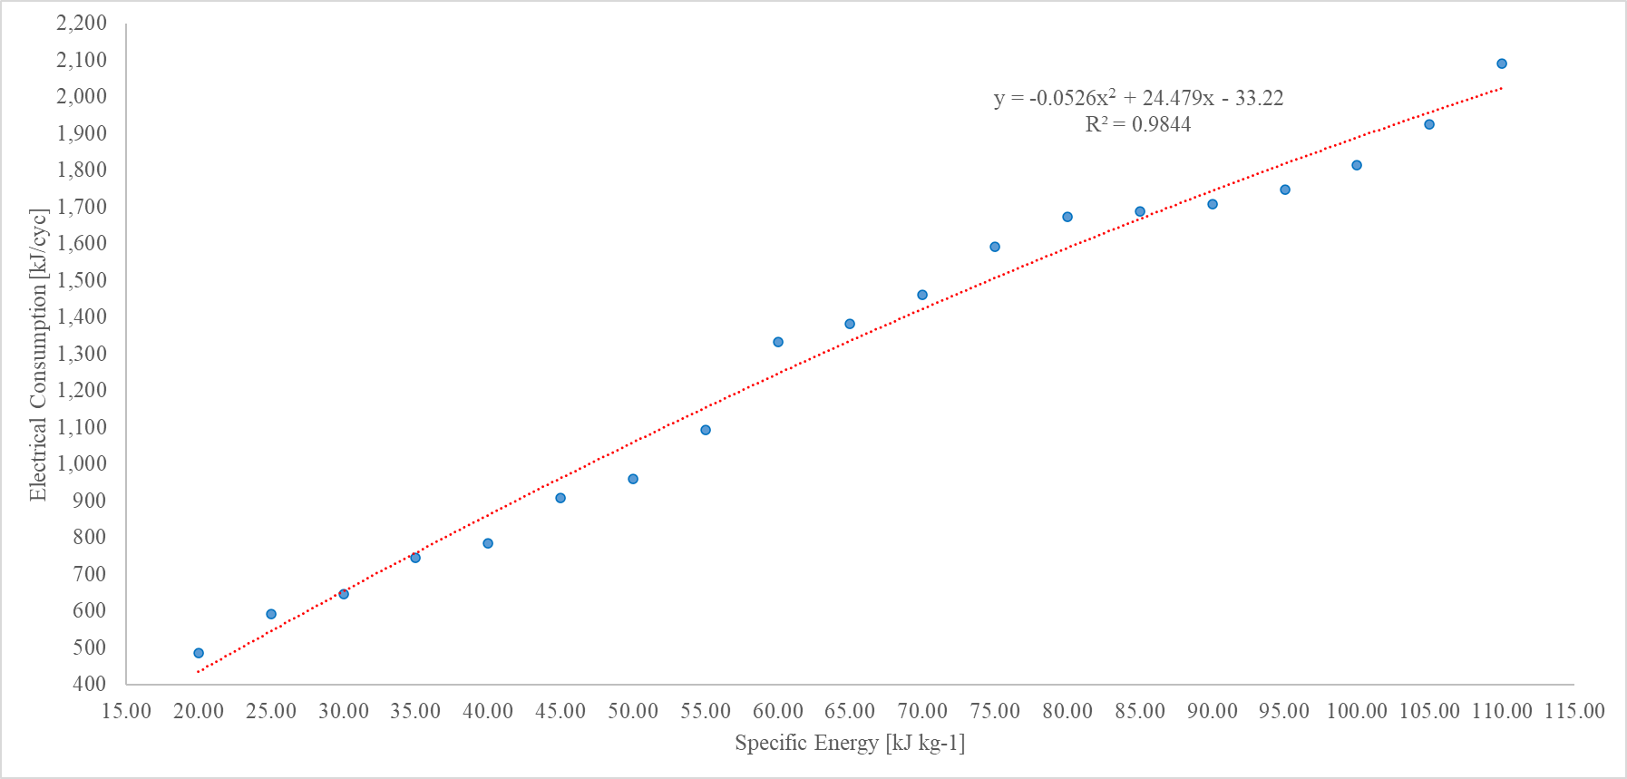

Figure 4: Trend of Specific Energy and optimal Electrical Consumption

* 1. Conclusions

The pilot plant designed with 3D modeling allows the disinfestation in a short time of seeds such as chickpea from insects which are mainly responsible for product losses during the storage phase.

Experimental tests on the operational behavior of the system have made it possible to define the operating curves at different electrical powers (from 2.25 kW to 7.50 kW) and residence times between 130-340s.

This study has developed a numerical model that makes it possible to predict, through mathematical calculation, the energy consumption of the system as the Specific Energy varies and therefore to be able to define the operating configurations of the system with the lowest electrical energy consumption. The model does not study the transient, but only the operating conditions of the machine that do not take into account the beginning and end phase of the transition of electrical consumption.

The results shown confirm energy savings of up to approximately 20% (maximum value measured) for the same treatment results. The results probably arise from the possible variation of magnetron efficiency in the power range of their operation.

MW technology, being a physical process, presents significant advantages and innovation compared to traditional disinfestation systems. Unlike pesticides, dusts and fumigants, it does not release residues of chemical substances on the product subjected to treatment and at the same time it does not deteriorate the qualitative and nutritional parameters of the product itself after treatment. This process is therefore sustainable for the environment and not harmful to humans.

The results presented in this study highlight the feasibility of integrating microwave technology into the chickpea processing industry, in full compliance with sustainable food processing practices.

The developed prototype, considering the satisfactory results obtained in terms of disinfestation and at the same time respect for the environment, could also be extended to other seeds, and considering its versatility and compactness, it could easily find use in the agri-food industry.

To be implemented at an industrial level, the numerical model for optimizing the energy consumption of the plant requires suitable systems for continuously measuring and monitoring the process parameters in order to be able to identify the optimal operating parameters for the plant in real time.

Industrial scale-up involves the use of the method set up with this research work in order to determine a model that also guarantees 100% mortality of pests.

Acknowledgments

The authors have contributed to the same extent to the present study

References

Gautam, C., Islam, S.M., Sadistap, S. and Sarma, U. (2018) ‘Effect of Microwave Heat on the Nutritional Properties of Infected Red Kidney Beans’. *IEEE Access*, 6, 57137–57143.

Chenlo, F., Moreira, R., Chaguri, L. and Torres, M.D. (2009) ‘Sugar, moisture contents, and color of chestnuts during different storage regimes’. *Food Sci. Technol. Int.*, 15, 169–178.

Wang, S., Tiwari, G., Jiao, S., Johnson, J. and Tang, J. (2010) ‘Developing postharvest disinfestation treatments for legumes using radio frequency energy’. *Biosyst. Eng.*, 105, 341–349.

Patil, H., Shejale, K.P., Jabaraj, R., Shah, N. and Kumar, G. (2020) ‘Disinfestation of red flour beetle (Tribolium castaneum) present in almonds (Prunus dulcis) using microwave heating and evaluation of quality and shelf life of almonds’. *J. Stored Prod. Res.*, 87, 101616.

Gao, M., Tang, J., Wang, Y., Powers, J. and Wang, S. (2010) ‘Almond quality as influenced by radio frequency heat treatments for disinfestation’. *Postharvest Biol. Technol.*, 58, 225–231.

Heather, N.W. and Hallman, G.J. (2008) ‘Pest Management and Phytosanitary Trade Barriers’. *Columns Design Ltd. Readind*, UK. 226 pp.

Tamborrino, A., Summo, C., Berardi, A., De Angelis, D., Ragone, G. and Leone, A. (2023) ‘Use of a Microwave Pilot Plant for Almond Disinfestation: Study on the Thermal Uniformity of the Treatment and Effect on Volatile Composition’, *Chemical Engineering Transactions*, Vol. 102, ISSN 2283-9216, doi: <https://doi.org/10.3303/CET23102014.>

Tamborrino, A., Berardi, A., de Lillo, E., Ragone, G., De Benedictis, M., Tufariello, M., Santino, A. and Leone, A. (2023) ‘Using a continuous microwave system for postharvest almond disinfestation’, *Postharvest Biology and Technology*, Volume 201, 112369, ISSN 0925-5214, <https://doi.org/10.1016/j.postharvbio.2023.112369>.

Wang, S. and Tang, J. (2001) ‘Radio frequency and microwave alternative treatments for nut insect control: A review’. *Agric. Eng. J.*, 10, 105–120.

Grieshop, M.J., Flinn, P.W. and Nechols, J.R. (2006) ‘Biological control of indianmeal moth (lepidoptera: Pyralidae) on finished stored products using egg and larval parasitoids’. *J. Econ. Entomol*. 99 (4), 1080–1084. https://doi.org/10.1093/jee/99.4.1080.

Mescia, L., Lamacchia, C., Berardi, A., Leone, A. and Tamborrino, A. (2022) ‘Continuous microwave pilot plant for almond disinfestation: preliminary tests’. *Mediterranean Microwave Symposium*. 1-4. 10.1109/MMS55062.2022.9825556.

Mescia, L., Leone, A., Lamacchia, C.M., Ferraris, A., Caggiano, D., Berardi, A. and Tamborrino, A. (2024) ‘Numerical Simulation and Development of a Continuous Microwave-Assisted Pilot Plant for Shelled Almond Processing’. *Appl. Syst. Innov.*, 7, 43. https://doi.org/10.3390/asi7030043.

Tamborrino, A., Catalano, F., Berardi, A. and Bianchi, B. (2021) ‘New Modelling Approach for the Energy and Steam Consumption Evaluation in a Fresh Pasta Industry’, *Chemical Engineering Transactions*, 87, 409-414.

Perone, C., Berardi, A., Dellisanti, C.D., Tamborrino, A. and Leone, A. (2023) ‘Investigation of an Energy-Saving System to Reduce the Energy Consumption of Decanter Machine’. *Chemical Engineering Transactions*, Vol. 102, ISSN 2283-9216, doi: https://doi.org/10.3303/CET23102027.

Romaniello R., Perone C., Berardi A., Leone A. and Tamborrino A. (2024) ‘Biomass Recovery from Olive Oil Extraction Line: Opportunities for Reuse of By-products and Energy Saving’. *Chemical Engineering Transactions*, 109, 25-30.

Moirangthem, T.T. and Baik, O.D. (2021) ‘Disinfestation of stored grains using non-chemical technologies. A review’. *ISSN 0924-2244 Trends Food Sci. Technol.* 107, 299–308. https://doi.org/10.1016/j.tifs.2020.11.002.