|  |  |
| --- | --- |
| cetlogo ***CHEMICAL ENGINEERING TRANSACTIONS***  ***VOL. 76, 2019*** | A publication of  aidiclogo_grande |
| The Italian Association  of Chemical Engineering  Online at www.aidic.it/cet |
| Guest Editors: Sauro Pierucci, Jiří Jaromír Klemeš, Laura Piazza  Copyright © 2019, AIDIC Servizi S.r.l. **ISBN** 978-88-95608-73-0; **ISSN** 2283-9216 | |

Instrumental and Sensory Analysis for the Design of Complex Tropical Fruit Beverage Flavorings: The Case of Soursop

Jenifer Prietoa,b, Carlos A. Fuenmayora,\*, Carlos M. Zuluaga-Domínguezc, Nelson Melob, Consuelo Díaz-Morenoa

aUniversidad Nacional de Colombia – Sede Bogotá – Instituto de Ciencia y Tecnología de Alimentos (ICTA) – Carrera 30 # 45-03 Edificio 500C, Bogotá D.C., 111321 – Colombia.

bGivaudan Colombia S.A.S. – Carrera 98 # 25G-20, Bogotá, D.C – Colombia.

cUniversidad Nacional de Colombia – Sede Bogotá – Facultad de Ciencias Agrarias – Carrera 30 # 45-03 Edificio 500, Bogotá D.C., 111321 – Colombia.

cafuenmayorb@unal.edu.co

This study aimed at designing nature-identical flavorings for dairy drinks based on soursop (*Anona muricata*) VOCs profile, at different ripening stages, and after its processing into a fruit beverage, by combining conventional sensory analysis, and instrumental techniques: gas chromatography (GC/FID/MS) and a metal oxide (MOS)-based electronic nose. For this purpose, unripe fruits were harvested and ripened in controlled conditions while monitoring soluble solids, pH and acidity. Furthermore, ripe fruits were processed into a soursop sugary drink. Dichloromethane extracts of semi-ripe, ripe and overripe pulps, and ripe soursop drink, were analyzed by GC-FID/MS for assessing their VOCs profiles. In parallel, pulps at the same three ripeness degrees, and the soursop drink were analyzed by e-nose, in order to study changes in their aromatic profile. Fifty-two aroma compounds were identified. Terpenes were the most representative group of the semi-ripe stage, whereas esters were more predominant in the ripe and overripe pulps. A greater incidence of lactones and small-chain acids and alcohols in the latter, indicated the start of degradation. In the sugary drink, there was higher predominance of esters, whereas the relative concentration of terpenes and alcohols decreased, probably due volatilization during heat processing. E-nose showed a higher aromatic intensity in the ripe pulp, and principal component analysis (PCA) clearly differentiated the three ripening stages and the sugary soursop drink. Four nature-identical flavorings were developed according to the determined profiles. A descriptive-comparative sensory analysis of flavorings vs. their natural targets, using 13 flavor descriptors, allowed to adjust the formulations. The adjusted flavorings were added (0.08%) to a sweetened whole yogurt, and subjected to descriptive and consumer acceptance sensory tests. The perceived flavor of yogurts was successfully associated with the sensory profile of the fruits at their respective ripening/processing stage. Finally, the consumer test showed a better performance of overripe soursop-flavoring in terms of acceptance and approximation to a naturally-flavored drink, suggesting that consumers favor more complex creamy and cider notes of the overripe soursop.

* 1. Introduction

Nature-identical flavouring substances are used as food additives in order to mimic, or evoke, sensorial effects of natural products. These substances are mixtures of compounds that must be chemically identical to those responsible for the characteristic flavor of the natural food matrix. The development of new nature-identical flavorings for beverages inspired in exotic tropical fruits is an important market driver for the industry of flavors and fragrances. Tropical fruit pulps have complex chemical compositions, including a rich diversity of volatile odor compounds (VOCs), which not only depend on the plant species, but undergo drastic changes during ripening, storage (Silva et al., 2015), minimal processing (Sortino et al., 2017) and heat treatments (Baskaran et al., 2016). In fact, these fruits are consumed at different ripening stages, and/or after various types of processing, adding further complexity to the “characteristic flavor” expected by consumers. For instance, in Latin American countries, several fruits are more commonly consumed as juices and beverages, rather than as fresh pulps. Fruit aroma evaluation, taking into consideration ripening degree and processing, is critical for the development of fruit nature-identical flavoring agents that successfully meet consumer expectations.

Soursop is a climacteric fruit from the tropical species *Annona muricata* L., a member of the *Annonaceae* family. Due to its sensory characteristics and the presence of bioactive compounds in several plant tissues, this fruit has great potential for use both as a fresh or processed product (Agu & Okolie, 2017). The flavour and VOCs profile of soursop pulp has been object of several studies, some of which has also considered the effect of ripening degree. In general, esters, terpenes, aldehydes, lactones, alcohols, aromatic hydrocarbons and alkanes, in decreasing order, have been identified and found as VOCs responsible for the complex soursop flavor. The most common extraction techniques reported for soursop VOCs characterization are headspace-solid phase microextraction (HS-SPME) and steam distillation with simultaneous extraction with organic solvent (DES), whereas the analytical techniques reported for VOCs separation and identification are GC coupled to mass spectrometry (MS). The use of other techniques, such as e-nose, has been much less widely explored (Márquez-Cardoso et al., 2013).

Due to the various actual forms of consumption of these fruits, and the fact that only few used human olfactory methods, the above-mentioned studies has had limited usefulness in the development of nature-identical flavourings based on soursop VOCs profiles. As a result, the soursop flavouring additives currently available, as for many tropical fruits, have often a poor performance in terms of similarity to the natural target. The combination of instrumental determination and conventional sensory analysis is pivotal in the development of nature-identical flavorings of fruits (Ziegler, 2007). The objects of this research were to design soursop flavorings based on VOCs profile determined by GC/FID/MS and e-nose aromatic profiles, using soursop at three ripening stages and a soursop sugary drink, and to adjust the flavorings in terms of a better proximity to the natural targets by means of sensory evaluation with trained and non-trained panels.

* 1. Materials and methods
     1. Soursop and soursop drink samples

Soursop fruits were collected in an orchard located in the municipality of Pandi (Colombia) [4°11′N 74°29′W; 1024 m.a.s.l.]. Fruits were harvested in near their semi-ripe state, transported in refrigerated containers to the Givaudan Colombia S.A.S. facilities in Bogotá, and left to ripe (24°C and 63% RH) during 10 days. Each day three fruits were randomly selected to determine its ripening stage by monitoring pH (S220 pHmeter, Mettler Toledo, USA), soluble solids refractometric index in °Brix (Pal-1, Atago, Japan) and tritatable acidity. This allowed for determining that the semi-ripe stage was reached at postharvest day 4, ripe at day 6 and overripe at day 10. The rest of the pulp was separated from seeds and stored at -20°C until analysis. For the soursop sugary drink preparation, ripe fruits were depulped, mixed (20%wt) with sugar (11%wt) and water (69%wt), homogenized in a blender (Javar, Colombia), pasteurized (85°C; 30s), bottled and steam-exhausted.

* + 1. VOCs extraction

Soursop pulp (25 g) at three different ripening degrees: unripe (4 days), ripe (6 days) and overripe (10 days), or soursop drink (20 g), were mixed with 0.05 g of chlorocyclohexane (GC/FID internal standard) (0.1% in methanol) and 25 ml of dichloromethane (or 20 ml for soursop drink extraction) in 50 ml tubes. The mixes were vortexed (2800 rpm, 10 min) and centrifuged (3000 rpm, 20 min). The supernatants were filtered with 10 g of anhydrous Na2SO4 and evaporated to 0.5 ml with nitrogen flow (32°C).

* + 1. GC/FID/MS and e-nose analyses

A GC/FID instrument (7890A Agilent, USA), coupled to a MS detector (5975C, Agilent, USA) operating in electron impact mode (70 eV), was used. Mass spectra were recorded between 30 and 550 Da, and processed with the software ChemStation (Agilent, USA). Column was DB-5MS (60 m x 0.32 mm x 0.1 µm) at 250°C and initial oven temperature 40°C (3°C/min up to 300°C; injection volume of 5 µm in split mode. Identity of the peaks was ascertained by (i) comparing each mass spectrum with an internal database (Genesis 2017, Givaudan, France) and (ii) calculating the linear retention index (LRI) using a C5-C28 alkanes mixture as external standard (Stashenko & Martínez, 2010). The concentration was calculated with the internal standard method using chlorocyclohexane (Stashenko & Martínez, 2010), considering both the FID and MS area, which were estimated using the software AMDIS (Nist, USA). The taste activity value (TAV) for each VOC was calculated dividing the VOC concentration (mg/kg), calculated by the internal standard method, by the taste threshold value TTV (mg/kg) in water reported in an internal database (Genesis 2017, Givaudan, France). Electronic nose analyses were performed with a portable electronic nose (PEN2, Airsense, Germany) consisting of an array of 10 metal oxide semiconductor (MOS) sensors, and a pattern recognition software (Win Muster v.3.0, Airsense, Germany) for data recording. Sensors were: W1C (aromatics), W5S (broad range), W3C (aromatic), WS6 (hydrogen), W5C (aromatic and aliphatic hydrocarbons), W1S (broad-methane) W1W (sulfur-organic), W2S (broad-alcohols), W2W (sulfur-chlorinated), W3S (methane-aliphatic hydrocarbons). The sensor response is expressed as resistivity (Ohm). Three samples of 1.5 g for the fruits, 2.0 g for beverages and flavored yogurts, were placed in 22 mL Pyrex® vials, closed with a pierceable Silicon Teflon disks in the cap, and kept during 20 min at room temperature. The analysis was done by using the methodology reported by Cuenca et al. (2015) with 100 ml/min sampling flow and 90 s of measurement time.

* + 1. Formulation and sensory analysis of the soursop flavorings

Once the VOCs profile of the four natural targets (semi-ripe, ripe and overripe pulp, and soursop drink) were determined, each identified compound (>90% purity) was weighed in a 50 ml beaker, at the same proportion, for a total weight of 30 g, and diluted in a medium-chain triglycerides mixture (Miglyol® 812, Caesar & Loretz, Germany) at a ratio between 9:1 and 2:1. The four flavorings diluted in water (0.05%) and samples of the corresponding natural targets were subjected to comparative-descriptive sensory analysis by a panel formed by 5 Givaudan Colombia S.A.S.expert flavorists. The flavorings and the natural targets were tasted and the intensity of 13 descriptors (Table 1) were scored from 0 (imperceptible) to 100 (very strong).

Table 1: Flavor descriptors selected for sensory analysis of soursop and other tropical fruits

|  |  |
| --- | --- |
| Descriptor | Flavor description |
| Aldehydic green | Green, waxy, associated with green citrus oils |
| Green | Oily, associated with fresh green fruits or cut grass |
| Green fresh | Associated with the green of fresh fruit |
| Green fruity | Green, associated with green pears, bananas and apples |
| Woody piney | Pine, citrus, medullous and lime, associated with tropical fruits such as mango |
| Lemon fresh | Peely, juicy, associated with freshly squeezed lemon yellow |
| Lemon candy | Sweet, citrus-like, associated with lemon candies, such as lemon heads. |
| Cider | Associated with fermented apple juice |
| Creamy fruity | Creamy, oily, waxy, often found in coconut, vanilla and peach products |
| Fatty dairy | Creamy, milky, buttery, associated with dairy products |
| Sweet | Basic sensation, associated with sugars and high-potency sweeteners in solution |
| Sour | Basic sensation, associated with acids in solution |
| Astrigent | Dry mouth sensation typically associated with tannins, black tea, unripe banana, or young red wine |

This analysis allowed to adjust the flavoring formulations to bring the flavor profiles of the additives closer to those of their natural targets by regulating the relative concentration of compounds related to over-expressed descriptors. The adjusted nature-identical flavorings were then tested in concentrations of 0.08% in sweetened whole yogurts. The flavored yogurts were subjected to a descriptive sensory test by 9 trained panelists (considering the same 13 flavor descriptors of Table 1, plus creamy mouthfeel, total aroma, total flavor and residual dairy flavor). Finally, the flavored yogurts were subjected to a consumer acceptance test by 40 frequent consumers of both yogurt and soursop. Consumers were informed they were testing soursop-flavored yogurts and asked to evaluate how much they liked the aroma and flavor of the soursop-flavored yogurts in a five-point scale, where 1 corresponded to “I dislike it a lot” and 5 to “I like it a lot”, and to indicate which one of the products better met their expectation of a soursop yogurt.

* 1. Results and discussion
     1. GC/FID/MS VOCs profile of soursop at three different ripening degrees and soursop drink

Table 2 presents the VOCs profile of semi-ripe, ripe, overripe soursop and a sugary soursop drink as determined by GC/FID/MS. In the semi-ripe pulp the predominant compounds were terpenes, in particular limonene and β-caryophyllene; alcohols, in particular *cis*-3-hexen-1-ol; and to a lesser extent ester, such as methyl-2-trans-hexenoate, and aldehydes, such as *trans*-2-hexenal. In the ripe pulp, a greater variety and total concentration of VOCs was found, with predominance of esters, of which the most important was methyl hexanoate; terpenes, such as limonene; and alcohols, such as ethyl 2-hexanol. In the overripe pulp, a decrease of the relative concentration of terpenes was found; limonene remained the main terpene, but linalool was also evidenced; esters were the major compounds in particular methyl hexanoate, followed by alcohols, such as ethanol and hexanol; acids such as hexanoic and butyric and lactones. These last three functional classes not only have an important impact on the flavor profile, but also suggest that the beginning of the fermentative degradation in the fruit occurred near that ripeness stage.

Table 3: GC/FID/MS VOCs profile of soursop at different ripening stages and soursop sugary drink

|  |  |  |  |  |  |  |
| --- | --- | --- | --- | --- | --- | --- |
| Compound | LRI | (*m/z*) | Concentration (mg/kg); *TAV* | | | |
| Semi-ripe | Ripe | Overripe | Drink |
| ethanolI | 464 | 31 | ND | ND | 0.5; *0.004* | ND |
| ethyl acetateIII | 648 | 43 | ND | ND | 0.05; *0.015* | 0.1; *0.03* |
| 1-butanolI | 707 | 56 | ND | 0.01; *0.001* | ND | ND |
| 2-pentanoneV | 727 | 43 | ND | ND | 0.3; *0.3* | ND |
| acetoinV | 746 | 45 | ND | 1.3; *2.2* | 11.9; *19.8* | 0.4; *0.7* |
| methyl butyrateIII | 757 | 74 | ND | 5.4; *27.0* | 8.6; *43.0* | 0.6; *3.0* |
| isoamyl alcoholI | 774 | 55 | ND | 0.02; *0.2* | 0.3; *3.0* | ND |
| ethyl lactateIII | 816 | 45 | ND | ND | 0.1; *0.01* | ND |
| butyric acidVI | 821 | 60 | ND | ND | 0.9; *0.1* | 0.9; *0.1* |
| methyl pentanoateIII | 851 | 74 | ND | 0.06; *1.5* | 0.1; *2.5* | ND |
| 1-heptanolI | 867 | 70 | 0.1; *0.2* | ND | ND | ND |
| *trans*-2-hexenalII | 879 | 41 | 0.4; *10* | 0.04; *1.0* | ND | ND |
| *cis*-3-hexen-1-olI | 880 | 67 | 2; *5* | 0.6; *1.5* | ND | ND |
| hexanolI | 889 | 56 | ND | ND | 0.5; *0.6* | ND |
| isoamyl acetateIII | 894 | 43 | ND | 1.4; *7.0* | ND | ND |
| 2-methylbutyl acetateIII | 896 | 43 | ND | 0.3; *3.0* | ND | ND |
| methyl hexanoateIII | 930 | 74 | 0.1; *1.0* | 15.7; *157* | 27.2; *272.0* | 2.6; *26.0* |
| methyl 3-hexenoateIII | 938 | 41 | ND | 0.03; *3.0* | 0.2; *20.0* | ND |
| α-pineneIV | 950 | 93 | 0.1; *0.5* | 1.3*; 6.5* | ND | ND |
| 2-ethylhexanolI | 964 | 57 | 0.4; *4.0* | ND | ND | ND |
| methyl *trans*-2-hexenoateIII | 964 | 55 | 0.05; *1.3* | 2.7; *67.5* | 5.7; *142.5* | 0.4; *10.0* |
| hexanoic acidVI | 974 | 60 | ND | 6.3; *10.5* | 3.0; *5.0* | 0.2; *0.5* |
| myrceneIV | 988 | 93 | 0.2; *0.7* | 2.9; *9.7* | ND | ND |
| ethyl hexanoateIII | 991 | 88 | ND | ND | 0.3; *1.5* | ND |
| hexyl acetateIII | 997 | 43 | ND | ND | ND | 0.1; *1.0* |
| octanalII | 999 | 41 | ND | 0.6; *100* | ND | ND |
| 3-carenIV | 1010 | 93 | ND | 0.3; *0.8* | 2.1; *5.3* | 0.2; *0.3* |
| 1,4-cineoleIV | 1013 | 43 | ND | 0.09; *1.3* | ND | ND |
| 2-ethylhexanolI | 1016 | 57 | ND | 0.3; *3.0* | 0.3; *3.0* | ND |
| *p*-cymeneIV | 1021 | 119 | 0.1; *1.7* | 1.5; *25.0* | ND | ND |
| limoneneIV | 1021 | 68 | 11.8; *118* | 122.4; *1224* | 2.3; *23.0* | 0.4; *4.0* |
| α-ocimeneIV | 1031 | 93 | ND | 0.4; *2* | ND | ND |
| γ-hexalactoneVII | 1040 | 85 | ND | ND | 0.4; *8.0* | 0.1; *2.0* |
| γ-terpineneIV | 1045 | 93 | ND | 0.8; *8.0* | ND | ND |
| linaloolIV | 1067 | 71 | ND | 3.2; *64.0* | 2.2; *44.0* | 0.2; *4.0* |
| nonanalII | 1073 | 57 | ND | 0.6; *40.0* | ND | ND |
| methyl octanoateIII | 1083 | 74 | ND | 0.1; *1.0* | 0.1; *1.0* | ND |
| methyl nicotinateIII | 1103 | 106 | ND | ND | 0.2; *0.2* | ND |
| citronellalIV | 1108 | 69 | ND | 0.1; *11.1* | ND | ND |
| 1-nonanolI | 1120 | 56 | ND | 0.3; *0.6* | ND | ND |
| octyl acetateIV | 1146 | 43 | ND | 0.2; *28.6* | ND | ND |
| decanalII | 1148 | 57 | ND | 3.3; *8.3* | ND | ND |
| α-terpineolIV | 1150 | 59 | ND | 0.2; *6.7* | ND | ND |
| neralIV | 1174 | 69 | ND | 0.5; *5.0* | ND | ND |
| linalyl acetateIII | 1176 | 93 | ND | 0.6; *6.7* | ND | ND |
| carvoneIV | 1185 | 82 | ND | 0.4; *4.0* | ND | ND |
| geraniolIV | 1253 | 69 | ND | 0.2; *2.0* | ND | ND |
| geranyl acetateIII | 1267 | 69 | ND | 0.2; *5.0* | ND | ND |
| dodecanalII | 1292 | 57 | ND | 0.7; *7.0* | ND | ND |
| β-caryophylleneIV | 1315 | 133 | 1; *10* | 0.9; *9.0* | 0.1; *1.0* | 0.4; *4.0* |
| neryl acetateIII | 1369 | 69 | ND | 0.3; *4.3* | ND | ND |
| valenceneIV | 1370 | 161 | ND | 1; *1.7* | ND | ND |
| ethyl laurateIII | 1410 | 88 | ND | ND | ND | 0.1; *0.2* |
| benzyl benzoateIII | 1557 | 105 | ND | 0.2; *2.0* | ND | ND |

LRI: linear retention index; m/z: mass-to-charge ratio of the predominant ion of the mass spectrum; TAV: taste activity value; ND: not detected. Roman superscripts indicate the functional class: I: alcohol; II: aldehyde; III: ester; IV: terpene; V: ketone; VI: acid; VII: lactone.

Overall, these results were in fair agreement with previous reports. Márquez-Cardoso et al. (2013) found 27 compounds in Colombian soursops, with methyl hexenoate and methyl (E)-2-hexenoate being predominant in overripe pulps, methyl (E)-2-hexenoate, methyl 2-butenoate, ethyl hexanoate, and β-ocimene in ripe pulps, and (Z)-3-hexenol, methyl (Z)-3-hexenoate, and (Z)-3-hexenal in unripe pulps. De Jesus et al. (2012) identified 47 compounds in Brazilian soursops, finding methyl hexenoate and other esters to be the predominant VOCs, in overall agreement with the previous reports. In comparison with the ripe pulp, which was used for the fabrication of the soursop drink, compounds such as butyric acid and hexalactone were detected only in the soursop drink; the esters increased their relative concentration, as did lactones and ketones, whereas that of terpenes and alcohols decreased, arguably due to volatilization losses during the heat treatment of pulp in the drink processing.

* + 1. Comparative-descriptive sensory analysis of nature-identical flavorings vs. natural targets

Four different flavoring agents were developed according to the determined VOCs profiles of soursop at each ripening stage and soursop drink. A comparative-descriptive sensory profile analysis (considering 13 relevant flavor descriptors of tropical fruits, Table 1) of both the flavoring agents and their corresponding natural targets (semi-ripe, ripe and overripe soursop pulps, and soursop drink) was performed by a panel of 5 flavorists of Givaudan Colombia S.A.S. Figure 1 shows the descriptive profile of the first flavor formulation (red lines) and their natural counterpart (blue lines). In general there was a remarkably good adjustment, however the descriptors “green” and “cider” appeared overexpressed in the flavorings. Therefore, limonene was 90%-reduced in all the flavoring formulations to reduce “green” notes and nonanal was eliminated from the ripe soursop-flavoring formulation to reduce its “cider” note. A comparative sensory profile analysis using the reformulated flavoring agents (green lines) allowed to confirm a better adjustment of the additives to their targets.

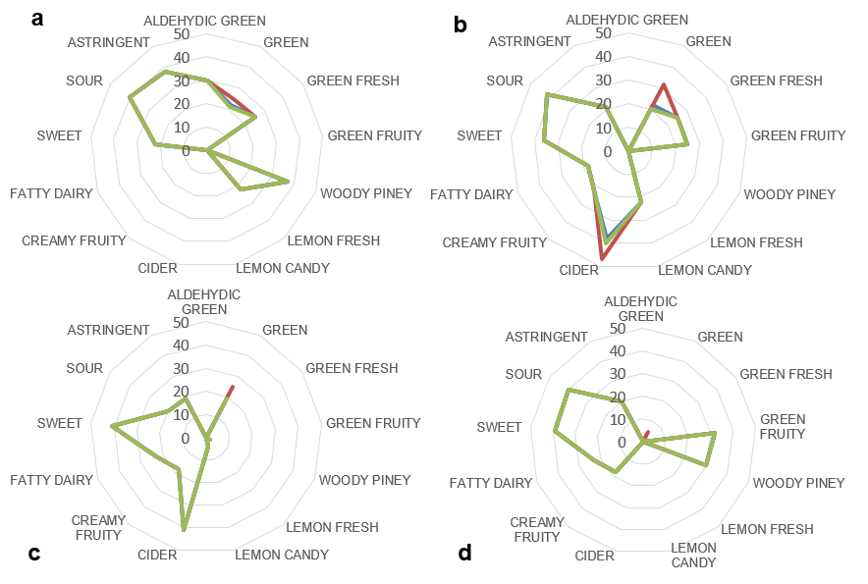

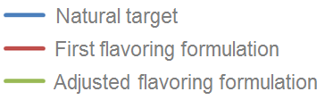

Figure 1: Descriptive flavor profile of nature-identical flavorings of (a) semi-ripe soursop, (b) ripe soursop, (c) overripe soursop, and (d) soursop drink, compared to their natural targets.

* + 1. E-nose aroma profile of soursop-flavored yogurts vs. soursop at three different ripening degrees

The adjusted flavoring agents were added (0.08%) to sweetened whole yogurts. An aroma profile analysis using a 10 sensors e-nose was done for the flavored yogurts and the pulps at the different ripening stages (the soursop drink and the flavored yogurt thereof, were not considered for these analysis). The resulting PCA is showed in Figure 2. According to PC2 (*y*-axis) there was a correspondence between the aroma profile of the flavored yogurts and the fruit at the respective ripening degree, in particular for the overripe soursop. This PC was defined by the sensors that are more responsive to aromatic and small-molecule hydrocarbons (W5C, W3C, W1C, W1S and W2S). However they were distant in PC1. This probably be due to the characteristic aroma of the yogurt, as confirmed by the position of the non-flavored yogurt in the score plot.

* + 1. Descriptive analysis and consumer acceptance of soursop-flavored yogurts

The descriptive test showed that the perceived sensory profiles of the flavored yogurts were associated with the sensory profile of the fruits at their respective ripening stage. For instance, yogurt flavored with the additive inspired in semi-ripe soursop was perceived as ‘greener’ (higher intensity of the descriptors ‘green’, ‘green fresh’ and ‘green fruity’) and more ‘astringent’; also, the perceived intensity of the descriptor ‘sweet’ was the highest for the overripe soursop-flavored yogurt and the lowest for the semi-ripe soursop-flavored yogurt. Finally, the consumer acceptance test showed a better performance of the nature-identical flavoring agent inspired in overripe soursop in terms of both the overall acceptance of the flavored yogurt and its approximation to a naturally flavored drink. This suggests that consumers prefer more complex creamy and cider notes of the overripe soursop, despite the presence of molecules (such as ethanol and lactones) which are associated to fermentation and quality loss.

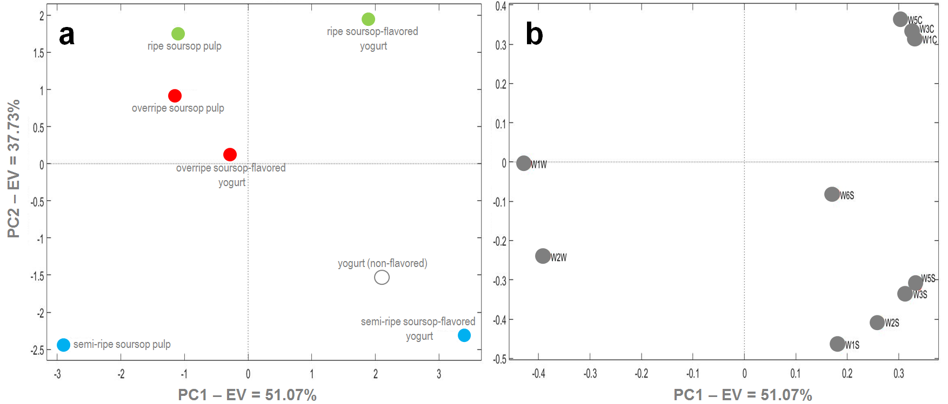

Figure 2: (a) PCA score plot of the e-nose aroma profile of whole-milk yogurt added with the nature-identical flavouring agents developed and natural soursop pulps; (b) PCA loading plot of the 10 MOS sensors responses. Total explained variance (EV) = 88.8%.

* 1. Conclusions

A total of 52 VOCs were identified in soursop samples by GC/FID/MS. The most important were esters and terpenes, in agreement with previous reports, with noticeable differences in the profiles according to the degree of ripening and processing of the fruit. Conventional sensory analysis allowed for characterizing the natural-identical flavorings inspired in the fruit, and adjusting them to their natural targets. E-nose, comparative-descriptive, and hedonic sensory analyses confirmed the accuracy of this approach for designing flavoring agents with better performance in terms of their capacity to evoke a tropical fruit with complex flavor.

Acknowledgments

Authors thank Givaudan Colombia, Pandi farming community, ICTA and Facultad de Ciencias Agrarias.

**References**

Agu K.C., Okolie P.N., 2017, Proximate composition, phytochemical analysis, and in vitro antioxidant potentials of extracts of *Annona muricata* (soursop), Food Science & Nutrition, 5, 1029-1036.

Baskaran R., Ravi R., Rajarathnam S., 2016, Thermal processing alters the chemical quality and sensory characteristics of sweetsop (*Annona squamosa* L.) and soursop (*Annona muricata* L.) pulp and nectar, Journal of Food Science, 81, S182-S188.

Cuenca M., Fuenmayor C.A., Benedetti S., Buratti S., 2015, Mead Fermentation Process Monitoring by Using Analytical Semiobjective Techniques, Chemical Engineering Transactions, 43, 31-36.

de Jesus M.S., Leite Neta, M.T.S., Araújo H.C.S., Sandes R.D.D., Narain N., 2012, Volatile profile of soursop (*Annona muricata* L.) using HS-SPME-GC/MS, III International Symposium on Medicinal and Nutraceutical Plants, 273-276.

Márquez-Cardozo C.J., Cartagena Valenzuela J.R., Correa Londoño G.A., 2013, Determination of Soursop (*Annona muricata* L. cv. Elita) fruit volatiles during ripening by electronic nose and gas chromatography coupled to mass spectroscopy, Revista Facultad Nacional de Agronomía, 66, 7117-7128.

Silva C.E.F., Moura E.M.O., Souza J.E.A., Abud A.K.S., 2015, Quality control of tropical fruit pulp in Brazil, Chemical Engineering Transactions, 44, 193-198.

Sortino G., Caviglia V., Liguori G., De Pasquale C., Gianguzzi G., Farina V., 2017, Quality Changes of Tropical and Subtropical Fresh-Cut Fruits Mix in Modified Atmosphere Packaging, Chemical Engineering Transactions, 58, 397-402.

Stashenko E., Martínez JR., 2010, Algunos aspectos prácticos para la identificación de analitos por cromatografía de gases acoplada a espectrometría de masas, Scientia Chromatographica, 2, 29-47.

Ziegler H. (Ed), 2007, Flavourings: Production, Composition, Applications, Regulations, John Wiley & Sons, Germany.