 CHEMICAL ENGINEERING TRANSACTIONS  VOL. | A publication of  
The Italian Association
of Chemical Engineering
Online at www.aidic.it/cet
Guest Editors:
Copyright © AIDIC Servizi S.r.l.
ISSN 2283-9216

Edible flowers as innovative ingredients for future food development: Anti-Alzheimer, antimicrobial and antioxidant potential
Flávia A. G. G. Rezendeª, Denise Sande^{b}, Amanda C. Coelho^{b}, Geane P. Oliveira^{b}, Maria Amélia D. Boaventura^{b}, Jacqueline A. Takahashi^{b,}*
ª Centro Federal de Educação Tecnológica de Minas Gerais (CEFET), Av. Amazonas 5253, Belo Horizonte, MG, Brazil
^{b} Chemistry Department, Exact Sciences Institute, Universidade Federal de Minas Gerais (UFMG). Av. Presidente Antônio Carlos, 6627, Belo Horizonte, MG, Brazil
*jat@qui.ufmg.br

Several flowers used as food, such as artichoke, cauliflower and broccoli have high nutritional value and huge gastronomic acceptance. However, they are only a few representatives of myriads of flowers recognized as strategic sources of bioactive natural antioxidants and anti-microbial compounds, which can be exploited as natural food preservatives and to decrease microbial spoilage. The potential of flowers as human food is still underestimated, although they have been lately utilized to bring flavor, color and visual appeal to food. Development of products containing edible ornamental flowers can be a sustainable solution to the industry of cut flowers, since tons of flowers are discarded every day regardless of their nutritional and functional value, because they lack ornamental quality. In this work, we evaluated anti-Alzheimer (acetylcholinesterase inhibition), antimicrobial and antioxidant activities of flowers from five plant species, orange hibiscus (Hibiscus sabdariffa), carnation (Dianthus caryophyllus), sunflower (Helianthus annuus), purple and pink violet (Saintpaulia ionantha), aiming at the future development of innovative foods or ingredients for food supplements industries. The flowers were dried at 40 °C and maintained good color quality. Both purple and pink violet species showed efficiency in inhibiting acetylcholinesterase (57.00 e 55.00%, respectively); the latter was also active against S. aureus (46.82%). Orange hibiscus was the most active species, possessing high concentration of phenolic compounds (4.04 g/100 g), and an excellent overall antioxidant activity in ferric reducing power (67.40%), DPPH capture (IC 50% 739.60 µg.mL⁻¹) and ABTS capture (IC 50% 96.21 µg.mL⁻¹) assays, in addition to antimicrobial activity against S. aureus (45.82%). This species was also able to inhibit acetylcholinesterase (42.37%). These results point out the potential of these edible flowers as innovative food for health and colorful diet or to be incorporated in new products as natural food preservatives and supplements. They can also be employed as a synergic resource for Alzheimer’s patients, already using prescription drugs, due to their antioxidant and acetylcholinesterase inhibition capacity.
Keywords: flower, functional food, hibiscus, Alzheimer.
  - Introduction
The food habits have changing worldwide. People are looking for healthier and functional foods. Edible flowers are used both for adding sensorial properties (colour, taste, aroma, flavour), to decorate dishes and, more recently, due to functional properties derived from their phytoconstituents with antioxidant, anti-inflammatory and antimicrobial activities (Prata et al., 2017).
Flowers antioxidant activity is associated to their phenolic compounds that present mechanisms of action that takes place by interception or blocking chain reactions caused by free radicals. This route avoids processes of cellular aging and emergence of chronic diseases (Araújo et al., 2013). The consumption of foods rich in natural antioxidants help in the prevention of coronary heart disease, diabetes, cancer and degenerative diseases such as Alzheimer's (Gonzalez-Barrio et al., 2018).
Alzheimer's disease causes progressive and irreversible neurodegeneration with episodes of memory loss, cognitive damage and depletion of acetylcholine levels in brain (Coin et al., 2016). Acetylcholinesterase (AChE) is responsible for physiological cleavage of acetylcholine but its action over Alzheimer's patients causes worsening of cognitive deficit. Some products of natural origin have antioxidant and anti-AChE activities, which allow a delay in Alzheimer's disease progression, inhibiting AChE and protecting neurons from oxidative damage (Olennikov et al., 2017).
Phytocompounds present in flowers with antioxidant and antimicrobial activity can also be applied as a natural preservative in foods once oxidation is primarily responsible for chemical degradation of food causing shelf life shortening. It also could help in controlling cross-contaminations by food-borne pathogens that threaten food safety (Mak et al., 2012).
In this context, the aim of this study was to determine the antioxidant, antimicrobial and anti-acetilcolinesterase potential of five different edible flowers, aiming to stimulate their consumption and the development of innovative ingredients for future flower-based foods.
  - Materials and Methods
Chemicals and microorganisms
Ascorbic acid, quercetin, 2,2’-azinobis-3-etilbenzotiazolin-6-sulfonic (ABTS), 1,1-Diphenyl-2-picrylhydrazyl (DPPH), hidroquinone, 5’,5-dithio-bis-(2-nitrobenzoate) (DTNB), gallic acid, dimethylsulfoxide (DMSO), acetylthiocholine iodide (ATCI), and bovine serum albumin (BSA) were purchased from Sigma-Aldrich (São Paulo, Brazil) and Folin-Ciocalteu reagent from Merck (Darmstadt, Germany). Gram-positive Staphylococcus aureus (ATCC 25923), and Streptococcus sanguinis (ATCC 49456), Gram-negative Escherichia coli (ATCC 25723) and Salmonella typhimurium (ATCC 13311) were obtained from American Type Culture Collection (ATCC, USA).
Plant material and extracts preparation
Five edible flowers, orange hibiscus (Hibiscus sabdariffa), carnation (Dianthus caryophyllus), sunflower (Helianthus annuus), and purple and pink violets (Saintpaulia ionantha) were used (Figure 1). They were obtained from a local market in Belo Horizonte, Brazil. The flowers were identified and authenticated at the Universidade Federal de Minas Gerais herbarium (BHCB, MG, Brazil). Ethanol extracts were prepared (0.3 % w/v, at room temperature, 72 h) and the solvent was removed using rotary evaporator.
Acetylcholinesterase inhibition assay (Anti-AChE)
An aliquot of 25 µL of sample (flower extract) or eserine (positive control), both at 10 mg/mL in DMSO, was mixed with a solution of 25 µL ATCI, 125 µL DTNB solution and 50 µL at 50 mM of Tris/HCl containing BSA. Mixture was prepared in 96 wells microplates and absorbance measure at 405 nm was performed immediately and every 1 min, repeating the procedure eight times. AChE (25 µL, 0.226 U/mL in Tris/HCl) was added to the wells and absorbance was again measured (Ellman et al., 1961).
Antimicrobial activity
Flowers extracts (50 mg/mL in DMSO) were added to sterile BHI culture medium for obtaining working solutions. Fresh microbial cultures (37 °C) of each bacterium (S. aureus, S. sanguinis, E. coli and S. typhimurium) were prepared in BHI, with subsequent dilution (0.5 McFarland scale) to obtain respective inocula (10⁸ CFU/mL). Working solution and inoculum (100 µL each) were added to microplate wells and incubated at 37 °C for 24 h. Absorbance was determined at 490 nm, according to M7-A10, NCCLS (2015).
Iron reducing power
Iron reducing antioxidant capacity was evaluated according to Oyaizu (1986) by mixing 0.25 mL of extracts at different concentrations (12.5 to 100 µg/mL), 0.625 mL of phosphate buffer (0.2 M, pH 6.6) and potassium ferrocyanide 1 % (w/v), and incubated for 20 min at 50 °C. Trichloroacetic acid 10 % (w/v, 0.625 mL) was added and the mixture was centrifuged (3000 rpm, 10 min). Supernatant (0.18 mL) was added to 1.8 mL of distillated water and 0.36 mL of ferric chloride (0.1 %, w/v). Absorbance was measured at 700 nm and results were expressed as mean ± standard deviation. Ascorbic acid was used as standard.
Radicals’ scavenger antioxidant activities (ABTS and DPPH)
Scavenger ABTS method (Olajuyigbe and Afolayan, 2011) consisted into preparation of an ABTS solution (7 mM ABTS and potassium persulfate 2.4 mM incubated for 12 h in dark). This solution was diluted with methanol until absorbance at 734 nm reached 0.708 ± 0.001. This solution (1 mL) was mixed with 1 mL of extracts solution in different concentrations (2.5-125 µg/mL) and the material was incubated for 7 min in the dark. Absorbance measurement was at 734 nm. Scavenger DPPH method (Brand-Williams et al., 1995) consisted in mixing the extracts solutions in different concentrations (100-1000 µg/mL) with DPPH 0.3 % in methanol followed by incubation for 30 min in the dark. Absorbance was determined at 517 nm. In both assays, ascorbic acid was used as positive control. A blank was made with methanol/ethanol and antioxidant activity was expressed as inhibition percentage, calculated by % inhibition = (blank absorbance - sample absorbance) / blank absorbance x 100. Sample concentration required for capturing 50 % of DPPH or ABTS radicals (IC50%) was obtained from an inhibition (%) vs. concentration curve.
Total phenolic compounds
Concentration of total phenolic compounds was evaluated by adding 0.5 mL of extracts (1000 µg/mL) to 2.58 mL of Folin-Ciocalteu reagent, according to methodology adapted from Gao et al., 2000. Absorbance was immediately measured at 760 nm. The results were expressed as gallic acid (reference standard) equivalents (g gallic acid /100 g dry weight of the extracts).
Statistical analysis
The results were analyzed by ANOVA (one-way), Tukey’s and Dunnett’s multiple comparison tests using Microsoft Excel 2010 (Roselle, IL, USA). Correlations between phenolic compounds contents and antioxidant activities were evaluated by Pearson correlation coefficient (r²) with p ≤ 0.05.
  - Results and Discussion
Figure 1 shows pictures of the flowers utilized in the present work.

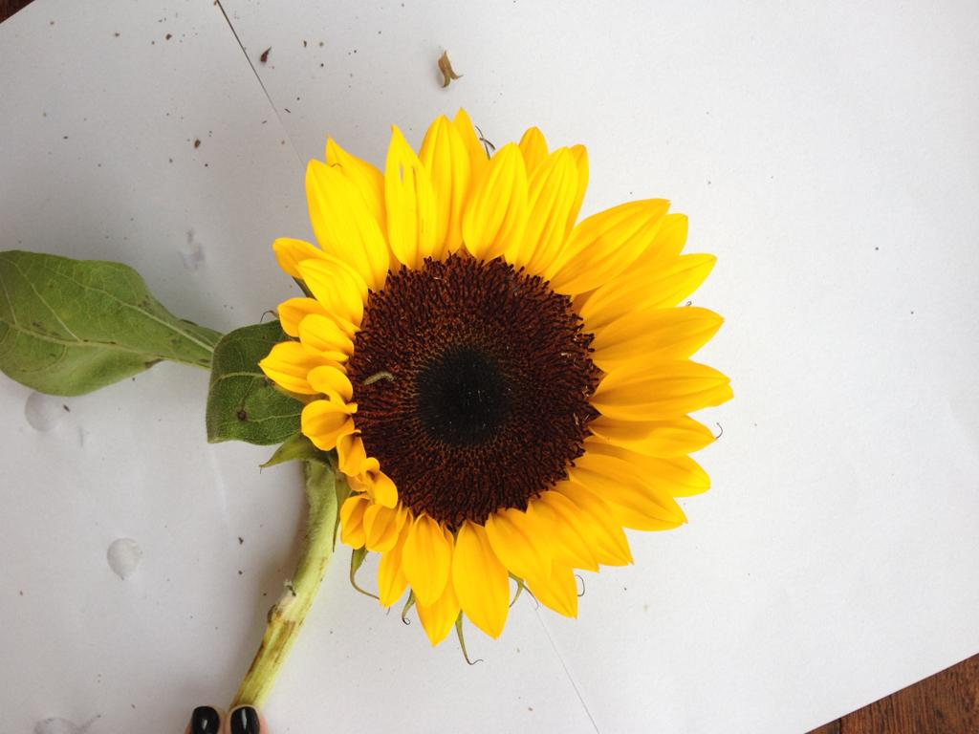S | 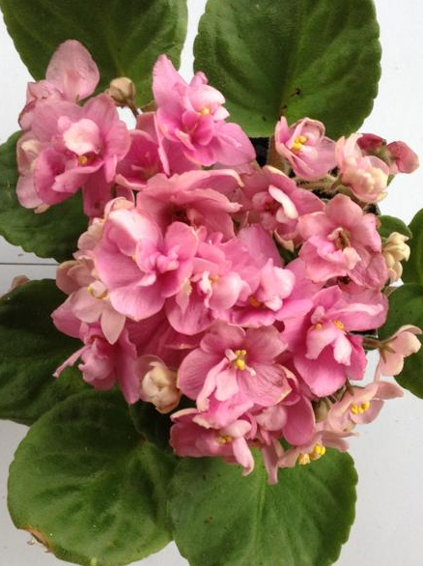PIV | 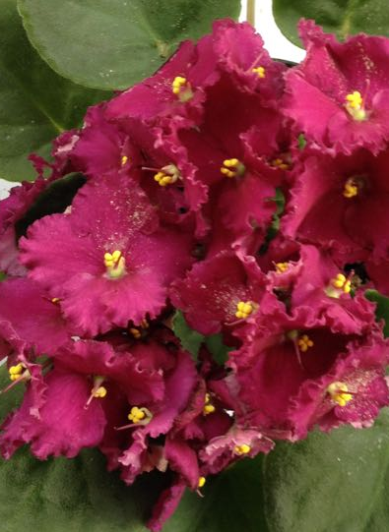PUV | 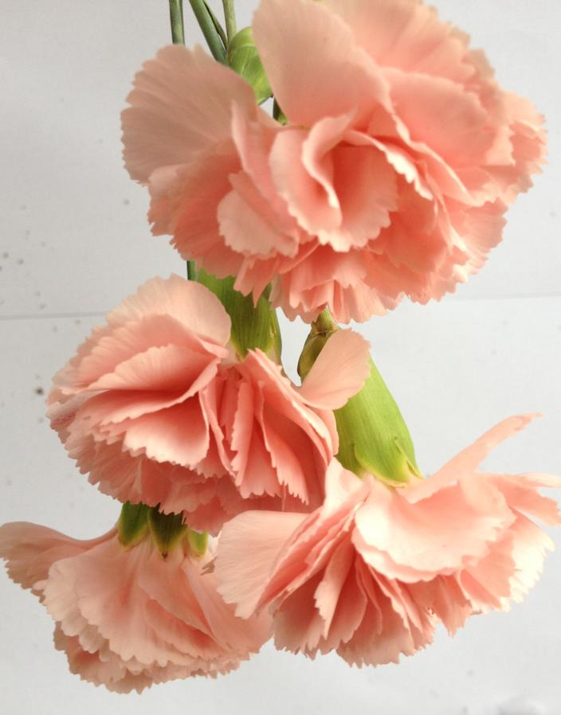 C | 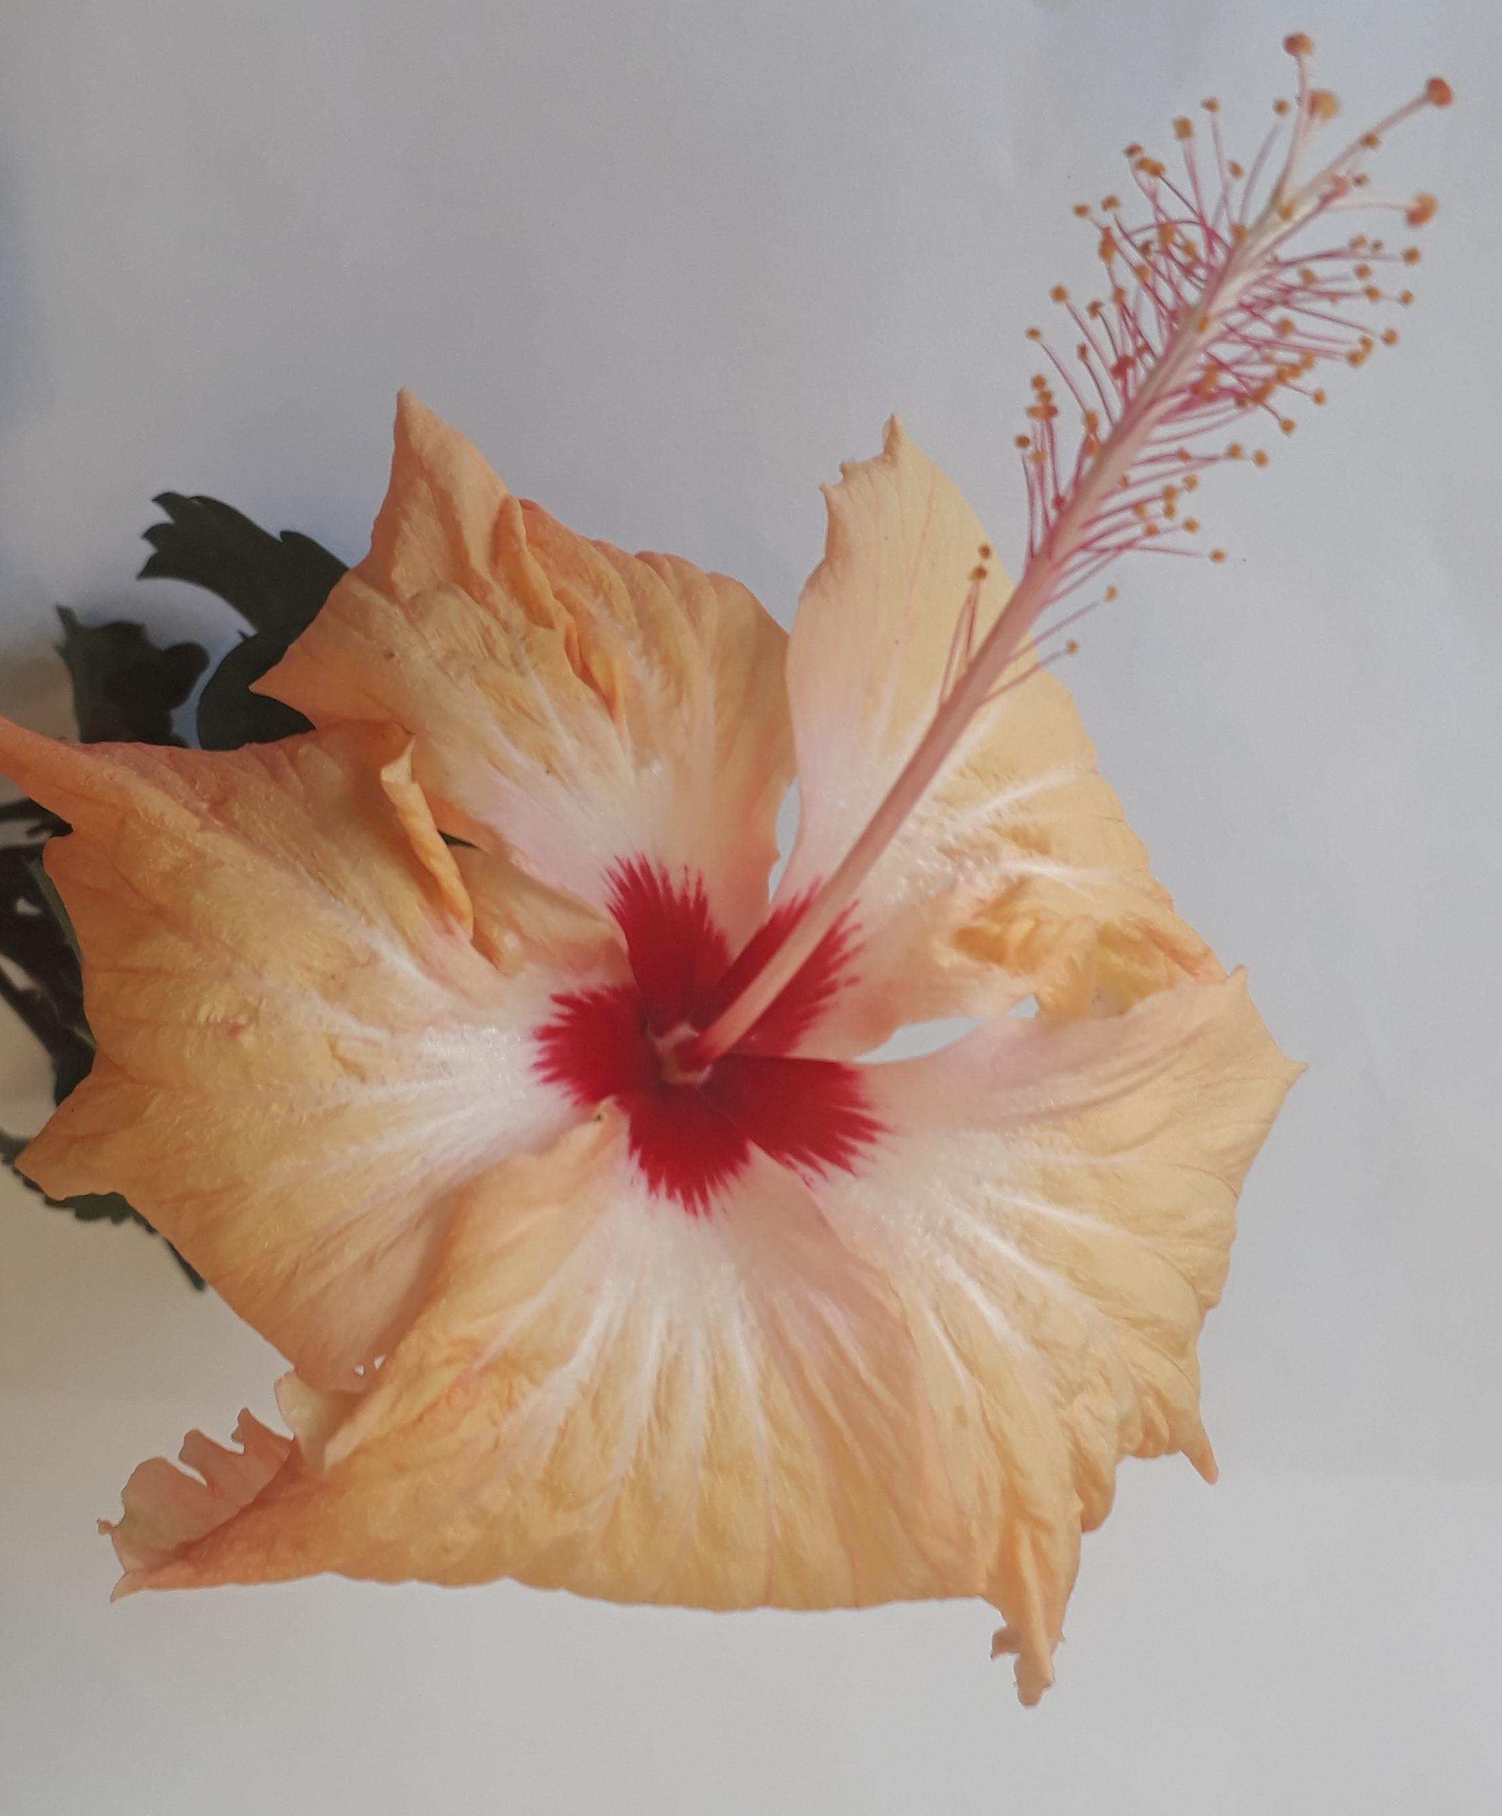H
Figure 1: Photography of sunflower (S), pink violet (PIV), purple violet (PUV), carnation (C), and orange hibiscus (H) in natura. Source: The authors, 2019.

3.1 Acetylcholinesterase inhibition assay
Four samples of edible flowers showed AChE inhibition (Table 1). Purple and pink violets presented higher inhibition activities, above 50 %, followed by carnation and orange hibiscus (about 40 %), with no significant difference between them (95% confidence). This level of activity can be considered very interesting considering that bioactive compounds are usually present in small amounts in foods. Anti-AChE activity of flowers has been associated to the concentration of alkaloids, terpenes, coumarins, flavonoid and phenols (Olennikov et al., 2017). Nowadays, choice therapeutic resource for Alzheimer's disease is based in AChE inhibitors but its use is limited due to side effects and different responses of patients to the treatment (Coin et al., 2016). Food supplements containing edible flowers bearing anti-AChE property can be used as supplemental therapies by Alzheimer’s patients or they can either be further developed as new drugs.
Table 1: Acetylcholinesterase inhibition and antimicrobial activities of edible flowers
Flowers | AChE Inhibition (%) | S. aureus inhibition (%) | S. typhimurium inhibition (%)
Carnation | 41.63 ± 2.17ª | 15.27 ± 0.46ª | 0ª
Sunflower | 0^{b} | 21.02 ± 0.46^{b} | 0ª
Orange hibiscus | 42.37 ± 2.41ª | 45.82 ± 0.41^{c} | 0ª
Pink violet | 55.30 ± 2.29 ^{c} | 46.82 ± 0.82^{c} | 0ª
Purple violet | 57.00 ± 3.23 ^{c} | 37.76 ± 0.31^{d} | 1.56 ± 0.1^{b}
Different letters in the same column indicate significant difference (P ≤ 0.05).
3.2 Antimicrobial activity
Some phenolic compounds from plants produced as part of defensive mechanisms against microbial infections, possessing antimicrobial activity (Sande et al., 2016). All edible flowers extracts (50 mg/mL) inhibited S. aureus growth (Table 1). None of the extracts was active against S. sanguinis and E. coli, therefore, they were not represented in Table 1. Pink violet and hibiscus presented higher antimicrobial activities against S. aureus (>45 %), with no significant difference between them (95 % confidence). Purple violet showed antimicrobial activity against S. aureus (37.7%). Literature corroborates antimicrobial activity of flowers extracts from different species. Methanol extracts of hibiscus (Hibiscus rosa-sinesis L.) and cassia flowers (Senna bicapsularis L.) (50 mg/mL) inhibited S. typhimurium and S. aureus growth (Mak et al., 2012).
According Mak et al. (2012), plants extracts are more effective against Gram-positive than Gram-negative bacteria. In fact, Gram-negative cell wall has a more resistant outer membrane constituted by peptidoglycans and lypopolisacchaaride, justifying the higher activity of the extracts against Gram-positive S. aureus. Considering the risks of food intoxication associated to S. aureus contamination, plant extracts are alternative natural preservatives for food industry (Lima et al., 2018), although the impact of this combination in the sensory properties of foods need to be studied.

3.3 Antioxidant activity
Antioxidant phytochemicals are of great interest nowadays and many plant species have been described as potential antioxidants (Montero et al., 2018). However, antioxidant properties of flowers are still understudied.
3.3.1 Iron reducing power
Iron reducing power measures the ability to reduce iron ions and it is important to prevent free radical formation. Flower extracts showed different levels of iron reducing power (Table 2). Hibiscus was the most active species, followed by purple violet and sunflower. Pink violet and carnation presented the smallest activities of iron reducing power, with no significant difference between them (95% confidence). These results are expressive considering data found in the literature obtained for other plant species like mulberry roots (Sande et al., 2016).
High reducing power presented by the flowers extracts tested indicate presence of natural antioxidant compounds in their composition, which are able to avoid oxidation mechanisms in food, preventing chain reactions and consequent spoilage (Araújo et al., 2013).
Table 2: Ferric reducing power and DPPH scavenger antioxidant activity of edible flowers
Flower | Ferric reducing power (Absorbance _{730nm}) | Ferric reducing power (%)* | DPPH scavenger  (IC50 - Extract concentration µg.mL⁻¹)
Carnation | 0.21ª | 42.8ª | 4205.6ª
Sunflower | 0.24^{b} | 48.7^{b} | 1336.2^{b}
Orange hibiscus | 0.33^{c} | 67.4^{c} | 739.6^{c}
Pink violet | 0.22^{ab} | 46.0^{ab} | 1933.4^{d}
Purple violet | 0.29^{d} | 59.5^{d} | 2342.7e
Ascorbic acid | 0.48e | 100e | 6.2^{f}
*Percentages calculated considering ascorbic acid absorbance (Abs_{730nm} =0.48) as 100%. Different letters in the same column indicate significant difference (P ≤ 0.05).

3.3.2 Radicals’ scavenger antioxidant activities (ABTS and DPPH)
ABTS scavenger flowers activities are shown in Figure 2, and evaluate flowers action on radicals stabilization. IC50% values are inversely related to antioxidant capacity. Hibiscus extracts showed the best activity followed by purple violet, corroborating results from iron reducing power assay. Sunflower, carnation and pink violet also presented interesting ABTS capture antioxidant activity (IC50% 429-646 µg.mL⁻¹), suggesting different mechanisms of antioxidant action in the flowers studied. High ABTS capturing radicals activity has been reported for leaves of Hibiscus tilaceus (IC 50% 6.25 µg.mL⁻¹) (Houssain et al., 2015), and for different beverages prepared with Hibiscus sp. chalices flour (Camelo-Méndez e al., 2018).
The ability to stabilize DPPH radical was demonstrated by all flowers extracts, mainly hibiscus extract, which presented the lowest IC50% value, meaning higher antioxidant activity, followed by sunflower and pink violet (Table 2). The results were similar to ABTS scavenger activity. On a similar work, hibiscus extracts presented IC50% 739.6 µg.mL⁻¹ in DPPH capture assay (Tai et al., 2011). The plants studied herein were notably more active than extracts from flowers Aloe vera, which needed a concentration about four times higher (30000 µg.mL-¹) to inhibit only 30.71 % of DPPH radical (López-Cervantes et al., 2018) and also more active than Centaurea cyanus L. (IC50% 10780 µg.mL⁻¹) and Calendula officinalis L. (IC50% 16710 µg.mL⁻¹) (Pires et al., 2017). Hibiscus extract also was more effective than Rosa sp petals (IC50% 820 µg.mL⁻¹) and Dahlia mignon (IC50% 1170 µg.mL⁻¹) infusions (Pires et al., 2017).

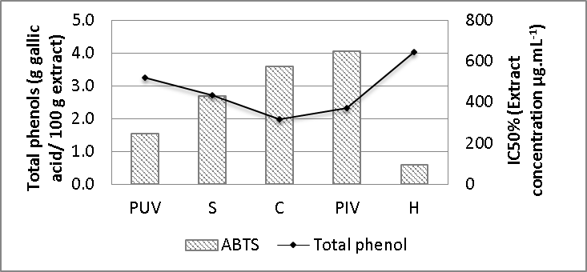
Figure 2: Total phenol content and ABTS scavenger activities of purple violet (PUV), sunflower (S), carnation (C), pink violet (PIV), orange hibiscus (H)

3.3.3 Total phenolic compounds
Edible flower presented high content of phenolic (95% confidence). Higher phenolic content was found in hibiscus and purple violet (4.04 and 3.26 g gallic acid/ 100 g extract, respectively), followed by sunflower, pink violet and carnation. These data are in agreement with DPPH (Table 2) and ABTS radical capture results (Figure 2), once flower samples that presented higher antioxidant activities also showed higher total phenolic compounds. It indicates a close relationship between phenolic content and antioxidant activity. In fact, Figure 2 shows a strong negative correlation (-0.96) between total phenolic contents and IC50% of ABTS scavenging data, since the lower extract concentration needed to inhibit 50 % of ABTS radicals higher is the antioxidant activity. Data herein reported show that the flowers chosen for this work have higher contents of total phenolic compounds than thirteen varieties of roses from Brazil (1.56 g gallic acid/ 100 g extract) (Prata et al., 2017) and than eight species of edible flowers from Thailand, which contained between 0.014 and 0.229 g gallic acid/ 100 g extract (Rachkeeree et al., 2018). Hibiscus and purple violet have higher levels of phenolic compounds than Antirrhinum majus flowers (2.83 mg gallic acid/ 100 g extract), however have smaller concentration than flowers from Viola wittrockiana (4.48 g gallic acid/ 100 g extract) (Gonzalez-Barrio et al., 2018). According to the author, the concentration of phenolics compounds is influenced by botanical origin, color of petals. Extraction method used also can influence phenolic compounds concentration obtained from plant extracts (Sillero et al., 2018). The higher the content of phenolic compounds, the lower the concentration of extract necessary to stabilize 50 % of ABTS radicals and the greater is the antioxidant efficiency.
  - Conclusion
Flowers productive chain has great challenges, as search for edible flowers that, besides safe, can offer important biological properties. Since not all flowers are edible, correct botanical identification, and knowledge of antinutritional factors, pesticide residue contents and toxicity must be observed (Prata et al., 2017). This study demonstrated the functional potential (anti-alzheimer and antioxidant) of five edible flowers. Presence of phenolic compounds in the flowers extracts reflected in good antioxidant, antimicrobial and antiacetilcolinesterase activities showing to be beneficial to human health. Purple and pink violets showed great efficiency in inhibiting AChE. Pink violet presented greater activity against S. aureus. Orange hibiscus stood out by its high concentration of phenolic compounds, excellent antioxidant activity (iron reducing power, DPPH and ABTS capture), in addition to a good antimicrobial activity against S. aureus and, also, AChE inhibitory activity. These results contribute to encouraging the consumption of flowers, fresh (in natura) or processed, not only to decorate dishes but as source of bioactive compounds and also as part of food supplements formulations.
Acknowledgments
The authors acknowledge grants and financial help from the Brazilian Funding Agencies CAPES, CNPq (Fellowship 304922/2018-8) and FAPEMIG (Process APQ-02604-16).
References
Araújo C.R.R., Silva T.M., Lopes M., Villela P., Alcântara A.F.C., Dessimoni-Pinto N.A.V., 2013, Total antioxidant capacity, total phenolic content and mineral elements in the fruit peel of Myrciaria cauliflora, Brazilian Journal of Food Technology, 16, 4, 30–309.
Brand-Williams W., Cuvelier M.E., Berset C., 1995, Use of a free radical method to evaluate antioxidant activity, LWT Food Science and Technology, 28, 25–30.
Camelo-Méndez G.A., Vanegas-Espinoza P.E., Escudero-Gilete M.L., Heredia F.J., Paredes-López O., Del Villar-Martínez A.A. Colorimetric analysis of hibiscos beverages and their potential antioxidant properties, Plant Foods for Human Nutrition, 73, 247–252
Coin M.V., Pamio C., Alexopoulos S., Granziera F., Groppa G., de Rosa A., Girardi G., Sergi E., Manzato R. Padrini, European Jounal of Clinical Pharmacology, 72 (2016) 711–717.
Corradi I.F., de Souza E., Sande D., Takahashi J.A., 2018, Correlation between phenolic compounds contents, antityrosinase and antioxidant activities of plant extracts, Chemical Engineering Transations, 64, 109–114
Ellman G.L., Courtney K.D., Andres jr. V., Featherstone R. M., 1961, A new and rapid colorimetric determination of acetylcholinesterase activity, Biochemical Pharmacology, 7, 2, 88–95.
Gao X., Ohlander M., Jeppsson N., Björk L., Trajkovski V., 2000, Changes in antioxidant effects and their relationship to phytonutrients in fruits of sea buckthorn (Hippophae rhamnoides L.) during maturation. Journal of Agricultural Food Chemistry, 48, 5, 1485–1490.
Houssain H., Akbar P.N., Rahman S.E., Yeasmin S., Khan T.A., Rahman M.M., Jahan I.A., 2015, HPLC profiling and antioxidant properties of the ethanol extract of Hibiscus tiliaceus leaf available in Bangladesh, European Journal of Medicinal Plants, 7, 7–15.
Lima D.S., Duarte N.B.A., Barreto DL.C., Oliveira G.P., Takahashi J.A., Fabrini S.P., Sande D., 2018, Passion fruit and apple: from residues to antioxidant, antimicrobial and anti-Alzheimer’s potential, Ciência Rural, 48, 9, e20180076.
López-Cervantes J., Sánchez-Machado D.I., Cruz-Flores P., 2018, Antioxidant capacity, proximate composition, and lipid constituents of Aloe vera ﬂowers, Journal of Applied Research on Medicinal and Aromatic Plants, 10, 93–98.
Mak Y.W., Chuah L.O., Ahmad R., Bhat R., 2012, Antioxidant and antibacterial activities of hibiscus (Hibiscus rosa-sinensis L.) and Cassia (Senna bicapsularis L.) ﬂower extracts, Journal of King Saud University – Science, 25, 275–282.
Montero I.F., Chagas E.A., Melo Filho E.A., Saravia S.A.M., Santos R.C., Chagas P.C., Duarte E.D.R.S., 2018, Evaluation of total phenolic compounds and antioxidant activity in Amazon fruit, Chemical Engineering Transaction, 64, 649–654.
NCCLS - National Committee for Clinical Laboratory Standards. Methods for dilution antimicrobial susceptibility tests for bacterial that grow aerobically, Approved Standard. 10ed. NCCLS document M07-A10. National Committee for Clinical Laboratory Standards Wayne, PA, 2015.
Olajuyigbe O.O., Afolayan A.J., 2011, Phenolic content and antioxidant property of the bark extracts of Ziziphus mucronata Willd. subsp. mucronata Willd. BMC Complementary and Alternative Medicine, 11:130.
Olennikov D.N., Kashchenko N.I., Chirikova N.K., Akobirshoeva A., Zilﬁkarov I.N., Vennos C., 2017, Isorhamnetin and quercetin derivatives as anti-acetylcholinesterase principles of marigold (Calendula ofﬁcinalis) flowers and preparations, International Journal of Molecular Science, 18, 8, 1685.
Oyaizu M., 1986, Studies on product of browning reaction prepared from glucose amine. Japanese Journal of Nutrition, 44, 307–315.
Pires T.C., Dias M.I., Barros L., Ferreira I.C., 2017, Nutritional and chemical characterization of edible petals and corresponding infusions: Valorization as new food ingredientes, Food Chemistry, 220, 337–343
Prata G.G.B., de Souza K.O., Lopes M.M.A., Oliveira L.S., Aragao F.A.S., Alves R.E., Silva S.M., 2017, Nutritional characterization, bioactive compounds and antioxidant activity of Brazilian roses (Rosa spp), Journal of Agricultural Science and Technology, 19, 929–941.
Rachkeeree A., Kantadoung K., Suksathan R., Puangpradab R., Page P.A., Sommano S.R., 2018, Nutritional composition and phytochemical properties of the edible flowers from selected Zingiberaceae found in Thailand, Frontiers in Nutrition, 5,3,1–7.
Sande D., Solares M.D., Rodríguez Y.E.M., Cabrera I.C., Carballo L. F., Pérez N.A., Morales Y.L., Colen G., Takahashi J.A., 2016, Roots from mulberries (Morus alba) natural and hybrids varieties: phenolic contend and nutraceutical potential as antioxidant, Journal of Applied Pharmaceutical Science, 6, 11, 63–69.
Sillero L., Prado R., Labidi J., 2018, Optimization of different extraction methods to obtaining bioactive compounds from Larix Decidua Bark, Chemical Engineering Transactions, 70, 1369–1374.
Tai Z., Cai L., Dai, L., Dong L., Wang M., Yang Y., Cao Q., Ding Z., 2011, Antioxidant activity and chemical constituents of edible flower of Sophora viciifolia, Food Chemistry, 126, 1648–1654.

