 CHEMICAL ENGINEERING TRANSACTIONS  VOL. 76, 2019 | A publication of  
The Italian Association
of Chemical Engineering
Online at www.aidic.it/cet
Guest Editors: Sauro Pierucci, Jiří Jaromír Klemeš, Laura Piazza
Copyright © 2019, AIDIC Servizi S.r.l.
ISBN 978-88-95608-73-0; ISSN 2283-9216

Low-Temperature Pyrolysis of Poultry Litter for Biofuel Production
Rafail Isemin^{b,}*, Alexander Michalevª, Natalia Muratova ^{b}, Vadim Kogh-Tatarenko^{b}, Yuri Teplitskii^{c}, Anatoly Grebenkov^{c}, Evgeny Pitsukha^{c}
ª Clean Energy LLC, 112i – 392000, Sovetskaya Str., Tambov, Russia
^{b} Tambov State Technical University, 106 – 392000, Sovetskaya Str., Tambov, Russia
^{c} A. V. Luikov Heat and Mass Transfer Institute, National Academy of Sciences of Belarus, 15 – 220072, P. Brovka Str., Minsk, Belarus
penergy@list.ru
There was investigated the process of poultry litter (PL) low-temperature pyrolysis in a fluidized bed in an environment of superheated steam at a temperature of 300°C. It was established that the duration of the low-temperature pyrolysis process in a fluidized bed does not exceed 840 seconds, which is significantly less than the duration of the pyrolysis process in a fixed bed (2400 seconds). As a result of the pyrolysis process, the weight loss of a poultry litter sample reaches 50%. After pyrolysis, the carbon content in the poultry litter increases 1.16 times, the oxygen content decreases 2.46 times, and the combustion heat of the poultry litter increases 1.13 times. According to its characteristics, the poultry litter after its treatment by the method of low-temperature pyrolysis approaches lignite.
  - Introduction
The agricultural production, especially livestock and poultry keeping, has a great influence on environment in Russia.
There are about 20 million head of cattle, more than 17 million pigs, 21 million sheeps and near 450 million poultry in the Russian Federation (Mogilevtsev et. al.,2012). The waste volume from cattle farms and poultry farms in the form of liquid dung, poultry litter and wastewater are about 700 million m³ per year. The environmental damage caused by agricultural production in Russia as a whole amounts to more than 15 billion euros per year, about 90% of which is caused by poultry litter and excrements (pticaru.ru, 2017).
Currently, there are two most important biotechnological approaches to recycling of organic substance from poultry litter: exothermic fermentation or composting for production of humus substrate, and anaerobic digestion for biogas production (Kelleher et. al., 2002). The main disadvantages of both processes are a long duration (up to 90 days) and a significant loss of organic matter and nutrients (50%). In addition, composting leas to the formation of a great amount of conditioned plant pathogens in the resulting compost, the toxicity of which is often manifested in the seed germination delay (Ghanim et. al., 2016.).
Disposal of all kinds of poultry litter involves its recycling into biofuels with the following conditions ( Ghanim et. al., 2016.).:
1) the full and guaranteed decontamination of PL,
2) preservation of the maximum amount of organic substance,
3) minimization of energy and time spent on the PL decontamination.
These conditions are satisfied in the case of treatment of the original poultry litter by the low-temperature pyrolysis.
The low-temperature pyrolysis is a process of biomass heat treatment at temperatures not exceeding 300 °C in a low oxygen content medium. This kind of treatment causes a substantial removal of moisture and oxygen from the biomass and a slight removal of hydrogen (Chew, Doshi, 2011; Acharya et. al., 2012; Nhuchhen et. al., 2014).
In a previous study (Isemin et. al., 2017), have conducted poultry litter decontamination by a process of dry torrefaction. The process was carried out in a Hearth - type reactor in which pellets made from mixture of poultry litter and sawdust were subjected to torrefaction at 155-250 °C for 60 minutes. The obtained result was positive since pathogenic microflora was completely removed. However, the disadvantage of the proposed technology was the low rate of heat treatment.
The aim of this study is to analyze the process of dry and wet torrefaction of poultry litter. Wet torrefaction (WT) is performed in a fluidized bed in a medium of water steam at a temperature of 300 °C. Superheated steam is used both for drying and gasification (Barrio et al., 2000, Proell et al., 2005). It is well known that gasification in a steam environment is much faster than in carbon dioxide environment (Walker, 1959). However, there is no available information in literature on the superheated steam utilization as a fluidizing medium for the torrefaction process of biomass.
1.1 Theory
It was proposed to carry out the WT process in a fluidized bed consisting of thermally treated PL particles, with a periodical load of “fresh” poultry litter.
First, it should be estimated the value of the mass fraction of the incoming “fresh” PL, which enters the reactor with a temperature of 20°C and humidity of 8%. At the same time, the temperature of the pre-heat-treated poultry litter in the reactor is 300 ºС and the temperature of the bed consisting of a mixture of "fresh" and thermally treated litter (<T>) should not be below 260°C
An equation for this value:
(1.1)
where Т_{НТ} и Т_{Т} – the temperature of the "fresh" and heat-treated litter, respectively. Then the mass fraction of "fresh" litter:
(1.2)
For Т_{Т} = 300 ºС; Т_{НТ} = 100 ºС; ˂Т˃ = 260 ºC from Eq(1.2) follows φ(0) = 0,14. Thus, the mass fraction of "fresh" litter should not exceed 14%.
Suppose that during the torrefaction process, the size of PL particles does not change, but at the same time their density decreases about 2 times: ρ_{НТ} ≈ 600 kg/m³; ρ_{Т} ≈ 300 kg/m³.
The pressure drop when there is only thermally treated PL in the bed will be:
(1.3)
where ∆Н – bed material height. The mass of thermally treated litter MT can be determined by the formula:
(1.4)
where D – internal diameter of the reactor.
If the mass of “fresh” М_{НТ} PL enters the reactor, then the total pressure drop will be:
(1.5)
where - equivalent density of a PL particles mixture at the initial time; h – additional bed height from the input of "fresh" PL mass М_{НТ}:
(1.6)
The value is determined by the equation similar Eq(1.1):
(1.7)
The mass fraction of “fresh” PL is equal to:
(1.8)
Taking into account Eq(1.7) and Eq(1.8) for from Eq(1.5) derive:
(1.9)
From Eq(1.9) it is easy to determine the relation of the incoming “fresh” PL mass М_{НТ} с ∆Р_{Т} и ∆Р_{Σ} (0):
(1.10)
Note that when ∆Р_{Т} = 0:
(1.11)

Equation (1.10) makes it possible to control the mass of “fresh” PL entered the reactor using the
and ∆Р_{Т} values. Using Eq(1.10), the value of h in Eq(1.6) can also be expressed in terms of pressure drops:
(1.12)
The equivalent density of litter particles in the reactor ρ_{э}(t) at any time is equal to:
(1.13)
In this case, at the initial moment of time (loading moment), taking into account Eq(1.7), Eq(1.8):
(1.14)
During the pyrolysis process and . The mass loss can be determined using the following equation:
(1.15)
Determination of the minimum fluidization rate of the PL particles bed fluidization after loading a portion of "fresh" PL is made according to:
(1.16)
Values and are determined by the equation (Aerov,1968):
(1.17)
where Ar – Archimedes criterion.

  - Experimental section
2.1 Materials sampling and chemical characterization
The elemental composition (Table 1) of PL samples obtained by means of a CHN 2000 LECO analyzer with the ASTM D5373 standard method. The oxygen content estimated by subtracting the sum of the percentages (dry basis) of C, H, N and ash from 100%. All the analyses performed in triplicate at least. The higher heating value (HHV, MJ/kg, dry basis) measured using a Parr 6200 Isoperibol 142 Calorimeter.
Table 1. Poultry litter characteristics before torrefaction
Material | The characteristics being determined
 | С, % | Н, % | N, % | S, % | O₂, % | Ash  А, % | Lower combustion heat, MJ/ kg
Poultry litter initial | 41,4 | 5,7 | 4,8 | 0,8 | 30,7 | 16,6 | 16,7

As a bed material there was used quartz sand with particle sizes of 0.16-0.25 mm and poultry litter that underwent preliminary thermal treatment (torrefaction). Heat-treated poultry litter samples (tor-PL) were ground to a powder with a particle size of 0.4-1.1 mm.

2.2 Apparatus and procedures for poultry litter torrefaction
The same apparatus analyzed dry and wet torrefaction processes of poultry litter. Dry torrefaction (DT) is performed in a fixed bed of quartz sand blown with nitrogen, and wet torrefaction (WT) is performed in a fluidized bed in a medium of water steam at a temperature of 300°C. The experimental setup scheme is shown in Figure 1. During the experiments, the reactor bed operates in fixed or fluidized state.
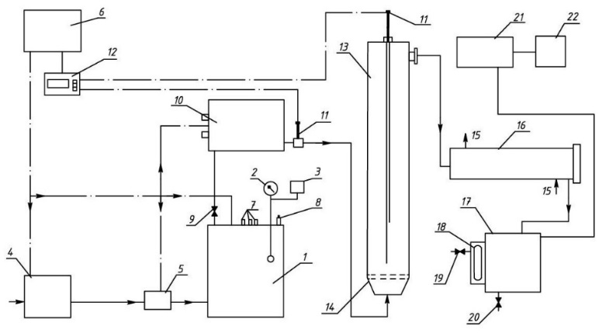
Figure 1: The experimental setup scheme for studying the poultry litter torrefaction process
1 – electric boiler, 2 – pressure gauge, 3 – steam pressure sensors, 4 – water supply pipe, 5 – valve, 6 –automation and regulation system, 7 – sensors for monitor the boiler water level, 8 –safety valve, 9 – control valve, 10 –electric super heater, 12 – temperature regulators, 13 –reactor, 14 – the gas distribution grid, 15 - the water supply pipe, 16 - the refrigerator, 17 – the tank for condensed products, 18 –the inspection window, 19, 20 – the condensate discharge valves, 21 – gasholder, 22 - gas analyzer «VarioPlusSynGaz»

The water steam produced in the boiler (1) having an overpressure of less than 0.07 MPa and a temperature of 117°C, enters the electric superheater (10) where it is superheated to the required temperature. Then, the superheated steam enters the torrefaction reactor (13). The reactor (13) is made of stainless steel and has a diameter of 80 mm and a height of 800 mm. The reactor walls are heat-insulated. Reactor (13) is provided with an inlet for delivering the poultry litter pellets into the fluidized bed. The amount of poultry litter loaded into the reactor was 20 – 23 g. During poultry litter pellets torrefaction, the content of carbon dioxide, carbon monoxide, CH₄ and hydrogen in the gases behind the condenser (16) continuously measured with the «VarioPlusSynGaz» gas analyzer. The experiment stopped as soon as the gas analyzer ceased to detect the releasing of these gases. After completion of the experiment, the reactor purged with cold nitrogen for 2 hours, and subsequently, the poultry litter were unloaded.
The steam consumption was determined by measuring the amount of condensate obtained after cooling the condensable products of torrefaction. The nitrogen consumption was determined using a flow meter.

3. Results and discussion
Figure 2 shows that the DT (temperature of 300°C) duration of raw PL in a fixed bed is 2400 seconds.

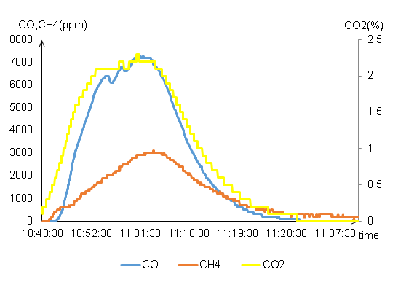
Figure 2. CO₂, CO and CH₄ concentrations of non-condensable gases in a fixed bed
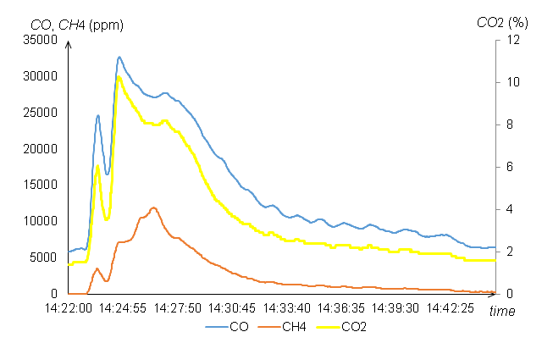
Figure 3: CO₂, CO and CH₄ concentrations for non-condensable gases in a fluidized bed

As can be seen from

Figure 3, the
duration of the WT (temperature of 300°C) process in a fluidized bed of tor-PL particles is approximately 600 seconds.

This indicates that the WT process in a fluidized bed is 4 times more intense than in a fixed bed.
Table 2 shows the main PL characteristics after treatment by the torrefaction method. The similar characteristics of biochar (carbon content 49.83%, hydrogen content 4.45%) obtained during the poultry litter treatment by hydrothermal carbonization at 300°C with a processing time of 480 minutes (Ghanim et al., 2016).
Table 2. The main PL characteristics after treatment by the torrefaction method.
Material | The characteristics being determined
 | С, % | Н,% | N, % | S, % | O₂, % | Ash  А, % | Lower combustion heat, MJ / kg
PL pellets after DT | 47,6 | 3,7 | 6,3 | 0,96 | 10,9 | 30,5 | 18,9
PL after WT | 48,2 | 3,63 | 4,65 | 0,9 | 12,48 | 30,1 | 18,8

Conclusion
The use of any studied methods of poultry litter processing into biofuel (DT or WT) in a fixed bed or in a fluidized bed does not affect the chemical composition of the resulting biofuel. Due to the poultry litter processing using the DT or WT method, it is possible to increase the carbon content in the litter by 1.13 - 1.16 times, to reduce the hydrogen content 1.54 - 1.57 times, to reduce the oxygen content 2.46 - 2.84 times and to increase the heat of the poultry litter combustion 1.11 - 1.13 times.
The use of fluidized bed technology, both with DT and WT, makes it possible to reduce the poultry litter treatment duration 2.8 - 4.0 times in comparison with the poultry litter treatment in a fixed bed.
Acknowledgments
This research was supported by the Ministry of Science and Higher Education of the Russian Federation (Agreement No. 074-11-2018-018 dated May 29, 2018).

References
Barrio, M., Gbel, B., Rimes, H., Henriksen, U., Hustad, J., & Srensen, L. Steam Gasification of Wood Char and the Effect of Hydrogen Inhibition on the Chemical Kinetics. Progress in Thermochemical Biomass Conversion, 32–46. http://doi.org/10.1002/9780470694954.ch2

Ghanim, B. M., Pandey, D. S., Kwapinski, W., & Leahy, J. J. (2016). Hydrothermal carbonisation of poultry litter: Effects of treatment temperature and residence time on yields and chemical properties of hydrochars. Bioresource Technology, 216, 373–380. http://doi.org/10.1016/j.biortech.2016.05.087

Isemin, R. L., Mikhalev, A. V., Milovanov, O. Y., Stepantsova, L. V., & Solopov, V. A. (2017). Development of the Technology of Poultry Litter Treatment into Organic Fertilizer through Its Decontamination by the Low-Temperature Pyrolysis Method. International Journal of Chemical Engineering and Applications, 8(3), 184–188. http://doi.org/10.18178/ijcea.2017.8.3.653

Pröll Tobias, Rauch, R., Aichernig, C., & Hofbauer, H. (2005). Fluidized Bed Steam Gasification of Solid Biomass: Analysis and Optimization of Plant Operation Using Process Simulation. 18th International Conference on Fluidized Bed Combustion. http://doi.org/10.1115/fbc2005-78129

Mogilevtsev, V., Brukhanov, D., Maksimov, E. Vasiliev, I. Subbotin, C. Chernin, Y. Parubets, A. Garzanov, Manure / poultry litter disposal on livestock farms to ensure ecological safety of the territory surface and groundwater bodies in the Leningrad region, 2012. Available online at: eco.sznii.ru/booklet.pdf.
Walker, P., Rusinko, F., & Austin, L. (1959). Gas Reactions of Carbon. Advances in Catalysis, 133–221. http://doi.org/10.1016/s0360-0564(08)60418-6

Why is often the most successful poultry farms and bring the greatest harm to the environment., 2017 [Electronic resource]. URL: pticaru.ru/per-prod-ptic/698-vred-pticefabrik.html.
Kelleher, B., Leahy, J., Henihan, A., Odwyer, T., Sutton, D., & Leahy, M. (2002). Advances in poultry litter disposal technology – a review. Bioresource Technology, 83(1), 27–36. http://doi.org/10.1016/s0960-8524(01)00133-x

Chew, J., & Doshi, V. (2011). Recent advances in biomass pretreatment – Torrefaction fundamentals and technology. Renewable and Sustainable Energy Reviews, 15(8), 4212–4222. http://doi.org/10.1016/j.rser.2011.09.017

Nhuchhen, D., Basu, P., & Acharya, B. (2014). A Comprehensive Review on Biomass Torrefaction. International Journal of Renewable Energy & Biofuels, 1–56. http://doi.org/10.5171/2014.506376

Acharya, B., Sule, I., & Dutta, A. (2012). A review on advances of torrefaction technologies for biomass processing. Biomass Conversion and Biorefinery, 2(4), 349–369. http://doi.org/10.1007/s13399-012-0058-y

Aerov M.E. Hydraulic and Thermal Bases of Operation of Devices with a Stationary and Fluidizing Bed. 512 pages. Leningrad: Chemistry, 1968.

