CHEMICAL ENGINEERING TRANSACTIONS  VOL. 76, 2019 | A publication of  
The Italian Association
of Chemical Engineering
Online at www.aidic.it/cet
Guest Editors:Sauro Pierucci,Jiří Jaromír Klemeš, Laura Piazza
Copyright © 2019, AIDIC Servizi S.r.l.
ISBN978-88-95608-73-0;ISSN 2283-9216

Anatomical Traits of Pumpkin (Cucurbita moschata Duch) as Evaluation Parameters of Bioaccessibility of Carotenoids

André Luis de Alcantara Guimarãesª, Lucia Maria Jaeger de Carvalhoª*, Ana Cláudia de Macêdo Vieiraª, Joyce Aparecida Tavares Mirandaª, Fernanda D. B. Abadio Fincoª, José Luiz Viana de Carvalho^{b}.
* Corresponding Author: luciajaeger@gmail.com

ªFederal University of Rio de Janeiro (UFRJ). Post-Graduate Program in Pharmaceutical Sciences, Department of Natural Products and Food, Rio de Janeiro, Rio de Janeiro, Brazil.
^{b} Embrapa – Food Technology, Rio de Janeiro, Rio de Janeiro, Brazil.
* Corresponding Author: luciajaeger@gmail.com

Abstract
Pumpkin (Cucurbita moschata Duch.) has high potential as source of carotenoids with provitamin A activity, especially all-trans-β-carotene, and are widely consumed by the Brazilian population. Consumption may be useful in preventing the vitamin A deficiency, which corresponds to a public health concern in Brazil. The cooking style can affect the carotenoids retention, induce the isomerization cis-trans of the β-carotene, bioaccessibility and bioavailability. The aim of this study was to evaluate the bioaccessibility of carotenoids in biofortified pumpkins submitted to different cooking styles through microscopic techniques. Five biofortified pumpkin genotypes were submitted to three cooking methods (boiled in water, steam and microwave oven). The anatomical analyses revealed some differences regarding the integrity and morphological traits of parenchyma cells from mesocarp, related to the type and time of cooking. In natura samples revealed intact fragments with round shaped cells connected to each other, the middle lamella preservation and, carotenoids preserved in the plastids. The cooking preparation with boiling water harmed most of middle lamella, resulting in small fragments and abundant isolated mesocarp parenchyma cells. These cells had variable shapes, round but most exhibiting flatten and collapsed cells, but still intact with preserved cell walls. Broken cells were rare. Carotenoids were abundant within the cells. The microwave oven cooking showed that mesocarp parenchyma cells remain mostly preserved, with most cells still connected to each other, which indicates the integrity of middle lamella. The cells showed rounded shape, and carotenoids were abundant and preserved within cells. Preparations with water vapor for 5 minutes exhibited sparse isolated cells and small fragments with cells still connected to each other. Most isolated cells showed rounded and flattened shapes, mostly collapsed but still preserved cell walls. Carotenoids were abundantly preserved within mesocarp parenchyma cells. Those cells which retained the integrity of middle lamella were still bonded to each other. They remained mostly rounded shaped, and carotenoids were within cells. Thus, cell walls and chromoplasts act as barriers that retain carotenoids encapsulated avoiding their cell release and absorption during digestion, compromising their bioaccessibility.

Keywords: carotenoids; pumpkin; bioavailability; bioaccessibility

1. Introduction

Carotenoids represent one of the most diverse group of natural pigments in nature. They may be responsible for yellow to reddish colors in different plant organs, such as flowers, fruits, leaves, and roots, but also in egg yolk and crustaceans (A. Rodríguez-Bernaldo de Quirós, H. S. Costa, 2009). They are also bioactive substances, and act as vitamin A precursors.
Several factors may affect bioavailability of carotenoids, such as its physical state in food, the type of preparation or cooking, the presence of other nutrients, and season and geographical variations. Additionally, several factors may reduce bioaccessibility - the potential amount of the substance that is absorbable – which will further limit bioavailability of target substances. Thus, the mere presence of higher amounts of carotenoids, for instance, may not represent their nutritional availability.
In Brazil and other developing countries, poor people tend to suffer from hunger and malnutrition, which may cause diseases by the shortage of proteins and calories, and micronutrients, such as vitamins and minerals. The vitamin A deficiency represents a critical public health issue, which can be minimized by ingestion of food rich in carotenoids, mainly beta-carotene. Thus, pumpkin (Cucurbitaceae) plays a key role, since several species, such as Cucurbita moschata, C. maxima e C. Pepo are pumpkins rich in carotenoids, especially beta-carotene, beta-cryptoxanthin, lutein and zeaxanthin. Nevertheless, studies regarding the bioaccessibility of such carotenoids are important to evaluate the introduction of new pumpkin cultivars into the diet of local populations.
Thus, the aim of this study is to analyze morphological and anatomical traits of biofortified pumpkin samples (Cucurbita moschata Duch.) prepared through different cooking methods to evaluate the bioaccessibility of carotenoids.

2. Material and Methods

2.1. Preparation of pumpkin samples

Samples of in natura fortified variety of pumpkin were cultivated and harvested at Embrapa – Coastland Tables (Figure 1). The fruits were washed with chlorinated and distilled waters, subsequently. Then, they were divided into 4 pieces and homogenized with an IKA Ultraturrax T18 basic disperser .

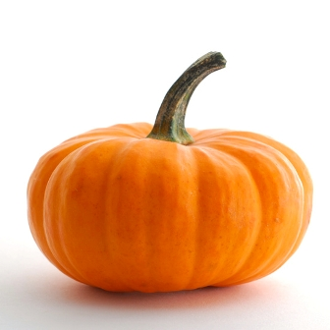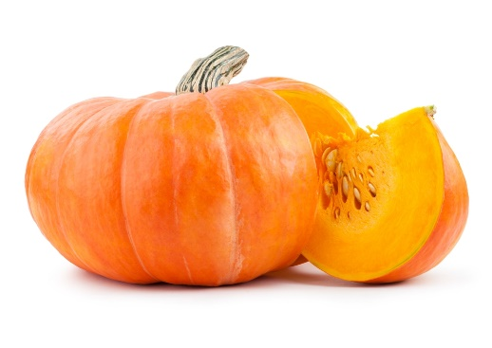

Figure 1: In natura samples of Cucurbita mochata

The samples were separated in 5 g of in narura pumpkin and cooked in different types of preparation: cooking with boiling water (1:2 – pumpkin : water), steaming and microwave oven. The samples were cooked for 5 minutes in each methods of preparation. After cooking, each sample was weighed and kept frozen (-20°C) and protected to light and oxygen until morphological analyses to prevent the loss of carotenoids and/or isomerization. In natura samples were used as control to establish usual morphological and anatomical traits. All analyses were performed in triplicates.

2.2. Morphological analyses

For anatomical studies, we used botanical material from each cooked pumpkin sample. The fixed control samples of mature and in natura pumpkin were cut into 10–12 µm thick sections with a Ranvier microtome . Some of them were then stained with 1% astra blue and 1% safranin (9 :1, v/v) and the other samples were observed without staining process to establish control parameters. Sample was mounted in triplicates in histological glass slides with glycerin 50%.
All analyzes and image records were performed with an optical microscope Zeiss Axio Scope A1 connected to digital photographic equipment and Zen Powerlite Imaging software. The images were prepared in Adobe Photoshop 7.0® and PowerPoint 2007®.

3. Results and Discussion

The anatomical analyses revealed some differences regarding the integrity and morphological traits of parenchyma cells from mesocarp, related to the type and time of cooking. In natura samples revealed intact fragments with cells connected to each other, preserving the middle lamella. Cells exhibited round shape, and carotenoids are preserved in the plastids (Figure 2A). The preparation with boiling water for 5 minutes harmed most of middle lamella, resulting in small fragments and abundant isolated mesocarp parenchyma cells (Figure 2B-C). These cells had variable shapes, round but most exhibiting flatten and collapsed cells, but still intact with preserved cell walls. Broken cells were rare. Carotenoids were abundant within the cells. The microwave oven cooking for 5 minutes revealed that mesocarp parenchyma cells remain mostly preserved, with most cells still connected to each other, which indicates the integrity of middle lamella. The cells showed rounded shape, and carotenoids were abundant and preserved within cells (Figure 2D). Preparations steamed cooked for 5 minutes exhibited sparse isolated cells (Figure 2E) and small fragments with cells still connected to each other (Figure 2F). Most isolated cells showed rounded and flattened shapes, mostly collapsed but still preserved cell walls. Carotenoids were abundantly preserved within mesocarp parenchyma cells. Those cells which retained the integrity of middle lamella were still bonded to each other (Figure 2F). They remained mostly rounded shaped, and carotenoids were within cells.
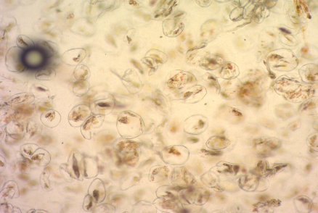
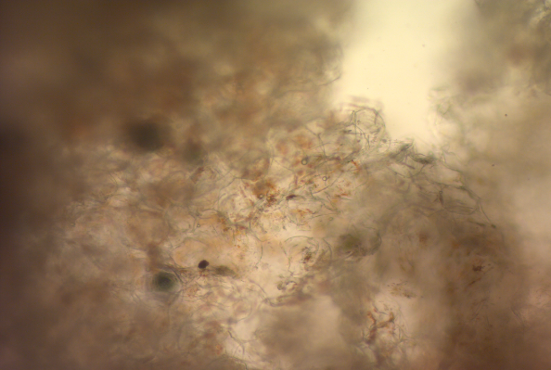
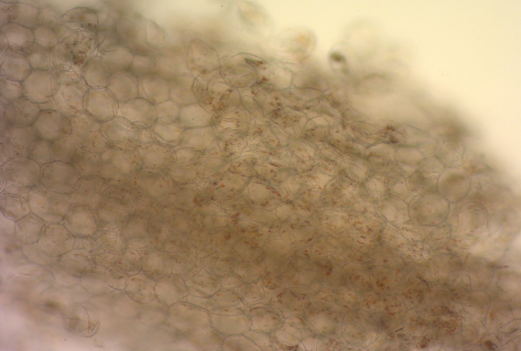
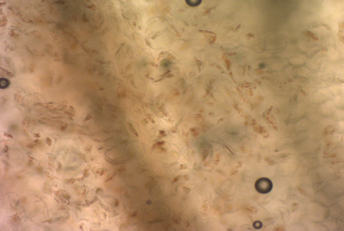
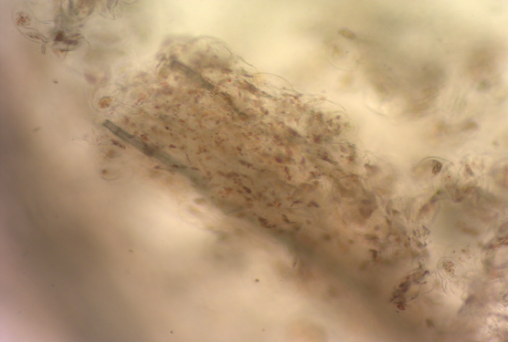
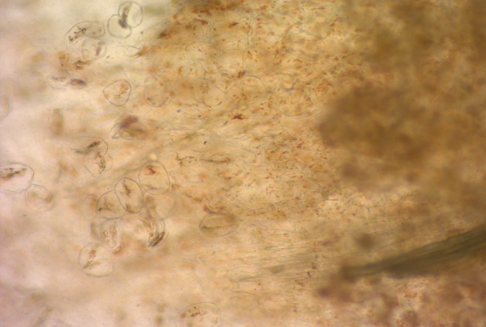
A
F
E
D
C
B
Figure 2: Samples of pumpkin in different types of preparation. (A) In natura sample, showing parenchyma cells adjacent to each other, with preserved chromoplasts and carotenoids within. (B-C) Samples boiled in water, showing degeneration of middle lamella, with isolated collapsed cells. (D) Sample cooked in microwave oven showing mesocarp parenchyma cells mostly preserved, with most cells still connected to each other, which indicates the integrity of middle lamella. Carotenoids were abundant and preserved within the cells. (E-F) Samples steamed cooked exhibited sparse isolated cells and small fragments with cells still connected to each other. Most isolated cells showed rounded and flattened shapes, mostly collapsed but still preserved cell walls. Carotenoids were abundantly preserved within mesocarp parenchyma cells.
There are several differences concerning amount and profile of carotenoids between pumpkin species (Cucurbita spp.) and varieties of the same species, as a result of genotypes variation, climate conditions, seeding, growth and, harvesting processes . It is worth noting that biofortification program from Embrapa does not focus only in high amounts of beta-carotene, but also in satisfactory agronomical and reproduction features, resistance to diseases with economic viability and good market acceptance .
Ribeiro (2016) registered the high content of carotenoids pro-vitamin A in different biofortified pumpkin genotypes, which reinforces the use of such food in replacement to the of usual commercial pumpkin to improve the diet of local population. This study also revealed no differences regarding carotenoids loss between in natura and cooked samples. The retention of carotenoids pro-vitamin A after cooking was high (about 80%), despite fluctuations between cooking methods .
Ribeiro (2016) registered low bioavailability of carotenoids despite the high amount of pro-vitamin A in the studied pumpkin genotypes. The author suggested that most of carotenoids pro-vitamin A was retained within food matrix instead of by the transference to micelles. Furthermore, the intense orange of the precipitate after centrifuging indicated that cooking was unable to release the carotenoids into food matrix. Our results indicated that, no matter the cooking method applied, most cell walls remained intact. Heating was able to degenerate pectic substances and destroy only the middle lamella in different degrees depending on the method. Nevertheless, most of parenchyma cells kept their integrity and carotenoids were abundant within cells. Their presence in the extracellular matrix was rare and sparse.
Tydeman et al. (2010) registered similar results between in natura and cooked samples in carrot samples . The anatomical analyses revealed that most parenchyma cells remained intact, and carotenoids were not released into the extracellular matrix, after cooking and in vitro digestion. Such differences in bioaccessibility of fruits and other vegetables are due to the pro-vitamin A location in plant tissues since these compounds are encapsulated in the cellular organelles avoiding their release and further absorption during digestion . Finally, the morphology of chromoplasts from parenchyma cells of pumpkin samples, with microtubules retaining proteins attached to carotenoids, has great impact over the release and absorption of such substances during digestion .

4. Conclusion

Our results revealed that most parenchyma cells remained intact, and carotenoids were not released into the extracellular matrix, after cooking, no matter the heating cooking process. Thus, cell walls and chromoplasts act as barriers that keep carotenoids encapsulation avoiding their release and absorption during digestion, compromising their bioaccessibility and bioavailability. Further studies are necessary to fully understand the morphology of plastids and cells and propose new methods of preparation to improve bioaccessibility and, consequently bioavailability of provitam A carotenoids from pumpkin biofortified genotypes.

Acknowledgments

The authors thank the Rede de Biofortificação do Brasil, HarvestPlus and Fundação Carlos Chagas de Aparo à Pesquisa do Estado do Rio de Janeiro – FAPERJ for the financial support.

5. References

Aherne, S. A., M. A. Jiwan, et al. (2009). "Geographical location has greater impact on carotenoid content and bioaccessibility from tomatoes than variety." Plant Foods for Human Nutrition 64(4): 250-256.
Azevedo-Meleiro, C. H. and D. B. Rodriguez-Amaya (2007). "Qualitative and quantitative differences in carotenoid composition among Cucurbita moschata, Cucurbita maxima, and Cucurbita pepo." Journal of Agricultural and Food Chemistry 55(10): 4027-4033.
Bukatsch, F. (1972). "Bermerkungen zur Doppelfärbung Astrablau-Safranin." Mikrokosmos 61(255).
Carvalho, L. M. J. d., J. L. V. d. Carvalho, et al. (2015). "Variability of total carotenoids in C. moschata genotypes." Chemical Engineering Transactions 44: 247.
Cheng, D., Y. Zhang, et al. (2019). "An improving method for extracting total carotenoids in an aquatic animal Chlamys nobilis." Food Chemistry 280: 45-50.
Della Lucia, C. M., F. M. Campos, et al. (2008). "Controle de perdas de carotenoides em hortaliças preparadas em unidade de alimentação e nutrição hospitalar." Ciência & Saúde Coletiva 13: 1627-1636.
Failla, M. L., S. K. Thakkar, et al. (2009). "In Vitro bioaccessibility of β-Carotene in orange fleshed sweet potato (Ipomoea batatas, Lam.)." Journal of Agricultural and Food Chemistry 57(22): 10922-10927.
Gugliucci, A. and D. H. M. Bastos (2009). "Chlorogenic acid protects paraoxonase 1 activity in high density lipoprotein from inactivation caused by physiological concentrations of hypochlorite." Fitoterapia 80(2): 138-142.
Jacobs, D. R. and L. C. Tapsell (2007). "Food, not nutrients, is the fundamental unit in nutrition." Nutrition Reviews 65(10): 439-450.
Jeffery, J., A. Holzenburg, et al. (2012). "Physical barriers to carotenoid bioaccessibility. Ultrastructure survey of chromoplast and cell wall morphology in nine carotenoid-containing fruits and vegetables." Journal of the Science of Food and Agriculture 92(13): 2594-2602.
Kraus, J. E. and M. Arduin (1997). Manual básico de métodos em morfologia vegetal. Seropédica.
Lemmens, L., I. Colle, et al. (2014). "Carotenoid bioaccessibility in fruit- and vegetable-based food products as affected by product (micro) structural characteristics and the presence of lipids: A review." Trends in Food Science & Technology 38(2): 125-135.
Ngamwonglumlert, L. and S. Devahastin (2019). Carotenoids. Encyclopedia of Food Chemistry. L. Melton, F. Shahidi and P. Varelis. Oxford, Academic Press: 40-52.
O'Conell, O., L. Ryan, et al. (2008). "Carotenoid micellarization varies greatly between individual and mixed vegetables with or without the addition of fat or fiber." International Journal for Vitamin and Nutrition Research 78(45): 238-246.
Panozzo, A., L. Lemmens, et al. (2013). "Microstructure and bioaccessibility of different carotenoid species as affected by high pressure homogenisation: A case study on differently coloured tomatoes." Food Chemistry 141(4): 4094-4100.
Pertig, D., C. Schäfer, et al. (2012). "Stabilization of carotenoids." Chemical Engineering & Technology 35(6): 1045-1050.
Ribeiro, E. M. G. (2016). Bioacessibilidade in vitro e biodisponibilidade de beta-caroteno em cultivares de abóbora amarela (Cucurbita moschata Duch.). Master Thesis, Universidade Federal do Rio de Janeiro.
Rivero, D. S., A. B. Aguilar, et al. (2016). "The effect of magnetic and electromagnetic fields on the morpho-anatomical characteristics of corn (Zea mays L.) during biomass production " Chemical Engineering Transactions 50.
Rodriguez-Amaya, D. and M. Kimura (2004). HarvestPlus handbook for carotenoid analysis. HarvestPlus Technical Monograph 2 Washington, D.C. and Cali, International Food Policy Research Institute and International Center for Tropical Agriculture.
Rodriguez-Amaya, D. B., M. Kimura, et al. (1988). "Assessment of provitamin A determination by open column chromatography/visible absorption spectrophotometry." Journal of Chromatografic Sciences 26(12): 624-629.
Tydeman, E. A., M. L. Parker, et al. (2010). "Effect of carrot (Daucus carota) microstructure on carotene bioaccessibility in the upper gastrointestinal tract. 2. In Vivo Digestions." Journal of Agricultural and Food Chemistry 58(17): 9855-9860.
Welch, R. M. and R. D. Graham (2002). "Breeding crops for enhanced micronutrient content." Plant and Soil 245(1): 205-214.
Xu, Y., D. An, et al. (2011). "Review: Breeding wheat for enhanced micronutrients." Canadian Journal of Plant Science 91(2): 231-237.

