 CHEMICAL ENGINEERING TRANSACTIONS  VOL. 76, 2019 | A publication of  
The Italian Association
of Chemical Engineering
Online at www.aidic.it/cet
Guest Editors: Sauro Pierucci, Jiří Jaromír Klemeš, Laura Piazza
Copyright © 2019, AIDIC Servizi S.r.l.
ISBN 978-88-95608-73-0; ISSN 2283-9216

Mass Transfer Modeling Phenomena at Breakfast Cereal Hydrated with Lactose-free Milk by Artificial Neural Network, Empirical Models and Response Surface
Andréia Ibiapinaª, Eduardo H. de Oliveira^{b}, Camila M. S. Soaresª, Aynaran O. de Aguiarª, Warley G. da Silvaª, Tarso da C. Alvimª, Antonio A.de Melo Filho^{c}, Glêndara A. S. Martinsª.
ªLaboratory of Konetic and Process Modeling, Federal University of Tocantins, PPGCTA/ UFT, Palmas, TO, Brazil;
^{b}Academic course in food engineering, Federal University of Tocantins, Palmas, TO, Brazil;
^{c}Post-Graduate in Chemistry Program, Center for Research and Post-Graduate in Science and Technology, Federal University of Roraima, PPGQ/NPPGCT/UFRR, Boa Vista, RR, Brazil.

Breakfast cereals are extruded products and have crispness as an important attribute. Usually, it is consumed in the hydrated form with milk which can cause great absorption of humidity and alteration of its characteristics. In order to study the hydration kinetics above the characteristics of the cereal, a 2³ design, having as independent variables time, temperature and the proportion of hydration. The data were treated using the response surface methodology, empirical models and artificial neural network. Physicochemical analyses were performed during hydration to monitor and analyze possible changes at milk and cereal composition. The processing conditions caused a significant effect (<0.05) on moisture and ash analysis at cereals and ashes and reducing sugars in milk. When compared to empirical models of the literature, the neural network presented better adjustments and greater capacity to predict the response variables behavior (R² = 0.97).

Keywords: Kinetics, Mass transference, Hydrolysis.
  - Introduction
Taking into account the importance of milk consumption and the lactose intolerance that many people have, the production of reduced lactose content or lactose free products has started (Feijoo et al., 2017).
Breakfast cereals are extracted from ultra-processed foods, long consumed. They are highly nutritious being mainly maize with or without the addition of other ingredients during processing (Siqueira et al., 2018).
Grains and cereals humidification depends to variables such as temperature and initial water content. The water content variation in grains and cereals on a certain period of hydration can be used to describe the behavior of hydration data through mathematical modeling using empirical or phenomenological models, which allows simulating the parameters and processes behavioral (Balbinoti et al., 2018). The artificial neural network is a computational model composed of simple processing elements (artificial neurons) which apply a certain mathematical function to the data (activation function) generating a unique response (Binoti et al., 2014).
The objective of this work was to study the kinetics of morning cereal hydration with skimmed and hydrolyzed milk for quality loss analysis physicochemical during the mass transfer process and determination of the best behavior prediction model.
  - Material and methods
The milk used was of the skimmed type, purchased in local commerce, in its bottled form and ready for consumption. Commercial β-galactosidase (lactase) enzymes from Kluyveromyces lactis yeasts (Maxilact® LX-5000), according to the legislation specification (Brazil, 2003). For the hydrolysis process, 1% of the enzyme was used over a period of 90 minutes at a temperature of 37 °C.
The cereal used was maize (sugar), purchased from the local shops and hydrant fluid was hydrolyzed skimmed UHT milk, both in its form ready for consumption. In this step, a full 2³ factorial planning (levels ± 1) was used, adding 3 central points (level 0), totaling 11 trials (Table 1).

Table 1: Experimental design for hydration tests.
Essay | Coded Variables |  |  | Real Variables
Essay | X1 | X2 | X3 | Proportion (%) | X2 (°C) | Time (min)
1 | +1 | +1 | +1 | 1/10 | 55 | 90
2 | +1 | +1 | -1 | 1/10 | 55 | 30
3 | +1 | -1 | +1 | 1/10 | 45 | 90
4 | +1 | -1 | -1 | 1/10 | 45 | 30
5 | -1 | +1 | +1 | 1/15 | 55 | 90
6 | -1 | +1 | -1 | 1/15 | 55 | 30
7 | -1 | -1 | +1 | 1/15 | 45 | 90
8 | -1 | -1 | -1 | 1/15 | 45 | 30
9 | 0 | 0 | 0 | 1 / 12.5 | 50 | 60
10 | 0 | 0 | 0 | 1 / 12.5 | 50 | 60
11 | 0 | 0 | 0 | 1 / 12.5 | 50 | 60

Moisture, ashs, protein, crude fiber, and lipids analysis were carried out in the cereal during hydration, as well on cereal before the hydration process. Soluble solids analysis, reducing sugars, ashs, density and lipids of the milk moisturizing fluid were performed during the hydration process, also the fluid before being subjected to the hydration process. All analyses were performed following the methodology of the Adolf Lutz Institute (IAL, 2008).
To evaluate the effects of time, temperature and hydration ratio (independent variables) on response variables (in-process analyzes), the response surface methodology was used for data processing (Box, Draper, 1987).
The hydration was conducted under the following conditions: 3 proportions of cereal/milk (1/10, 1/12.5 and 1/15) and three soaking temperature (45 °C, 50 ºC and 55 ºC). The procedure was done in a water bath (TECNAL, model TE-0541-1), with temperature control. The hydration was done in triplicate (with 2 replicates), and occurred for 2 hours, with the cereal removal at different immersion times (15, 30, 45, 60, 75, 90, 105 and 120 minutes) for analysis of the milk absorption kinetics. Based on the mass increasement of the samples due to the initial mass, the milk content was calculated for a given instant. Were used two empirical models cited in the literature: Peleg Model and Exponential Model.
The parameters models were estimated by performing a non-linear regression using the least squares method, using the STATISTICA 7.0® software. The degree of adjustment of each model considered the magnitude of the coefficient of determination (R²), the magnitude of relative mean error (Equation 1) and the standard error of the estimate (Equation 2) that were calculated by the following expressions:

Where Y is the experimentally observed value, Ŷ is the model estimated value, n is the experimental observations number and GLR represents the degree of freedom (number of model parameters subtracted from the number of observations).
Equation 3 represents the Peleg Model. C₁ and C₂ represent the constants of the model (Peleg, 1988).
The exponentiation l model is represented by Equation 4, where k₂ is the constant model (Cox et al., 2012):

To perform the Artificial Neural Network (ANN), a data processing was necessary. Both the input and the output data were normalized before feeding into the ANN, according to Equation 5:
The network performance was measured by the linear correlation coefficient (R²), the mean relative error (P) and the standard error of the estimate (SE). The network was developed with the programming language python.
  - Results and Discussion
Ordinance 29/98 (Brazil, 1998) sets the 0.5% content as a safe lactose level for ingestion by people with intolerance to this nutrient. According to the results, the using of hydrolyze 1% β-galactosidase for a time of 90 minutes and a temperature of 37°C is suitable and safe for consumption by people with lactose intolerance. Similar conditions were found for milk hydrolysis tests using the same enzyme (Campos et al., 2015). Table 2 shows the characteristics studied for milk cereal before the lactose hydrolysis process and skim milk already hydrolyzed, both before the hydration process. The data obtained are in accordance with established by the Brazillian Table of Food Composition (TACO) (2011) for maize cereals without sugar and milk.
Taco
Table 2: Characteristics of the cereal before submitted to the hydration process.
CEREAL |  | SKIMMED MILK |  | HYDROLIZED SKIMMED MILK
Feature | Mean/ SD(±) | Feature | Mean/SD(±) | Feature | Mean/SD(±)
Moisture (%) | 3.02 ± 0.12 | Soluble solids (ºBrix) | 10,750 ± 0,25 | Soluble solids (ºBrix) | 10.9 ± 0.29
Lipids (%) | 0.37 ± 0.12 | Ashes (%) | 0.790 ± 0.04 | Ashes (%) | 0.73 ± 0.09
Proteins (%) | 7.28 ± 0.36 | Lipids (%) | 0.400 ± 0.01 | Lipids (%) | 0.37 ± 0.06
Ashes (%) | 2.22 ± 0.15 | Reducing sugars (%) | 4.133 ± 0.04 | Reducing sugars (%) | 0.44 ± 0.008
Gross Fiber (%) | 0.52 ± 0.11 | Density (g / cm³) | 1.032 ± 0.003 | Density (g / cm³) | 0.31± 0.001

Figure 1(a) shows the response surface plot for the humidity results obtained during the hydration process. It is observed that the increasement in temperature, as well as the bigger amount of available fluid, raise the absorption of the cereal. This behavior can be explained by the fact that the higher temperature influences the diffusion of liquids inside grains and cereals, increasing the available area inside the food and facilitating the entrance of the fluid. This may be worrying about the increased hydration time, as it may cause the cereal barriers to break, expanding it, and causing the moisture content to drop considerably (Borges et al., 2017). A similar result was observed with some types of grains such as chickpeas and soybeans (Fracasso et al., 2014; Pramiu et al., 2015).

In Figures 1(b), 1(c) and 1(d) we can observe the ashes behavior during the hydration process in the cereal. The response surface graph for the interaction Time x Proportion of cereal during hydration (Figure 1b) shows that the ash content is higher when the hydration time is longer and the amount of fluid available in the process is lower. The mass transfer tends to decrease with the fluid concentration increasement in the grain or cereal because the system leads to come into equilibrium (Das et al., 2015), but with a long hydration time, the cereal tries to absorb the maximum fluid to this interior, incorporating the minerals available in the milk.

Figure 1(c) shows that in the interaction Temperature x Time hydration at high temperatures over a long time interval causes an increasement at the ash content in the cereal.
Figure 1(d) shows the response surface graph of the Temperature x Time interaction for the hydrating fluid during the hydration process. It is possible to observe that at time and temperature of hydration, there is a enhancing amount of ash presents on the milk. This behavior was the inverse one found for analysis of cereal ash, indicating a transfer of ash from the milk to the cereal confirming the fact that the mass transfer is greater with the increasement of temperature during the kinetics of grains and cereals hydration. Similar behavior was observed during soybeans and beans hydration kinetics, respectively (Somavilla et al., 2016).

Figure 1(e) presents the response surface graph that shows the behavior of the content of reducing sugars in the milk during the cereal hydration process. The ratio of 1/10 (cereal/milk) over a longer period of hydration showed higher rates of lactose reducing sugars, which is advantageous since it is intended to obtain a hydrated cereal for lactose intolerant.
The other analyzed characteristics (density, lipids, and crude fiber) did not change significantly.
Although during hydration there was a solids reduction to the medium, the solids amount did not change significantly.
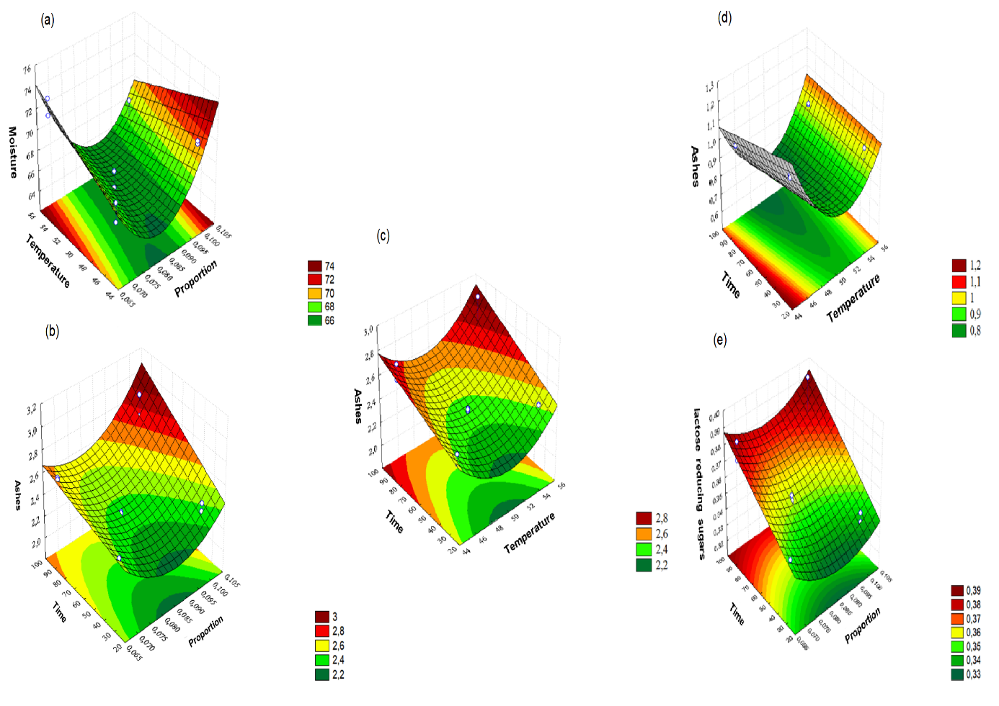
Figure 1: Behavior in response surface of cereal moisture (a), cereal ashes (b) and (c), ashes in milk (d) and reducing sugars in milk (e) during the hydration process.

Table 3 presents the R² values and the models estimated by the response surface. The equations show a good fit of the graphs since they present a correlation coefficient above 0.69 (Silva et al., 2017).

Table 3: Cereal analysis R² values and equations response surface graphs.
 | ANALYZE | INTERACTION | R² | EQUATION
CEREAL | Moisture | Prop. x Temp. | 0.80 | Z = 151.24-2039.48x + 13423.66 * x² + 0.184y
CEREAL | Ashes | Prop. x Time | 0.94 | Z = 7.43-123.85x + 712.71x²-0.005y + 0.13xy
CEREAL |  | Temp. x Time | 0.83 | Z = 21.62-0.78x + 0.01x²-0.002y + 0.00013xy
MILK | Reducing sugars | Prop. x Time | 0.81 | Z = 0,57-5,84x 33,26x²+ 0,0003y 0,003xy
MILK | Reducing sugars | Temp. x Time | 0.94 | Z = 1.19-0.03x + 0.0003x²-0.001y + 0.00003xy
MILK | Ashes | Temp. x Time | 0.98 | Z = 24.82-0.94x + 0.01x²-0.01y+ 0.0002xy

Table 4 shows the parameters models applied to the moisture absorption kinetics at the morning cereal. It is noticed that, in general, there is a decreasement of the C₁ and C₂ Peleg model’s constants with the temperature increasement in the process thus occurring the raise of the equilibrium moisture (U_{eq}). This behavior was also observed on the hydration and beans birdseed studies, respectively (Feijoo et al., 2017; Pramiu et al., 2015). The Peleg model’s constant C₁ is related to the mass transfer ratio and the smaller their values are, greater is the initial water absorption rate and the C₂ constant is related to the capacity of water absorption, and the lower its value, greater is the product’s water absorption (Galdeano et al., 2014).
In the exponential model, the k2 constant is related to the absorption rate. In Table 3 are described k2 values during absorption. It can be seen that at higher temperatures the absorption speed is increased. Similar results are reported in the literature for hydration of transgenic maize, which the authors observed fast water absorption by the grains and the subsequent reduction of this phenomenon approaching equilibrium conditions (Marques and Jorge, Jorge, 2015).
The values of the coefficients of determination (R²), mean relative error (SE) and standard error of estimate (P) for the Peleg and Exponential models adjusted during the cereal hydration, are shown in Table 4. Closest to 100% is the coefficient of determination, smallest is the relative mean error and best is the fit of the model. Thus, the Peleg model presented better results than the Exponential model, since the Peleg model determination coefficient reached 99% and the mean relative error did not exceed 2.58, as well as the standard error of the estimate, was below 10%.

Table 4: Peleg and Exponential models’ parameters applied to the moisture absorption kinetics at morning cereal and statistical indices.
 |  | Peleg |  |  |  |  |  | Exponentia
Prop | T (°C) | R² | SE | P (%) | C1 | C2 | Ueq | R² | SE | P (%) | k2 | Ueq
1/10 | 45 | 0.97 | 1.48 | 4,84 | 0,12 | 0.06 | 21.14 | 0.90 | 2.50 | 15.82 | 22.69 | 20.46
1/10 | 50 | 0,99 | 0.95 | 2.61 | 0.04 | 0.06 | 21.96 | 0.93 | 2.14 | 13.73 | 25.32 | 21.70
1/10 | 55 | 0.97 | 1.85 | 5.91 | 0.12 | 0.05 | 25.23 | 0.92 | 2.81 | 17.29 | 25.09 | 24.2
1 / 12.5 | 45 | 0.97 | 1.33 | 5,46 | -0.02 | 0.07 | 18.86 | 0.89 | 2.32 | 16.54 | 23.62 | 18.93
1 / 12.5 | 50 | 0.97 | 1.32 | 4.83 | 0,20 | 0.06 | 22.07 | 0.90 | 2.52 | 16.29 | 21.76 | 20.89
1 / 12.5 | 55 | 0.97 | 1.58 | 5.16 | -0.03 | 0.06 | 22.62 | 0.92 | 2.51 | 16.23 | 27.34 | 22.82
1/15 | 45 | 0.98 | 1.11 | 4.61 | 0.10 | 0.07 | 19.57 | 0.90 | 2.26 | 15.83 | 21.77 | 19.11
1/15 | 50 | 0.91 | 2.58 | 9.6 | -0.11 | 0.07 | 20.08 | 0.85 | 15.06 | 20.60 | 26.73 | 20.67
1/15 | 55 | 0.94 | 2.12 | 7.19 | -0.12 | 0.06 | 20.65 | 0.88 | 3.07 | 19.74 | 29.45 | 21.71

Figure 2 shows the milk absorption data at the morning cereal through ANN adjustment and compared to the Peleg model (which compared to the exponential model presented a, better fit). The Artificial Neural Network obtained better SE and P values and R² values satisfactory (0.97) and similar to that observed by the Peleg model. This tool has been used by many authors due to their effectiveness on data adjustment and the possibility of joint analysis of input data (independent variables) and output data (dependent variable), presenting the general correlation of all parameters studied (Lima et al., 2016).
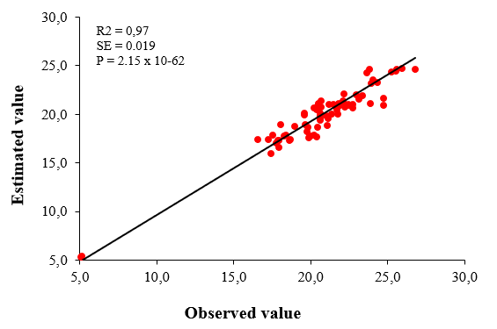
Figure 2: Correspondence between experimental and estimated ANN values for milk absorption at the morning cereal.

In order to define the model that indicates the best fit to the experimental data, were observed the coefficient of determination (R²), the standard error of the estimate and the mean relative error (Reis et al., 2015). Considering these parameters, the neural network presented data adjustment superior to the empirical models abundantly studied in the literature (Vásquez et al., 2018).
  - Conclusions
The treatment conditions used during the cereal hydration kinetics with skimmed and hydrolyzed milk had a significant effect on the characteristics of both cereal and milk during the mass transfer process.
The milk cereal hydration kinetics was satisfactorily explained by the response surface. From the empirical models, Peleg's model was the one that best fit the experimental data. However, the Artificial Neural Network (ANN) presented better adjustments than the Peleg model, representing more satisfactorily mass transfer phenomenon.
References
Balbinoti T. C. V., Jorge L. M. M., Jorge R. M. M., 2018, Mathematical modeling of paddy (Oryza sativa) hydration in different thermal conditions assisted by Raman spectroscopy. Journal of Cereal Science, 79, 390-398.
Binoti D. H. B., Silva M. L. M., Leite H. G., 2014, Configuration of artificial neural networks to estimate the volume of trees. Braz. J. Wood Sci., 5, 58-67.
Borges C. W. C., Jorge L. M. D. M., Jorge R. M. M., 2017, Kinetic modeling and thermodynamic properties of soybean cultivar (BRS257) during hydration process. Journal of Food Process Engineering, 40, 1-8.
Box G. E., Draper N. R.,1987, Empirical model-building and response surfaces (Vol. 424). New York: Wiley.
Brazil. Ministry of Agriculture, Livestock and Supply. Normative Instruction No. 68, of December 12, 2003. It officializes the Official Physical-Chemical Analytical Methods for the control of milk and dairy products. Federative of Brazil, 2003.
Brazil, Secretary Of Health Surveillance. Concierge Nº 29, de 13 de Janeiro de 1998. Approves the Technical Regulation Concerning Foods for Special Purposes, Brasília, DF: Anvisa, 1998. <www.anvisa.gov.br/e-legis/> accessed 12/05/2017.
Campos T. C. Á. S., Almeida W. K., Alegro L. C. A., Roig S. M., Suguimoto H. H., 2015, Use of β-galactosidase in Low-Temperature Milk Lactose Hydrolysis. Journal of Health Sciences, 11, 51-54.
Cox S., Gupta S., Abu-ghannam N., 2012, Effect of Different Rehydration Temperatures on the Moisture, Content of Phenolic Compounds, Antioxidant Capacity and Textural Properties of Edible Irish Brown Seaweed. LWT - Food Science and Technology, 47, 300-307.
Das B., Roy A. P., Bhattacharjee S., Chakraborty S., Bhattacharjee C., 2015, Lactose hydrolysis by β-galactosidase enzyme: optimization using response surface methodology. Ecotoxicology and environmental safety, 121, 244-252.
Feijoo S., González-García S., Lema J. M., Moreira M. T., 2017, Life cycle assessment of β-Galactosidase enzyme production. Journal of Cleaner Production, 165, 204-212.
Fracasso A. F., Perussello C. A., Haminiuk C. W. I., Jorge L. M. M., Jorge R. M. M., 2014, Hydration kinetics of soybeans: Transgenic and conventional cultivars. Journal of Cereal Science, 60, 584–588.
Galdeano M. C., Wilhelm A. E., Grossmann M. V. E., Mali S., 2014, Effect of processing and environmental conditions on the properties of biodegradable oat starch materials. Polímeros: Ciência e Tecnologia, 24, 80-87.
Instituto adolfo lutz (IAL), 2008, Normas Analíticas do Instituto Adolfo Lutz. V. 1: Chemical and physical methods for food analysis, 3. ed. São Paulo: IMESP.
Lima M. A., Ferreira G. G., Oliveira L. L. C., Silva R. F., Diniz C. B. F., 2016, Use of artificial neural networks (rna) of the multilayer perceptrons (mlp) type modified with parallel statistical processing to study the classification problem of red wine origin. Revista Brasileira de Agropecuária Sustentável (RBAS), 6, 58-65.
Marques B. C., Jorge L. M. M., Jorge R. M. M., 2015, Hydration kinetics and release of soluble solids from genetically modified maize and its isoline. Blucher Chemical Engineering Proceedings, 1, 2958-2965.
Peleg M., 1988, An empirical model for the description of moisture sorption curves. Journal of Food Engineering, 52, 1216-1219.
Pramiu P.V., Rizzi R.L., Prado N.V., Coelho S.R.M., Bassinello P.Z., 2015, Numerical modeling of chickpea (Cicer arietinum) hydration: The effects of temperature and low pressure, Journal of Food Engineering, 165, 112-123.
Reis D. R. D., Santos, P. D., Silva, F. S. D., Porto, A. G., 2015, Influence of air characteristics on drying kinetics of beak pepper. Brazilian Journal of Food Technology, 18, 146-154.
Silva A. R. A., Bezerra F. M. L., Lacerda C. F., Sousa C. H. C., Chagas K. L., 2017, Photosynthetic pigments and leaf water potential in young coconut plants under water and saline stress. Revista Agro@ mbiente On-line, 10, 317-325.
Siqueira A. P. S., Silva T., Amorim F., Pereira T., Santos J., Lourenço M. F., 2018, Technological use of corn pericarp for the production of snacks. Agrarian, 11, 79-88.
Somavilla M., Oliveira V. R., Storck C. R., 2016, Centesimal and mineral composition in the freezing and associated use of microwave for bean thawing. Disciplinarum Scientia| Saúde, 12, 103-114.
Brazilian Food Composition Table - TACO. 4th edition revised and expanded. UNICAMP- Campinas – SP – 2011.
Vásquez N., Magán C., Oblitas J., Chuquizuta T., Avila-George H., Castro W., 2018, Comparison between artificial neural network and partial least squares regression models for hardness modeling during the ripening process of Swiss-type cheese using spectral profiles. Journal of Food Engineering, 219, 8-15.

