BIONICO Project – A Case Study of
Chemical Reactors Development & Prototyping at ICI Caldaie.
Carlo Tregambe
ICI Caldaie S.p.A. via G.Pascoli 38 , 37059 Campagnola di Zevio (VR) Italy
*Corresponding author: carlo.tregambe@icicaldaie.com
Highlights
- Reactors development and prototyping
- Industrialization: from lab scale (TRL 4) to turnkey transportable reactors (TRL 9)
- Complete system integration and testing

1. Introduction
In the H2020 BIONICO project, a novel reactor concept that integrate H2 production and separation in a single vessel is been built by ICI Caldaie and will be demonstrated at TRL 6 at a real biogas plant, with a H2 production capacity of 100 kg/day. Main characteristics of the novel reactor are the utilization of fluidized bed catalyst for reforming reaction and Pd based membrane for pure H2 separation.
2. Methods
Synergies and deep cooperation between project partners were essential for the obtainment of the results.
Politecnico di Milano (coordinator): modelling and optimization of the innovative fuel processor - TECNALIA: Development of Pd-based supported membranes and membrane characterization - Eindhoven Unversity of Technology: Design, construction and testing of the lab scale membrane reformer - Johnson Matthey: development, characterization and testing of novel fluidizable reforming catalysts - ICI Caldaie: design, manufacturing and integration of the novel reactor at full size - Quantis: research on adapting environmental life cycle assessment (LCA) - Rauschert: Development of ceramic porous supports for the membranes - ENC POWER: field testing of the novel reactor in the ENC biogas plant.

3. Results and discussion
The activity of ICI Caldaie started 60 years ago in the business of high temperature and high pressure boilers (up to 950°C and 50 bar).
In the early 2000’ ICI Caldaie became aware that chemical reactors were the proper and natural way to exploit the high level reached by its R&D department and started a dedicated laboratory called “ICI LAB”.
Since the beginning of the activity “ICI LAB” created synergies between its academic partners and the industrial department of ICI CALDAIE, becoming a player able to have an holistic approach to the reactors business, starting from joint design solutions, through feasibility studies and up to the manufacturing, industrialization and integration of the reactors. Partnerships with universities, research centers and other industries all over the world have led to many projects (Internal 1, National 2,3, European 4,5) focused on the realization of chemical reactors and its integration in complex systems like CHP and production plant.
The first field of application was identified in the onsite hydrogen production from natural gas and Bio gas. Different reactors for hydrogen production were developed according to different sizes (from 3 to 50 Nm3/h) and different grades of purity for different hydrogen applications.
Together with hydrogen production and purification, the experience and knowhow acquired so far range from “CO2 capture and sequestration”, “gas to liquid reactors” to several other systems
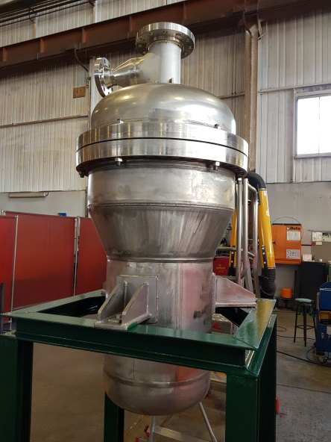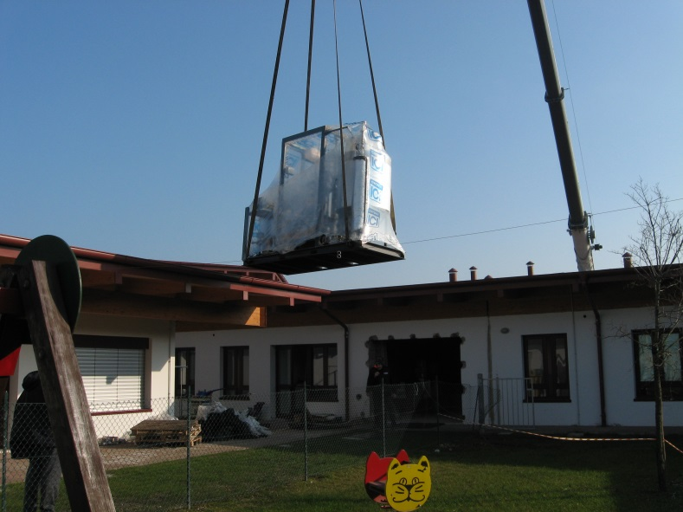
Figure 1. BIONICO membrane reactor Figure 2. Installation of H2FC cogeneration system prototype

4. Conclusions
Thanks to ICI manufacturing capability and proven ability of good knowledge transfer between industry and university, ICI is now screening new markets in reactor manufacturing business.
References
- Sidera30 – (http://www.icicaldaie.com/sidera-30.asp)
- Microgen30 – (Progetto EE01_00013 – Bando Efficienza Energetica – Decreto di concessione D.M. n° 00019EE01 del 26/05/2011) - (http://www.h2it.org/it/2009/industria-2015-progetto-microgen-30)
- STAR – (Prot. CCSE n° 4609 del 03/07/2009 – Decreto MISE del 16/02/2010) – (http://www.icicaldaie.com/progetti.asp)
- CISTEM - (FCH JU, Grant number 325262) – (http://www.project-cistem.eu/)
- BIONICO - (FCH2 JU, Grant number 671459) – (http://www.bionicoproject.eu/)

