**Generic Model-based Framework for Predictive Particle Monitoring using Advanced Image Analysis and Deep Learning**

Rasmus Fjordbak Nielsen1, Krist V. Gernaey1, Seyed Soheil Mansouri1

*1Process and Systems Engineering Centre (PROSYS), Department of Chemical and Biochemical Engineering, Technical University of Denmark, Sølvtofts Plads, Building 229, DK-2800 Kgs. Lyngby, Denmark*

*\*Corresponding author: seso@kt.dtu.dk*

**Highlights**

* Generic modeling framework for particle processes using real time imaging
* Using raw images and deep neural network to estimate particle birth/growth rates
* Estimating particle size distribution measurement uncertainty
* Including measurement uncertainty to enhance model robustness

**1. Introduction**

Particle processes has gained significant importance in chemical and biochemical engineering in the last two decades. Especially within fermentation, flocculation, crystallization, there has been an increased industrial focus on optimizing and enhancing controllability of these processes. At the same time, both optics and image-analysis algorithms have improved significantly. It is now possible to analyze sample particle populations in real-time. This can be done by automatically sampling particle suspensions from the production tank to a mono-layer lab-on-a-chip device, where microscopy images are taken and analyzed using automatized advanced image analysis.

In this work, a deep neural network is used to estimate the birth and growth rates of the given particle process in real-time. Here we use the raw image, the results from the image analysis, and the measured and controlled process variables as inputs. When using deep neural networks, there is a greater risk of overfitting [1]. To accommodate this, it has previously been suggested to add random noise to the input data [2]. Here we utilize the prior knowledge on the inherent sampling error from the image analysis, and show how it is possible to reduce the risk of overfitting the neural network model. At the same time, we also account for the measurement uncertainty already during the model generation.

**2. Methods**

The suggested model structure can be seen in Figure 1. The network consists of a range of dense neural network layers, one generic population balance model and a loss function. Here we evaluate the performance of the model by calculating the mean absolute error (MAE) of the predicted relative size distribution. By adding Gaussian, zero-mean, random noise to the size-distribution data during training, with the same standard deviance as the known sampling error of the image analysis, the risk of overfitting can be reduced. At the same time, the uncertainties of the measurements are included in the process model during model generation, resulting in a more robust model. This will work for even crude errors, as long as the measurement uncertainty is correctly estimated.



Figure 1. Modelling structure, where y represents measured and controlled variables. The time-derivative data of y is only supplied for controlled variables. The number based particle size distribution is abbreviated as PSD.

The sampling error of image analysis is here be estimated by assuming a random and unbiased sampling, where total sample size $\sum_{i}{N_{i}}$ (number of particles detected on the image) is much smaller than the total number of particles in process tank [3]: $σ=\sqrt{N_{i}∙\left(1-N_{i}/\sum_{i}{N_{i}}\right)}$

**3. Results and discussion**

**Figure 2.** Training error (left) and validation error (right). ● Without noise ● Random noise ● Measurement specific noise

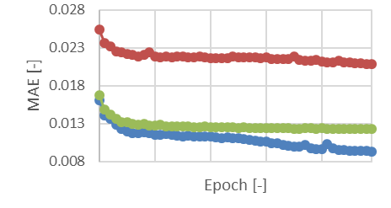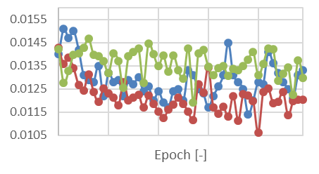

By applying the presented framework on a case study of lactose crystallization, where the temperature is the only measured and controlled process variable, it is here shown that the generated model is able to predict the evolution of the crystal size-distribution with high precision. As can be seen in Figure 2, by adding measurement-specific noise, compared to no noise addition and random noise, the model precision is increased. Furthermore, the tendency to overfitting is also shown to be reduced.

**4. Conclusions**

With the presented framework, it is shown possible to model a particle process using advanced image analysis and deep learning, giving accurate predictions of the size-distribution evolution. Here, the image analysis uncertainty is already taken into account during model training, showing to give even better predictions.

**References**

1. X. Meng, C. Liu, Z. Zhang, D. Wang, IEEE ChinaSIP, 16-20, 2014
2. Y. Grandvalet, S. Canu, IEEE Trans Syst Man Cybern 25 (4) 678–681, 1995
3. S. Singh, Advanced Sampling Theory with Applications, Springer 71-136, 2003