Root cause diagnosis of multiple process faults: Integrating pattern matching with active simulation
Weijun Li¹, Xiangping Zhang², Sai Gu¹, Tao Chen¹*
¹ Department of Chemical and Process Engineering, University of Surrey, Guildford GU2 7XH, United Kingdom; ² Beijing Key Laboratory of Ionic Liquids Clean Process, Institute of Process Engineering, Chinese Academy of Sciences, Beijing 100190, China
*Corresponding author: t.chen@surrey.ac.uk
Highlights
- A novel and effective framework for root cause diagnosis.
- Applicable to both single fault and multiple faults.
- Integrating mechanistic model, pattern matching and optimisation.

1. Introduction
With increasing demand on process safety, fault detection and diagnosis (FDD) has attracted considerable attentions [1]. Despite the significant success in fault detection and isolation, root cause analysis remains a challenge for data-driven methods [2]. On the other hand, dynamic process simulations, based on mechanistic models, encapsulate a large amount of process knowledge especially the causal information, thus could be an effective tool in root cause diagnosis. Although hybrid mechanistic-empirical modelling is well known, its application in FDD for medium-to-large scale industrial processes has not been well explored. In this work, a generic root cause analysis method applicable to both single and multiple faults is developed by use of mechanistic model and pattern matching technique. Case study with the Tennessee Eastman (TE) process [3] is conducted to demonstrate its effectiveness, and the current limitations and potential solutions are discussed.
2. Methods
Figure 1. Flowchart of the proposed root cause analysis method.
The proposed strategy is summarised in Figure 1. Firstly, a fault database is built by simulating process faults at different magnitudes offline. Then, the operational data sample is compared with the database to screen fault candidates. From the candidates, the root cause is further confirmed by use of an optimisation based fault reconstruction method, in which a multi-objective optimisaiton algorithm (NSGA-II: Non-dominated Sorting Generic Algorithm II [4]) is used to search for the root cause of the fault based on pattern matching [5] and process simulations. Two similarity metrics are employed in the pattern matching, i.e. PCA similarity (Spca) and Mahalanobis distance similarity (Sdist). Spca measures the similarity between datasets by relative angles between their principle components while Sdist by the distance between their centers.
3. Results and discussion
Figure 2(a) and 2(b) show the results in diagnosing single fault (caused by IDV1) and multiple faults (caused by IDV1+IDV7), respectively, in which IDV indicates the disturbances as described in [3]. Similarities (Spca and Sdist) displayed in Figure 2 represent the average values over individuals at each iterations in the optimisation. Figure 2(a) successfully identifies IDV1 as root cause of the single fault due to its much improved similarity values after optimisation. In Figure 2(b), the similarities of all the candidates are still low (symbols connected by solid line) after optimisation. Considering multiple faults scenario, we further evaluate candidate combinations and identify IDV1+IDV7 (the red dotted line) as the root cause due to its much improved similarities.
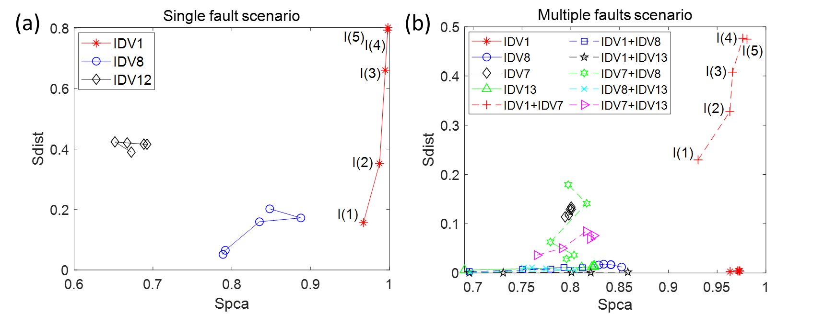
Figure 2 Similarity of candidates after fault reconstruction; I(i) indicates the i-th iteration during the optimisation.
4. Conclusions
This work proposes a novel root cause diagnosis method and demonstrated its effectiveness with the TE process. It is worthy to note its effectiveness depends largely on two aspect: 1) real-time model update technique to lessen model-plant mismatch; 2) pattern matching method effectively extracts similar features between operational and simulated dataset.
Acknowledgement
This work has been partially supported by the UK EPSRC (EP/R001588/1), BBSRC (BB/S020896/1), and the Unilever-IPE-Surrey collaborative doctoral training (CDT) programme.
References
- B. He, J. Zhang, T. Chen, and X. Yang, Ind. Eng. Chem. Res. 52 (2013) 7784-7794.
- B. He, T. Chen, and X. Yang, Comput. Chem. Eng. 64 (2014) 167–177.
- J. Downs and E. Vogel, Comput. Chem. Eng. 3 (1993) 245–255.
- K. Deb, A. Pratap, S. Agarwal, and T. Meyarivan, IEEE T. Evolut. Comput. 6 (2002) 182-197.
- A. Singhal and D. Seborg, IEEE control systems 22 (2002) 53-63.

