Chemically enhanced bitumen and road pavements of the future
Pilar Cabanillas^{1*}, María González², Vicente Pérez², Carlos Prieto¹, Juana Frontela¹
¹ CEPSA Research Centre. Avda. Puntocom 1, 28805. Alcalá de Henares (Spain)
² CEPSA Comercial Petróleo. Ctra. Daganzo km 5.5. 28806. Alcalá de Henares (Spain)
*pilar.cabanillas@cepsa.com
Highlights
- A new generation of improved bituminous binders for paving solutions is being developed.
- Sustainability by developing long lasting materials with outstanding performance.
- Chemical modification of the base bitumen with additives is key to the project.

1. Introduction
The world is growing at a fast pace, a fact with great impact on the use of transport infrastructures and its weathering: more vehicles, heavy transports, roads with poor maintenance, climate change, etc.
Long-lasting pavements are currently a need for the higher demands of society, for the emerging economies where sustainability is a key factor to guarantee continuous growth. During the last decade, environmental aspects such as “life cycle inventory” or “carbon footprint” have gained importance and they have become familiar concepts to both the industry and the society. Therefore, improving durability of structures has become a goal for the paving industry [1, 2, 3].
In this work two strategies towards increasing sustainability of pavements have been studied, both of them focused in the bituminous binder. First, increasing the pavement durability by tuning the composition of bitumen in order to minimize the impact of aging processes and maximize the service life of pavements. Second, incorporating additives from either natural renewable sources or waste materials from other industries with the ability of restoring the damage resulting from aging phenomena (rejuvenating) or preventing it.
2. Methods
A set of model bitumen with different chemical compositions was produced using two different industrial processes (straight run and mild oxidation process) both at pilot and industrial scale. The materials obtained were fully analyzed according the current European Standard (EN 12591) and its chemical composition was determined by Iatroscan analysis (SARA).The materials were aged using two standardized aging methods: Rolling Thin Film Oven Test (which mimics the aging experienced by the binder during preparation of the asphalt mix) and Pressure Aging Vessel (mimicking aging after 10-20 years’ service life). Dynamic shear and bending beam rheological measurements (DSR and BBR respectively) of the materials at different aging stages were used to determine the binder with best performance when aged (and therefore highest durability). Also Iatroscan analysis was performed in order to determine the chemical structure of the aged bitumen showing the best performance.
The highest performance binder was further chemically modified with additives from renewable sources with antioxidant or rejuvenator effect in order to yield a family of novel binders with improved lifespan and a novel eco dimension. These binders were also fully characterized, aged and rheologically tested in order to characterize its performance and suitability as paving grade binders.
3. Results and discussion
In this work it has been observed that the chemical parameter colloidal instability index of bitumen (defined as the ratio between the asphaltene + saturates and aromatics+resins fractions) is related with the performance if the material in in terms of fatigue (see figure 1). Tuning the manufacturing processes and the origin of the crude oil raw material makes possible obtaining high durability binders. Once the best performance bitumen is selected, its performance during service life was further improved by incorporating vegetal rejuvenators and antioxidants.
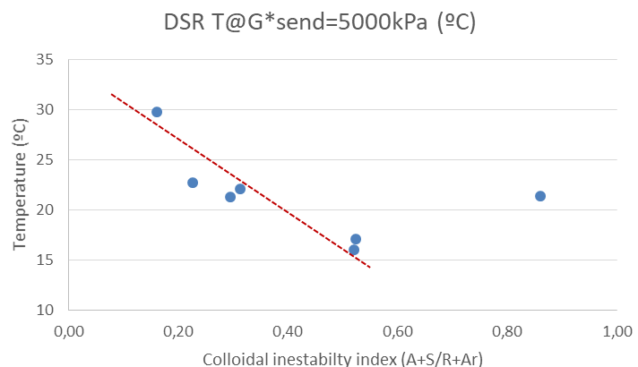

Figure 1. Dependence of fatigue resistance of bitumen on colloidal instability index
4. Conclusions
Improved durability bitumen materials have been manufactured on the basis of physical-chemical parameters. Different types of chemical additives from renewable sources have been assessed in order to improve the long term performance of the asphalt binder.
References
- Lu, X.; Talon, Y.; Redelius, P. (2008). 4th Eurasphalt Eurobitume Congress.
- Cortes, C.; Perez, A.; Fermoso, J.; Costa, A.; Guisado, F.; Esquena, J.; Potti, J.J.. (2010). V Jornada Nacional de ASEFMA, Madrid (Spain)
- Apeagyei, A. K. (2011). Construction and Building Materials 25(1), pp. 47–53.

