Hierarchical and non-hierarchical HZSM5 based catalysts for selective alkylation and hydrogenation of guaiacols in Kraft lignin derived bio-oil.
Ashutosh Agarwal¹, Masud Rana¹, Seong-Jae Park¹, Jeong-Hun Park¹*
1 Department of Environment and Energy Engineering, Chonnam National University, Gwangju 61186, Republic of Korea
*Corresponding author: parkjeo1@jnu.ac.kr
Highlights
- Ni and/or Zn impregnated HZSM5 significantly enhanced the formation of alkylated guaiacols
- Hydrogenation was favored over hierarchical catalysts
- Deoxygenation was favored over non-hierarchical catalysts

1. Introduction
Diminishing fossil fuels and increasing energy demand have sparked immense interest in the utilization of biomass as renewable resource for biofuel production . Partly replacing fossil fuels with upgraded bio-oil would be an alternative approach to accomplish reduction in massive consumption of fossil fuels. Lignin is often preferred as renewable feedstock for the production of bio-oil due to its low cost and ease of availability . Among various types of lignin, Kraft lignin is essentially used for the production of bio-oil via thermochemical conversion. Due to low heating value and high instability derived from oxygenated compounds, upgrading of bio-oil becomes inevitable .
Bio-oil upgrading normally occurs via three main mechanisms, which involves hydrogenation, hydrodeoxygenation and alkylation. Catalyst employed during bio-oil upgrading chiefly governs the quality and cost of upgraded bio-oil . Noble metal catalysts such as Pd/C, Pt/C and Ru/C which holds high potential for hydrodeoxygenation activates towards bio-oil upgrading remains unpreferred for industrial applications due to high cost and scarcity . Besides this, traditional sulfur based catalysts are also not employed for bio-oil upgrading as they tend to deactivate the catalyst leading to the formation of coke . Non-noble metal catalysts such as Ni and Zn have recently been attracting great attention for hydrodeoxygenation of bio-oil due to their high activity and low cost . Ni metal catalyst activates hydrogen and drastically prohibits the polymerization of unsaturated hydrocarbons while Zn enhances catalytic performance of zeolites during bio-oil upgrading process. Metal catalysts are often incorporated in support material such as zeolite in order to avoid agglomeration of metal catalysts that helps in enhancing their catalytic activity. HZSM5 has been widely used as support material for incorporation of metal catalysts due to its high thermal stability, porous structure, controllable acidity and ability to accomplish hydrodeoxygenation and alkylation . Besides this, HZSM5 zeolite have been known for its ability to convert heavier components of bio-crude into smaller fuel range fractions . Mesoporosity in zeolites enhances production of aromatic compounds enriched biofuel by promoting easy diffusion of hydrocarbons to acid sites . Further, incorporation of active metal species onto zeolite support improves catalytic activity by promoting hydrogenation of oxygenated compounds .
Generally, the size, dimensionality of zeolite channels and its acidity plays vital role in governing the activity and selectivity of HZSM5 for organic reactions. Incorporation of secondary porosity at mesoscale in hierarchical HZSM5 acts as molecular sieves which favors fast mass transport . In this research, we compared the catalytic performances of hierarchical and non-hierarchical Ni and/or Zn/HZSM5 catalyst at different Ni and/or Zn loading ratios for bio-oil upgrading. Several analytical techniques such as FE-SEM, EDS, XPS, ICP-OES, XRD and N₂ adsorption-desorption isotherms were used for catalyst characterization. The catalytic activity of synthesized catalysts was compared with Ru/C catalyst.
2. Methods
20 g Kraft lignin (Sigma-Aldrich) dissolved in 200 ml ethanol was hydrothermally depolymerized to raw bio-oil in a 300 ml batch reactor (model: Hastelloy-C-276 HR-8300). The reactor was purged with high purity N₂ gas to create inert atmosphere. 1 MPa N₂ pressure was created inside the reactor before heating it up to 300 ℃. A constant 300 ℃ was maintained for 1 h while stirring the reactor at a speed of 250 rpm. After the reaction was completed, the reactor was cooled instantaneously to room temperature using an ice-water bath.
Ni and/or Zn non-hierarchical and hierarchical HZSM5 catalysts were synthesized by loading different mass ratios of Ni and/or Zn over commercial non-hierarchical HZSM5 (P-38 type, ACS materials USA) and synthesized hierarchical HZSM5 respectively. Catalysts were designated as 20Ni-HZSM5, 15Ni5Zn-HZSM5, 10Ni10Zn-HZSM5, 5Ni15Zn-HZSM5 and 20Zn-HZSM5. Number denotes respective percentage weight loading of metal. In brief, stock aqueous solutions of ZnCl₂ (0.76 M) and Ni(NO₃)₂.6H₂O (0.85 M) were used to impregnate HZSM5 at room temperature (25 ℃) for 3 h. Samples were then dried in an over at 120 ℃ for 10 h followed by calcination in air at 550 ℃ for 5 h. The catalysts were then grinded to powder with a mortar and pestle and sieved with 100 mesh sieve.
Hierarchical mesoporous HZSM5 was synthesized by mixing 15 g commercial non-hierarchical HZSM5 with 150 ml aqueous solution of NaOH (0.4 M) at 70 ℃ for 2 h. The sample was then filtered and washed with deionized water and dried in an oven at 100 ℃ for 24 h. The product thus obtained was protonated by refluxing with 150 ml NH₄NO₃ (0.2 M) at 80 ℃ for 24 h and then dried in an over at 100 ℃ for 12 h followed by calcination in air at 550 ℃ for 5 h. Different mass ratios of Ni and Zn were loaded on HZSM5 support following the wet impregnation method as described earlier.
3D high resolution X-ray diffractometer (PANalytical EMPYREAN) was used to record XRD patterns using Cu Kα radiation (λ=1.5406 Å) at a scan speed of 0.417° min⁻¹ and following a step size of 0.02° (2θ). XRD patterns were not used for quantitative study.
Surface area and pore size of the synthesized catalysts were evaluated by employing BET equation and BJH method, respectively from the nitrogen adsorption-desorption isotherms recorded at -196 ℃ using BELCAT-A instrument. Total pore volume of the catalysts were evaluated at a relative pressure of P/P_{O} = 0.990. ICP-OES (PerkinElmer Optima 8300, US) was used to estimate Ni and Zn contents in the synthesized hierarchical and non-hierarchical catalysts.
FESEM of the catalysts was recorded on JSM-7500F FE-SEM at a magnification of 20 K X and EHT = 15 kV. All the samples were coated with Pt before analysis to inhibit sample charging. XPS of the catalysts were recorded on Perkin-Elmer PHI-1600 spectrometer using Mg Kα monochromatic radiation.
GC-6890 system equipped with HP-5MS column was used to determine the chemical compositions of bio-oil samples. HPLC grade ethanol was used as solvent to dissolve the bio-oil samples prior to GC-MS analysis. Helium was used a carrier gas at a flow rate of 1 ml min⁻¹. Injection and oven temperatures were set at 280 and 40 ℃ respectively. Holding time was set at 2 min between two ramps to 170 and 300 ℃ at a heating rate of 5 ℃. The ratio of peak area of compounds as appeared in the chromatogram to the total peak area was used to evaluate the relative content of compounds.
Higher heating values (HHV) of the bio-oil were estimated using Boie’s formula employing an elemental analyzer (CHNS) by vario MARCO cube/elementar (Germany).
HHV_{Boie} (MJ/kg) = 0.3516C + 1.16225H – 0.1109O + 0.0628N + 0.10465S
Where C, H, O, N and S represents respective percentages of the elements. High value of HHV indicates better quality of bio-fuel.
150 ml batch reactor (Hasterlloy-C-276 HR-8300) equipped with a stirrer was used for bio-oil upgrading experiments. Reaction mixture was prepared by dissolving 3 g bio-oil in 50 ml ethanol followed by addition of 300 mg catalysts. H₂ was purged into the reactor to remove air and then H₂ pressure of 1 MPa was maintained inside the reactor at room temperature. The system was then heated to 300 ℃ at a heating rate of 5 ℃ min⁻¹. The reactor was maintained at 300 ℃ for 1 h at a constant stirring speed of 250 rpm. Upon completion of the reaction, the upgraded bio-oil was separated from coke by filtration and the residual coke was washed several times with ethanol to extract light bio-oil. Coke deposited catalyst was washed with acetone to collect tar deposited on the catalyst. Coke deposited catalyst was dried overnight in an oven at 110 ℃. Ethanol and acetone solvents were removed from the upgraded bio-oil and tar by evaporation under reduced pressure in a rotatory evaporator at 55 ℃ and 40 ℃ respectively. Following equations were used to calculate the yields of upgraded bio-oil, coke, tar and gas formation.
Upgraded bio-oil = (upgraded bio-oil (g)/3.0 (g)) x 100%
Coke = (((weight of coke deposited catalyst (g) – 0.3 (g))/3.0 (g)) x 100%
Tar = ((weight of tar (g))/3.0 (g)) x 100%
Gas formation = ((3.0 (g) – (upgraded bio-oil (g) + coke (g) + tar (g)))/3.0 (g)) x 100%
3. Results and discussion
XRD patterns of hierarchical and non-hierarchical HZSM5 based catalysts are shown in Figures 1a and 1b, respectively. Typical diffraction peaks of HZSM5 are clearly visible in the range of 2θ = 23-25° . HZSM5 framework was found to remain intact even after Ni and/or Zn loading. Upon metal loading typical peaks intensity of HZSM5 increased in case of non-hierarchical HZSM5 suggesting increase in crystallinity. Diffraction peaks of NiO particles are clearly visible at 37.40°, 43.45° and 62.95° which corresponds to (111), (200), (220) crystal planes , respectively (JCPDS 73-1523). The peak intensities vary according to the mass percentage loading of Ni in HZSM5 catalysts. ZnO diffraction peaks are visible at 31.7°, 34.3° and 36.2° corresponding to (100), (002) and (101) crystal planes , respectively (JCPDS 36-1451) in case of 20 wt% Zn loaded hierarchical and non-hierarchical catalysts. In other catalysts, due to high dispersion of Zn over both hierarchical and non-hierarchical HZSM5, no diffraction peaks of ZnO were obtained. This was confirmed by FE-SEM analysis.
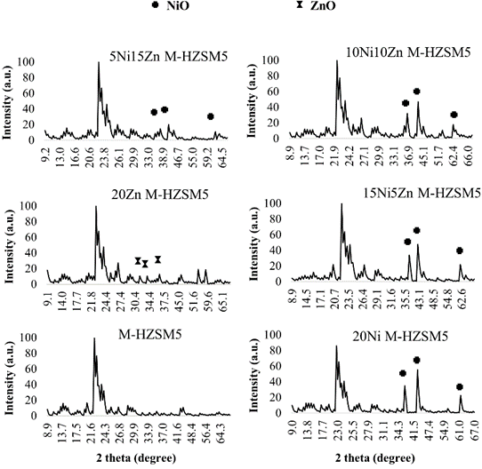
Figure 1a. XRD profiles of hierarchical HZSM5 based catalysts.
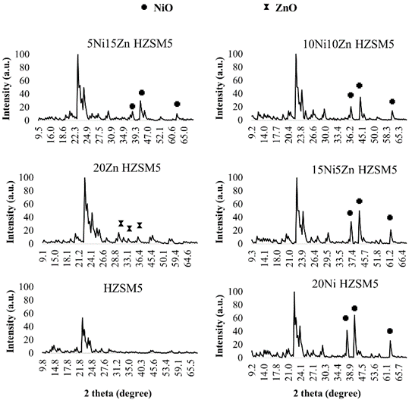
Figure 1b. XRD profiles of non-hierarchical HZSM5 based catalysts.
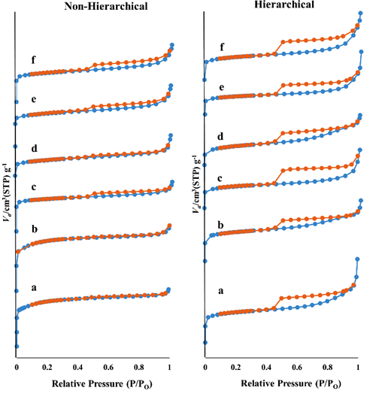
Figure 2. N₂ adsorption-desorption profiles of hierarchical and non-hierarchical Ni and/or Zn loaded HZSM-5 catalysts (a) HZSM5, (b) 20Ni-HZSM5, (c) 20Zn-HZSM5, (d) 15Ni5Zn-HZSM5, (e) 10Ni10Zn-HZSM5, (f) 5Ni15Zn-HZSM5.

Table 1. Textural Properties of hierarchical and non-hierarchical Ni and/or Zn loaded HZSM-5 catalysts.
Catalyst | S_{BET} (m²/g) | Average pore size (nm) | Pore Volume (cm³/g)
 |  |  | Total | Mesopores | Micropores
Non-Hierarchical
HZSM5 | 407.4 | 2.0 | 0.21 | 0.02 | 0.19
20Zn-HZSM5 | 240.0 | 2.0 | 0.12 | 0.02 | 0.10
20Ni-HZSM5 | 299.3 | 2.2 | 0.16 | 0.03 | 0.13
15Ni5Zn-HZSM5 | 245.8 | 2.2 | 0.13 | 0.03 | 0.10
5Ni15Zn-HZSM5 | 230.8 | 2.5 | 0.14 | 0.05 | 0.09
10Ni10Zn-HZSM5 | 236.3 | 2.3 | 0.14 | 0.04 | 0.10
Hierarchical
HZSM5 | 231.9 | 3.0 | 0.17 | 0.10 | 0.07
20Zn-HZSM5 | 184.7 | 3.0 | 0.14 | 0.07 | 0.07
20Ni-HZSM5 | 266.5 | 2.6 | 0.18 | 0.09 | 0.09
15Ni5Zn-HZSM5 | 313.9 | 2.6 | 0.21 | 0.11 | 0.10
5Ni15Zn-HZSM5 | 203.9 | 3.2 | 0.17 | 0.09 | 0.08
10Ni10Zn-HZSM5 | 189.5 | 3.3 | 0.16 | 0.09 | 0.07

Figure 2 shows the N₂ adsorption-desorption isotherms of the synthesized catalysts. All the catalysts exhibited type VI isotherms as per IUPAC classification. The presence of hysteresis loop in case of hierarchical HZSM5 catalysts indicates the formation of mesoporous structure with narrow slit-like pores (secondary pores) . Table 1 lists the textural properties of hierarchical and non-hierarchical Ni and/or Zn loaded HZSM5 catalysts. In comparison with bare HZSM5 catalyst, the BET specific surface area and pore volume of metal loaded hierarchical and non-hierarchical HZSM5 catalysts decreased in all cases due to deposition of NiO and ZnO particles in the pores of HZSM5 . In addition, increase in pores size suggests enlargement of HZSM5 pores upon deposition of metal oxide . The shape of isotherms remained unchanged in case of hierarchical monometallic and bimetallic HZSM5 catalysts revealing the presence of still open mesopores on the outer surface of the catalysts.
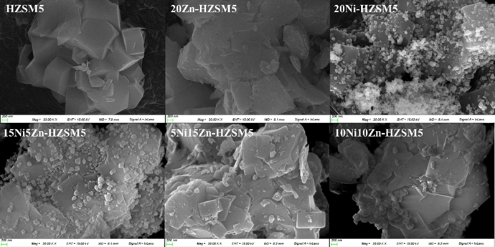

Figure 3a. FE-SEM images of non-hierarchical Ni and/or Zn-HZSM5 catalysts.

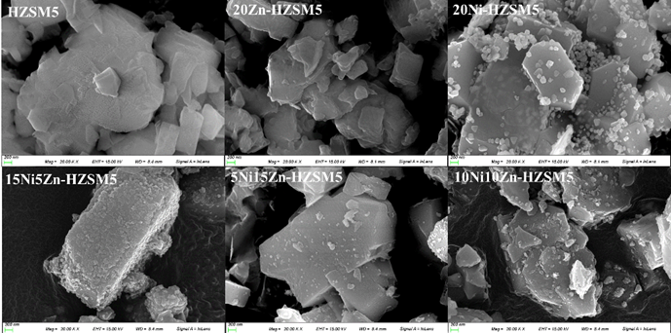

Figure 3b. FE-SEM images of hierarchical Ni and/or Zn-HZSM5 catalysts.
FE-SEM micrographs of Ni and/or Zn loaded non-hierarchical and hierarchical HZSM5 are shown in Figures. 3a and 3b, respectively. Bare HZSM5 showed typical orthogonal crystal shape while all other catalysts consisted of agglomerate particles. ZnO was found to highly disperse over HZSM5 surface while NiO particles formed loose agglomerates resulting in high surface area of Ni loaded HZSM5 compared to other catalysts.
Chemical compositions of Si and Al as obtained from EDS analysis are shown in Table 2. BET characterization suggests desilication of non-hierarchical HZSM5 catalysts with 0.4 M NaOH resulting in decrease in surface area from 407.36 to 231.93 m²/g and increase in average pore size from 1.98 to 2.99 nm.
Table 2. Chemical compositions of Si and Al for bare hierarchical and non-hierarchical HZSM5 as obtained from EDS.
Catalyst | Si content (wt.%) | Al content (wt.%) | Si/Al
Non-hierarchical HZSM5 | 48.93 | 2.33 | 21.00
Hierarchical HZSM5 | 40.01 | 2.45 | 16.33

Catalysts  Non-Hierarchical | HZSM5 | 20Zn-HZSM5 | 20Ni-HZSM5 | 15Ni5Zn-HZSM5 | 5Ni15Zn-HZSM5 | 10Ni10Zn-HZSM5
Ni content (wt.%) | 0 | 0 | 18.77 | 14.67 | 4.54 | 9.68
Zn content (wt.%) | 0 | 18.65 | 0 | 4.74 | 14.71 | 9.81
Catalysts  Hierarchical | HZSM5 | 20Zn-HZSM5 | 20Ni-HZSM5 | 15Ni5Zn-HZSM5 | 5Ni15Zn-HZSM5 | 10Ni10Zn-HZSM5
Ni content (wt.%) | 0 | 0 | 18.72 | 14.69 | 4.57 | 9.83
Zn content (wt.%) | 0 | 18.73 | 0 | 4.79 | 14.78 | 9.79
Table 3. Actual metal contents of synthesized hierarchical and non-hierarchical Ni and/or Zn-HZSM5 catalysts.

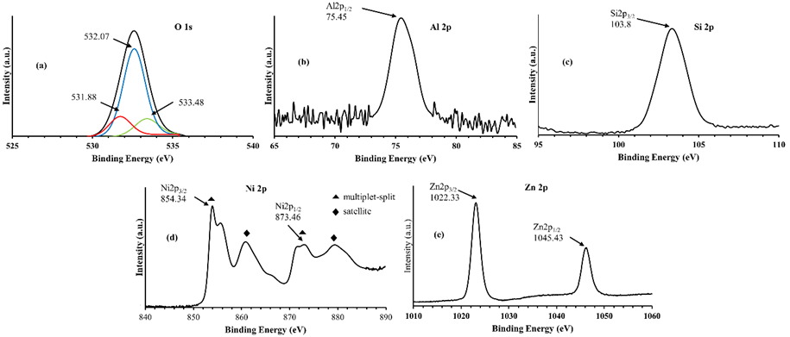

Figure 4. X-ray photoelectron spectrums of (a) O (1s), (b) Al (2p), (c) Si (2p), (d) Ni (2p) and (e) Zn (2p) for non-hierarchical 5Ni15Zn-HZSM5 catalyst.
Inductively coupled plasma-optical emission spectroscopy (ICP-OES) was used to estimate Ni and Zn contents of the synthesized catalysts following the aqua regia method. Table 3 shows the actual contents of Ni and Zn in various synthesized catalysts as obtained via ICP-OES analysis. Due to non-uniform distribution of metals over HZSM5 catalysts, Ni and Zn contents were found to be little lower than calculated values .

Table 4. Yields of major compounds (by relative % peak area) obtained upon bio-oil upgrading over hierarchical HZSM5 based catalysts.
Groups | Compound Name | Stock  Bio-oil | Upgraded Bio-oil With Catalysts
Groups | Compound Name | Stock  Bio-oil | HZSM5 | 10Ni10Zn-HZSM5 | 20Ni-HZSM5 | 15Ni5Zn-HZSM5 | 20Zn-HZSM5 | 5Ni15Zn-HZSM5 | Ru/C
Guaiacol | 2-Methoxyphenol | 16.15 | 13.37 | 14.57 | 13.85 | 14.97 | 16.13 | 14.19 | 11.74
Alkyl Guaiacol | 4-Methylguaiacol | 14.02 | 12.88 | 14.08 | 13.65 | 13.41 | 15.08 | 13.87 | 11.75
Alkyl Guaiacol | 4-Ethylguaiacol | 15.72 | 16.70 | 17.08 | 17.81 | 19.15 | 18.51 | 18.32 | 18.70
Alkyl Guaiacol | 4-Propylguaiacol | 11.18 | 16.70 | 17.86 | 18.45 | 17.84 | 18.06 | 17.43 | 27.52
Alkyl Guaiacol | Total | 40.92 | 46.28 | 49.02 | 49.91 | 50.40 | 51.65 | 49.62 | 57.97
Alkenyl Guaiacol | 4-(2-propenyl)guaiacol | - | - | - | - | - | - | - | -
Alkenyl Guaiacol | 4-(1-propenyl)guaiacol | 11.90 | 4.42 | 4.54 | 4.77 | 4.67 | 4.37 | 4.18 | 2.22
Alkenyl Guaiacol | Total | 11.90 | 4.42 | 4.54 | 4.77 | 4.67 | 4.37 | 4.18 | 2.22
Alkoxyalkyl Guaiacol | 2-methoxy-4-(methoxymethyl)phenol | - | - | - | - | - | - | -
Homovanillic acid |  | 8.11 | 6.54 | 6.44 | 6.63 | 6.41 | 5.69 | 6.22 | 6.12
Alkyl Vanillate | Ethyl Vanillate | - | - | - | - | - | - | - | -
Alkyl Vanillate | Ethyl Homovanillate | - | - | - | - | - | - | - | -
Alkyl Vanillate | Methyl Homovanillate | - | 7.51 | - | - | - | - | - | -
Alkyl Vanillate | Total | - | 7.51 | - | - | - | - | - | -
 | Acetovanillone | - | - | - | - | - | - | - | -
 | Homovanillyl alcohol | - | - | 4.44 | - | - | - | 4.24 | 4.42
 | 2-Amino-4-methoxytoluene | - | - | - | - | - | 4.28 | - | 1.55
 | Methyl 3-methoxy-L-tyrosinate | 5.98 | - | - | -- | - | - | - | -
 | Vanillin | - | - | - | - | - | - | - | -
 | Methyl Vanillylether | - | - | - | 1.95 | - | - |  | -
 | Gigantol | 7.47 | - | 9.83 | 9.17 | 9.33 | 7.71 | 8.44 | 10.17
 | Dehydroabietic acid | - | 12.11 | 7.77 | 7.20 | 6.77 | 7.43 | 7.91 | 4.48
 | Anilazine | - | - | 3.40 | - | 3.23 | - | - | -
 | 7,8-Dimethyl-1,2,3,4-tetrahydroxyphenazine | 9.47 | - | - | - | - | - | - | --

Table 5. Yields of major compounds (by relative % peak area) obtained upon bio-oil upgrading over non-hierarchical HZSM5 based catalysts.

Groups | Compound Name | Stock  Bio-oil | Upgraded Bio-oil With Catalysts
Groups | Compound Name | Stock  Bio-oil | HZSM5 | 10Ni10Zn-HZSM5 | 20Ni-HZSM5 | 15Ni5Zn-HZSM5 | 20Zn-HZSM5 | 5Ni15Zn-HZSM5
Guaiacol | 2-Methoxyphenol | 16.15 | 14.16 | 12.97 | 12.43 | 14.35 | 12.97 | 13.98
Alkyl Guaiacol | 4-Methylguaiacol | 14.02 | 14.36 | 12.81 | 12.66 | 13.57 | 13.36 | 12.85
Alkyl Guaiacol | 4-Ethylguaiacol | 15.72 | 17.03 | 18.18 | 17.95 | 17.50 | 18.53 | 16.08
Alkyl Guaiacol | 4-Propylguaiacol | 11.18 | 17.90 | 18.69 | 18.31 | 19.14 | 18.75 | 23.60
Alkyl Guaiacol | Total | 40.92 | 49.29 | 49.68 | 48.92 | 50.21 | 50.64 | 52.53
Alkenyl Guaiacol | 4-(2-propenyl)guaiacol | - | - | 1.12 | - | 1.28 | 1.16 | 1.31
Alkenyl Guaiacol | 4-(1-propenyl)guaiacol | 11.90 | 3.78 | 4.29 | 4.35 | 4.97 | 4.18 | 5.80
Alkenyl Guaiacol | Total | 11.90 | 3.78 | 5.41 | 4.35 | 6.25 | 5.34 | 7.11
Alkoxyalkyl Guaiacol | 2-methoxy-4-(methoxymethyl)phenol | - | - | - | 4.70 | - | - | -
Homovanillic acid |  | 8.11 | 6.24 | 6.54 | 6.48 | 6.38 | 6.76 | 6.69
Alkyl Vanillate | Ethyl Vanillate | - | 1.35 | - | 1.21 | - | 1.28 | 1.44
Alkyl Vanillate | Ethyl Homovanillate | - | - | - | - | - | - | 1.79
Alkyl Vanillate | Total | - | 1.35 | - | 1.21 | - | 1.28 | 3.23
 | Acetovanillone | - | 1.74 | 1.63 | 1.74 | 1.73 | - | 1.77
 | Homovanillyl alcohol | - | 7.80 | 4.89 | - | 4.84 | 4.88 | -
 | Methyl 3-methoxy-L-tyrosinate | 5.98 | - | - | - | - | - | -
 | Vanillin | - | - | - | - | - | - | -
 | Methyl Vanillylether | - | - | 1.56 | - | - | - | -
 | Gigantol | 7.47 | 6.49 | 6.28 | 6.95 | 5.87 | 6.44 | 6.21
 | Dehydroabietic acid | - | 6.91 | 7.76 | 8.00 | 7.60 | 5.37 | 7.67
 | 7,8-Dimethyl-1,2,3,4-tetrahydroxyphenazine | 9.47 | - | - | - | - | - | -

Figure 4 shows the X-ray photoelectron spectrums (XPS) of O (1s), Al (2p), Si (2p), Ni (2p) and Zn (2p) for non-hierarchical 5Ni15Zn-HZSM5 catalyst. Other catalysts also showed similar XPS profile. The oxidation states of Ni and Zn were determined by the binding energies spin-orbit components. The peaks identified at 854.34 eV and 873.46 eV corresponds to NiO 2p_{3/2} and NiO 2p_{1/2}, respectively, while peaks identified at 1022.33 eV and 1045.43 eV corresponds to ZnO 2p_{3/2} and ZnO 2p_{1/2} respectively (Figures 4d and 4e). This confirms +2 oxidation state of Ni and Zn in all the catalysts. The satellite peaks followed by multiplet-splits are clearly visible in Ni (2p) XPS spectrum (Figure 4d). Existence of principle and shake-up satellite peaks in the range of 531.88 to 533.48 eV in case of O (1s) (Figure 4a), indicates the presence of different forms of oxygen associated with Ni/Zn, Si and Al. The binding energies at 103.8 eV, 75.45 eV and 531.88 to 533.48 eV corresponds to Si (2p), Al (2p) and O (2p), respectively that were associated with silicon oxide and aluminium oxide.
Tables 4 and 5 lists all the compounds detected in upgraded bio-oil via GC-MS analysis. Significant difference in the chemical compositions was obtained upon upgrading of Kraft lignin derived bio-oil over synthesized catalysts. All the compounds in the upgraded bio-oils were not detected due to limited ability of GC-MS analyzer . Since the quantity of compounds follows a linear relationship with the chromatographic peak areas and as all the experiments and analysis were carried out with the same mass of bio-oil, therefore corresponding peak areas were used to compare the changes in the yields of compounds in the upgraded bio-oils . Alkylated guaiacols were the major compounds accounting to almost 40.92% of the total compounds detected by GC-MS.
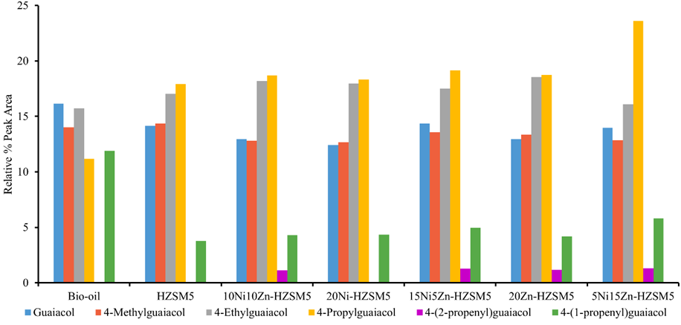

Figure 5a Yields of guaiacols in upgraded bio-oils (in terms of relative percentage peak area) obtained employing various catalysts (non-hierarchical).
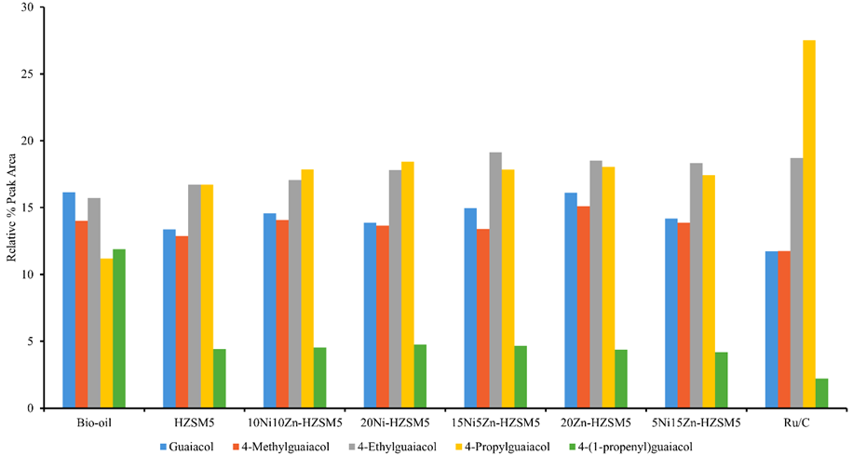

Figure 5b Yields of guaiacols in upgraded bio-oils (in terms of relative percentage peak area) obtained employing various catalysts (hierarchical).
Yields of various guaiacols in terms of relative percentage peak areas are shown in Figures 5a and 5b. Ru/C was used as a benchmark in this study as it exhibits highest selectivity for production of guaiacols along with the production of significant amount of bio-oil . Ni and/or Zn supported HZSM5 may be considered as an alternative to Ru/C for bio-oil upgrading due to extremely low cost of Ni and Zn in comparison with ruthenium.
Considerable increase in the amounts of 4-ethylguaiacol and 4-propylguaiacol was found in the upgraded bio-oils while guaiacol, 4-methylguaiacol, 4-propylguaiacol and homovanillic acid reduced significantly. Unlike hierarchical catalysts, non-hierarchical catalysts favored the formation of medicinally useful compounds such as homovanillyl alcohol and acetovanillone . In addition, gigantol showed both reduction and increment in its amount over non-hierarchical and hierarchical catalysts, respectively. Dehydroabietic acid being a bulky molecule was obtained in large proportions in upgraded bio-oil over hierarchical catalysts than non-hierarchical catalysts. This was attributed towards the fact that hierarchical zeolites acts as pathway for diffusion of bulky molecules thus ensuring their entry to accessible Bronsted acid sites while retaining such sites for acid catalysis . As a result, large aromatic species are more likely to be formed over hierarchical than non-hierarchical HZSM5 . The amounts of guaiacol and 4-methylguaiacol decreased upon bio-oil upgrading over all the catalysts due to C-alkylation of aromatic rings resulting in the production of 4-ethylguaiacol. Incorporation of metals into HZSM5 pores have been found to increase the para selectivity . Small amount of ZnO particles plays vital role in enhancing side-chain alkylation of toluene to ethyl benzene in methanol over Zn modified zeolite .
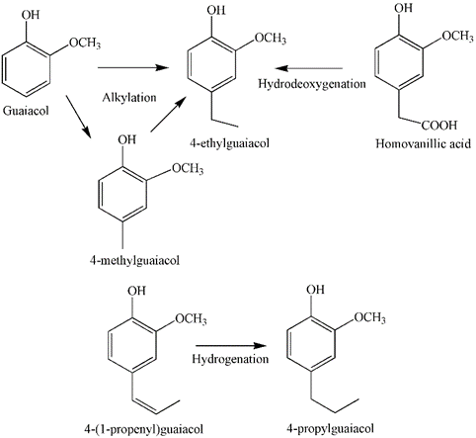

Figure 6. Plausible reaction mechanism for the formation of different monomers.

Table 6. Physicochemical properties of bio-oils before and after upgrading over different catalysts.
 | Non-Hierarchical Catalysts
 | HZSM5 | 10Ni10Zn-HZSM5 | 20Ni-HZSM5 | 15Ni5Zn-HZSM5 | 20Zn-HZSM5 | 5Ni15Zn-HZSM5
pH (Before Experiment) | 5.73 | 5.74 | 5.97 | 5.33 | 5.56 | 5.06
pH (After Experiment) | 6.66 | 6.29 | 6.74 | 6.52 | 6.57 | 6.72
Char (%) | 2.27 | 0.43 | 0.93 | 1.14 | 1.62 | 1.38
Upgraded Bio-oil (%) | 91.67 | 93.33 | 86.67 | 83.33 | 91.67 | 86.67
Tar (%) | 1.81 | 5.73 | 1.94 | 11.74 | 3.76 | 5.53
Gases + Others (%) | 4.25 | 0.51 | 10.46 | 3.78 | 2.96 | 6.42
 | Hierarchical Catalysts
 | HZSM5 | 10Ni10Zn-HZSM5 | 20Ni-HZSM5 | 15Ni5Zn-HZSM5 | 20Zn-HZSM5 | 5Ni15Zn-HZSM5 | Ru/C
pH (Before Experiment) | 6.17 | 5.72 | 5.88 | 5.70 | 5.55 | 5.62 | 5.88
pH (After Experiment) | 6.83 | 6.72 | 7.01 | 6.90 | 6.85 | 6.73 | 7.42
Char (%) | 0.57 | 1.44 | 0.33 | 0.89 | 0.33 | 0.33 | 3.31
Upgraded Bio-oil (%) | 92.20 | 90.51 | 92.27 | 95.75 | 90.00 | 91.78 | 94.55
Tar (%) | 7.00 | 6.93 | 5.34 | 2.67 | 8.13 | 6.20 | 1.76
Gases + Others (%) | 0.23 | 1.12 | 2.06 | 0.69 | 1.54 | 1.68 | 0.38

Physicochemical properties of upgraded bio-oils are stated in Table 6. Figure 6 shows plausible reaction mechanism for the formation of different monomers via alkylation, hydrogenation and deoxygenation. Hydrogenation of 4-(1-propenyl)guaiacol resulted in significant increase in the amount of 4-propylguaiacol (Tables 4 and 5). Hydrodeoxygenation of homovanillic acid and alkylation of guaiacol and 4-methylguaiacol accounted for increase in the amount of 4-ethylguaiacol. Metal loaded both hierarchical and non-hierarchical HZSM5 catalysts favored the formation of alkylated guaiacols. The amounts of total alkyl guaiacols increased from 40.92% to 51.65% over hierarchical 20Zn-HZSM5 catalyst while it increased to a maximum of 52.53% over non-hierarchical 5Ni15Zn-HZSM5 catalyst. Synergetic effect of Ni and Zn was more prominent in non-hierarchical catalysts than hierarchical catalysts. For instance, average increment in the amounts of total alkyl guaiacols for bimetallic non-hierarchical catalysts was higher than monometallic non-hierarchical catalysts. In contrast, catalytic effect of Ni and/or Zn was prominent in hierarchical than non-hierarchical catalysts. Catalytic effect of Ni and/or Zn was insignificant in case of non-hierarchical catalysts due to the presence of micropores that would have accommodated significantly less amount of metal in their pores in comparison with hierarchical catalysts.

Table 7. Elemental analysis and HHV (MJ/Kg) values for upgraded bio-oils employing different catalysts.
 | C (%) | H (%) | O (%) | N (%) | S (%) | O/C | H/C | HHV_{Boie} (MJ/Kg)
Stock Bio-oil | 67.15 | 5.40 | 25.93 | 0.45 | 0.78 | 0.39 | 0.08 | 27.12
 | Upgraded Bio-oil
Non-Hierarchical Catalysts | C (%) | H (%) | O (%) | N (%) | S (%) | O/C | H/C | HHV_{Boie} (MJ/Kg)
HZSM5 | 68.84 | 6.08 | 23.91 | 0.40 | 0.77 | 0.35 | 0.09 | 28.73
20Zn-HZSM5 | 68.86 | 6.74 | 23.18 | 0.39 | 0.83 | 0.34 | 0.10 | 29.59
20Ni-HZSM5 | 69.12 | 6.11 | 23.69 | 0.40 | 0.67 | 0.34 | 0.09 | 28.87
15Ni5Zn-HZSM5 | 69.56 | 6.78 | 22.64 | 0.36 | 0.66 | 0.33 | 0.10 | 29.92
5Ni15Zn-HZSM5 | 69.89 | 5.97 | 23.16 | 0.39 | 0.60 | 0.33 | 0.09 | 29.03
10Ni10Zn-HZSM5 | 69.14 | 5.94 | 23.34 | 0.40 | 1.17 | 0.34 | 0.09 | 28.77
Hierarchical Catalysts | C (%) | H (%) | O (%) | N (%) | S (%) | O/C | H/C | HHV_{Boie} (MJ/Kg)
HZSM5 | 67.65 | 6.60 | 24.53 | 0.45 | 0.78 | 0.36 | 0.10 | 28.84
20Zn-HZSM5 | 68.60 | 7.18 | 23.42 | 0.37 | 0.43 | 0.34 | 0.10 | 29.93
20Ni-HZSM5 | 67.85 | 7.20 | 24.11 | 0.39 | 0.45 | 0.36 | 0.11 | 29.62
15Ni5Zn-HZSM5 | 68.03 | 6.80 | 24.08 | 0.42 | 0.66 | 0.35 | 0.10 | 29.25
5Ni15Zn-HZSM5 | 68.35 | 6.89 | 23.87 | 0.37 | 0.53 | 0.35 | 0.10 | 29.47
10Ni10Zn-HZSM5 | 68.50 | 6.86 | 23.68 | 0.40 | 0.57 | 0.35 | 0.10 | 29.52
Ru/C | 68.75 | 7.64 | 22.82 | 0.34 | 0.46 | 0.33 | 0.11 | 30.58

Table 7 shows the elemental composition of upgraded bio-oils over Ni and/or Zn loaded hierarchical and non-hierarchical HZSM5 catalysts. Raw bio-oil possessed H/C and O/C ratios of 0.08 and 0.39, respectively accounting for 27.12 MJ/Kg HHV_{Boie.} Maximum decrease in O/C ratio to 0.33 was observed for non-hierarchical 15Ni5Zn-HZSM5 and 5Ni15Zn-HZSM5 catalysts while maximum increase in H/C ratio to 0.11 was obtained for hierarchical 20Ni-HZSM5 catalyst. Among all catalysts, 15Ni5Zn-HZSM5 and 20Zn-HZSM5 showed maximum increase in HHV_{Boie}. Hydrogen percentage increased to a maximum of 7.20% over hierarchical 20Ni-HZSM5 catalyst while oxygen percentage decreased to a minimum of 22.64% over non-hierarchical 15Ni5Zn-HZSM5 catalysts. Additionally, sulfur and nitrogen contents decreased to 0.43% and 0.36% from 078% and 0.45% respectively over hierarchical 20Zn-HZSM5 and 15Ni5Zn-HZSM5 catalysts, respectively.
4. Conclusions
The main reaction mechanisms responsible for bio-oil upgrading over Ni and/or Zn loaded hierarchical and non-hierarchical HZSM5 catalysts in supercritical ethanol involved hydrogenation, alkylation and deoxygenation. The amounts of alkylated guaiacols increased significantly over Ni and/or Zn impregnated HZSM5 catalysts in comparison with non-impregnated catalysts. Catalytic and synergetic effects were more pronounced in hierarchical and non-hierarchical catalysts, respectively. Maximum increase in HHV_{Boie} of the upgraded bio-oil was observed in case of non-hierarchical 15Ni5Zn-HZSM5 and hierarchical 20Zn-HZSM5 catalysts. Further, deoxygenation and hydrogenation were more prominent in non-hierarchical and hierarchical catalysts, respectively. Although, bio-oil quality was improved with Ni and/or Zn supported HZSM5 catalysts, Ru/C still remains the best choice for enhancing HHV_{Boie}. Ni-Zn based catalysts may be considered as an alternative for bio-oil upgrading.
References
[1] S. Cheng, L. Wei, J. Julson, K. Muthukumarappan, P.R. Kharel, E. Boakye, Hydrocarbon bio-oil production from pyrolysis bio-oil using non-sulfide Ni-Zn/Al2O3 catalyst, Fuel Process. Technol., 162 (2017) 78-86.
[2] A. Agarwal, M. Rana, J.-H. Park, Advancement in technologies for the depolymerization of lignin, Fuel Process. Technol., 181 (2018) 115-132.
[3] S. Kadarwati, X. Hu, R. Gunawan, R. Westerhof, M. Gholizadeh, M.D.M. Hasan, C.-Z. Li, Coke formation during the hydrotreatment of bio-oil using NiMo and CoMo catalysts, Fuel Process. Technol., 155 (2017) 261-268.
[4] P. Duan, Y. Xu, F. Wang, B. Wang, W. Yan, Catalytic upgrading of pretreated algal bio-oil over zeolite catalysts in supercritical water, Biochem. Eng. J., 116 (2016) 105-112.
[5] S. Cheng, L. Wei, J. Julson, K. Muthukumarappan, P.R. Kharel, Upgrading pyrolysis bio-oil to biofuel over bifunctional Co-Zn/HZSM-5 catalyst in supercritical methanol, Energy Convers. Manage., 147 (2017) 19-28.
[6] J. Wildschut, F.H. Mahfud, R.H. Venderbosch, H.J. Heeres, Hydrotreatment of Fast Pyrolysis Oil Using Heterogeneous Noble-Metal Catalysts, Ind. Eng. Chem. Res., 48 (2009) 10324-10334.
[7] H.R. Rahimpour, M. Saidi, P. Rostami, B.C. Gates, M.R. Rahimpour, Experimental Investigation on Upgrading of Lignin-Derived Bio-Oils: Kinetic Analysis of Anisole Conversion on Sulfided CoMo/Al2O3 Catalyst, Int. J. Chem. Kinet., 48 (2016) 702-713.
[8] Y. Li, C. Zhang, Y. Liu, S. Tang, G. Chen, R. Zhang, X. Tang, Coke formation on the surface of Ni/HZSM-5 and Ni-Cu/HZSM-5 catalysts during bio-oil hydrodeoxygenation, Fuel, 189 (2017) 23-31.
[9] J. Peng, P. Chen, H. Lou, X. Zheng, Catalytic upgrading of bio-oil by HZSM-5 in sub- and super-critical ethanol, Bioresour. Technol., 100 (2009) 3415-3418.
[10] A. Veses, B. Puértolas, J.M. López, M.S. Callén, B. Solsona, T. García, Promoting Deoxygenation of Bio-Oil by Metal-Loaded Hierarchical ZSM-5 Zeolites, ACS SUSTAIN CHEM ENG, 4 (2016) 1653-1660.
[11] L. Wang, J. Zhang, X. Yi, A. Zheng, F. Deng, C. Chen, Y. Ji, F. Liu, X. Meng, F.-S. Xiao, Mesoporous ZSM-5 Zeolite-Supported Ru Nanoparticles as Highly Efficient Catalysts for Upgrading Phenolic Biomolecules, ACS Catal., 5 (2015) 2727-2734.
[12] B. Puértolas, A. Veses, M.S. Callén, S. Mitchell, T. García, J. Pérez-Ramírez, Porosity–Acidity Interplay in Hierarchical ZSM-5 Zeolites for Pyrolysis Oil Valorization to Aromatics, ChemSusChem, 8 (2015) 3283-3293.
[13] T.M. Sankaranarayanan, A. Berenguer, C. Ochoa-Hernández, I. Moreno, P. Jana, J.M. Coronado, D.P. Serrano, P. Pizarro, Hydrodeoxygenation of anisole as bio-oil model compound over supported Ni and Co catalysts: Effect of metal and support properties, Catal. Today, 243 (2015) 163-172.
[14] A. Feliczak-Guzik, Hierarchical zeolites: Synthesis and catalytic properties, Microporous Mesoporous Mater., 259 (2018) 33-45.
[15] K. Annamalai, J. M. Sweeten, S. C. Ramalingam, Technical Notes: Estimation of Gross Heating Values of Biomass Fuels, Trans ASAE, 30 (1987) 1205-1208.
[16] M. Ammar, Y. Cao, P. He, L.-G. Wang, J.-Q. Chen, H.-Q. Li, Zn-Co bimetallic supported ZSM-5 catalyst for phosgene-free synthesis of hexamethylene–1,6–diisocyanate by thermal decomposition of hexamethylene–1,6–dicarbamate, Chin. Chem. Lett., 28 (2017) 1583-1589.
[17] M.M. Yung, A.K. Starace, C. Mukarakate, A.M. Crow, M.A. Leshnov, K.A. Magrini, Biomass Catalytic Pyrolysis on Ni/ZSM-5: Effects of Nickel Pretreatment and Loading, Energy Fuels, 30 (2016) 5259-5268.
[18] V. Mohan, C. Raghavendra, C.V. Pramod, B.D. Raju, K.S. Rama Rao, Ni/H-ZSM-5 as a promising catalyst for vapour phase hydrogenation of levulinic acid at atmospheric pressure, RSC Adv., 4 (2014) 9660-9668.
[19] S. Cheng, L. Wei, X. Zhao, E. Kadis, J. Julson, Conversion of Prairie Cordgrass to Hydrocarbon Biofuel over Co-Mo/HZSM-5 Using a Two-Stage Reactor System, Energy Technol., 4 (2016) 706-713.
[20] I. Othman, R.M. Mohamed, I.A. Ibrahim, M.M. Mohamed, Synthesis and modification of ZSM-5 with manganese and lanthanum and their effects on decolorization of indigo carmine dye, Appl. Catal., A, 299 (2006) 95-102.
[21] S. Thangalazhy-Gopakumar, S. Adhikari, R.B. Gupta, Catalytic Pyrolysis of Biomass over H+ZSM-5 under Hydrogen Pressure, Energy Fuels, 26 (2012) 5300-5306.
[22] H. Ben, A.J. Ragauskas, Pyrolysis of Kraft Lignin with Additives, Energy Fuels, 25 (2011) 4662-4668.
[23] Q. Lu, Z.-F. Zhang, C.-Q. Dong, X.-F. Zhu, Catalytic Upgrading of Biomass Fast Pyrolysis Vapors with Nano Metal Oxides: An Analytical Py-GC/MS Study, Energies, 3 (2010) 1805.
[24] B.A. T Hart, J.M. Simons, K.-S. Shoshan, N.P.M. Bakker, R.P. Labadie, Antiarthritic activity of the newly developed neutrophil oxidative burst antagonist apocynin, Free Radical Biol. Med., 9 (1990) 127-131.
[25] R. De la Torre, D. Corella, O. Castañer, M.A. Martínez-González, J. Salas-Salvador, J. Vila, R. Estruch, J.V. Sorli, F. Arós, M. Fiol, E. Ros, L. Serra-Majem, X. Pintó, E. Gómez-Gracia, J. Lapetra, M. Ruiz-Canela, J. Basora, E.M. Asensio, M.I. Covas, M. Fitó, Protective effect of homovanillyl alcohol on cardiovascular disease and total mortality: virgin olive oil, wine, and catechol-methylathion, Am. J. Clin. Nutr., 105 (2017) 1297-1304.
[26] J. Hertzog, V. Carre, L.Y. Jia, C.L. Mackay, L. Pinard, A. Dufour, O. Masek, F. Aubriet, Catalytic Fast Pyrolysis of Biomass over Microporous and Hierarchical Zeolites: Characterization of Heavy Products, ACS SUSTAIN CHEM ENG, 6 (2018) 4717-4728.
[27] A.J. Foster, J. Jae, Y.-T. Cheng, G.W. Huber, R.F. Lobo, Optimizing the aromatic yield and distribution from catalytic fast pyrolysis of biomass over ZSM-5, Appl. Catal., A, 423-424 (2012) 154-161.
[28] K. Gao, S. Li, L. Wang, W. Wang, Study of the alkylation of benzene with methanol for the selective formation of toluene and xylene over Co3O4–La2O3/ZSM-5, RSC Adv., 5 (2015) 45098-45105.
[29] L.L. Song, Y. Yu, Z.R. Li, S.Q. Guo, L.F. Zhao, W. Li, Side-Chain Alkylation of Toluene with Methanol over Zn-Modified KX Zeolite, J. Braz. Chem. Soc., 25 (2014) 1346-1354.

