Investigation of Metastable Zones and Induction Times in Glycine Crystallisation across Three Different Antisolvents
John McGinty^{1,2}, Lennart A. I. Ramakers¹, Wolfgang Beckmann³, Guillaume Levilain³, Mei Lee⁴, Helen Wheatcroft⁵, Ian Houson¹, Jan Sefcik^{1,2,}*
1 Future Manufacturing Research Hub in Continuous Manufacturing and Advanced Crystallisation, University of Strathclyde, Glasgow, UK; 2 Department of Chemical and Process Engineering, University of Strathclyde, Glasgow, UK; 3 Bayer AG, Research & Development, Pharmaceuticals, Material Science, 42096 Wuppertal, Germany; 4 Product Development and Supply, GlaxoSmithKline, Stevenage, Hertfordshire SG1 2NY, UK; 5 PT&D, AstraZeneca Macclesfield, Macclesfield, SK10 2NA, UK.
*Corresponding author: jan.sefcik@strath.ac.uk
Highlights
- Compared three different antisolvents for glycine crystallisation
- Measured solubilities, metastable zone widths and induction times across metastable zones for all antisolvents
- Assessed effect of rapid antisolvent addition vs continuous mixing on induction times

1. Introduction
There has been a significant amount of research on metastable zone width (MSZW) and induction times for cooling crystallisation, while relatively little has been done for antisolvent crystallisation. Experimental data on effects that different antisolvents and antisolvent addition strategies have on nucleation behavior in antisolvent crystallisation is very limited and our understanding of these effects is sparse. In literature there has been no direct comparison of the effects of different antisolvents on induction times and only a single publication directly assesses the MSZW for different antisolvents [1]. Furthermore, only a single publication was found which investigates both induction times and MSZW for the same antisolvent crystallisation system [2]. With regards to mixing effects only a single publication was found which uses a continuous static mixer when measuring induction times for antisolvent crystallisation [3]. In this work we measured solubilities and MSZWs in the antisolvent crystallisation of glycine using methanol, ethanol and DMF as antisolvents. We then investigated induction times across the metastable zone for these antisolvents. In order to investigate the effects of mixing, induction times were measured either with rapid antisolvent addition or using a continuous static mixer.
2. Methods
Solubilities were measured by equilibration of solids with solvent mixtures under agitation and gravimetric determination of equilibrated liquid phase compositions. The MSZW were assessed under isothermal conditions by adding the antisolvent at constant flow-rate via a syringe pump to an agitated undersaturated aqueous glycine solution in an 8 ml vial. The point at which the solution became turbid was taken as the metastable limit. The MSZW was determined by measuring a series of metastable limits starting from different initial compositions. The induction times were measured by preparing supersaturated solutions by mixing an antisolvent with an undersaturated aqueous glycine solution, either by rapid antisolvent addition or using a continuous static mixer. Induction times were recorded under agitated isothermal conditions in 8ml vials. The static mixer had a 1/8 inch internal diameter.
3. Results and discussion
Figure 1A shows the comparison of induction times within MSZs for the three different antisolvents using batch rapid antisolvent addition. For these antisolvents, there was a little difference between induction times at similar supersaturations. At lower supersaturations induction times were very long as expected. However, at higher supersaturations induction times were relatively short, similar among different antisolvents and only weakly dependent on supersaturation. This indicates that crystal growth and secondary nucleation may become rate limiting factors in observed induction times as supersaturation increases. Investigation of mixing effects showed that using continuous mixing with the ethanol antisolvent decreased the induction times by up to one order of magnitude compared to batch rapid antisolvent addition while using continuous mixing with the methanol antisolvent increased the induction times by up to two orders of magnitude (Figure 1B).
A | 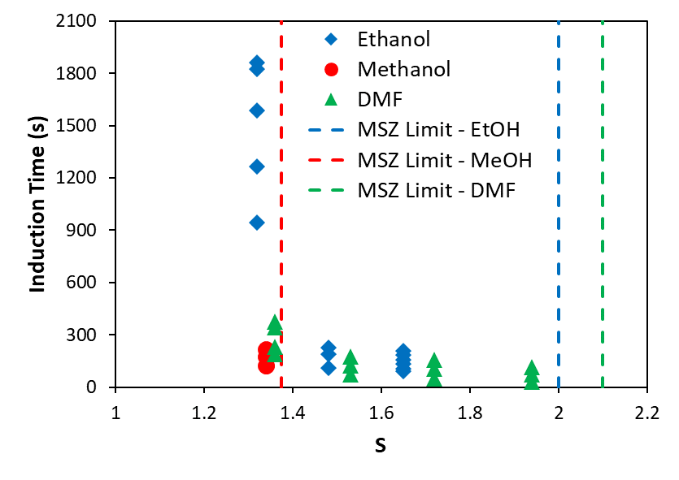 | B | 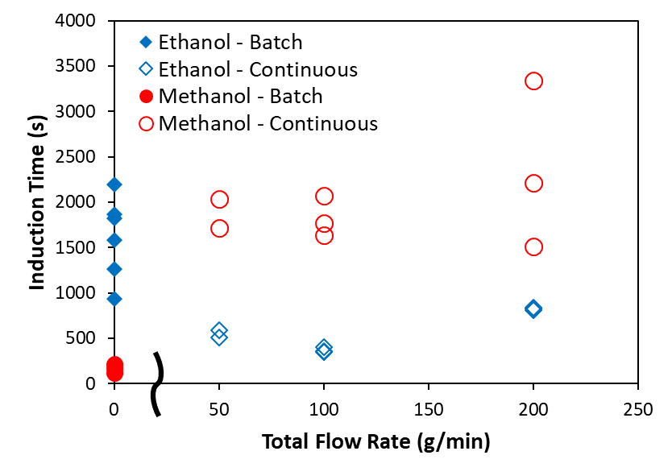
Figure 1. A) Induction time measurements for different antisolvents in batch rapid antisolvent addition. B) Comparison between batch rapid antisolvent addition and continuous static mixing (total flow rate = 0 is batch).
4. Conclusions
Well defined induction times were measured across MSZs which shows that primary nucleation is present at much lower supersaturations than those identified in conventional metastable zone width measurements. At higher supersaturations other factors become rate limiting, including crystal growth and secondary nucleation, which may need to be considered when interpreting induction time data in terms of primary nucleation kinetics as is commonly done in the literature. Induction times are strongly dependent on the mode of mixing (batch rapid antisolvent addition vs continuous mixing) which shows that appropriate mixing strategies are crucial for rational development of robust scalable antisolvent crystallisation processes.
References
- K. Sangwal, E. Mielniczek-Brzóska, Cryst. Res. Technol. 2017, 52, 1600361.
- C. T.Ó’Ciardhá, P. J. Frawley, N. A. Mitchell, Journal of Crystal Growth. 2011, 328, 50-57.
- S. K. Poornachary et al., Cryst. Growth Des. 2016, 16, 749-758.

