Hydraulic Characterization of Water-Air Flows in Cooling-Tower Packing.
Nicolas Jourdan^{1,2}, Mohamed Kanniche¹, Thibaut Neveux¹, Olivier Potier²
1 EDF R&D, EDF Lab Chatou, 6 quai Watier 78400 CHATOU FRANCE
2 LRGP, CNRS UMR 7274, Université de Lorraine, 1 rue Grandville, 54000 NANCY FRANCE
*Corresponding author: nicolas.jourdan@edf.fr
Highlights
- Study of wet-cooling tower packing hydrodynamics
- Experimental characterization of falling water films: thickness and instabilities
- Benchmark of CFD approaches for simulations of water films
1. Introduction
Industrial wet-cooling towers are used in various industrial fields such as power plants, refineries or chemical plants. These cooling towers are filled with packing to increase heat and mass transfer between hot water and counter-current air flow [1]. Despite numerous investigations of heat transfer performances and pressure losses [2], hydraulic characteristics such as wetting ratios or water film thicknesses –prerequisite for study of fouling phenomena– are yet to be determined. This study aims at presenting both experimental and numerical characterization of packing hydrodynamics using a dedicated pilot-plant and CFD simulations.
2. Methods
To obtain local information on the flow characteristics along the cooling tower packing, a small scale transparent cooling tower pilot-plant was designed and built, with attention put on the representativeness of water and air distributions. Falling films along the packing channels are observed using a fast camera system tangent to the packing surface. The transparent walls allow the visualization all around the packing structure on different spots. The water film is isolated by subtracting images with and without water with the help of a specific program and Matlab Image Analysis toolbox. The global characterization of the packing is obtained by a statistical analysis film thickness over time and location in the various flow conditions (liquid load, air flow rate, temperature and humidity).
In the same time, CFD simulations are performed on simplified geometry, taken from literature [3], in order to investigate the ability of different CFD approaches to predict correctly falling water films along vertical surfaces.
3. Results and discussion
With the experimental apparatus, data on the flow characteristics are obtained and particularly on water films thickness. One example of post-treatment is shown on Figure 1. From the videos, two phenomena are observed: the wavy film instabilities that came from the flow regime and drops falling along the wall significantly increasing the film thickness. Film thickness evolution is one main parameter influencing fooling phenomena such as kinetics of calcium carbonate precipitation and biofilm development. The wavy film instabilities are estimated by plotting the film thickness over time and processing data with a harmonic analysis using Matlab.

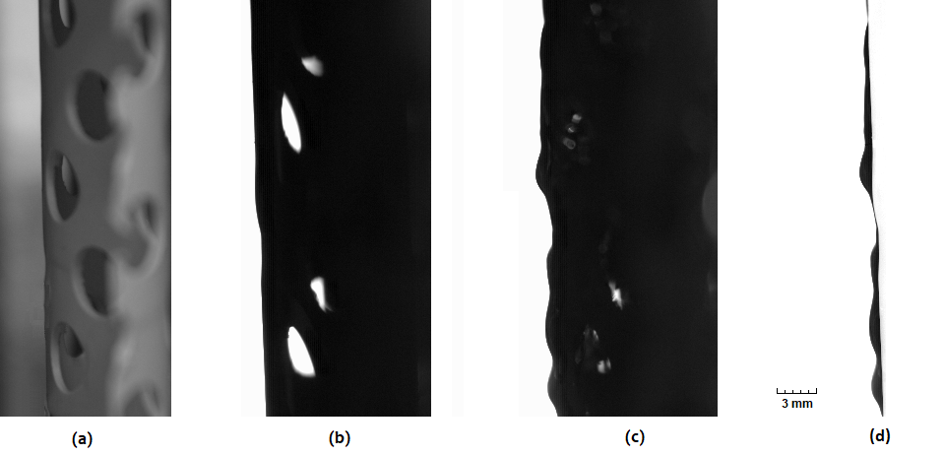
Figure 1. (a) Picture of packing. (b) Reference dry frame. (c) Picture of wetted packing. (d) Subtracted frames to obtain the resulting water film
CFD simulations were performed with two different approaches: Eulerian-Eulerian two-phase model with interface tracking using NEPTUNE_CFD software [4] and VOF method using OpenFOAM software. First results showed that the VOF method is more suitable for falling film simulations because it takes into account the contact angle with the wall for better prediction of wettability, near-wall velocity profiles and shear-stress that influence fouling phenomena (Figure 2).
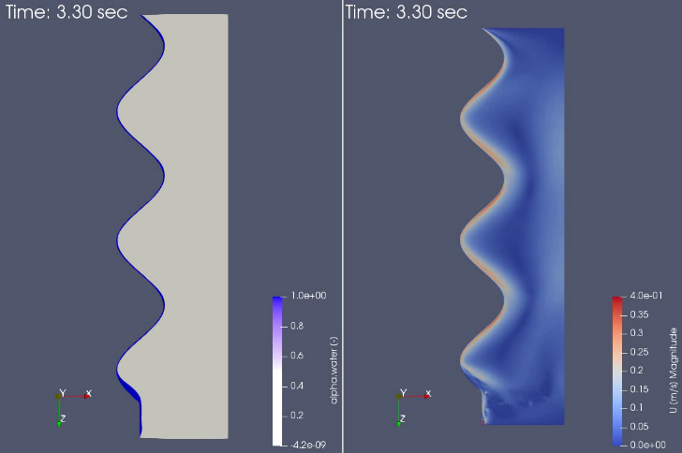 | 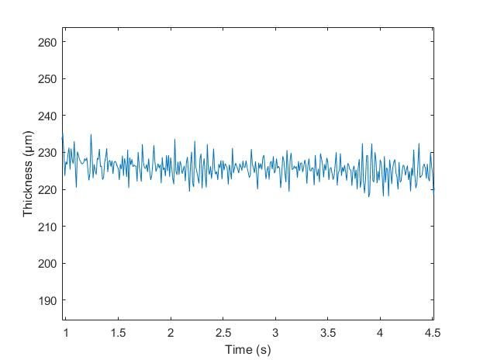
(a) | (b)
Figure 2. VOF simulations results (a) Water phase rate and air velocity (b) Water film thickness (z=13mm)
4. Conclusions
The experimental setup allows the characterization of falling water on cooling tower packing surface. The water films thickness and their variations were pointed out and the instabilities characteristics were estimated to better understand the phenomena that depend on hydrodynamics. The CFD simulation is promising methods to complete experimental data towards predictive results. These two approaches are complementary to model phenomena of interest such as mass transfer, heat transfer or chemical reactions.
References
- R. Terblanche, H.C.R Reuter, D.G. Kröger, Appl. Therm. Eng., 29 (2009) 1552–1560.
- M. Lemouari, m. Boumaza, A. Kaabi, Energ. Conv. Manag., 50 (2009) 1610-1617
- S. Negny, M. Meyer, M. Prevost, Int. J. Heat Mass Tran., 44 (2001) 2137-2154
- P. Coste, Nuc. Engin. Design., 255 (2013) 38-50

