OPC UA-based Concept for Online Implementation of Model-based Advanced Process Control Tools
Volodymyr Kozachynskyi¹, Saskia Bublitz¹, Markus Illner¹, Joris Weigert¹, Christian Hoffmann¹, Erik Esche¹, Jens-Uwe Repke¹
1 Technische Universität Berlin, Fachgebiet Dynamik und Betrieb technischer Anlagen, Berlin, Germany
*Corresponding author: volodymyr.kozachynskyi@tu-berlin.de
Highlights
- A concept for the online application of APC tools on plants in real time is proposed
- This concept utilizes an OPC UA standard for efficient data exchange
- The implementation of the concept is successfully demonstrated in a case study

1. Introduction
The structural implementation and application of model-based advanced process control tools based on methods such as data reconciliation, state estimation, sequential optimal experimental design or dynamic real-time optimization is a complicated and time-consuming task. It requires the development of a methodology for coupling of the tools with a process model, selection of a solver and implementation of a data-processing algorithms. The robust online application of these tools brings even more challenges for a developer. Solution must ensure that the APC tool can (i) read current and historical data from the plant in real-time, (ii) indicate relevant information to the plant operator, and (iii) influence the operation of the plant by manipulating variables, e.g. set points of the controllers.
This gap between the development of an APC tool and its efficient online implementation is being addressed in this contribution. The proposed data communication model is independent from the specific plant and APC tool and is based on the OPC UA standard [1], which fulfills all requirements for Industry 4.0 communication [2].
2. Methods
The data communication concept is shown in Fig.1. The connection between a plant and an APC tool is achieved via an intermediate aggregating OPC UA server, which is the main feature of the concept. It mirrors data from the real plant, stores it in a database and assures a bidirectional communication between the plant and the APC tool. Complex data types, provided by a server, specify a communication data model for APC tools allowing for a standardized data handling. The process model and the APC tool based on it are generated with the web-based modeling platform MOSAICmodeling [3]. The latter contains information about mapping of process variables (sensors, actuators, etc.) and model variables.

3. Case Study and Results
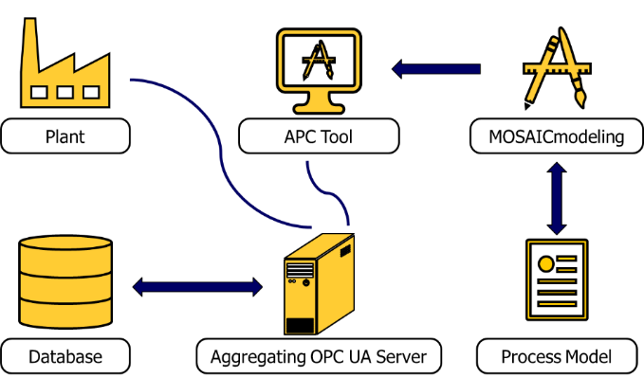
In order to check the applicability and potential of the developed concept, a case study has been conducted. Real-time plant operation is mimicked by the simulation of a dynamic model of a continuously stirred tank reactor with a chemical reaction of the second order. This simulation is connected to an aggregating OPC UA server, which constantly stores measurements in a database. This data is accessed by different APC tools, which are based on the same dynamic model: moving horizon state estimation, dynamic optimization of plant trajectories, and parameter estimation. The concept has been implemented in Python [4] and successfully tested. Simulation and state estimation have been running in parallel for twenty hours, while all the generated data has been stored in the database. No data has been lost during the experiment and no bottlenecks that hinder long lasting experiments were found. This allows for further investigations of the concept applicability on a real mini-plant for homogeneously catalyzed liquid multiphase reactions at TU Berlin operated by the SIMATIC PCS 7 distributed control system.
Figure 1. Proposed data communication concept.

4. Conclusions
Online implementation of APC tools is a complex task, which requires an efficient and easily applicable solution. On the one hand, this solution must be robust and secure, while on the other hand it must be easy in use and flexible. The concept presented in this contribution, fulfills these requirements. Based on results it is suggested that the OPC UA standard is to be used as a base layer for online application of APC tools, while the proposed concept and its Python implementation are a good example of a possible generalized solution of the highlighted challenge.
Acknowledgment
This work is part of the Collaborative Research Center "Integrated Chemical Processes in Liquid Multiphase Systems" (subproject D2, D4) coordinated by the Technische Universität Berlin. Financial support by the German Research Foundation (Deutsche Forschungsgemeinschaft, DFG) is gratefully acknowledged (TRR 63).
References
- https://opcfoundation.org/developer-tools/specifications-unified-architecture
- F. Pethig, S. Schriegel, A. Maier, J. Otto, S. Windmann, B. Böttcher, O. Niggemann, J. Jasperneite. (2017). Industrie 4.0 Communication Guideline Based on OPC UA.
- E. Esche, C. Hoffmann, M. Illner, D. Müller, S. Fillinger, G. Tolksdorf, H. Bonart, G. Wozny, J.-U. Repke (2017) “MOSAIC – Enabling Large-Scale Equation-Based Flow Sheet Optimization”, Chemie Ingenieur Technik, DOI: 10.1002/cite.201600114
- https://www.python.org/

