Potential formation of PCDD/Fs during TCS electrochemical oxidation. Influence of the operation variables
Claudia Solá-Gutiérrez, Sophie Schröder, María Fresnedo San Román, Inmaculada Ortiz
Biomolecular and Chemical Engineering Department, ETSIIT, University of Cantabria, Avda. De los Castros, 39005, Santander, Spain
*Corresponding author: solac@unican.es
Highlights
- Electrochemical oxidation of triclosan in aqueous phase is investigated.
- The influence of initial concentration of triclosan, supporting electrolyte and presence of copper in the solutions has been studied.
- The formation of highly toxic PCDD/Fs congeners within the oxidation is assessed.
1. Introduction
Triclosan (TCS), 5-chloro-2-[2,4-dichlorophenoxy]-phenol, classified as a PPCP (pharmaceutical and personal care product) is widely used as a broad-spectrum antimicrobial and antifungal agent in many professional and personal products (deodorant soaps, toothpaste and mouthwash, plastic consumer goods…) [1]. Triclosan and related compounds are characterized by acute resistance to biodegradation, environmental persistence and high lipophilicity. Therefore, in order to protect the environment from the harmful effects caused by the discharge of wastewater containing triclosan, the application of efficient technologies able to mineralize this type of compounds becomes crucial. Advanced Oxidation Processes (AOPs) have emerged as powerful alternatives to remove many chlorinated organic compounds. Electrochemical oxidation, among them, has been successfully applied to remediate aqueous solutions containing TCS [2]. However, powerful oxidation media can favor the formation of minor and more harmful byproducts such as polychlorinated dibenzo-p-dioxins and furans (PCDD/Fs); thus, the traceability of the formation of this kind of by-products during the oxidation treatment has become an issue of concern [2,3]. In this work, the influence of the supporting electrolyte (NaCl and Na₂SO₄), the presence of copper in the aqueous solution and the initial concentration of TCS on the potential formation of PCDD/Fs has been studied. Finally, based on previous literature, a reaction mechanism describing the formation of PCDD/Fs from triclosan solutions in aqueous and gas phase is proposed.
2. Methods
The electrochemical oxidation experiments were carried out in batch mode in a laboratory system with a labELOX 1/176 cell (APRIA Systems S.L.). The cell consisted of two regular electrodes: BDD as anode and titanium as cathode. An initial volume of 1 L was treated. Initial concentrations of TCS were 10, 100 and 150 mg L⁻¹, and the current density applied was 6, 60 and 90 A m⁻², respectively. The concentration of the two supporting electrolytes was 56.34 mM NaCl and 21.11 mM Na₂SO₄. In the solutions were the copper salt was present, its concentration was 39.63 mg L⁻¹ (10 mg L⁻¹ of Cu). TCS removal has been quantified in a HPLC using the original standard. PCDD/Fs analysis have been performed following USEPA 1613 method by high-resolution gas chromatography coupled with high-resolution mass spectrometry (HRGC-HRMS) [3].
3. Results and discussion
Complete degradation of TCS was achieved after 2, 3 and 4.5 hours when its initial concentration was 10, 100 and 150 mg L⁻¹, respectively. Total concentration of PCDD/Fs achieved values up to 3.68 x 10², 3.42 x 10⁴ and 1.64 x 10⁵ pg L⁻¹ when the initial concentration of TCS was 10, 100 and 150 mg L⁻¹, respectively. The results confirmed the dominance of tetrachlorodibenzo-p-dioxin (TCDD) in the homologue profile of the total PCDD/Fs, reaching values up to 1.11 x 10⁵ pg L⁻¹ in samples with initial TCS concentration of 150 mg L⁻¹ and NaCl as electrolyte (Figure 1 (a)). The International Toxicity Factor (I-TEF), as expected, increased with the initial concentration of TCS from 4.8 to 379.7 pg L⁻¹ for 10 and 150 mg L⁻¹ TCS samples, respectively. This value is much higher than the maximum contaminant level established by the USEPA for drinking water, 30.0 pg L⁻¹. However, the presence of copper in the oxidation medium tends to reduce I-TEF values.
- b) c)
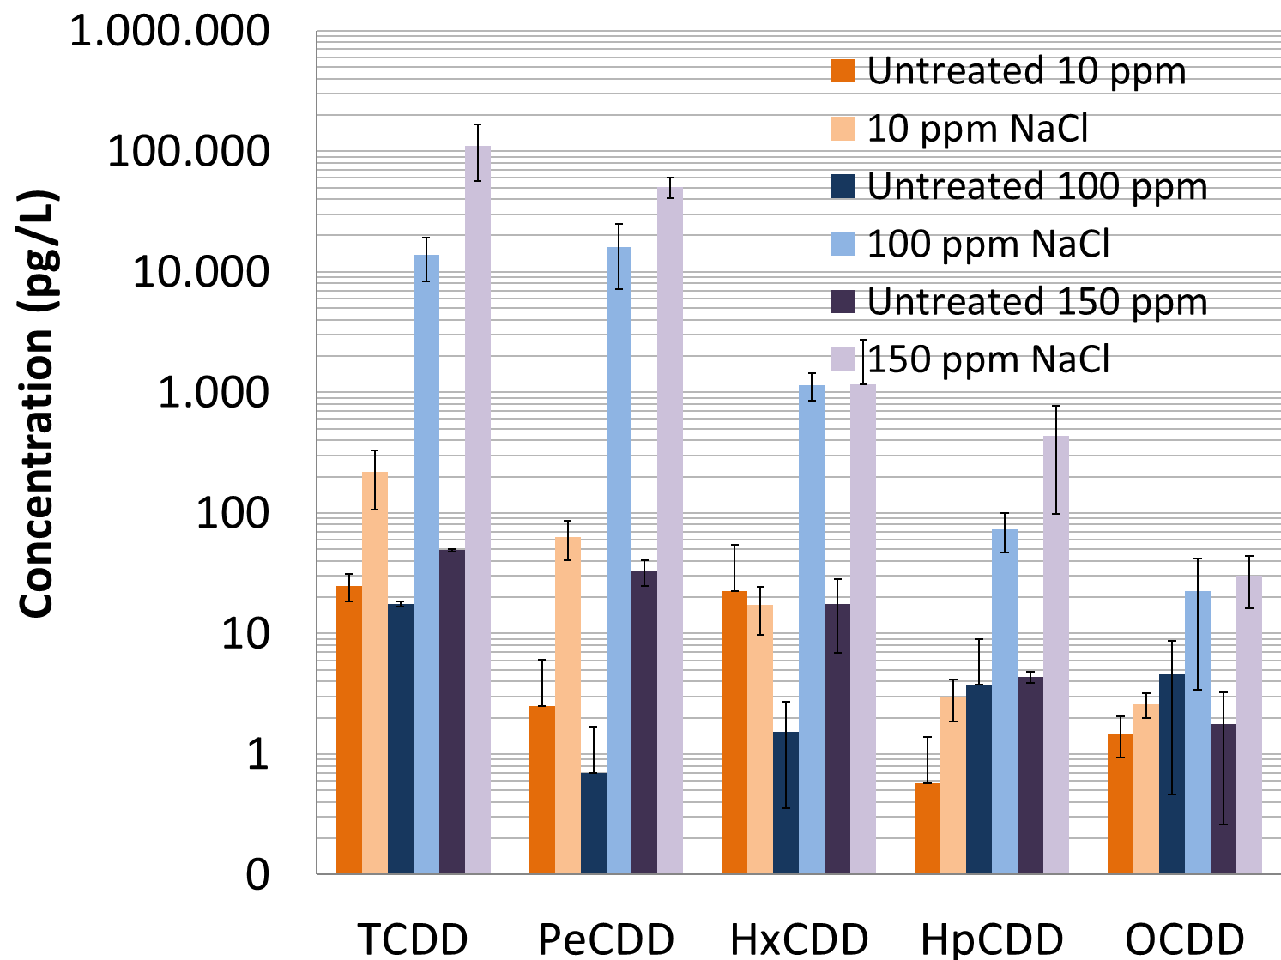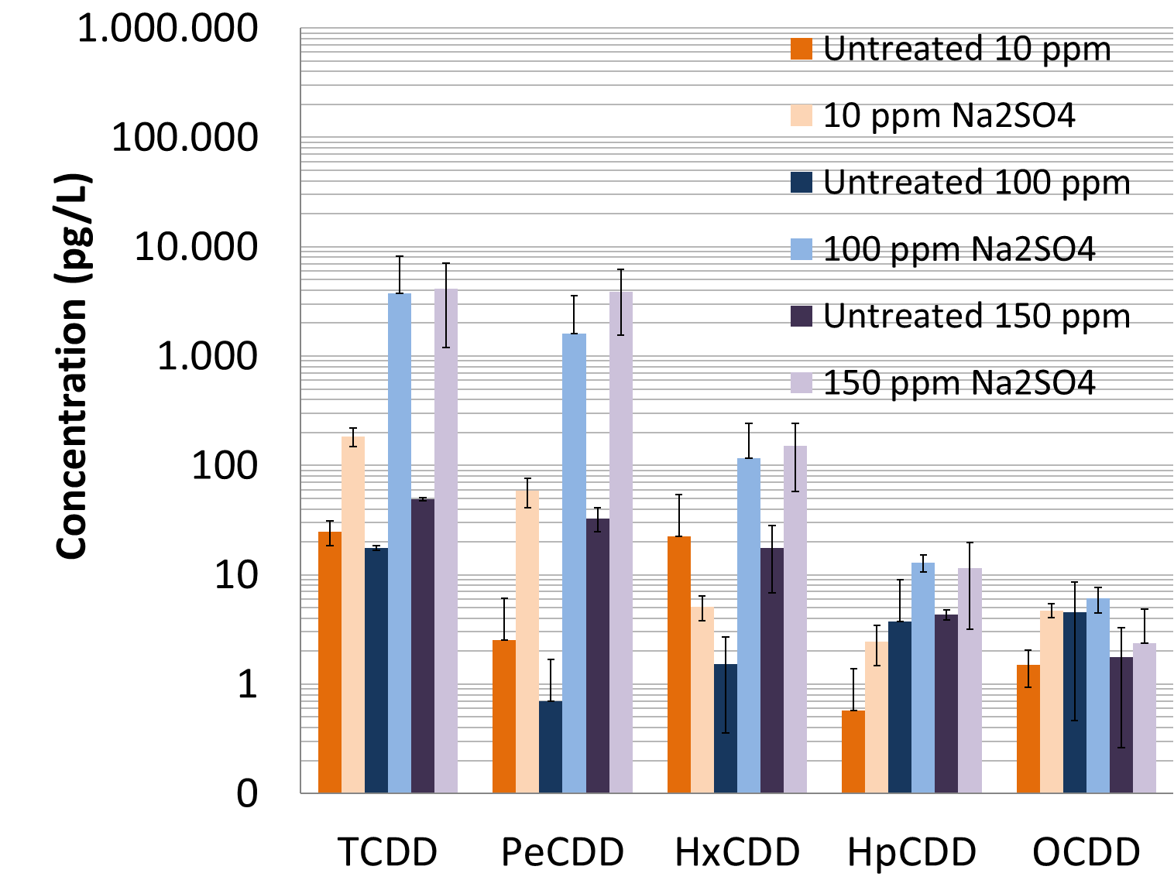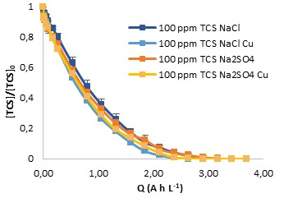
Figure 1. PCDD concentration after electrochemical oxidation of 10, 100 and 150 mg L⁻¹ of triclosan using NaCl (a) and Na₂SO₄ (b) as supporting electrolytes; c) Influence of the supporting electrolyte and the presence of copper in the aqueous medium on the removal of triclosan with the specific charge.
The presence of copper did not show influence on the TCS degradation rate (Figure 1 (b)); however, the total concentration of PCDD/Fs was reduced by 55.26 % and 18.06 % for NaCl and Na₂SO₄ as supporting electrolytes, respectively. Finally, a detailed reaction mechanism describing the formation of PCDD/Fs from triclosan was proposed and supported by the experimental results [4,5].
4. Conclusions
Electrochemical oxidation allowed complete elimination of triclosan in all experiments. However, it has to be highlighted the increased concentration of PCDD/Fs in comparison with the untreated samples, specially the concentration of TCDD homologues. The comparison between the results obtained using two broadly applied electrolytes, NaCl and Na₂SO₄, emphasizes the role and importance of the chloride concentration on the formation of chlorinated byproducts during the electrochemical oxidation of triclosan; when NaCl was used as supporting electrolyte, I-TEF levels increased from values closed to zero for the untreated solution to 379,7 pg L⁻¹ when complete removal of 150 mg L⁻¹ triclosan was achieved. Finally, the reaction pathway leading to the formation of PCDD/Fs from TCS oxidation has been proposed.
References
- M. Muñoz, Z.M. de Pedro, J.A. Casas, J.J. Rodríguez, Chem. Eng. J. 198-199 (2012) 275-281.
- C. Solá-Gutiérrez, M.F. San Román, I. Ortiz, Sci. Total Environ. 626 (2018) 126-136.
- M. Vallejo, M.F. San Román, I. Ortiz, Environ. Sci. Technol. 47 (2013) 14200-12408.
- Y. Gao, Y. Ji, G. Li, T. An, Water Res. 49 (2014) 360-370.
- X. Zhang, C. Zhang, X. Sun, L. Kang, Y. Zhao, Int. J. Mol. Sci. 16 (2015) 8128-8141.

