Characterization of edible oil foams with a fast inline measurement using acoustic and ultrasound spectroscopy
Lorenzo Metilli¹, Mathew Francis, Megan Povey, Aris Lazidis, Stephanie Marty-Terrade, Elena Simone
¹ School of Food science and Nutrition, University of Leeds, UK; ² Nestlè PTC York, UK
*Corresponding author: fslme@leeds.ac.uk, e.simone@leeds.ac.uk
Highlights
- Edible oil foams are used for reducing caloric density and modify food texture.
- The physical properties of foams affect rheology and stability of the final products.
- Acoustic techniques can be used to assess the physical properties of foams.

1. Introduction
Because of the dramatic rise of obesity in UK in the last three decades, several food companies have committed to design and manufacture healthier foods with reduced caloric content. An effective way of achieving this goal is by using edible oil-based foams (oleofoams) to prepare aerated confectionary food (e.g., mousses) [1].. The main constituents of edible oleofoams are a liquid oil phase, air bubbles and a further high-melting, crystalline fat phase, which stabilizes the bubbles via a Pickering effect. Such complex microstructure determines the macroscopic physical and nutritional properties of oleofoams [2]. Therefore, a correct characterization and continuous monitoring and control of oleofoams microstructure during process design and manufacturing is essential to ensure the quality of the final food product. Ultrasound spectroscopy is a fast and affordable monitoring technique, characterized by non-intrusiveness and non-destructive behaviour, which is particularly promising for inline, in situ characterization of oleofoams. The aims of this work are: (1) identify a methodology based on multiple offline techniques to characterize the microstructure of oleofoams and (2) find a robust correlation between the physical properties and microstructure of oleofoams and specific characteristic acoustic measurements.
2. Methodology
High oleic sunflower oil and cocoa butter were used to prepare the oleofoams. Melted cocoa butter was mixed to sunflower oil and recrystallized (oleogel phase) by cooling in a jacketed vessel equipped with temperature control. Aeration was performed using a Kitchen Aid whipping machine. The structures of oleogels and oleaofoams were characterized using several offline techniques including polarized and confocal microscopy, x-ray scattering and tomography as well as differential scanning calorimetry. Acoustic measurements were carried out using an airborne acoustic microscope, with two focused transducers at three variable frequencies.
3. Results and discussion
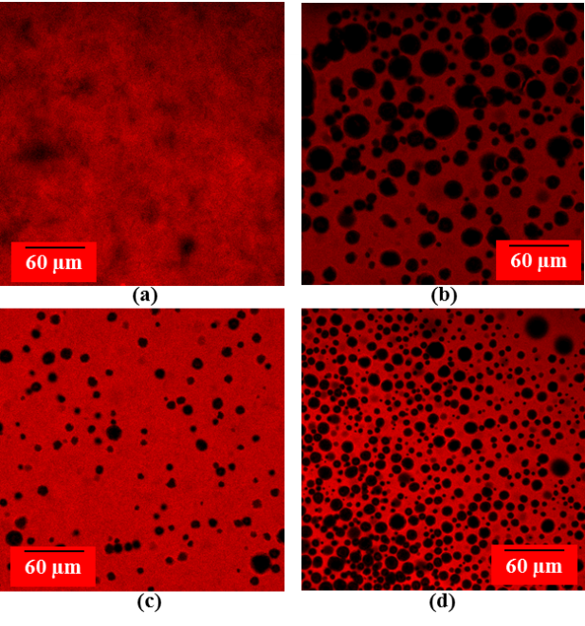
The experiments showed that both foamability and foam stability are dependent from cocoa butter content, with heavier (20-30%) oleogels reaching equilibrium air content later compared to lighter ones (10%). Confocal microscopy was proven successful to image surface layers of the foams, allowing an estimate of bubble size distribution. Figure 1 shows how air bubbles can be easily detected by this technique. Finally, samples were analyzed with the acoustic microscope and a positive correlation between the intensity of the reflected signal and the content of cocoa butter crystals in the samples was found.
Figure 1. Confocal microscope images of four samples at (a) 0%, (b) 70% (c) 175% and (d) 200% overrun.
4. Conclusions
Oleogels and oleofoams were characterized with offline techniques as well as acoustic measurements. Initial finding showed the applicability of acoustic spectroscopy in detecting and quantifying fat crystals within oleofoams. In fact, acoustic reflectivity increased with increasing solid fat content in such foams.
References
- Campbell, G. M., & Mougeot, E. (1999). Creation and characterisation of aerated food products. Trends in Food Science and Technology, 10(9), 283–296.
- Heymans, R., Tavernier, I., Dewettinck, K., & Van der Meeren, P. (2017). Crystal stabilization of edible oil foams. Trends in Food Science and Technology, 69, 13–24

