**Evaluation of the Catalytic Activity of Red Mud for Olive Mill Wastewater Tretament by Fenton’s Process**

E. Domingues, J. Gomes, D. Lopes M..J. Quina, R. M. Quinta-Ferreira, R. C. Martins

1CIEPQPF – Chemical Engineering Processes and Forest Products Research Center, Department of Chemical Engineering, Faculty of Sciences and Technology, University of Coimbra, Pólo II – Rua Sílvio Lima, 3030-790 Coimbra, Portugal, Portugal; 2CICECO –Aveiro Institute of Materials, Department of Materials and Ceramic Engineering, University of Aveiro, 3810-193 Aveiro Portugal.

**Highlights**

* Fenton, photo-Fenton, Red-mud, low cost catalyst

**1. Introduction**

Fresh OMW is considered phytotoxic because it has in its constitution phenolic compounds. The traditional physical chemical treatments only solve part of the problem since the contaminants are not destroyed but rather phase changed. Thus, an oxidation (chemical or biological) treatment is necessary to complete the treatment of the effluent. In this work, a low-cost catalyst, red mud, was applied in the Fenton process with the objective of reducing the costs of operation and reusing a waste that is currently produced in large quantities. Red-mud richness in iron and aluminium as well as some rare metals can enhance the Fenton´s process. In this context, the aim of the present research was to analyze the efficiency of red-mud as a solid catalyst in Fenton’s process for OMW treatment.

**2. Methods**

Red mud was characterized morphologically by scanning electron microscopy (SEM) with a Hitachi S-4100 microscope. Particle size distribution was performed with a Coulter LS 230 (0.040 - 2000 μm). Specific surface area by the Brunauer-Emmett-Teller (BET) method was studied with a Micromeritics Germini 2380. X-ray diffraction was used to ascertain the crystallography of the powder with a PANalyticalXPert PRO diffractometer (2θ =10-80°, CuKα radiation), where a Panalytica lHigh Score Plus 4.1 (PDF-4) was used for phase identification.

The simulated OMW was prepared by dissolving 100 mg/L of each of the following phenolic acids in ultrapure water: trans-cinnamic, 3,4-dimethoxybenzoic, 4-hydroxybenzoic, 3,4,5-trimethoxybenzoic and 3,4-dihidroxybenzoic acid.

Dark and photo-Fenton’s experiments were carried out in a glass spherical reactor (500 mL). A high-pressure sodium grow lamp (LUMATEK 600 W) was used for photo-Fenton’s experiments.

**3. Results and discussion**

SEM images of RM are shown in Figure 1, where the waste seems to be formed by agglomerates with heterogeneous shape and size of particles (Figure 1 a)). Regardless the shape, the particles seem to be around 1.00 µm (Figure 1 b)), in average. Particle size analysis showed that the average size of particles is 1.10 µm, with a mean size (D50) of 0.58 µm (Figure 2a), where 10% of particles have a particle diameter lower than 0.17 µm (D10) and 90% of particles have a diameter lower than 2.86µm (D90). The waste catalyst has a surface area of BET of 10.57 m2/g and 0.02cm3/g of pore volume. XRD studies (Figure 2b) confirm the presence of several phases, in accordance with SEM results.

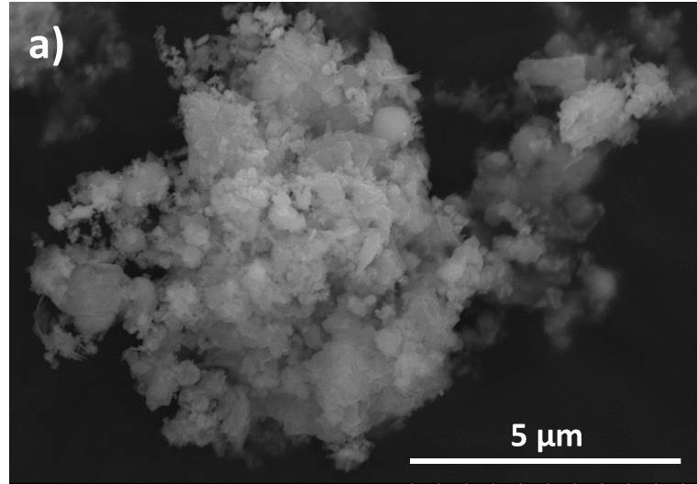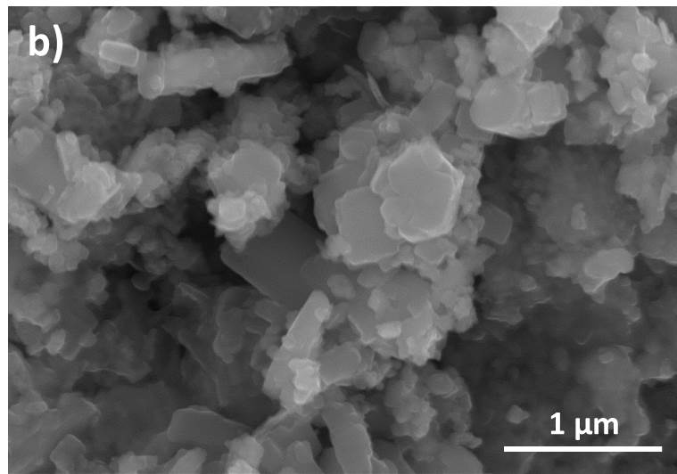

Figure 1. SEM of the red mud powder.



Figure 2. a)Cumulative volume (%) of red mud particles. b) XRD pattern of red mud.

Fenton’s experiments showed that red mud is a suitable low-cost catalyst for the removal of the phenolic content. The operating parameters were optimized and the impact of Fenton’s process over the treated wastewater ecotoxicity was evaluated.

**4. Conclusions**

Fe2O3 is the major constituent of RM, followed by AlO(OH) and an iron silicate hydroxide phase. Minor compositions of SiO2, TiO2, Ca3SiO and Al(OH)3 are present.

The presence of visible radiation in Fenton´s process decreased the efficiency of the process, probably led to the decomposition of hydrogen peroxide into non-reactive species with contaminants such as water and oxygen. The catalyst load above 1 g / L shows that the scavenger effect of the catalyst prevails. It has been found that increasing the concentration of hydrogen peroxide to 100 mg / L favors the process by increasing the rate of degradation of the phenolic acids.

**References**

1. A. Bianchi, N.C. Jones, Chem. Eng. J. 157 (2019) 326–337.
2. W. Black, E.B. White, The Elements of Science, third ed., MacCluski, New York, 1987.
3. G.R. Pangar, L. Liu, in: N.C. Jones, A. Bianchi (Eds.), The Electronic Technology, E-Publishing Inc., New York, 2009, pp. 181–304.
4. Khairul, M.A., Zanganeh, J., Moghtaderi, B. (2019). The composition, recycling and utilisation of Bayer red mud.Resources, Conservation & Recycling 141, 483–498.