Relational Database for the Description of Fermentation inside a Simulation Software.
Simoneta Caño de las Heras*, Ulrich Krühne, Seyed Soheil Mansouri
Process and Sytems Engineering Center (PROSYS), Department of Chemical and Biochemical Engineering, Technical University of Denmark, Søltofts Plads, Building 229, 2800 Kgs. Lyngby, Denmark
*Corresponding author: simoca@kt.dtu.dk
Highlights
- Fermentation simulators could be beneficial to asses the feasibility of different kinetic scenarios.
- A database is developed that incorporates information related to kinetic parameters of fermentation models.
- This database is integrated inside a pedagogical software platform, FermProc.
1. Introduction
Simulators are well established tools for instructing, design, and development of bioprocesses with the advantages of its portability, safety, user friendliness, and cost-effectiveness [1]. However, commercially simulators commonly work as a black box and consequently, their mathematical models are not displayed and/or being available for its modification. And therefore, it is not possible to recognize the assumptions made [2], [3] complicating the comprehension of the process. Furthermore, simulators are not generally intended to evaluate the feasibility of the simulated scenarios ergo users require a high previous knowledge of the bioprocess. This is highly relevant in case of fermentation processes as their mathematical models have several complexity layers and involve biological, chemical, physical and mechanical components. Moreover, bioprocess simulators commonly suffer from the lack of an organized database for the differentiation and analysis of the model components as well as the aforementioned limitations [4].
In this work, a prototype database that embeds common limits and values of the parameters of bioprocesses, is presented. This database is integrated inside a software platform called FermProc[5]. FermProc allows the display, reuse and modification of models and it is being developed at the Department of Chemical and Biochemical Engineering of the Technical University of Denmark as a pedagogical software for teaching of bio-manufacturing processes.
2. Architecture of the system
Figure 1 illustrates the functional system architecture. The architecture is designed with modular capabilities and involves the dynamic simulation of the bioprocess with the automatic solution of the model and its display. To do so, a relational database (in SQL) that collects and reuses interrelated rules, usually associated with characteristic values of the bioprocess is developed. This database uses the parameter, constant or variable as the data value. Therefore, a “parameter set id” uniquely identifies the record and associates each of them with specific maximum and minimum values. The “parameter set id” is connected with the process conditions such as the microorganism, the limiting substrate or bioreactor that may influence the data.
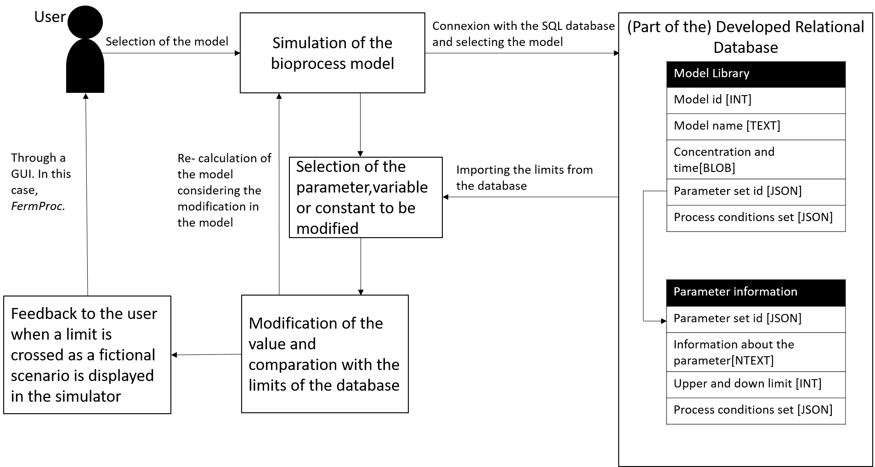
Figure 1. Schematic functional system architecture.
Furthermore, the database includes a theoretical explanation with the source of information so users can trust the database. Finally, an example of the use of the database can be found at https://youtu.be/qhucwjf_i0E. This video shows how a user interacts with a model of the aerobic growth of Saccharomyces cerevisiae and how a warming window will pop up when the oxidative yield of the consumption of glucose is modified over the thermodynamic limit [6].
3. Conclusions
Although there are several bioprocess simulators and common values and limits of different parameters involved in fermentation can be found in literature; there is a lack of an integrated system in which this information can be collected and displayed. To fulfill this need, a relational database that stores information about parameters of fermentation processes is developed. Furthermore, the database is implemented in a simulator, called FermProc, to facilitate the analysis of fictional scenarios through interactive modifications of the model.
References
[1] H. Shen et al., “Conducting laboratory experiments over the internet,” IEEE Trans. Educ., vol. 42, no. 3, pp. 180–185, 1999.
[2] M. G. Rasteiro et al., “LABVIRTUAL-A virtual platform to teach chemical processes,” Educ. Chem. Eng., vol. 4, no. 1, pp. 9–19, 2009.
[3] M. Heitzig, G. Sin, P. Glarborg, and R. Gani, “A computer-aided framework for regression and multi-scale modelling needs in innovative product- process engineering,” Comput. Aided Chem. Eng., vol. 28, pp. 379–384, 2010.
[4] S. Caño de las Heras, “A Systematic Computer-aided Framework for Development of Pedagogical Process Simulators using Gamification Elements A fermentation case study,” Aalborg Universy Copenhagen, 2018.
[5] S. Caño de las Heras, U. Krühne, and S. S. Mansouri, “FermProc : A Pedagogical Simulation Tool for Fermentations,” in Proceedings of the 46th SEFI Annual Conference 2018, 2018.
[6] P. M. Doran, Bioprocess Engineering Principles. 1995.

