Segregation Modeling in the Course of rapid gravity Flow of particulate Solids on a vibrated rough Chute

Viktor Dolgunin¹*, Andrei Kudi¹, Oleg Ivanov¹, Alexander Tarakanov¹, Vasilii Pronin¹
1 106 Sovetskaya street, Tambov state technical university, Tambov, 392000, Russia
*Corresponding author: dolgunin-vn@yandex.ru

Highlights
- One experimental kinetic constant needs to model segregation on size-density.
- The less vibration frequency the greater interdiffusion-induced migration.
- Segregation on size dominates in the area of high solid fraction plateau.
1. Introduction
Earlier [1] the profiles of velocity, fraction of the void volume and test particle distribution in rapid gravity flows of granular materials on a vibrated rough chute were investigated experimentally. In the present paper the profiles of test particle distribution in the flow of binary granular mixtures consisting of particles differing in size and density are calculated analytically. The earlier obtained profiles [1] of velocity and fraction of the void volume are used for the mathematical modeling. As a result the vibration influence of high and low vibration frequencies on segregation dynamics and basic segregation mechanisms in rapid gravity flows of particulate solids are studied analytically.
2. Methods
The mathematical modeling was carried out on the basis of a general equation of segregation dynamics [2, 3]. In the case of the steady state of two-dimensional rapid shear flow this equation takes into account the fluxes of test particles caused by convection in the shear direction x, quasidiffusion mixing, interdiffusion-induced separation (migration) and segregation in transversal direction y. The general equation of segregation dynamics with the above mentioned fluxes describes the distribution of test particles c(x,y,t) in the following way
$\frac{∂({cρ}_{b})}{∂t}=−\frac{∂(\text{uc}ρ_{b})}{∂x}+\frac{∂}{∂y}\left[ρ_{b}\left(D_{\text{dif}}\frac{∂c}{∂y}−{\text{cD}}_{m}\frac{∂\text{ln}s}{∂y}−K_{S}cΔM\right)\right]$, (1)
where t - time, u(y) – mean velocity towards shear direction x, s – mean distance between particles, ρ_{b} – bulk density, ΔM – driving force of segregation (total excess moment of forces of friction, gravity and impact moments, acting on a test particle), D_{dif}, D_{m}, K_{S} – coefficients of quasidiffusion mixing, migration and segregation respectively.
The kinetic characteristics D_{dif}, D_{m}, ΔM are calculated analytically as functions of shear rate, void volume fraction, concentration of particles c(x,y,t) and their physical and mechanical properties [3]. Only the segregation coefficient K_{S} is determined experimentally as the velocity of a test particle towards y-direction per unit driving force of segregation ΔM [2, 3]. It was found out [2] the segregation coefficient has properties which characterize K_{S} as the kinetic constant for wide range of flow parameters and particle characteristics. Boundary conditions for eq. (1) are formulated as the flux absence of particles through the bed boundaries (free surface and bed bottom). During the mathematical modeling the general equation of segregation dynamics (1) with the boundary conditions had been integrated numerically.

3. Results and discussion
Figs. 1 and 2 show the experimental and calculated distributions of large and light particles as well as the profiles of fraction of the void volume. The adequacy of the experimental and analytical results creates conditions for analysis of physical separation mechanisms.
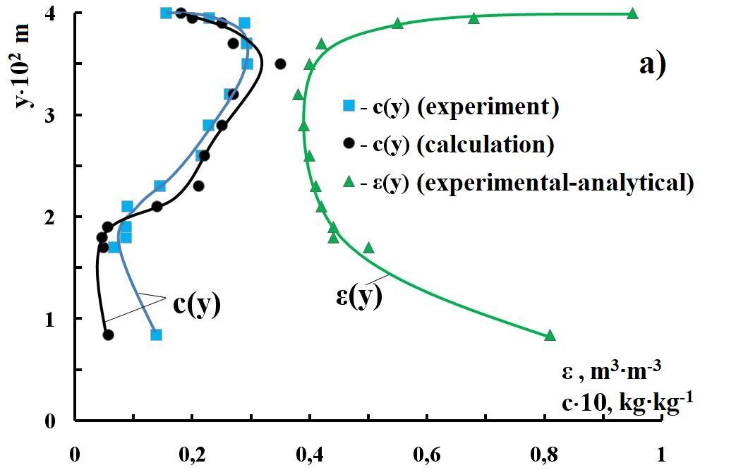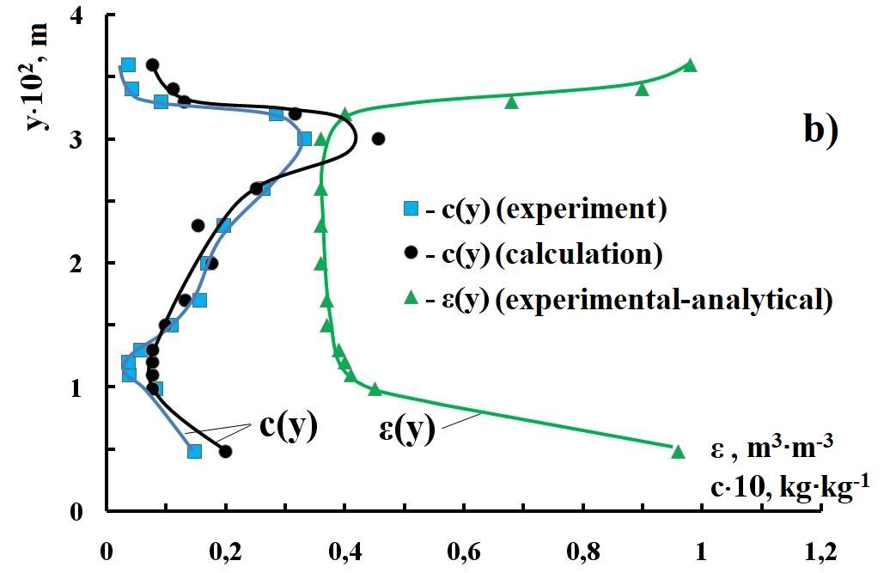
Fig. 1 Profiles of fraction of the void volume ε(y) and concentration of large particles c(y) in rapid gravity flow of binary mixture of glass beads (fractions +3.0-3.5 and +5-5.5 mm) on a vibrated rough chute (α=28.5°, a_{v}=2g) at vibration frequencies: a) – 15 Hz, b) – 50 Hz,
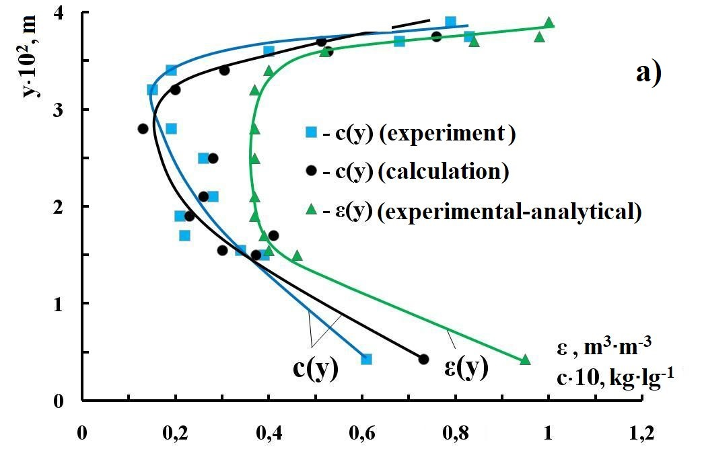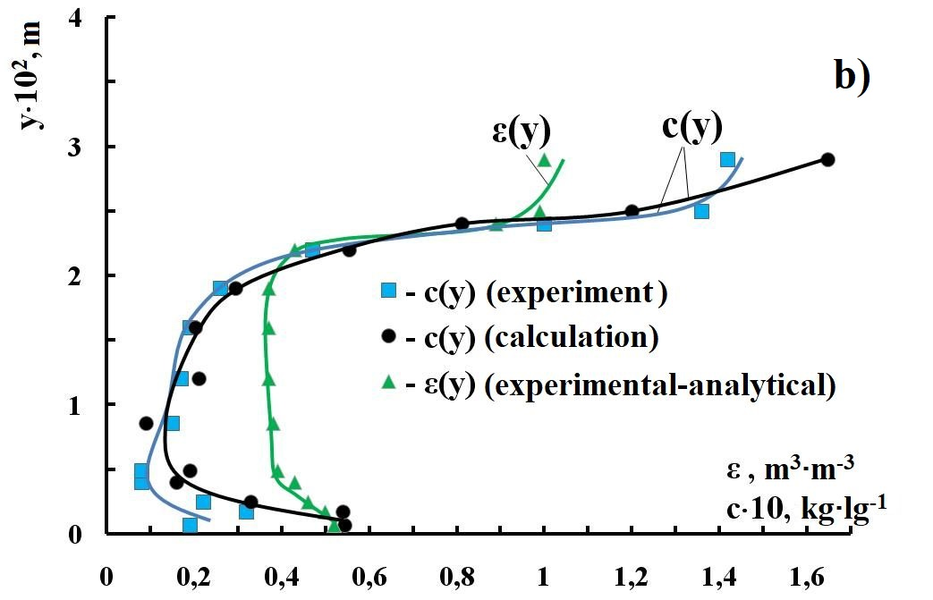
Fig. 2 Profiles of fraction of the void volume ε(y) and concentration of light particles c(y) in rapid gravity flow of particles differing in density (fraction +5-5.5 mm of glass beads and silica gel) on a vibrated rough chute (α=27°, a_{v}=2g) at vibration frequencies: a) – 15 Hz, b) – 50 Hz,
The combined analysis of distributions of the test particles and profiles of fraction of the void volume on the basis of the kinetics of separation fluxes in eq. (1) leads to the following conclusions. The segregation mechanism of separation dominates for particles differing in size and density when the relatively wide plateau of low values of void volume fraction is formed in the central part of the bed because of vibration of high frequency (Figs. 1-b and 2-b). Under such conditions ∂lns/∂y≈0 and segregation of particles differing in size is most pronounced (Fig. 1-b). In the thin upper part of the bed of particles differing in density (Fig. 2-b) the effect of separation is enhanced by the coincidence of directions of segregation and migration.
On the contrary the migration mechanism of separation prevails when the relatively high gradients of the void volume fraction are formed in the most part of the bed volume under the action of low-frequency vibration (Figs. 1-a and 2-a). Under such conditions ∂lns/∂y>>0 and migration of particles differing in density is most pronounced (Fig. 2-a).
4. Conclusions
In order to study basic separation mechanisms of particles differing in size and density during rapid gravity flow on a vibrated rough chute mathematical modeling was used. It was found out that low-frequency vibration intensifies interdiffusion-induced separation (migration) and high-frequency vibration forms flow conditions conducive to segregation.
References
[1] V.N. Dolgunin, A.N. Kudi. A.A. Ukolov, M.A. Tuev, Chem. Eng. Research and Design 122 (2017) 22–32.
[2] V.N. Dolgunin, A.A. Ukolov, O.O. Ivanov, Theor. Found. of Chem. Eng. 40(4) (2006) 393-404.
[3] V.N. Dolgunin, A.A. Ukolov, O.O. Ivanov, Theor. Found. of Chem. Eng. 43(2) (2009) 187–196.

