Precipitation of lithium carbonate by homogeneous carbonate reactions and heterogeneous CO₂ reactions
Bing Han¹, Marjatta Louhi-Kultanen¹
1 School of Chemical Engineering, Aalto University, P.O. Box 16100, FI-00076 Aalto, Finland
*Corresponding author: marjatta.louhi-kultanen@aalto.fi
Highlights
- Precipitation processes to separate lithium as carbonate were investigated
- Temperature and mixing intensity affected mainly precipitation
- lithium will be a key element for modern electric vehicles and devices
- Efficient recovery of lithium from secondary materials will be crucial in future

1. Introduction
The demand of lithium is expected to increase significantly within next ten years mainly due to the need to increase battery production capacities for electric vehicles. It is reported that batteries consume 39 % of total lithium [1]. This is because lithium is the lightest metal and the most energy dense of battery materials [2]. It is essential to recover and recycle lithium more efficiently from different sources to avoid the shortage of this critical metal. Xu et al [3] investigated the usage of saline lake waters as feedstock for lithium recovery. The review published by Swain [4] introduced the lithium recovery processes from brines. In our previous work, Han et al. [5], we investigated the recovery of lithium carbonate by precipitation from aqueous multicomponent solution simulating battery waste leachate. Precipitation results of lithium carbonate (Li₂CO₃) via homogeneous reactions with sodium carbonate as the reactant are reported by [5-7]. A few studies [8, 9] reported the application of CO₂ to precipitate Li₂CO₃. However, there has not been a study to compare the homogeneous reaction and heterogeneous reaction for the Li₂CO₃ precipitation. The aim of the present work was to compare precipitation and reaction kinetics of lithium with reactant of Na₂CO₃ solution and reactant CO₂ gas in alkaline solution at various operational conditions in terms of residence time, mixing intensity and precipitation temperature.
2. Methods
In the present work semi-batch precipitation of lithium carbonate was investigated by homogeneous and heterogeneous reactions in a stirred jacketed crystallizer. For homogeneous reaction study, sodium carbonate was used as the reactant. Na₂CO₃ solution was pumped to Li₂SO₄ solution to precipitate Li₂CO₃. In heterogeneous reaction study, CO₂ gas was used as a carbonate source to feed into the Li₂SO₄ solution to precipitate Li₂CO₃. NaOH solution was added to adjust the solution pH at the beginning. Different variables including temperature, stirring rate and feeding rate (residence time) were studied. Conductivity and pH was monitored with a Consort Multi-parameter analyzer (C3050). A thermostat (Lauda ECO RE630) with an external temperature sensor that immersed into the solution was used to control the temperature of the solution. An inline probe (Particle track G400, Mettler Toledo) was placed into the reactor and used to monitor the whole precipitation process in order to obtain kinetics data. After precipitation, the solid sample was separated by vacuum filtration with a Büchner funnel. The crystals were characterized by X-ray powder diffraction (XRD, X’Pert PRO), and Raman spectroscopy (PicoRaman, Timegate Instrument Oy) to determine crystal composition and crystal morphology. The crystal yield was determined with the mass of precipitates.
3. Results and discussion
Generally, high temperature can accelerate reaction, and enhance the nucleation and crystal growth. Figure 1 shows conductivity and pH changes in heterogeneous reaction with temperature of 25 and 50 °C. It can be clearly seen that the pH reduced slightly at the beginning, then dropped suddenly at some point, and kept decreasing gently for both temperatures. The conductivity reduced gently for a certain period and then kept constant at the end for both cases. The clear differences within two studied temperatures can be found: residence time is shorter at higher temperature. This means that the chemical reactions and precipitation are faster at higher temperature. The crystal yield obtained from precipitation process at 50 °C was even doubled at higher temperature. Another reason is also due to the lower solubility of Li₂CO₃ at higher temperature [10]. Stirring rate enhanced the reaction, which can accelerate the occurrence of precipitation.
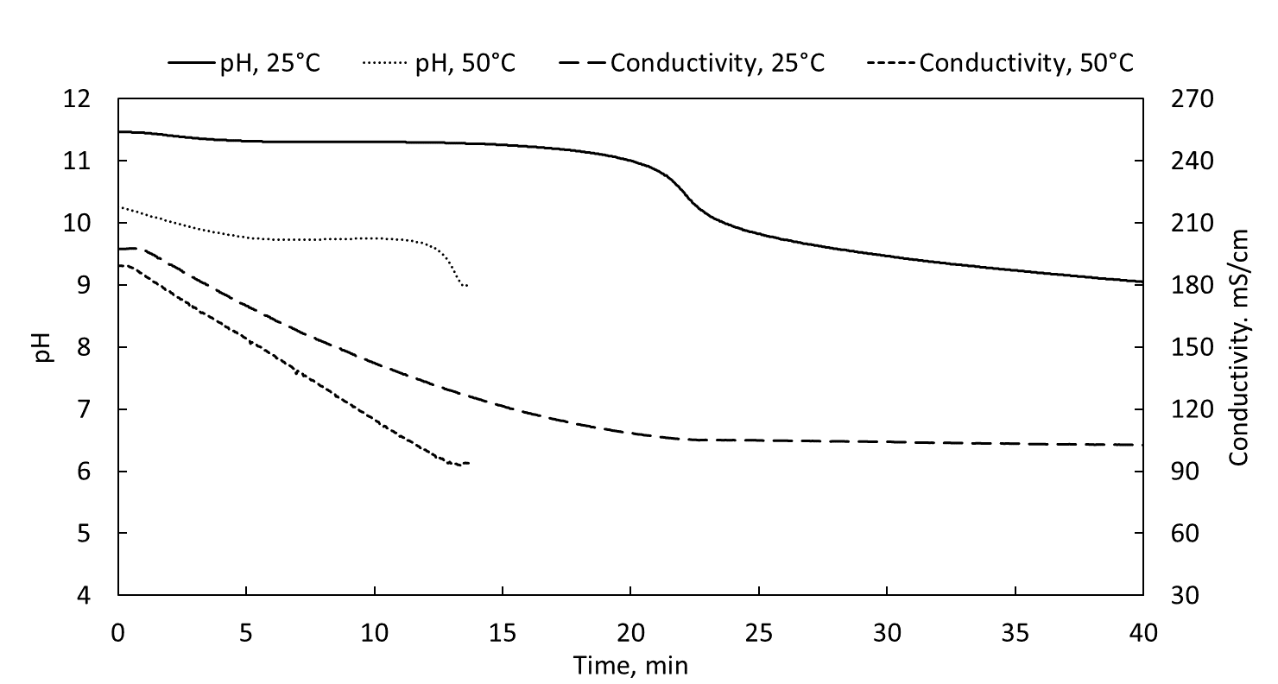

Figure 1. Trends of pH and conductivity changes at 25 and 50 °C in heterogeneous reaction.
4. Conclusions
The precipitation of Lithium carbonate from homogeneous and heterogeneous reactions were compared. Higher crystal yield can be obtained at higher temperature. Precipitation was enhanced by the increase of stirring rate.

References
- Discover what is hype and reality, and what counts most, in: BU-308: Availability of Lithium, Isidor Buchmann 2016.
- M. S Whittingham, Chem. Rev. 104, (2004), 4271−4301.
- Z. Xu, H. Zhang, R. Wang, W. Gui, G. Liu, Y. Yang, Ind. Eng. Chem. Res. 53, (2014), 16502-16507.
- B. Swain, Separation and Purification Technology 172 (2017), 388-403.
- B. Han, A. Porvali, M. Lundström, M. Louhi-Kultanen, Chem. Eng. Technol. 41(6), (2018), 1205-1210.
- P. W. Zhang, T. Yokoyama, O. Itabashi, T. M. Suzuki, K. Inoue, Hydrometallurgy 47, (1998), 259–271.
- A. A. Nayl, R. A. Elkhashab, S. M. Badawy, M. A. El-khateeb, Arabian J. Chem. 10, (2017), S3632–S3639.
- M. Matsumoto, Y. Morita, M. Yoshinaga, S. Hirose, K. Onoe, JCEG 42, (2009), s242-s248.
- Z. Zhou, F. Liang, W. Qin, W. Fei. AIChE 60, (2014), 282-288.
- J.W. Mullin, Crystallization, 4th ed., Butterworth Heinemann, Oxford, 2001, p. 485.

