On the enzymatic oxidation of aniline, p-aminodiphenylamine (PADPA) or their mixtures by using an industrial laccase and vesicles as templates
Tomoyuki Fujisaki¹, Keita Kashima^{1†}, Peter Walde²
1 Department of Materials Chemistry and Bioengineering, National Institute of Technology, Oyama College, 771 Nakakuki, Oyama, Tochigi, 323-0806, Japan;
2 Department of Materials, ETH Zurich, Vladimir-Prelog-Weg 5, 8093 Zürich, Switzerland
†Corresponding author: keitakashima@oyama-ct.ac.jp
Highlights
- Aniline and PADPA were enzymatically oxidized with a commercial laccase and O₂
- The reaction products resemble the conductive polyaniline emeraldine salt form, PANI-ES
- The products have good stability for at least 28 days if stored at room temperature

1. Introduction
Polyaniline in its conductive emeraldine salt form (PANI-ES) is characterized by a good dispersibility in water phase, and by good thermal and radiation stability.^{[1]} The enzymatic oxidation of aniline or the aniline dimer, p-aminodiphenylamine (PADPA), in the presence of dispersed anionic soft-interfaces in slightly acidic aqueous solution is an environmentally friendly process for obtaining PANI-ES. We previously reported about the enzymatic synthesis of PANI-ES-type products from PADPA oxidized with Trametes versicolor laccase (TvL)/O₂ as catalyst in aqueous pH = 3.5 solution at room temperature in the presence of anionic vesicles from sodium bis(2-ethylhexyl) sulfosuccinate (AOT) as reaction templates.^{[2-3]} The focus of this previous work was on fundamental aspects of the reaction. For possible industrial applications, two points are important to consider: (i) the use of an industrial laccase which would decreases the production costs, and (ii) enabling the synthesis of PANI-ES from aniline (instead of PADPA), which is cheaper and chemically more stable than PADPA. In this study, the enzymatic oxidation of aniline, PADPA or their mixtures was investigated in the presence of AOT vesicles by using a laccase which is used in food industry. The formation of PANI-ES-type products (with their characteristic absorption bands around 1000 nm) was analyzed by in situ UV/visible absorption measurements.
2. Methods
The enzymatic oxidation of aniline, PADPA, or aniline/PADPA mixtures using laccase (Y120, from Amano Enzyme) was investigated. The concentrations of the laccase and the AOT vesicles were fixed at [laccase] = 0.207 µg/mL, [AOT] = 1.5 mM, in a 10 mL reaction volume. The reaction was carried out in 50 mL Schott glass bottles at pH = 3.5 by using an aqueous phosphate solution (0.1 M NaH₂PO₄ + H₃PO₄). The concentrations of the substrates in each reaction mixture were [aniline] = 2.0 mM, [PADPA] = 1.0 mM, or [aniline] = 0.6 mM + [PADPA] = 0.7 mM, respectively. The reaction mixture was withdrawn and poured into a quartz cuvette (l = 0.1 cm, V = 300 µL) at desired times (t = 1 min, 1 h, 4 h, 24 h, 2 days, 3 days, 4 days, 7 days, 14 days, 21 days, 28 days), and the UV/visible absorption spectrum was measured with a UV mini-1240, from SHIMADZU.
3. Results and discussion
Figure 1 shows the time course of the absorbance at λ = 1000 nm (A₁₀₀₀) in each reaction with either aniline, PADPA, or an aniline/PADPA mixture. In the reaction with aniline only, the value of A₁₀₀₀ was clearly very low. In the reaction of [PADPA] = 1.0 mM, a major peak developed at λ ≈ 1000 nm which indicates formation of highly conductive PANI-ES. The value of A₁₀₀₀ in the reaction with PADPA reached a maximum value after t = 24 h, and then decreased after 7 days. In the reaction of [aniline] = 0.6 mM + [PADPA] = 0.7 mM, the major peak at λ ≈ 1000 nm appeared with almost the same intensity as in the case of the PADPA] = 1.0 mM system. Interestingly, A₁₀₀₀ of the reaction with the aniline/PADPA mixture kept a higher value for 28 days than the reaction with PADPA only. In the reactions with PADPA only and with the aniline/PADPA mixture, PANI-ES-type oxidative products were obtained. Especially, the reaction products obtained from the aniline/PADPA mixture showed good stability in aqueous solution.
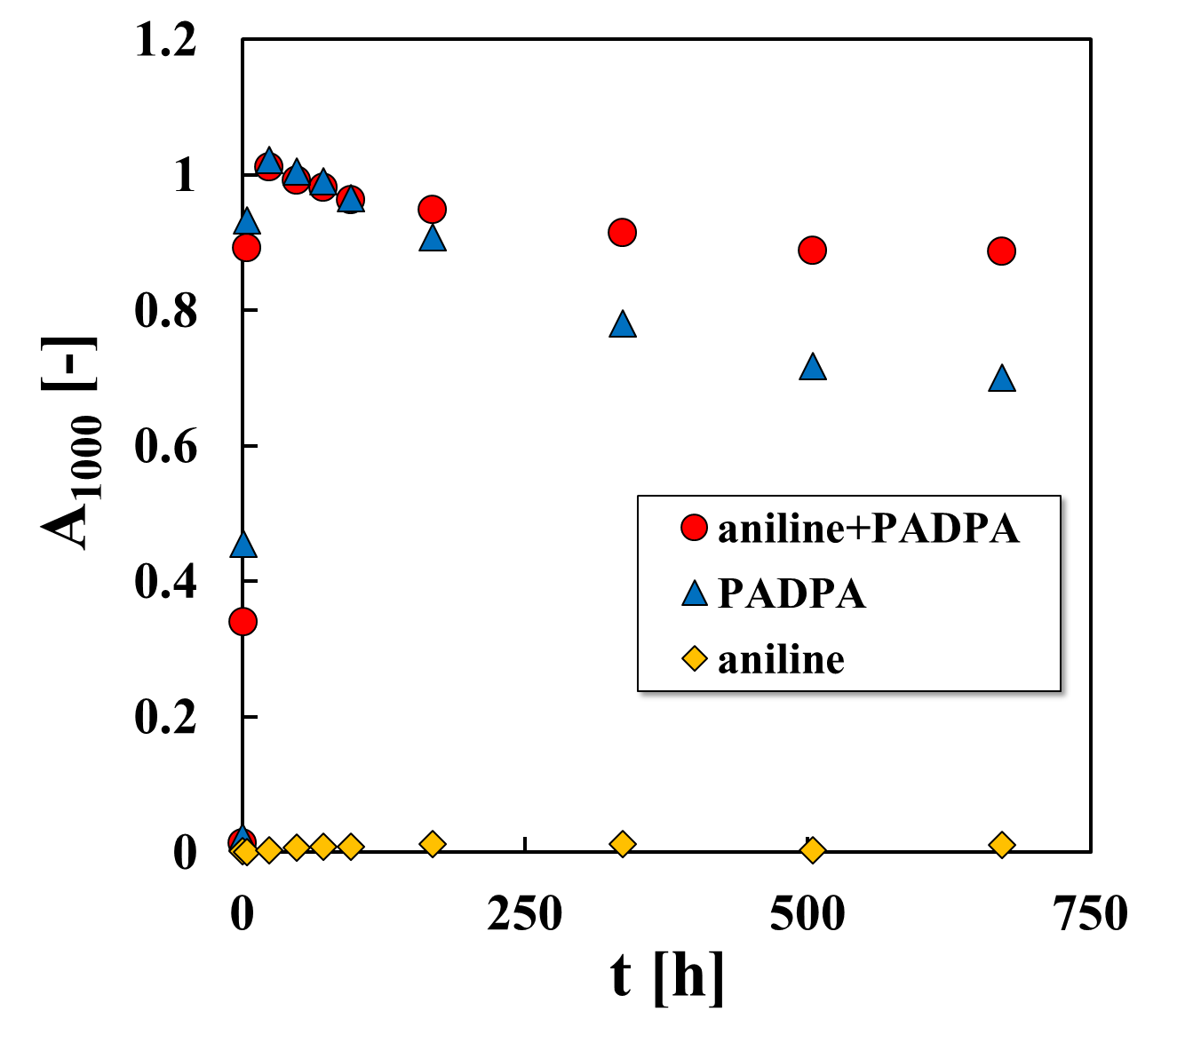
Figure 1. Comparison of the absorbance at λ = 1000 nm (A₁₀₀₀) in three different reaction mixtures, pH = 3.5, [laccase] = 0.207 µg/mL, [AOT] = 1.5 mM. ● [aniline] = 0.6 mM + [PADPA] = 0.7 mM, ▲ [PADPA] = 1.0 mM, ◆ [Aniline] = 2.0 mM.
4. Conclusions
The industrial laccase/O₂-catalyzed oxidation of the investigated aniline/PADPA mixture ([aniline] = 0.6 mM + [PADPA] = 0.7 mM) in the presence of AOT vesicles as templates results in stable conductive PANI-ES-type products. This reaction is promising due to its reduced costs for both, enzyme and substrate, as compared to the previously investigated systems.^{[2-4]}
References
- M. Atesa, T. Karazehir, A. Sezai Sarac, Curr. Phys. Chem., 2012, 2, 224-240.
- K. Kashima, T. Fujisaki, S. Serrano-Luginbühl, A. Khaydarov, R. Kissner, A. J. Ležaić, D. Bajuk-Bogdanović, G. Ćirić-Marjanović, L. D. Schuler, P. Walde, RSC Adv., 2018, 8, 33229-33242.
- S. Luginbühl, L. Bertschi, M. Willeke, L. D. Schuler, P. Walde, Langmuir, 2016, 32, 9765-9779.
- K. Junker, R. Kissner, B. Rakvin, Z. Guo, M. Willeke, S. Busato, T. Weber, P. Walde, Enzyme Microb. Technol., 2014, 55, 72-84.

