OXIDATIVE COUPLING OF METHANE IN A GAS-SOLID VORTEX REACTOR
Kevin M. Van Geem^{*,1}
1 Laboratory for Chemical Technology, Ghent University Technologiepark 125, 9052 Zwijnaarde, Belgium
*Corresponding author: kevin.vangeem@ugent.be
Highlights
- oxidative coupling of methane in 3D printed reactor
- gas-solid vortex reactor optimization
- reactive simulation using computational fluid dynamics

1. Introduction
Oxidative coupling of methane is considered one of the most promising routes to directly convert methane into more valuable hydrocarbons. The uncertain economics related to the tradeoff between conversion and C2 selectivities is an important reason why OCM is currently not industrially applied.¹ In the last decades, numerous studies have focused on developing a viable catalyst that has the potential to improve the low C2 yields. However, so far, the research on catalyst development has not led to any major breakthrough. One of the reasons is that next to the catalyst aspects, reactor design is of crucial importance for OCM. The lack of an appropriate reactor is one of the primary reasons why OCM has not been commercialized at industrial scale. Previous studies based on bifurcation theory ² have shown that the key features of an ideal OCM reactor are high thermal backmixing (i.e. high effective thermal conductivity) and low species backmixing (i.e. narrow residence time distributions). Narrow residence time distributions, i.e. plug flow behavior, is necessary to control and maximize the selectivity towards the intermediate products ethane and ethylene. High effective thermal conductivity creates the opportunity to exploit the bifurcation behavior and operate an OCM reactor autothermally, in this way utilizing the reaction heat in the best possible way. Both these characteristics can be obtained in the gas-solid vortex reactor (GSVR) that is studied in this work. In a gas-solid vortex reactor in a static geometry, gas is injected tangentially via a number of inlet slots (see Figure 1). The swirling gas transfers its momentum to the particles in the reactor chamber, which in turn start rotating. A fluidized state is obtained when the drag force exerted by the gas balances the apparent weight of the particles in the centrifugal force field. In contrast to conventional gravitational fluidized beds, higher gas throughput, lower
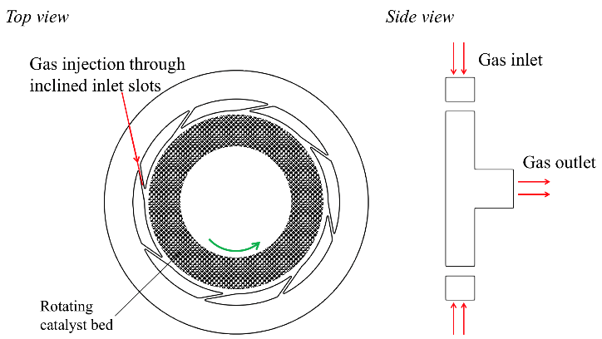
Figure 1. Gas-solid vortex reactor in a static geometry.

residence times, more uniform beds, higher slip velocities and hence better heat and mass transfer can be achieved in this reactor type. Therefore, the GSVR is an excellent candidate for process intensification. As the reactor can combine short residence times and narrow residence time distributions with optimal heat transfer characteristics, it is a very promising technology for OCM. In this work, the open-source CFD package OpenFOAM is used to simulate an adiabatic gas-solid vortex reactor using an Euler-Euler approach. Detailed microkinetic models are used for different types of catalyst (Sn-Li/MgO, Mn/Na2WO4/SiO2, Sr/La2O3). The effect of operating conditions and reactor geometry is evaluated.

2. Methods
The simulated GSVR geometry is adopted from the work of Gonzalez-Quiroga et al. ³ It basically consists of a cylindrical unit positioned along a vertical axis with eight gas injection slots of 1 mm width, equally distributed over the circumferential wall and tangentially inclined at a 10° angle. A reactor diameter of 80 mm and length of 15 mm are defined. The reactive two-phase flow in the GSVR is simulated with an Euler-Euler approach using the open-source CFD package OpenFOAM. A dedicated solver was developed, coupling OpenFOAM and Cantera, the latter being used as mechanism interpreter. This allows to use detailed microkinetic models. In this work, the microkinetic model consists of 39 gas phase reactions and 26 catalytic reactions.⁴ The same model can be used for different catalysts (Sn-Li/MgO, Mn/Na2WO4/SiO2, Sr/La2O3), provided the kinetic parameters are adjusted accordingly. The GSVR is simulated as an adiabatic unit.
3. Results and discussion
Non-reactive simulations show that narrow residence times can indeed be obtained in the GSVR. Plug flow behavior for species/mass transport is indicated by the quasi parallel streamlines (see Figure 2) and a simulated Péclet number >> 1. Preliminary reactive simulations also indicate a good thermal mixing in the reactor, without hot spot formation. High C2 selectivities ~75% can be obtained, but in the non-ignited state, methane conversion is limited because of the very small residence times (<5 ms) in the catalyst bed. Employing the effects of ignition/extinction behavior, the methane conversion can be increased while maintaining a high C2 selectivity, and at the same time working at lower inlet temperatures.
Figure 2. Gas streamlines, shown on top of the catalyst volume fraction field. Simulated conditions: 16-slot GSVR, 75 m/s slot velocity (CH₄:O₂ = 4), 11.2 g catalyst particles (2300 kg/m³, ∅ 500 µm)

4. Conclusions
In this work a new reactor technology is proposed for the oxidative coupling of methane (OCM). A gas-solid vortex reactor (GSVR) combines the two most important features required in an ideal OCM reactor: good heat management and narrow residence time distributions. This allows to utilize the exothermic reaction heat in the best possible way while also maximizing the selectivity towards intermediate C2 products. Computational Fluid Dynamic simulations are used to optimize and design the GSVR specifically for OCM. The CFD simulations show that the narrow residence time distributions and efficient heat management in the GSVR can give rise to C2 yields ~25 %.
References
1. L. A. V. Ismael l Amghizar, Kevin M. Van Geem,Guy B. Marin, Engineering, 3, 0-.
2. L. A. Vandewalle, I. Lengyel, D. H. West, K. M. Van Geem and G. B. Marin, Chemical Engineering Science, 2018, DOI: https://doi.org/10.1016/j.ces.2018.08.053.
3. A. Gonzalez-Quiroga, P. A. Reyniers, S. R. Kulkarni, M. M. Torregrosa, P. Perreault, G. J. Heynderickx, K. M. Van Geem and G. B. Marin, Chemical Engineering Journal, 2017, 329, 198-210.
4. P. N. Kechagiopoulos, J. W. Thybaut and G. B. Marin, Industrial & Engineering Chemistry Research, 2014, 53, 1825-1840.

