The Application, Required Investments and Operational Costs of
Geological CO₂ Sequestration: a Case Study.

Pedro Junior Zucatelli¹, Daniel da Cunha Ribeiro¹, Marielce de Cássia Ribeiro Tosta¹, Gisele de Lorena Diniz Chaves¹, Ana Paula Meneguelo¹
1 Federal University of Espirito Santo, BR 101 Norte, São Mateus, Espirito Santo, Brazil. Tel: 5527-3312-1590.
*Corresponding author: ana.meneguelo@ufes.br
Highlights
- Environment.
- Geological Storage.
- Operational costs.
- Global warming..

1. Introduction
Human actions, such as the burning of fossil fuels, the use of aerosols, and biomass combustion, liberate greenhouse gases (GHG) into the atmosphere [1]. The most abundantly released gases and therefore the most responsible for the greenhouse effect are N₂O, CH₄ and CO₂. In particular, CO₂ causes global warming and consequently climate changes.
Carbon sequestration through the Capture, Transport and Geological Storage of CO₂ (CCS technology) is an important alternative for reducing emissions [2] and stabilizing the atmospheric concentration of GHGs from a sustainable development perspective. The geological storage of CO₂ can be safely performed in three types of reservoirs: depleted oil and gas reservoirs, saline aquifers and coal layers. In depleted oil and gas reservoir after the beginning of CO₂ injection, the reservoir pressure increases and an increase of the oil production. However, when the geological storage is in saline aquifers the competitive differential between companies and industries will be based on providing services and manufacture of products with low carbon emissions. However, the main obstacle for CCS implementation in Brazil and in the other countries is the high financial cost [3].
This paper presents the CO₂ storage in a saline aquifer and oil and gas reservoir based on scenarios for the application of CCS projects, investments and operating costs.
2. Methods
The amount of recoverable oil by CO₂ injection varies as a function of the oil displacement mechanism and the characteristics of the field. The maximum amount of oil that can be recovered can be calculated using Equation as follows [4]. The extra percentage of recoverable oil due to CO₂ injection (%EXTRA) is an estimated value based on the API gravity of the oil. Probabilistic studies and simulations were performed by the IEA GHG to determine %EXTRA and was used in this study.
3. Results and discussion
To give an example of the estimated financial profitability resulting from CCS projects applied for CO₂ injection, the historical average of the Brent oil price [5] was designed between the years 2005 and 2018 (Figure 1). In this case study considers the Roncador field (original oil in place is 9.7 billion barrels). For the purpose of comparison, the extra recoverable oil percentages as a result of CO₂ injection were estimated to be 1.3%, 5.3% and 9.3%. From the analysis presented it can be observed that CCS projects yield variable amounts of gross revenue. This variation is directly linked, among other factors, to variations in oil prices and recoverable oil percentages.
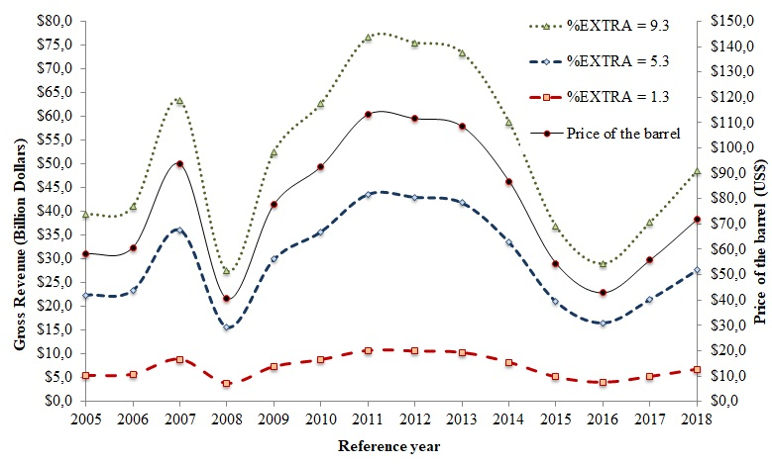
Figure 1 Variation of the average price of the Brent oil barrel and the gross revenue resulting from CCS projects.
The CO₂ storage potential in saline aquifers was analyzed: the Paraná Basin, Solimões Basin and the Santos Basin. These basins have, respectively, CO₂ storage potentials equal to 462 000, 252 000 and 148 000 MtCO2.
4. Conclusions
Using mathematical models, it can be concluded that the Roncador field presents higher gross revenue when the amount of extra oil that can be retrieved is 9.3% (US$ 48.55 billions approximately in 2018). Additional calculations show that the Paraná saline aquifer has the highest gross revenue (US$ 6.90 trillions in 2018) when compared to the Solimões (US$ 3.76 trillions approximately in 2018) and Santos saline aquifers (US$ 2.21 trillions approximately in 2018) if a CCS project were to be employed.
References [Calibri 10]
- X. Li, N. Wei, Y. Liu, Z. Fang, R.T. Dahowski, C.L. Davidson. CO2 point emission and geological storage capacity in China. Energy Proc.1 (2009) 2793-2800.
- Qiao, X. and Li, G. 2014. Factors influencing the safety of CO2 geological storage in deep saline aquifers. Environmental Engineering and Management Journal 13: 2917-2928.
- G.M. Jannuzzi M.K. Pop. Development, cooperation and transfer of low carbon energy technologies. In: Climate change in Brazil: economic, social and regulatory aspects. Brasília: IPEA (2011) 157.
- C. Hendriks, W. Graus, F. Van Bergen. Global Carbon Dioxide Storage Potential And Costs. Report nº EEP – 02001, ECOFYS. Utrecht, Netherlands (2004).
- Investing. Commodities. Accessed August 21, 2018. https://goo.gl/JM5ihY.

