Inhibition Kinetics of a High-Strength Nitrification Batch Reactor
Safae Sali¹, Hamish Robert Mackey¹*, Guang-hao Chen²
1 Division of Sustainable Development, College of Science and Engineering, Hamad bin Khalifa University, Qatar Foundation, Doha, Qatar; 2 Department of Civil and Environmental Engineering, Hong Kong University of Science and Technology, Clear Water Bay, Kowloon, Hong Kong, China.
*Corresponding author: hmackey@hbku.edu.qa
Highlights
- Urine nitrifying sequencing batch reactor studied for inhibition by FA, FNA and pH
- Large parallel batch testing and 15 inhibition models considered
- Noncompetitive FA, uncompetitive FNA, 2 way Prosser pH model found best
- Ammonia oxidizers insensitive to FA, both nitrifying organisms sensitive to FNA.

1. Introduction
Nitrification is a key biological wastewater treatment process, yet application to high strength wastewaters is challenging due to substrate and product inhibition as well as wide pH variations in poorly buffered systems. Understanding how these inhibitions affect removal kinetics is critical to optimum system design but is confounded by the close relationship between the inhibitors: free ammonia (FA), free nitrous acid (FNA) and pH [1]. Sequencing batch reactors can achieve higher rates of treatment [2], but are also more stressed by these inhibitors compared to more widely studied continuous flow systems [2,3]. Moreover, disagreement remains over the most suitable inhibition models [1,4]. This study undertakes a large set of extended batch tests across a wide range of pH, FA and FNA concentrations and extensive model assessment to determine the most suitable kinetic equations describing high strength nitrification of source separated urine.
2. Methods
A 13.8 L nitrifying SBR was operated with real urine diluted to 30% strength at a loading rate of 380 mg-N.L⁻¹.d⁻¹. Between days 227 and 332 a series of 18 separate 6 h batch experiments were conducted with constant pH using a consistent urine dose and additional spiking of NH₄Cl and NaNO₂ to adjust FA and FNA. The tests covered FA concentrations up to 225 mg-N.L⁻¹, FNA concentrations up to 0.20 mg-N.L⁻¹ and a pH range of 7 to 9. The nitrifying community was quantified using fluorescent in-situ hybridization and published probe sets. Fifteen separate two-stage nitrification rate expressions were evaluated consisting of different combinations of non-competitive (nc), uncompetitive (uc) and Aiba (A) type inhibition by FA and FNA coupled with either Presser two-way (P2), Cardinal three-way (C3) or Cardinal extended three-way (CE3) pH response models [5]. The system model consisted of a series of ordinary differential equations covering FA volatilization, urea hydrolysis, total ammoniacal nitrogen (TAN) oxidation (FA as substrate) and total nitrite nitrogen (TNN) oxidation with up to 19 parameters for estimation. Parameter estimation used parallel time-series estimation in the COPASI modelling package. Fitted models were validated against an independent batch experiment with uncontrolled pH. Best model selection considered both the average relative standard deviation (ARSD) of individual parameters across the 18 parallel batch tests and combined absolute error of TAN+TNN+NO₃ predictions for the validation file.
3. Results and discussion
Ammonia oxidizing bacteria (AOB) Nitrosomonas (Probe Nso1225) comprised 23.6 ± 0.3 % of the microbial community while Nitrobacter was the only nitrite oxidizing bacteria (NOB) detected (probe NIT3) at 1.0 ± 0.1 %. Treatment was stable throughout this period with full conversion of ammonia to nitrate. Evolution strategy was found to be the most successful optimization strategy for the relatively noisy experimental data. nc-FA, nc-FNA inhibition with CE3 pH gave the lowest parameter optimization objective value, while un-FA, nc-FNA with CE3 pH gave the lowest ARSD of 0.22. However, neither showed good fit to the validation data. Rather nc-FA, uc-FNA P2 pH and uc-FA, uc-FNA P2 pH gave the best fits to the experimental data with similar absolute errors across the predictions of TAN, TNN and NO₃ with the former model performing slightly better. Both also showed relatively low parameter optimization objective values and ARSD confirming them as suitable models for high strength nitrification. Both ammonia and nitrite oxidation were relatively insensitive directly to pH. Ammonia oxidation inhibition constants K_{i,NH3} and K_{i,HNO2} were 464 mg-N.L⁻¹ and 0.055 mg-N.L⁻¹ while for nitrite oxidation they were 9.64 mg-N.L⁻¹ and 0.027 mg-N.L⁻¹.This indicates AOB were highly acclimated to high FA concentrations, as expected since the reactor was fed with roughly 2000 mg-TAN/L feed with pH 9.2, while NOB were sensitive to FA in the system. Similar inhibition was experienced by both organisms from FNA.
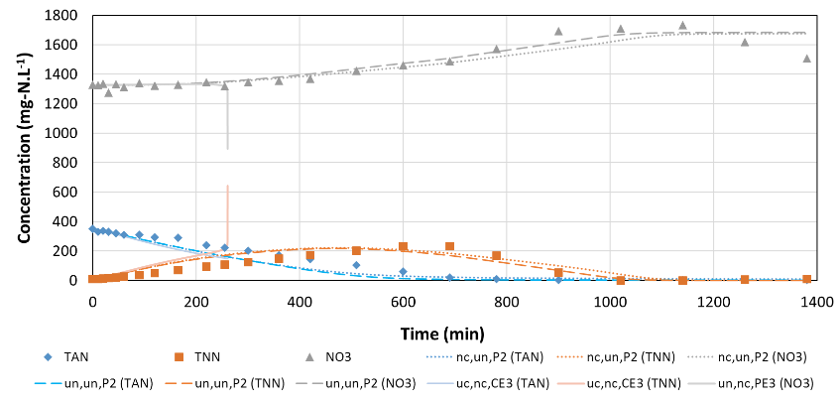
Figure 1. Fit for three models described in text against validation data where X,Y,Z stands for FA,FNA and pH inhibition model. The ODE was unstable for un-FA,nc-FNA,PE3 pH but fit was poor before instability.
4. Conclusions
These results are in contrast to Park and Bae [1] who found un-FA, nc-FNA, and Carerra et al [4] who found Aiba-FA, Haldane-FNA models were best respectively. This highlights the need for large-scale parallel testing and parameter optimization and consideration of pH to unravel interactions between FA, FNA and pH.
References
- S. Park, W. Bae, Proc. Biochem. 44 (2009) 631–640.
- K.M. Udert, C. Fux, M. Münster, T.A. Larsen, H. Siegrist and W. Gujer, Water Sci. Technol. 48 ,1 (2003) 119-130.
- E. Jiménez, J.B. Giménez, A. Seco, J. Ferrer, J. Serralta, Bioresour. Technol. 124 (2012) 478–484.
- J. Carrera, I. Jubany, L. Carvallo, R. Chamy, J. Lafuente, Proc. Biochem. 39 (2004) 1159-1164.
- R.J.W. Lambert J. Appl. Microbiol. 110, 1 (2011), 61-68.

