Experimental Investigation of Mass Transfer in a Miniplant Scale Rotating Packed Bed.
Matthias Hilpert¹, Jens-Uwe Repke¹
1 Process Dynamics and Operations Group, Technische Universität Berlin, Sekr. KWT-9, Str. des 17. Juni 135, D-10623 Berlin, Germany
*Corresponding author: matthias.hilpert@tu-berlin.de
Highlights
- RPB miniplant test stand constructed
- liquid side mass transfer coefficient evaluated from O2-stripping from water
- gas side mass transfer coefficient determined by distillation of binary alcohol mixtures

Rotating Packed Beds (RPBs) provide one approach to intensification of absorption and distillation processes by enhancing heat and mass transfer through intensified micromixing and increased effective specific surface area. Furthermore, much higher throughputs can be achieved without flooding. This leads to an up to 10-fold reduction in equipment size and thus lower space requirements and capital expenditure, as compared to conventional packed columns [1]. The RPB consists of packing material in the shape of a hollow cylinder clamped between two plates that rotate at speeds up to about 2000 min⁻¹. As illustrated in Figure 1, liquid is fed in the center near the axis of rotation and flows through the bed at multiples of normal gravity, while gas in countercurrent flows radially inward. The high centrifugal forces and thus the possibility to use high surface area packing that would flood in conventional columns lead to the aforementioned process intensification.
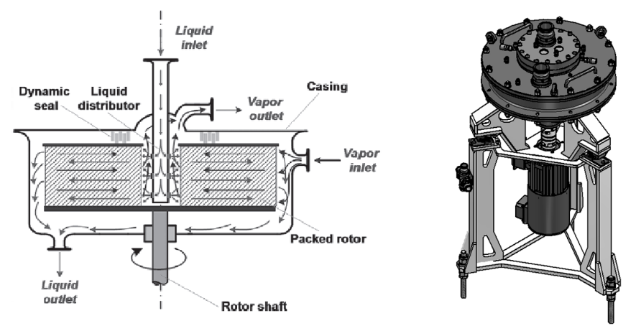
Figure 1. Flow pattern inside a single-stage horizontal RPB (left) [1], CAD-model of the constructed RPB (right).
Despite the potential of RPBs there are still few reported distillation applications in the European chemical industry which is among other factors due to the lack of validated design models for predicting RPB separation performance. While some studies regarding the distillation of binary mixtures have been published, to the best of our knowledge no publications on multi-component mixtures exist up to now. These however are necessary to validate models of the required complexity. Furthermore, the existing studies report processed results in the form of correlations or specific NTU-values that are of limited use to the development of new correlations. Therefore, a test stand has been built at our institute to generate the required data.
The RPB test stand enables distillation, absorption and desorption experiments over a broad range of operating parameters at a semi-industrial scale. Different bed types, depths and heights, as well as different options for liquid distribution can be employed. Distillation under infinite and finite reflux conditions is possible.
To develop a validated model for multicomponent distillation in the RPB, the following systematic approach is chosen, as illustrated in Figure 2. Mass transfer inside the RPB takes place during the very short residence time of less than 1 s. Therefore, a rate-based modeling approach is adopted, requiring correlations for liquid and vapor side mass transfer coefficients. Liquid side coefficients are determined from desorption of oxygen from water into nitrogen atmosphere. Overall mass transfer coefficients are derived from distillation of binary mixtures of lower-chain alcohols at infinite reflux. Gas side mass transfer coefficients will be back-calculated and correlated using the results. To test the validity of the model, binary and ternary ideal and non-ideal mixtures will be distilled and modeled.
Figure 2. Schematic of approach for determination of mass transfer coefficients.
The contribution presents details of the RPB test stand and the experimental design. Results from desorption experiments and from binary distillation runs will be shown, which form the basis for the development of mass transfer coefficient correlations.
References
- G.E. Cortes Garcia, J. van der Schaaf, A.A. Kiss, J. Chem. Technol. Biotechnol. 92 (2017) 1136–1156.

